Reedley College

New Credit Course Outline

Course # / Title | NR 45 – Logging Skills

CHECK OFF SHEET
PRELIMINARY STEPS (Do before completing Course Outline):

☑ 1. | Communicate with the Curriculum Chair regarding intent to propose a new course (scheduling an appointment for discussion is highly recommended for first time proposers).

☑ 2. | List term for Implementation: | [] | Fall |  | [☑] | Spring | 2007 | [ ] | Summer

☑ 3. | Determine if there is a similar course or program at FCC:
 | Yes
☑ | No

If yes, you will fill out the RC/FCC Course Alignment form (included in packet) after you have completed the cover page (Part I, Items 1-12) of the Course Outline of Record.

☑ 4. | Determine placement of course:
Desired CSU General Education Code | Yes |  | No | ☑
Transfer Baccalaureate List | Yes |  | No | ☑
Corresponds for CSUF Course? | Yes |  | No | ☑

If Yes, schedule an appointment with the Articulation Officer.

☑ 5. | Course repeatability for credit: If any of these are checked
☑ | Yes
 | No

If yes, secure a Course Repetition form from the Curriculum Office.

☑ 6. | Suggested maximum enrollment for course: | 20

☑ COURSE OUTLINE OF RECORD completed.

FINAL steps (Do after completing Course Outline of Record)

☑ 1. | Signature Form. Secure signatures of the Department Chair and the Associate Dean before submitting the completed course proposal to the Curriculum Office.

☑ 2. | Program Description. Course will change an existing program/is part of a new program which is or will be described in the college catalogue.
☑ | Yes
 | No

If yes, fill out the Program Description form (included in packet) before submitting your finalized proposal to the Curriculum Office.

☑ 3. | Final Check. All items above have been completed and checked off before proposal is submitted.

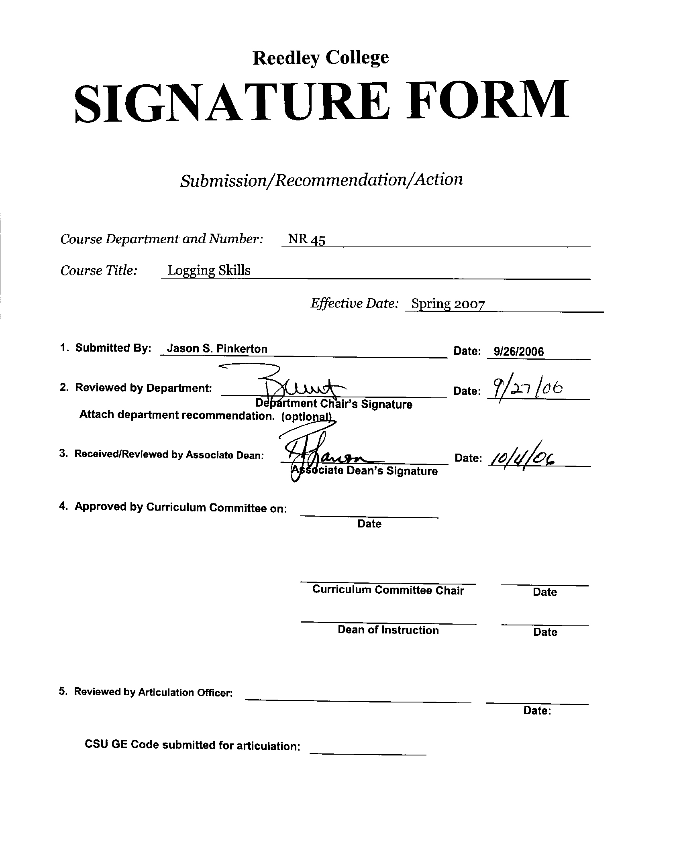



CREDIT COURSE OUTLINE

I. COVER PAGE

(1)  Course ID: NR 45 |  | (2)  Course Title: Logging Skills |  | (3)  Units: 1.0

(4) Lecture / Lab Hours: |  |  | (8)Classification:
Semester course  Hours per week | Lec hrs:
 | Lab hrs: |  |  |  | Degree applicable: |  |  | x
Lab will generate ______ hour(s) per week outside work. |  |  |  |  | Non-degree applicable:
Short-term course:  Hours per course | Lec hrs: | 9 |  |  | Pre-collegiate basic skills:
 | Lab hrs: | 27
Lab will generate ______ total hour(s) outside work. |  |  | (9)RC | Fulfills AS/AA degree requirement: (area)
(5)Grading Basis: | Grading scale only |  |  | General education category:
 | CR/NC option | X |  | Major:
 | CR/NC only
(6)Basic Skills Prerequisites: |  |  | (10)CSU: |  | Baccalaureate:
 |  |  | (11) Repeatable: (A course may be repeated  three times) |  |  |  |  | 3
Basic Skills Advisories:  Eligibility for ENGL 125, ENGL 126, and MATH 101 |  |  | For Office Use Only
 |  |  | CATID: |  |  |  | DATATEL:
(7)Subject Prerequisites (requires C grade or better): |  |  | Course LHE: |  |  |  | Unit Code:
 |  |  | VEA Code: |  |  |  | SAM Priority:
 |  |  | TOPS Code: |  |  |  | Effective Date:
Subject Corequisites: |  |  | CSU: |  |  |  | Replaces:
Subject Advisories: |  |  |  |  |  |  | Replaced by:  Date:
(12)Catalog Description:

An introduction to historic and modern logging activities. Topics may include instruction in choker setting, vertical and horizontal chopping, tree climbing, crosscut saw use, log burling, dendrology, and comparisons of conventional/current timber harvesting techniques. May also include participation at competitive collegiate level logging events.

Course ID: NR 45 |  | Course Title: Logging Skills

II. COURSE OUTCOMES:

(Specify the learning skills the student demonstrates through completing the course and link critical thinking skills to specific course content and objectives.)

Upon completion of this course, students will be able to:

A. Select the appropriate knot style for tree climbing.

B. Perform chainsaw or crosscut saw operation, choker setting, and tree climbing.

C. Differentiate among various conventional or modern timber harvesting techniques.

- Choose the proper safety equipment and technique for sharpening or using a crosscut saw, throwing axe, and a chopping axe.

E. Differentiate among common western United States commercial tree species (e.g. ponderosa pine, incense cedar, coast redwood, or Douglas-fir).

III. COURSE OBJECTIVES:

(Specify major objectives in terms of the observable knowledge and/or skills to be attained.)

In the process of completing this course, students will:

A. Demonstrate the proper technique for sawing a log with a chainsaw or crosscut saw, setting a choker, climbing a tree, and building a fire.

B. Describe the safety procedures related to axe throwing, chainsaw or crosscut saw operation, choker setting, and tree climbing.

C. Discuss the differences between horizontal and vertical chopping as related to safety and technique.

D. Identify varying tree and shrub species native to California.

E. Describe the proper technique for sharpening a crosscut saw, throwing axe, and a chopping axe.

F. Identify several conventional/modern timber harvesting strategies.

G. Describe the various portions of a crosscut saw (e.g. gullet, raker, taper ground, etc.)

Course ID: NR 45 |  | Course Title: Logging Skills

IV. COURSE CONTENT OUTLINE:

Lecture Content  A. Introduction  1. Course outline  B. Axe Throwing  1. Technique  2. Safety procedure  3. Axe sharpening  C. Choker Setting  1. Technique  2. Safety procedure  D. Vertical and Horizontal Chopping  1. Techniques  2. Safety procedure and equipment  E. Tree Climbing  1. Climbing techniques  2. Rappelling techniques  3. Safety procedure  4. Knot selection  5. Gear selection  F. Crosscut Saw Sharpening and Use  1. Technique  2. Safety procedure and equipment  3. Saw cutting methodology  4. Saw model identification  G. Dendrology  1. Species identification  2. Species importance to industry  H. Harvesting Methods  1. Historic methods  2. Conventional methods  3. Modern techniques | Laboratory Content  A. Axe Throwing  1. Safety procedure  2. Axe sharpening  B. Choker Setting  1. Technique  2. Choker parts identification  3. Setting procedures  C. Vertical and Horizontal Chopping  1. Techniques  2. Equipment  3. Axe sharpening  D. Tree Climbing  1. Climbing techniques  2. Rappelling techniques  3. Safety procedure  4. Knot tying  5. Gear selection  E. Crosscut Saw Use  1. Saw sharpening procedures  2. Tool use and identification  3. Bucking logs  F. Dendrology  1. Species identification  2. Species characteristics  G. Harvesting Methods  1. Axe and crosscut saw use  2. Chain saws  3. Modern mechanized equipment (i.e. harvesters, feller- bunchers, and/or de-limbers).

Course ID: NR 45 |  | Course Title: Logging Skills

V. APPROPRIATE READINGS

Reading assignments may include but are not limited to the following:

A. Sample Text Title: Humboldt State University. 2004. Association of western forestry clubs (AWFC) logging sports rule book.

B. Other Readings: Miller, W. 1988. Crosscut saw manual.

Forest Service Technology and Development Program. 2004. An ax to grind: a practical ax manual
http://www.fhwa.dot.gov/environment/Fspubs/99232823/page16.htm

Global or international materials or concepts are appropriately included in this course
Multicultural materials and concepts are appropriately included in this course.

If either line is checked, write a paragraph indicating specifically how global/international and/or multicultural materials and concepts relate to content outline and/or readings.

Course ID: NR 45 |  | Course Title: Logging Skills

VI. METHODS TO MEASURE STUDENT ACHIEVEMENT AND DETERMINE GRADES:
Students in this course will be graded in at least one of the following four categories. Please check those appropriate. A degree applicable course must have a minimum of one response in category A, B or C.

A. Writing
Check either 1 or 2 below
 | 1. Substantial writing assignments are required. Check the appropriate boxes below and provide a written description in the space provided.
X | 2. Substantial writing assignments are NOT required. If this box is checked leave this section blank. For degree applicable courses you must complete category B and/or C.
 | a. essay exam(s) |  | d. written homework
 | b. term or other papers(s) |  | e. reading reports
 | c. laboratory reports |  | f. other (specify)
Required assignments may include but are not limited to the following:

B. Problem Solving
1. Computational or non-computational problem-solving demonstrations, including:
X | a. exam(s) |  | d. laboratory reports
X | b. quizzes | X | e. field work
 | c. homework problems |  | f. other (specify)
Required assignments may include, but are not limited to the following:

- Identify the following parts of a crosscut saw?
- Compare and contrast historic vs. modern logging systems.
- Demonstrate the proper technique for safely chopping with an axe.

Course ID: NR 45 |  | Course Title: Logging Skills

C. Skill demonstrations, including:
X | a. class performance(s) | X | c. performance exam(s)
 | b. field work |  | d. other (specify)
Required assignments may include, but are not limited to the following:

Students may perform several of the following skills: axe throwing, choker setting, vertical and horizontal chopping, tree climbing, crosscut saw use, and tree identification.

D. Objective examinations, including:
 | a. multiple choice |  | d. completion
 | b. true/false | X | e. other (specify) Lab practical
 | c. matching items

COURSE GRADE DETERMINATION:
Description/Explanation: Based on the categories checked in A-D, it is the recommendation of the department that the instructor’s grading methods fall within the following departmental guidelines; however, the final method of grading is still at the discretion of the individual instructor. The instructor’s syllabus must reflect the criteria by which the student’s grade has been determined. (A minimum of five (5) grades must be recorded on the final roster.)

If several methods to measure student achievement are used, indicate here the approximate weight or percentage each has in determining student final grades.

Performance Evaluations of Specified Skills 50%
Participation 20%
Exams 20%
Quizzes 10%

FOR DEGREE APPLICABLE COURSES

Course ID: NR 45 |  | Course Title: Logging Skills

VII. EDUCATIONAL MATERIALS
For degree applicable courses, the adopted texts, as listed in the college bookstore, or instructor-prepared materials have been certified to contain college-level materials.

Validation Language Level (check where applicable): | College-Level  Criteria Met
 | Yes | No
Textbook
Reference materials | X
Instructor-prepared materials
Audio-visual materials

Indicate method of evaluation:
Used readability formulae (grade level 10 or higher)
Text is used in a college-level course | X
Used grading provided by publisher
Other: (please explain; relate to Skills Levels) Satisfactory

Computation Level (Eligible for MATH 101 level or higher where applicable) |  | X

Content
Breadth of ideas covered clearly meets college-level learning objectives of this course |  | X
Presentation of content and/or exercises/projects:
Requires a variety of problem-solving strategies including inductive and deductive reasoning. |  | X
Requires independent thought and study |  | X
Applies transferring knowledge and skills appropriately and efficiently to new situations or  problems. |  | X
List of Reading/Educational Materials

Humboldt State University. 2004. Association of western forestry clubs (AWFC) logging sports rule book.
Miller, W. 1988. Crosscut saw manual.

Forest Service Technology and Development Program. 2004. An ax to grind: a practical ax manual
http://www.fhwa.dot.gov/environment/Fspubs/99232823/page16.htm

Comments:

 | This course requires special or additional library materials (list attached).
X | This course requires special facilities: Reedley College Conclave Area (Reedley College Farm)

FORM A
TARGET COURSE | NR 45 |  | Logging Skills
 | Number |  | Title

BASIC SKILLS ADVISORIES PAGE The skills listed are those needed for eligibility for English 125, 126, and Math 101. These skills are listed as the outcomes from English 252, 262, and Math 250. In the right hand column, list at least three major basic skills needed at the beginning of the target course and check off the corresponding basic skills listed at the left.

Math Skills (eligibility for Math 101)  (as outcomes for Math 250)  x Performing the four arithmetic operations on whole numbers, arithmetic fractions, and decimal fractions.  x Making the conversions from arithmetic fractions to decimal fractions, from decimal fractions to percents, and then reversing the process.  Applying the concepts listed above to proportions, percents, simple interest, markup and discount.  Applying the operations of integers in solving simple equations.  x Converting between the metric and English measurement systems | Ability to convert English to metric systems when working with machinery.  Calculate volumes and area related to machinery and forest treatments.  Convert from fractions to decimals.
Reading Skills (eligibility for English 126)  (as outcomes for English 262)  x Using phonetic, structural, contextual, and dictionary skills to attack and understand words.  x Applying word analysis skills to reading in context.  x Using adequate basic functional vocabulary skills.  Using textbook study skills and outlining skills.  Using a full range of literal comprehension skills and basic analytical skills such as predicting, inferring, concluding, and evaluating. | Ability to read and comprehend textbook.  Ability to understand and use specialized vocabulary within the context of the course.  Ability to read and comprehend recent literature related to the course.
Writing Skills (eligibility for English 125)  (as outcomes for English 252)  x Writing complete English sentences and avoiding errors most of the time.  x Using the conventions of English writing: capitalization, x punctuation, spelling, etc.  x Using verbs correctly in present, past, future, and present perfect tenses, and using the correct forms of common irregular verbs.  x Expanding and developing basic sentence structure with appropriate modification.  x Combining sentences using coordination, subordination, and phrases.  Expressing the writer's ideas in short personal papers utilizing the writing process in their development. | Ability to write short answers to test questions.  Organize thoughts into paragraphs to respond to written material.  Ability to write laboratory reports.

Check the appropriate spaces.
x Eligibility for Math 101 is advisory for the target course.
x Eligibility for English 126 is advisory for the target course.
x Eligibility for English 125 is advisory for the target course.
If the reviewers determine that an advisory or advisories in Basic Skills are all that are necessary for success in the target course, stop here, provide the required signatures, and forward this form to the department chair, the appropriate associate dean, and the curriculum committee.

Content review completed by |  | Date

Reedley College

REQUEST FOR COURSE REPEATABILITY
(For reasons other than alleviating substandard work)

Course ID: NR 45 |  | Course Title: Logging Skills | Date: 9/26/06
Number of times course may be repeated, excluding initial enrollment (1, 2, or 3): 3
or
Maximum units to which course may be repeated, including initial enrollment:

The following information is required under Title V, Part VI, Section 58161
1. Explain how the course content differs each time it is offered:

Varying techniques with regard to skill application will be covered in greater depth with repetition. Students may be exposed to competitions at the collegiate and or professional level further enhancing skills.

2. Using reasons “A” or “B” listed below, explain how the student, by repeating this course will gain an expanded educational experience (A or B):
X | A. Skills or proficiencies are enhanced by supervised repetition and practice within class periods. Explanation:
Advanced techniques with regard to axe throwing, choker setting, vertical and horizontal chopping, tree climbing, crosscut saw use/sharpening, log burling, and dendrology are greatly enhanced by repetition. Participation at the professional level is a possibility with honed skills.
 | B. Active Participatory experience in individual study or group assignments is the basic means by which learning objectives are attained. Explanation:

