College Office of Research and Evaluation
reedley college | June 2017
2017 Technology Student Survey Response
Campus wide survey

Which campus do you take most of your courses?

Answer Options | Response Percent | Response Count
Reedley College | 54.2% | 39
Madera Community College Center | 22.2% | 16
Oakhurst Community College Center | 0.0% | 0
Other (please specify) | 23.6% | 17
Fresno City College | 16.7% | 12
Clovis Community College | 0.5% | 4
Online | 0.0% | 1

For each item, consider how important the item is to you:
– | Very Important– | Somewhat Important– | Not Important– | N/A– | Total–
–  Available computers hardware and software help me effectively perform my required assignments. | 91.49%  43 | 8.51%  4 | 0.00%  0 | 0.00%  0 | 47
–  There are an adequate amount of work stations available in the computer lab. | 78.72%  37 | 21.28%  10 | 0.00%  0 | 0.00%  0 | 47
–  The equipment in the computer lab is kept in proper working order. | 80.85%  38 | 17.02%  8 | 0.00%  0 | 2.13%  1 | 47
–  Access to the Internet and email is sufficient. | 82.61%  38 | 15.22%  7 | 2.17%  1 | 0.00%  0 | 46
–  Specialty software is available. | 67.39%  31 | 23.91%  11 | 4.35%  2 | 4.35%  2 | 46
–  The lab is clean and well maintained. | 72.34%  34 | 25.53%  12 | 2.13%  1 | 0.00%  0 | 47
–  The availability of printers is adequate. | 72.34%  34 | 21.28%  10 | 6.38%  3 | 0.00%  0 | 47
–  The quality of printing is good. | 80.85%  38 | 10.64%  5 | 8.51%  4 | 0.00%  0 | 47
–  Printers are current and well maintained. | 72.34%  34 | 21.28%  10 | 6.38%  3 | 0.00%  0 | 47
–  I am satisfied with the hours the computer lab is open. | 78.72%  37 | 14.89%  7 | 6.38%  3 | 0.00%  0 | 47
–  The computer lab is user friendly for ALL students. | 76.60%  36 | 14.89%  7 | 4.26%  2 | 4.26%  2 | 47
–  The staff in the computer lab is helpful. | 74.47%  35 | 14.89%  7 | 10.64%  5 | 0.00%  0 | 47
–  The staff in the computer lab is friendly and approachable. | 76.60%  36 | 14.89%  7 | 6.38%  3 | 2.13%  1 | 47
–  My questions are answered in a timely fashion. | 72.34%  34 | 19.15%  9 | 6.38%  3 | 2.13%  1 | 47
–  The staff is helpful when I need technical support or training. | 74.47%  35 | 17.02%  8 | 6.38%  3 | 2.13%  1 | 47

For each item, consider how satisfied you are with the item or service:
– | Very Satisfied– | Somewhat Satisfied– | Not Satisfied– | N/A– | Total–
–  Available computers hardware and software help me effectively perform my required assignments. | 59.57%  28 | 27.66%  13 | 8.51%  4 | 4.26%  2 | 47
–  There are an adequate amount of work stations available in the computer lab. | 61.70%  29 | 27.66%  13 | 8.51%  4 | 2.13%  1 | 47
–  The equipment in the computer lab is kept in proper working order. | 55.32%  26 | 27.66%  13 | 14.89%  7 | 2.13%  1 | 47
–  Access to the Internet and email is sufficient. | 65.96%  31 | 19.15%  9 | 12.77%  6 | 2.13%  1 | 47
–  Specialty software is available. | 34.78%  16 | 43.48%  20 | 13.04%  6 | 8.70%  4 | 46
–  The lab is clean and well maintained. | 60.00%  27 | 28.89%  13 | 4.44%  2 | 6.67%  3 | 45
–  The availability of printers is adequate. | 47.83%  22 | 30.43%  14 | 17.39%  8 | 4.35%  2 | 46
–  The quality of printing is good. | 53.19%  25 | 21.28%  10 | 21.28%  10 | 4.26%  2 | 47
–  Printers are current and well maintained. | 48.94%  23 | 34.04%  16 | 12.77%  6 | 4.26%  2 | 47
–  I am satisfied with the hours the computer lab is open. | 58.70%  27 | 32.61%  15 | 4.35%  2 | 4.35%  2 | 46
–  The computer lab is user friendly for ALL students. | 57.45%  27 | 29.79%  14 | 10.64%  5 | 2.13%  1 | 47
–  The staff in the computer lab is helpful. | 56.52%  26 | 26.09%  12 | 10.87%  5 | 6.52%  3 | 46
–  The staff in the computer lab is friendly and approachable. | 59.57%  28 | 25.53%  12 | 6.38%  3 | 8.51%  4 | 47
–  My questions are answered in a timely fashion. | 55.32%  26 | 29.79%  14 | 8.51%  4 | 6.38%  3 | 47
–  The staff is helpful when I need technical support or training. | 55.32%  26 | 31.91%  15 | 8.51%  4 | 4.26%  2 | 47

How often do you use the computers or computer labs on campus?
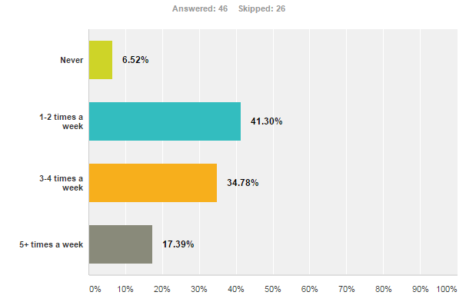

Do you have Internet access away from school?
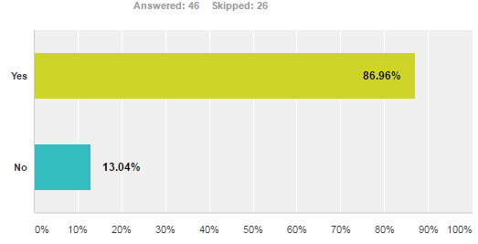

If you are in an Online class, where do you complete most of your course work?

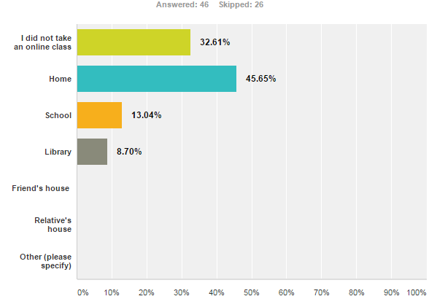

Are there any software programs that the computer lab does not have that you need for class work?
no
I have everything I need in lab
No
No, everything I needed was available in the computer labs. The only thing I have to complain about is how the printing card machine only takes in paper bills. I would love if it could take in change as well because sometimes that's all I have.
N/A
no
Photoshop or for programs artistic projects)
Photoshop
Matlab would be a great addition if possible.
no
No
n/a
N/A
not at the moment.
N/A
Photoshop
no
no
no
N/A

Your Age

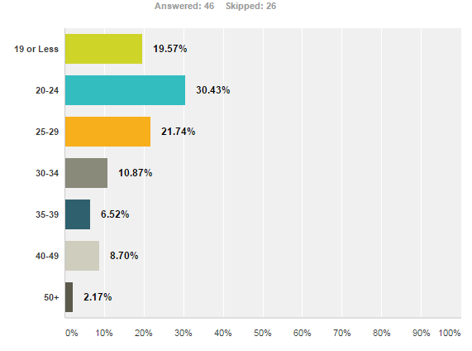

Gender:
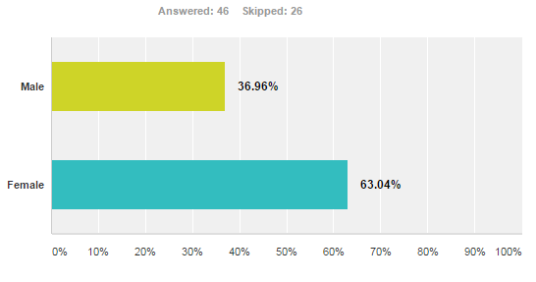

Ethnicity

