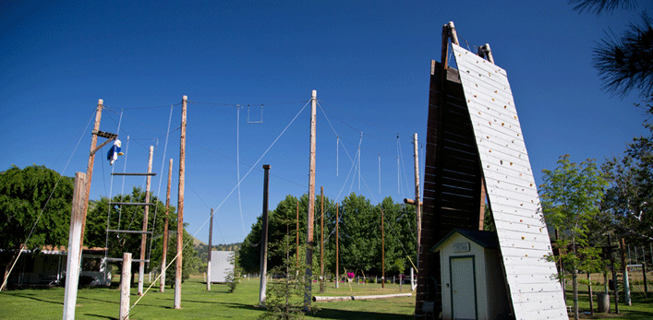
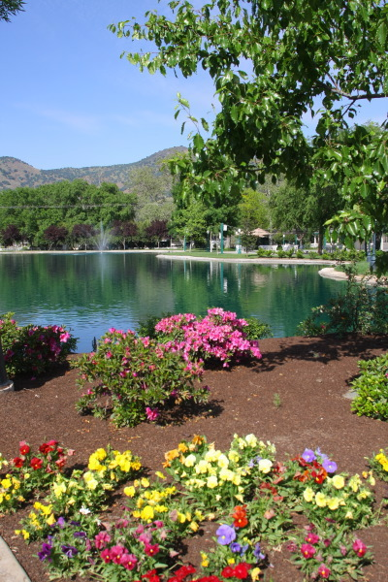
We have been given the opportunity for a
Counselor Retreat

friday, September 16
8:00-5:00
AT wONDER VALLEY RANCH

RETREAT PROGRAM

8:00-8:30 Open recreation and social
8:30-9:00 Registration, coffee, and mixer
9:00-10:30 Moving Toward Understanding
Dr. Darlene Murray, Student Equity Coordinator
10:30-10:45 Snack break
10:45-12:00 Me, Counseling and Equity- continuing the dialogue
12:00-1:00 Buffet lunch and recreation
1:00-2:30 Introduction to Electronic Educational Planning (EPI)
Kayla Mannon
2:30-2:45 Snack Break
2:45-4:00 Now what? -planning with EQUITY and EPI in mind
Kayla, Samara, Darlene, and Michelle
4:00-5:00 Open recreation and social
Blind Canoe Race

