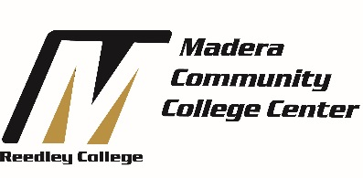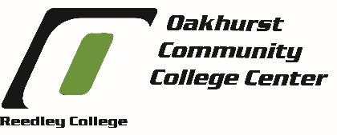

Counselor Work Retreat Agenda
Wonder Valley Conference Center
May 15, 2015

8:15 | Check in
8:30 | Welcome, Student Services Directions through the lens of SSSP & Equity | Claudia/Julie
 | Ice Breaker | TJ/Kristine/Maria
 | Counseling Goals and Outcomes | Samara
9:45 | Ropes Course | All
12:00 | Lunch
1:00 | Determine PLO Work Groups | Julie/Samara
 | Work on Group Plans | Teams
2:30 | Report Out | Julie
3:00 | Evaluation | All

Expected Outcomes for the Day:

Retreat Goal | RC Strategic Plan Goal | Desired Outcome
Engage in department planning to improve program effectiveness and planning for program review. | 3.4: Ensure continuous integration and implementation of the colleges' Program Review and Student Learning Outcomes assessment to improve institutional effectiveness. | Have a draft of suggested Counseling Department PLOs for fall 2015.
Promote unity in the counseling department across all of MOR. | 6.2: Promote communication and collaboration about college programs, services and activities between Reedley, Madera, and Oakhurst. | 100% counselor engagement in day’s activities (Ice Breaker, Ropes Course, Work Groups, etc.)

