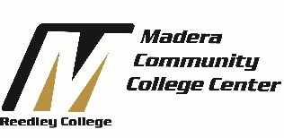
Summer Bridge
We Motivate and Inspire Students to Succeed!
Program Benefits
Upon successful completion of Summer Bridge, students will…
- Earn up to 9 units of academic credit
- Reserved seating for Fall 2016 (English 1A & Counseling 53)
- Receive early registration for fall & spring semester courses
- Establish relationships with college counselors, instructors and staff
- Understand academic expectations and college culture
- Attend fieldtrips to four-year colleges & universities
- Receive FREE bus passes, textbook vouchers, & classroom supplies

Summer Bridge 2016 Begins

June 20 – July 29

Who is eligible?
- All new students who are planning to attend Madera Community College Center for the first time.
- Students who have placement levels of English 125 and English 126
- Students must have an interest in a transfer degree pathway to a CSU/UC
How to apply?
Complete the Madera enrollment process including:
- Online application
- Online Orientation
- Assessment Testing
- Advising
- Submit the Madera CCC - Summer Bridge Application Deadline: April 1, 2016
For more information, contact the Madera Counseling Department at (559) 675-4800 or talk with a Madera Community College Center Counselor.

