Table of Contents

Contact Page i
Table of Contents
Needs Statement 1
Response to the Need 5
Work Plan 11
Program Management 14
Project Budget Summary 17
Budget Detail Sheet 18
Sustainability Plan 19

NEED

Getting students in and through with success: Transforming Reedley College Basic Skills

Reedley College (RC) is asking for 1.5 million dollars in order to transform its basic skills program through systemic change to get students placed into higher-level courses, accelerate students through the basic skills sequence more quickly and provide students the support they need to succeed.

Reedley College has selected three evidence-based practices to focus on in this grant.
- Adopt placement tests or other student assessment indicators and related policies that may include multiple measures of student performance including grades in high school courses, especially overall grade point averages, results from the common assessment system and input from counselors. (Strategy #1)
- Develop two-and-three course sequences, as appropriate, for completion of college level English and/ or Mathematics courses for underprepared students by utilizing technology, where appropriate, to enhance the adoption of high impact practices specified in methods (1) to (5), inclusive. (Strategy #6)
- Provide proactive student support services that are integrated with the instruction. (Strategy #5)

A group of faculty and administrators identified the three strategies as the best option to increase the number of students completing the basic skills sequence and to address the completion deficiencies seen in the RC Student Success Scorecard data by scaling up local best practices.
CCCCO Scorecard | RC | Statewide | Difference
Remedial Math | 34.3% | 31.0% | 3.3%
Remedial English | 36.6% | 43.4% | - 6.8%
Remedial ESL | 7.4% | 28.4% | -21%
Completion (Prepared) | 71.6% | 69.7% | 1.9%
Completion (Unprepared) | 36.4% | 39.2% | -2.8%

Although RC does have slightly better scores than other colleges statewide in remedial math, the general need for RC to increase the number of students persisting through the basic skills sequence and complete degrees and certificates is obvious.

The group agreed that placement should be the first step toward change. This includes multiple measures to make sure students are placed in the highest and most appropriate class. After determining appropriate placement, those students still placed below college Mathematics and English would be offered accelerated pathways and proactive supplemental support services.

Reedley College (RC), an associate degree-granting institution of State Center Community College District (SCCCD), is located in the small rural community of
Reedley in Fresno County, California, 30 miles southeast of Fresno.

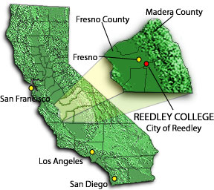
Reedley College - City of Reedley in the heart of San Joaquin Valley, an area with the highest agricultural production rate in the United States.
RC Main Campus Fall 2015 enrollment was 9,119 of which Hispanics comprised 69.5%. Reedley College also operates a rapidly growing college center in the city of Madera, located 30 miles north of Fresno and 60 miles north of the main campus of Reedley College. As the only higher educational opportunity in Madera County, RC’s Madera Community College Center (MCCC) enrollments climbed in Fall 2015 to 2,841 students with, 66% Hispanic.

Reedley College Enrollment Profiles (2015)
Demographic | Number | Student Race/Ethnicity** | Percent
Students | 9,119 | Hispanic | 69.5%
FTES | 4,171 | White | 20.2%
Credit Sections | 2,373 | Asian | 6.1%
Student Counseling Ratio | 587:1 | African American | 3.0%
Demographic | Percent | Two or More Races | 2.2%
% of Full-Time Faculty | 59% | Unknown Ethnicity | 2.0%
Female Students | 59.9% | Filipino | 1.2%
Male Students | 40.1% | Amer. Indian/Alaska Native | 1.0%
Student Age |  | Pacific Islander | 0.1%
Under 20 years old | 34.1%
20 to 24 years old | 40.9%
25 to 39 years old | 17.3%
40 or more years old | 7.7%
*Data includes enrollment data for all Reedley Campuses, including Madera Community College Center. Source: State Center Community College Institutional Researcher
Although the main campus of RC and the growing MCCC are divided by an hour’s driving distance, in vast central California that is close enough for the project team to work together, to jointly infuse new practices into programs to better serve basic skills students. Fresno and Madera Counties contain many small-impoverished communities with a large number of farm worker families who are predominantly high need and Spanish speaking. Middle and high schools in these small rural communities are often 90 percent Hispanic with over 70% qualifying as low-income. Rural communities suffer official poverty levels as high as 49.2% -a figure that more than triples the state poverty rate of 15.9%. Furthermore, 90% of the service area adult population has not completed a bachelor’s degree.

PLACEMENT—Low placement of students in transfer level Mathematics and English.
Completion of Transfer-Level English  Reedley College--Fall 2012-Spring 2015 | Percent Completing Transfer-Level English in 3 Years
Transfer Level | 69%
One Level-Below Transfer | 34%
Two Levels Below Transfer | 1%
Three or More Levels Below Transfer | 0%
Overall | 41%
Reedley College Placement Data (Fall 2014)
Title of Course | Students
Basic College Math – 3+ levels below college | 33%
Elementary Algebra – 2 levels below college | 43%
Intermediate Algebra – 1 level below college | 21%
College-Level | 4%
English Placement Levels—New Students
Title of Course | Students
Basic College English-2 levels below college | 8%
Writing Skills – 1 level below college | 69%
Composition & Reading - College Engish1A | 23%
Title of Course | Students
Basic Reading – 3 levels below college | .007%
Reading- 2 levels below college | 11.2%
Reading Skills – 1 level below college | 59.7%
Composition & Reading - College Engish1A | 29%
Currently students are placed primarily using Accuplacer data. According to the RP group, 20-35% of students are severely under-placed⁵. The college has limited multiple measure placement and currently has a work group to address this need. In addition to the multiple measures discussion, RC is working with our sister college Fresno City College to pilot the statewide Common Assessment. One issue that complicates the implementation of multiple measures is the fact that RC works with 14 different feeder schools. The college has started a K-12 bridge faculty collaboration program where RC faculty are matched with K-12 Mathematics and English faculty; they work collaboratively on curriculum alignment to help prepare students for college classes. This process needs to be scaled up to have community wide impact.
ACCELERATED BASIC SKILLS SEQUENCE —complicated basic skills sequence with too many exit points.
With 96% of entering students placing below college level math and 77% placing below college level English RC, needs to simplify and accelerate the basic skills pathways. Currently there are four basic skills levels of mathematics and three levels below in English. This issue is aggravated by the fact that students who place into lower level courses are less likely to complete a transfer level mathematics or English course. The Basic Skills committee on campus has been focused on moving students through the
__________________
⁵http://rpgroup.org
Completion of Transfer-Level  Math  Reedley College--Fall 2012-Spring 2015 | Percent Completing Transfer-Level Math in 3 Years
Transfer Level | 71%
One Level-Below Transfer | 27%
Two Levels Below Transfer | 13%
Three or More Levels Below Transfer | 6%
Overall | 19%
basic skills sequence with a first year experience program focusing on the Mathematics and English (ME) first initiative. BSI funding has been used to support cohort groups at 1 and 2 levels below college level mathematics and English courses supported with required time on task study facilitated through the college’s Writing/ Reading Center, Tutorial Center and Mathematics Center.
This has been a successful program with more than 70% of students progressed to college level mathematics and over 60% of students entering into college level English. This program is on a small scale with around 25 students per year. In Fall 2016 the program will expand to 4 cohorts (100 students). Added to this successful program is an accelerated English class (ENGL 130) that combines classes 1 and 2 levels below transfer level. This cohort model has been successful but is limited to a small number of students. This grant proposes systemic change to the basic skills sequence to create additional accelerated courses in mathematics and reading to impact the majority of incoming students.
PROACTIVE STUDENT SUPPORT— low number of students completing basic skills sequences and persisting to transfer level course.
The number of students who complete transfer level courses in Mathematics and English after being placed in the basic skill sequence is small (Mathematics 6-27%, English 0-34%). In fact, only 19% of students in Mathematics and 41% of students in English who start in the basic skills sequence ever complete a college level course. Even the students who enter at one level below transfer do not always make it to transfer level. Students need additional support. This help will be essential for students in the proposed accelerated basic skills pathways.
Reedley College has a successful supplemental instruction program focused on helping student succeed in transfer level courses. The RC program was based on the highly successful Extending the Classroom (ETC) program at Fresno City College. Supplemental instruction linked courses increased students success by 18%. Supplemental instructional leaders (peer tutors) facilitate regularly scheduled review sessions in which students compare notes, discuss readings, develop organizational tools and predict test items. Students work collaboratively to learn course content.
This successful program will be extended to basic skills courses. The proposal in the grant seeks to expand this program to accelerated mathematics, English and reading courses to give students optimum proactive support.

RESPONSE TO THE NEED

The goal of this grant is to systemically change the basic skills (BS) structure at Reedley College and move students through the basic skills sequence within three semesters or less. Key Strategies include:
- Implement multiple measure placement (faculty input, curriculum alignment and basic skills counseling) (Strategy #1)
- Create accelerated pathways for students to complete basic skills sequence in 1 semester (create accelerated curriculum, stats pathway, professional development, and computers to increase collaborative learning) (Strategy #6)
- Provide students in accelerated courses supplemental instruction (supplemental instruction leaders for accelerated courses, supplemental instruction faculty coordinators) (Strategy #5)

Number of Students impacted by grant objectives (estimated by RC IR)
Multiple Measures | All incoming students | 6000 students (3 years)
Accelerated Sequences | Incoming students who test below transfer | 4155 students (3 years)
Proactive Student Services | Students in accelerated courses | 2500 students (3 years)
 | RC  BS current  placement | RP estimates  with MM | Potential number of students impacted  (Fall 2015) | During 3 year Grant
Math | 4% | 42% | 450 | 1350
English | 23% | 61% | 510 | 1530

PLACEMENT—Increase the number of students placed directly into transfer level courses or in courses 1 level below including proposed new accelerated courses.

Reedley College has begun its work on multiple measures (MM) assessment in partnership with the CCCCO Common Assessment Initiative. RC is working as part of the SCCCD district to pilot the upcoming test. RC would also like to make multiple measures a significant part of the placement process. The RP group believes that using multiple measures can lead to more students being eligible for transfer level courses. Projections show up to 42% of students could be placed in transfer Math and 61% in transfer English.⁶ This would be a significant increase for RC students who have a low placement rate (4% math and 23% English). An additional 450 students in Math and 510 students in English could be placed directly in transfer level courses each Fall.

Research from CAL-PASS and the RP group has shown that using MM also addresses disproportionate placement of minority students into the basic skills sequence. As shown in the table below, a significant number of minority students test into
_________________
⁶ Ibid
courses 2-4 levels below transfer level. The RP group estimates much lower placement in basic skills with MM. This links with our equity plan goals.
Fall 2015 Placement Data | Reading | RP Group with MM |  | Math | RP Group with MM
African American | 99.9% place in BS | 60% | 100% place in BS |  | 78%
Asian | 60.6% place in BS | 27% | 100% place in BS |  | 47%
Hispanic | 80% place in BS | 49% | 99.9% place in BS |  | 68%
White | 49.6% place in BS | 26% | 100% place in BS |  | 35%

In order to create an effective MM placement program, it is important that instructional and counseling faculty work together to create and select appropriate MM and students are counseled into the most appropriate class. The RP has identified the most predictive variables for multiple measure placement.
MMAP Variables for predicating CC success⁷
ENGLISH | MATH
Cumulative HS GPA | Cumulative HS GPA
AP English Class Grade | Grade in Algebra I, II, Statistics, Geometry, Trigonometry, Calculus
Score on the English CST | Taking a challenging CST
Grade in last English Class | Score on Math CST
Many of the identified elements correspond to high school work. Reedley College works with 14 different feeder high schools (including adult schools). Over the past 2 years, several instructional faculty members in mathematics and English have worked with high school faculty from 3 local high schools to align curriculum and prepare students for assessment tests. Reedley College faculty members are partnered with a high school faculty member, observing each other’s classes and looking for opportunities for curricular alignment. These partnerships with K-12 are important for developing MM. Faculty who work with the high school will be helping to create the MM variables. Through this grant, RC would like to scale up this project by expanding this successful program to additional feeder high/adult schools and expand to reading and ESL in addition to math and English.

Another successful project RC would like to scale up is the hiring of a Basic Skills/ESL
Counselor for MCCC. For the past 6 years, RC has funded a Basic Skills/ESL counselor
________________
⁷ Ibid

through BSI funding. This position has been extremely successful in addressing the needs of our basic skills students, including being embedded in basic skills courses and student support service areas such as Writing Centers and Math Centers. A dedicated basic skills counselor at MCCC will provide students basic skills expertise when being placed and persisting in the math and English and ESL sequence. This counselor would be specifically trained in basic skills MM and could assist and train other counselors.

RC Proposed Accelerated Courses
Traditional Basic Skills | Accelerated Class | Next Course Transfer Level
English 252 and 125 | English 130 | English 1A
English 262 and 126 (Reading) | English 128 *starting SP 17 | English 1A
Math 250/256/201/103 | Accelerated Course for Stats Pathway to be established in Fall 17. Potential Accelerated course for 250/256 | Math 11, 45, 10A 10B* Stats Pathway
Placement Outcomes-- Increase the number of incoming students placed directly in transfer level courses from 4% in Mathematics to 30% and in English from 23% to 40% by the end of the grant.

RC Basic Skills Sections 2015-2016
2 Levels Below | # of Sections | 3 Levels Below | # of Sections | 4 Levels Below | # of Sections
Math 201 | 42 | Math256 | 18 | Math 250 | 10
English 252 (Composition) | 11
English 262(Reading) | 15
ACCELERATED BASIC SKILLS SEQUENCES-Create accelerated mathematics, reading and English courses that give students the opportunity to complete the basic skills sequence in 1 semester.
Through this grant, RC will address its complicated basic skills sequence by creating accelerated/pathway courses in mathematics and reading. According to the RP Group researchers, the colleges that redesigned remediation with acceleration had increased rates of students completing transferable courses by 2.3 times in effective accelerated English pathways and 4.5 times in accelerated statistics pathways⁷. These courses will join the already successful English 130 accelerated course. English faculty propose to suspend most 2 and 3 below transfer level courses in English and schedule only minimal reading courses 2 levels below by the end of the grant. Mathematics will reduce the number of scheduled 2 and 3 level courses, pilot an accelerated statistics pathway and investigate
_______________
⁸ Ibid
an accelerated 5 unit course combining (Math 256/250) as an accelerated STEM Pathway. This proposal is a scale up of the acceleration work done by RC English faculty in the English 130 class. According to the Basic Skills Cohort Tracker, students who completed English 130 were more successful in English 1A (92% successful as
opposed to 77% of students from English 125, 1 level below- not accelerated). English 130 students also completed English 1A at a greater rate (19%) than English 252 (10%) (2 levels below). This data confirms the promise of accelerated courses. This could potentially impact over 1300 students per year in the basic skills pathway. The reading faculty have developed an accelerated course and will begin offering it in Spring
2017.

The mathematics faculty are working on an accelerated statistics pathway for students who are not in STEM majors. Many students who are not in STEM majors may not need the full calculus pathway for their degree or transfer. Mathematics proposes to pilot a pre-statistics accelerated course to move students into appropriate transfer level courses. Mathematics would retain two lower level courses for students who want the traditional STEM pathway. Mathematics has been using a compression model to offer students an accelerated pathway through the traditional calculus pathway. The math acceleration coordinator will investigate additional accelerated models. According to the RP Group data, creation of a stats pathway more than tripled the number of students completing a transfer level course with in three semesters, many within one semester.

In addition to these accelerated courses for 1-2 levels below, it is estimated that the number of students being assessed into these courses will be reduced due to the implementation of multiple measures. These curricular changes will mean that approximately 60% of basic skills students (those in non-STEM fields) would be able to complete their basic skills sequence in only one semester.

In order for the accelerated courses to be successful, the college will need faculty members trained in acceleration to be campus wide acceleration champions. This grant proposes three partial release time positions to act as acceleration coordinators (1 Mathematics, 1 English, 1 MCCC). The acceleration coordinators will help write additional accelerated curriculum, become trained in acceleration, train and coach full and part time faculty members in accelerated teaching help with assessing data on success of acceleration program, and help coordinate the supplemental instruction and student support services for accelerated courses.

In addition to these curricular changes, the college identified the need to expand and update computer labs to laptop labs to increase opportunities for collaborative learning in accelerated courses. The Community College Survey of Student Engagement (CCSSE) identifies collaborative learning as a best practice for increasing student success. All English classes meet at least once a week in a computer lab. Having laptops to support accelerated classes would mean students could participate in small group collaborative learning using technology.
Acceleration Outcomes: 60% of students who are placed in to the basic skills sequence will complete transfer math and or English within 3 semesters.

Proactive Student Support Services- Provide supplemental instruction for accelerated courses to increase student success.

Supplemental instruction leaders
Support a specific class
Attends class lectures and labs
Prepares and implements session plans and incorporates study skills
Regularly schedule group review sessions
Communicate and collaborate regularly with course instructor
The final objective of this grant is to provide proactive supplemental instruction sessions for the new accelerated courses. Peer student leaders will lead these supplemental instruction groups. These student leaders have been successful students in the courses with which they are working. This peer-tutoring model is very successful since it is a proactive intervention. The supplemental instruction leader works with the class from the very start and becomes a familiar avenue for help.
Basic Skills Tracker Fall 2012-2015 | Number of Students | Successful Completion | Anticipated successful completion
Writing 3 levels below | 12 | 50% | Class will be phased out
Writing 2 levels below | 186 | 55% | Limited scheduling
Writing 1 level below | 1086 | 60% | 75%
Math 3+ levels below | 97 | 72% | Decrease scheduling
Math 2 levels below | 842 | 61% | Decrease scheduling
Math 1 level below | 729 | 71% | 80% for on-STEM majors

Supplemental instruction has been a highly successful program at Reedley College. The program at this time is focused on transfer courses with high failure rates and no prerequisites; when tied with supplemental instruction, the course has an 18% increase in student success. GPA is also impacted, those without supplemental instruction have a GPA of 1.58 and those attending supplemental instruction have an average of 2.13.
The data on successful completion of basic skills courses at Reedley shows the need for this proactive intrusive instruction, especially with accelerated courses.

The grant will pay for supplemental instruction leaders for accelerated courses in mathematics, English and reading. This will fund peer leaders and their training. Trained peer leaders will work with accelerated instructors to ensure that the instruction sessions are relevant to the course curriculum. This grant will also expand the faculty support for supplemental instruction by increasing currently locally funded part time supplemental coordinators at Reedley and Madera to full time positions. These faculty positions will coordinate instruction leaders, train leaders, and work with faculty to make sure that the supplemental instruction is effective and to collect and analyze data.

Proactive student services Outcomes: Increase the number of students successfully completing basic skills courses to 80% in Mathematics for non-STEM majors and 75% of students in Reading and English.

This grant is focused on scaling up successful programs at Reedley College to increase the number of students successfully completing the basic skills sequence and persisting to transfer level courses.

Best Practice | Scale up
Multiple Measures | Create multiple measures through consultation with faculty. Increase the use of multiple measures for all incoming students.  Expand from 10% (200) of students to 100% (2000) per year
K-12 Alignment | Expand the program to more feeder schools and expand it to Reading and ESL. Expand from 3 schools to 8 schools
Acceleration | Accelerated courses will be developed/scheduled in Mathematics stats pathway) and Reading based on the success of the English accelerated course. 75 RC students currently in accelerated courses expand to at least 400 per year (math, reading and English)
Supplemental instruction | Expand this successful program to basic skills courses.  350 student yearly participate, expand to 700 students (350 basic skills students)

Faculty involved in grant planning and implementation
Carey Karle (English) | Rebecca Snyder (English) | Kelly Winter (Math)
Julie Thurber (Reading/BSI Coordinator) | Jim Gilmore (Math) | Michael van Wyhe (Reading)
Stephanie Curry (Faculty Grants Coordinator) | Samara Trimble (DSPS/ Counseling Chair) | Danielle Reents (Basic Skills Counselor)
Jim Mulligan (Tutorial) | Ray Sanchez (Tutorial) | Nancy Frampton (ESL)

A strong component of this grant will be professional development. Significant funding is included to send faculty interested in multiple measures, acceleration and supplemental instruction to conferences and workshops. We will also use funds to bring in speakers on best practices. Faculty identified programs such as those done by the RP group, CAL-PASS, California Acceleration Project, Readers Apprenticeship, ASCCC and the CCCCO as important professional development opportunities.

WORK PLAN

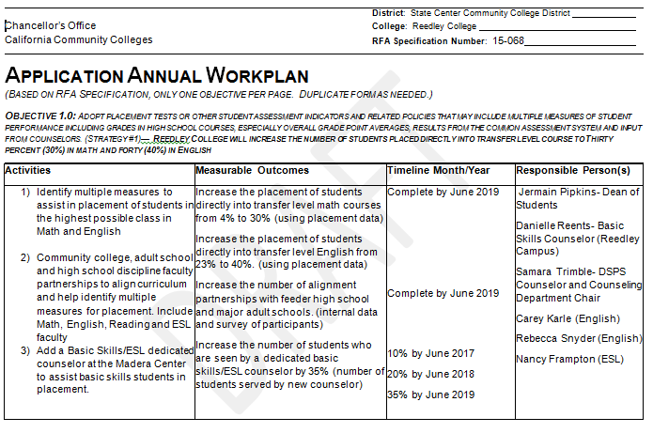

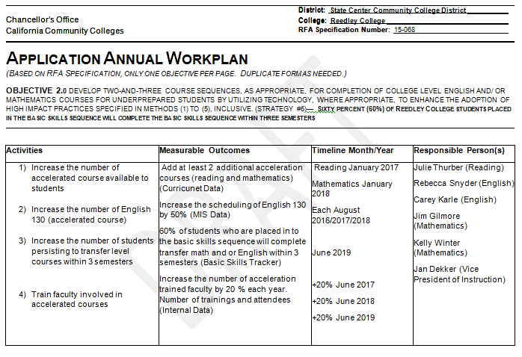
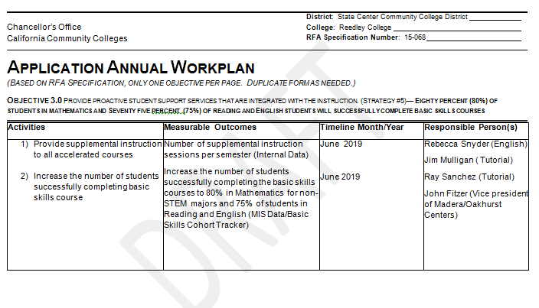

PROGRAM MANAGEMENT

Reedley College has an established record of successfully administrating both state and federally funded grants based in data driven and evidence based decision-making practices.

Reedley College has selected Rebecca Snyder, English Instructor and former Basic Skills Initiative (BSI) coordinator as the coordinator of this grant. Rebecca Snyder (MA, 1997, California State University, Fresno) has been an active English faculty member at Reedley College since 2009. She has played a significant role in planning and development of basic skills related programs at Reedley College including the First Year Experience cohorts, Math and English (ME) First and 5 years as the BSI Coordinator. Ms. Snyder has experience working with all areas of the grant’s proposed objectives. She has taught accelerated courses, was the coordinator of our Writing Center for 7 years, participated in a K-12 alignment partnership, and is currently part of the workgroup addressing multiple measures for placement. Reedley College and Ms. Snyder have had extensive experience working with data and establishing baseline measures using both College (MIS) and Chancellor’s Office data including, the Basic Skills Cohort Tracker.

The Grant Coordinator will collaborate with program faculty to align with the statewide transformation initiative and will actively engage in the integration of organizational structures to facilitate collaboration, quarterly grant reporting and data analysis. This
integrated design will insure constituency input, early identification of any program gaps and information distribution to all constituency groups. Reedley College will ensure the
progression of the Basic Skills project and broad dissemination of information regarding progress, challenges and successes.

Program staff will work in conjunction with District Auditors to ensure accurate record keeping compliant with district financial management requirements. Project expenses are paid through the purchase requisition system, which requires the signature of the Vice President of Administrative Services approval for expenditures; this practice increases the accuracy and efficiency of monitoring program funds. The college also has a categorical budget committee that meets regularly to monitor all categorical budgets. In addition, SCCCD contracts with an Independent Auditor yearly to audit all SCCCD financial records including grant-funded projects. Independent Evaluator and Auditor services are provided at no cost to the program.

This type of integrated design has assisted in the college in administration and reporting of current and prior Chancellor’s Office projects including
• IRDC Grant at Madera Center to expand Advanced Manufacturing program
• CAFYES Grant to work with foster youth
• CA Apprenticeship Grant for Manufacturing
• CCPT Grant for Paramount/Wonderful Dual Enrollment Program with Sanger High School

Reedley College also has experience with federal grants focused on student success
Grant | Years | Student Success Programs
HSI Title V Grant | 2010-2015 | Supplemental instruction, career center, laptop loan program
STEM | 2006-current | Math Study Center, STEM student ambassadors
TRIO/SSS | 2010-current | Intrusive Counseling, mentoring program
TRIO/Upward Bound | 1992-current | Intrusive Counseling, Summer Bridge Program

The college also has an active Basic Skills Committee that has been working with BSI funding to increase student success in basic skills. Some of the projects funded through BSI funds include

Basic Skills/ESL counselor | Basic Skills First Year Experience Program (FYE)
Textbooks for FYE students | Basic Skills embedded tutoring
Professional Development | Writing Center and Tutorial Center tutors

The project coordinator of this grant (Rebecca Snyder) will receive release time equivalent to 6LHEs and work with three acceleration coordinator each with 4 LHE release time. That totals 18 LHE of faculty release time to support this grant.

A number of Reedley College staff members will support Ms. Rebecca Snyder in administration and management of the Basic Skills Transformation project.

Name | Title | Activates | Time
Stephanie Curry | Faculty Grants Coordinator | Liaison with faculty and help with reports | 5%
Melanie Highfill | Accountant/Auditor | Budget monitoring/compliance checks | 5%
Janice Offenbach | IR Coordinator | Data collection and analysis | 10%
Julie Thurber | BSI Coordinator | Help Coordinate grant with ongoing BSI work | 5%

Grant Organizational Chart (page 18)

T
RC GRANT ORGANIZATIONAL CHART
Dr. Paul Parnell, SCCCD Chancellor
Ed Eng, Vice Chancellor of Finance and Administration

TBD, Mathematics Acceleration Coordinator
TBD, Madera Acceleration Coordinator
Donna Berry, VP Admin Ser.
Jan Dekker, VPI
Dr. John Fitzer, VPMO
TBD, English Acceleration Coordinator
Janice Offenbach, Institutional Research Coordinator
Julie Thurber, BSI Coordinator
Melanie Highfill, Accountant/Auditor
Stephanie Curry, Faculty Grants Coordinator
Rebecca Snyder Project Coordinator
Dr. Sandra Caldwell, College President

Reedley College Faculty including Si Coordinators and Basic Skills Counselor
Jermain Pipkins, Dean of Students

BUDGET SUMMARY

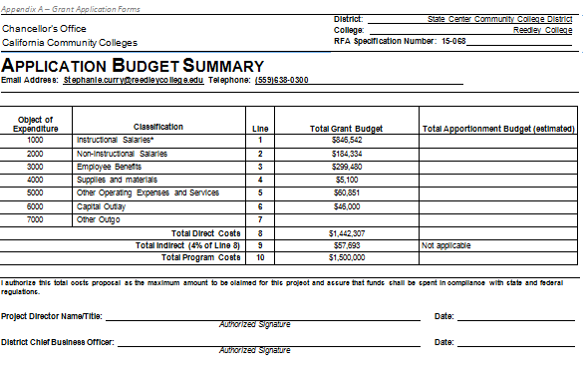

BUDGET DETAIL SHEET

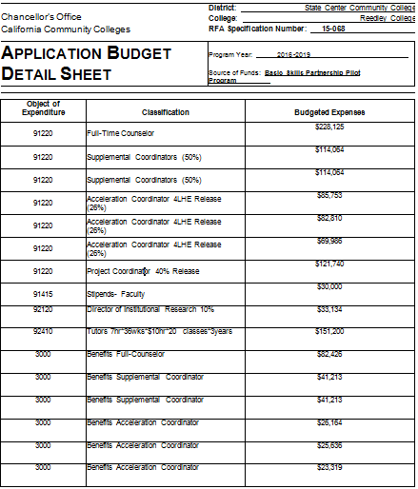

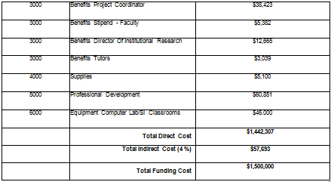

SUSTAINABILITY OF THE PROGRAM

Through this grant, Reedley College will be scaling up already successful models with optimum sustainability, using systemic change that will impact all incoming students.

The planning of this grant focused on sustainability; it was decided to focus the majority of the grant on enhancing internal capacity by identifying release time for the majority of the positions. This allows all the knowledge and expertise of the grant and acceleration coordinators to stay in the college. The coordinators will also train other full time and part time faculty to expand the institutional knowledge beyond the grant.

Multiple Measures—Create sustainable practices that can be systematically reviewed through already existing practices.

Multiple measures work done through the grant will be sustained with other categorical funding. The faculty working on multiple measures will make procedures for placement that will be longstanding. They will be reviewed through college processes systematically to ensure that they are working for counselors and that students are given their best opportunity for success. The college is committed to sustaining the Basic Skills/ESL counselor at MCCC and will use categorical funding to continue that position beyond the grant. If there is no categorical funding available, the college will assign the Basic Skills duties to another funded counselor.

Program | How Sustained
Multiple Measure Placement | Will be reviewed through several college processes including: Program Review, SSSP, Equity and BSI reports. Changes will be made as needed. (SSSP Funding)
Basic Skills Counselor | RC will fund after grant through categorical funding. (BSI Funding)
K-12 Alignment Partnerships | Faculty alignment partnerships will be established through the grant but faculty will extend past the funding as faculty have developed professional relationships and will continue to use those relationships to help students. (SSSP/AEBG Funding)

Acceleration--Create new curriculum that will be utilized beyond the grant and train faculty to teach the new courses.

Acceleration coordinators will create long-standing curricular changes with the addition of accelerated courses in reading and a much needed statistics pathway for Mathematics. Curriculum updates will be done at least every 5 years through the college’s established program review process. The grant will also expand the institutional knowledge on acceleration and teaching accelerated courses through multiple trainings provided by acceleration coordinators. Training beyond the grant will be funded through the college’s professional development funding.

Program | How Sustained
English, Math and Reading Accelerated Courses | Reviewed and updated through the college’s Program Review Process and Curriculum Review (General Fund)
Training of faculty | Funded through the college’s professional development funds (Lottery Funds)
Acceleration Coordinators | Will go back to teaching accelerated courses but college retains their expertise. (General Fund)
Technology Upgrades | The laptop labs and technology upgrades will be sustained through the college’s 5-year technology plan. (Instructional Equipment Funds)

Proactive Student Services—Expand supplemental instructions into basic skills courses and ensure that all courses that need proactive supplemental instruction have access.

Supplemental instruction is an established program at Reedley College. Although this is a high cost program during the grant, we estimate the expansion of multiple measure placement will cause a significant decrease in the number of accelerated courses being needed in the next 3 years. With the streamlining of the basic skills sequences, the college can use data to asses which courses will need supplemental instruction. The college will look at data to evaluate how many hours are needed for the supplemental instruction coordinators at each location.

Program | How Sustained
Accelerated Supplemental Instruction | College will use categorical/college funding to sustain supplemental instruction for accelerated courses that need assistance. (SSSP/Equity/BSI)
Supplemental Instruction coordinators | College already pays for part of the coordinator salary. Additional categorical fund would be used to sustain coordinators at needed level. (SSSP/Equity/BSI)

The faculty, staff and administration at Reedley College are committed to maintaining the systemic change to basic skills proposed in this grant.

SCCCD Institutional Research Website
Ibid
www.quickfacts.census.gov (2015)
http://www.citytowninfo.com/places/california/fresno/work

