College Office of Research and Evaluation Observation notes: For all sections, the response for ‘Very Little’ have decreased. Item 2.2 and 2.3 had a significant change across all response area, making improvements in the green categories and decreasing the ‘very little’ response.
Some area of opportunities: items 1.2 with improving oral and writing communication, response rate is low for ‘quite a bit’ or ‘very much’. This is consistent with CCSSE feedback when looking at the 5 benchmarks, more specifically with Academic Challenge, and looking at the areas of needs improvements (red arrows).
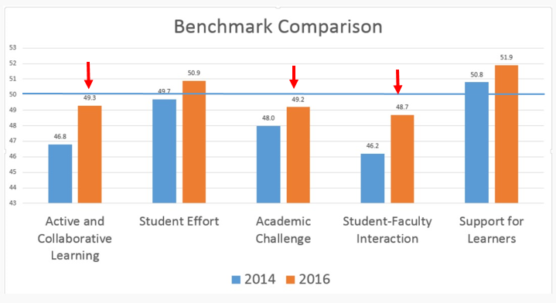

Below are comparison of CCSSE Spring 2014 and Spring 2016.
ILO | CCSSE Question | Responses | 2014 Spring | 2016 Spring | %Change
1.1 Interpret various types of written, visual, and verbal information | 5a. During this school year, how much has your coursework at this college emphasized the following mental activities: Memorizing facts, ideas, or methods from your courses and readings so you can repeat them in pretty much the same form? | Very little | 7% | 6% | -1%
 |  | Some | 22% | 24% | 1%
 |  | Quite a bit | 44% | 37% | -6%
 |  | Very much | 27% | 33% | 6%
ILO | CCSSE Question | Responses | 2014 Spring | 2016 Spring | %Change
1.2 Organize ideas and communicate precisely and clearly to express complex thoughts both orally and in writing | 4b. In your experience at this college during the current school year, about how often have you done each of the following: Made a class presentation? | Never | 27% | 23% | -5%
 |  | Sometimes | 37% | 41% | 4%
 |  | Often | 26% | 27% | 1%
 |  | Very Often | 10% | 10% | 0%
 | 4c. In your experience at this college during the current school year, about how often have you done each of the following: Prepared two or more drafts of a paper or assignment before turning it in? | Never | 17% | 13% | -4%
 |  | Sometimes | 29% | 30% | 2%
 |  | Often | 33% | 32% | 0%
 |  | Very Often | 22% | 25% | 3%
ILO | CCSSE Question | Responses | 2014 Spring | 2016 Spring | %Change
2.1 Analyze quantitative information and apply scientific methodologies | 5b. During this school year, how much has your coursework at this college emphasized the following mental activities: Analyze the basic elements of an idea, experience, or theory? | Very little | 7% | 4% | -3%
 |  | Some | 26% | 30% | 4%
 |  | Quite a bit | 42% | 38% | -4%
 |  | Very much | 25% | 28% | 3%
ILO | CCSSE Question | Responses | 2014 Spring | 2016 Spring | %Change
2.2 Employ critical and creative modes of inquiry to solve problems, explore alternatives, and make decisions | 5d. During this school year, how much has your coursework at this college emphasized the following mental activities: Making judgments about the value or soundness of information, arguments, or methods? | Very little | 14% | 10% | -3%
 |  | Some | 26% | 32% | 7%
 |  | Quite a bit | 33% | 35% | 2%
 |  | Very much | 18% | 23% | 5%
ILO | CCSSE Question | Responses | 2014 Spring | 2016 Spring | %Change
2.3 Synthesized researched information obtained from accurate, credible, and relevant sources to support, advance, or rebut an opinion | 5d. During this school year, how much has your coursework at this college emphasized the following mental activities: Making judgments about the value or soundness of information, arguments, or methods? | Very little | 14% | 12% | -2%
 |  | Some | 36% | 34% | -2%
 |  | Quite a bit | 33% | 35% | 1%
 |  | Very much | 18% | 20% | 2%
 | 5c. During this school year, how much has your coursework at this college emphasized the following mental activities: Synthesizing and organizing ideas, information, or experiences in new ways | Very little | 11% | 7% | -4%
 |  | Some | 32% | 31% | -1%
 |  | Quite a bit | 37% | 37% | 0%
 |  | Very much | 21% | 26% | 5%
 | 4d. In your experience at this college during the current school year, about how often have you done each of the following: Worked on a paper or project that required integrating ideas or information from various sources? | Never | 6% | 6% | -1%
 |  | Sometimes | 28% | 25% | -3%
 |  | Often | 35% | 36% | 1%
 |  | Very Often | 31% | 33% | 2%
ILO | CCSSE Question | Responses | 2014 Spring | 2016 Spring | %Change
4.1 Assess current knowledge, skills, and abilities to further develop them and apply them to new situations | 5c. During this school year, how much has your coursework at this college emphasized the following mental activities: Synthesizing and organizing ideas, information, or experiences in new ways? | Very little | 11% | 7% | -4%
 |  | Some | 32% | 31% | -1%
 |  | Quite a bit | 37% | 37% | 0%
 |  | Very much | 21% | 26% | 5%
 | 5e. During this school year, how much has your coursework at this college emphasized the following mental activities: Apply theories or concepts to practical problems or in new situations? | Very little | 13% | 10% | -3%
 |  | Some | 31% | 34% | 3%
 |  | Quite a bit | 34% | 33% | -1%
 |  | Very much | 22% | 23% | 0%
 | 5f. During this school year, how much has your coursework at this college emphasized the following mental activities: Using information you have read or heard to perform a new skill? | Very little | 7% | 10% | 2%
 |  | Some | 27% | 28% | 0%
 |  | Quite a bit | 39% | 38% | -1%
 |  | Very much | 26% | 25% | -1%

