- Manual Introduction
1.1 Introduction to the Financial Aid Office
1.2 Purpose & Philosophy of the Financial Aid Office
1.3 Policies & Procedures Development Responsibilities
1.3.1 Responsible Personnel
1.3.2 Documents & Methods
- Administrative Organization & Office Management
2.1 Institutional & Divisional Structure
2.2 Financial Aid Office Structure & Position Responsibilities
2.2.1 Personnel Policies
2.3 Frequent Contact Information
2.4 General Aid Office Administration
2.4.1 Accommodations for Disabilities
2.4.2 Appointments with Staff
2.4.3 Treatment of Correspondence/Forms
2.4.4 Telephone
2.4.5 Confidentiality of Student Records
2.5 Records Management & Retention
2.6 Information Sharing & the Family Education Rights and Privacy Act (FERPA)
2.6.1 Internal Disclosure
2.6.2 External Disclosure
2.6.3 Authorization Consent Form
2.6.4 Information Release via Telephone
- Financial Aid Programs
3.1 Institutional Eligibility Requirements
3.1.1 Program Eligibility
3.1.1.1 Ineligible Programs
3.1.1.2 Evaluation of New Programs
3.1.2 Administrative Capability
3.1.2.1 Provisions
3.1.2.2 Administration
3.1.2.3 Responsibilities of Institutional Offices
3.1.2.4 Separation of Duties
3.1.2.5 Records
3.1.2.6 Electronic Processes
3.1.2.7 Information Discrepancies
3.1.2.8 Reviews & Proceedings
3.1.2.9 Cohort Default Rates
3.1.3 Financial Responsibility
3.1.4 Reporting & Reconciliation
3.1.4.1 Fiscal Operation & Application to Participate
3.1.4.2 National Student Loan Data System
3.1.4.3 Program-Specific
3.2 General Title IV Student Eligibility Requirements
3.3 Federal Aid Programs in Which Institution Participates
3.3.1 First Federal Program
3.3.2 Second Federal Program
3.3.3 Third Federal Program
3.3.4 Fourth Federal Program
3.3.5 Fifth Federal Program
3.3.6 Sixth Federal Program
3.3.7 Seventh Federal Program
3.4 State Aid Programs in Which Institution Participates
3.4.1 First State Program
3.4.2 Second State Program
3.4.3 Third State Program
3.5 Institutional Aid Programs
3.5.1 First Institutional Program
3.5.2 Second Institutional Program
3.6 Other Aid Programs
3.6.1 First Other Program
3.6.2 Second Other Program
- Student Consumer Information Requirements
4.1 Federal Student Consumer Information Requirements
4.1.1 Financial Aid Information
4.1.2 Institutional Information
4.1.3 Completion or Graduation Rates
4.1.4 Annual Security Report
4.1.5 Completion or Graduation Rates for Student Athletes
4.1.6 Athletic Program Data
4.2 State-Required Consumer Information
4.3 Accrediting Agency Consumer Information
- Applications and Forms
5.1 Application Process
5.2 Forms
5.3 Deadlines
5.4 Document Collection & Tracking
5.5 Pre-Award Appeals
- File Review
6.1 Verification
6.1.1 Selection of Applicants to be Verified
6.1.2 Acceptable Documentation & Forms
6.1.3 Data Elements to be Verified
6.1.4 Conflicting & Inaccurate Information
6.1.5 Student Notification of Verification Changes
6.2 Database Matches, Reject Codes, & “C” Codes Clearance
6.2.1 Insert database match
6.2.2 Insert database match
6.2.3 Insert database match
6.2.4 Insert database match
6.2.5 Insert database match
6.3 Review of Subsequent ISIR Transactions – Post-screening
6.3.1 Insert post-screening process
6.3.2 Insert post-screening process
6.3.3 Insert post-screening process
6.3.4 Insert post-screening process
6.4 Additional Institution-Specific Data Elements
- Student Budgets
7.1 Various Student Populations
7.2 How Budgets are Derived & Updated
7.3 Additional Costs
7.4 Budget Restrictions
7.5 Budget Appeals
- Awarding/Packaging Financial Aid
8.1 Packaging Philosophy
8.2 Available Amounts & Number of Eligible Students
8.2.1 Campus-Based Programs Amounts
8.3 Packaging Groups
8.4 Determining Award Amounts
8.5 Package Construction
8.5.1 Treatment of Outside Resources
8.5.2 Program-Specific Packaging Criteria
8.5.3 Summer Awards
8.6 Award Package Notification
8.6.1 Packaging Appeals
8.6.2 Award Package Notification Revisions
8.7 Overawards
8.7.1 Resolving an Overaward
- Professional Judgment
9.1 PJ Authority & Individuals Who May Exercise It
9.2 Circumstances Where PJ May be Used & Possible Actions
9.3 Request for PJ Consideration
9.4 Documentation
- Disbursements
10.1 Disbursement Process
10.2 Definition of Disbursements & Disbursement Methods
10.3 Disbursement Dates & Schedules
10.4 Student Authorizations
- Satisfactory Academic Progress
11.1 Process Overview & Responsibilities
11.2 Same As or Stricter Than
11.3 Quantitative Measure
11.3.1 Increments
11.4 Qualitative Measure
11.5 Probationary or Conditional Periods
11.6 Categories of Students
11.7 Treatment of Remedial Courses & English as a Second Language Coursework
11.8 Treatment of Incompletes, Withdrawals, & Repetitions
11.9 Treatment of Transfer Students, Second Degrees, & Second Majors
11.10 Completion of Degree Requirements
11.11 Appeals
11.11.1 Documentation
11.12 Regaining Eligibility

- Return of Title IV Funds
12.1 Process Overview & Applicability
12.2 Withdrawal Date
12.3 Formula Calculation
12.4 Post-Withdrawal Disbursement
12.5 Returning Unearned Funds
12.5.1 Overaward Resolution

- Institutional Refunds
13.1 Institutional Refund Components
13.2 Institutional Refund Repayment Appeals
13.2.1 Documentation
- Title IV Fraud
14.1 Student Fraud
14.2 Institutional & Third Party Fraud
14.3 Referrals
- Audits
15.1 Type of Audit
15.2 Audit Submission Schedule
Appendices
17.1 Forms
17.2 Resources & Reference Documents
INTRODUCTION

- OVERVIEW AND PUPOSE

Reedley College participates in federal, state and institutional financial aid programs in order to provide its students with financial access to post-secondary education.

Each program has specific administrative and management requirements that necessitate the development of institutional policies and procedures to ensure compliance with regulatory requirements, to facilitate consistency of treatment among classes of students, other College personnel or state or federal agency representatives who request to review it.

This manual is intended to ensure Reedley College is in compliance with regulatory and audit requirements by clearly and comprehensively documenting the policies and procedures by which the office operates and reviewing them regularly with staff to guarantee consistency of treatment of all students in the financial aid process. The policies and procedures contained here support the philosophy of financial aid delivery and will not, in any case, supersede or be contrary to federal regulation or state law governing the financial aid programs.

The date at the end of each chapter of the manual represents the latest date revision of that chapter. However, because the financial aid process is a dynamic one that requires constant revision of existing procedures to conform to changing regulatory requirements, until it is revised, some areas of this manual may be supplemented by policy and procedural changes as documented in Financial Aid Office staff meeting minutes and district policy memoranda.

This policies and procedures manual reflects Reedley College’s institutional adaptation to the regulations and guidelines governing the student aid programs. For the most part, those regulations and guidelines are not included or referenced here but are available for review in the Financial Aid Office Library. The publications and documents used routinely by the aid office in establishing institutional policies and procedures include:

- The Congressional Federal Register, Congress

- The Financial Aid Handbook, Department of Education

- The Encyclopedia of Student Financial Aid, NASFAA

- Dear Colleague and Action Letters and Q & As distributed by the U.S. Department of Education

- The Federal Student Assistance Audit Guide

- The Application and Verification Guide

- And other resource materials provided by:

The California Student Aid Commission
The National Association of Student Financial Aid Administrators
The College Board
The California Community College Chancellor’s Office
The State Center Community College District Office

  - ORGANIZATIONS AND STRUCTURE

Reedley College has several centers and off site locations. The Willow International Center, the Madera Center and the Oakhurst Center collectively comprise The North Centers. These North Centers have their own organizational structure and are somewhat autonomous. However, North Centers students are considered Reedley College students for all reporting purposes and the financial aid offices at the North Centers follow Reedley’s FAO policies with small changes in procedures relative to their locations.

Reedley College maintains a consortium agreement with Fresno City College to allow students to attend both institutions and receive financial aid centrally through the Reedley College Financial Aid Office. This is applicable to the North Centers and other off site satellite locations.

The College is governed by a publicly elected Board of Trustees which develops and approves global polices relating to the operational direction of the College. In relation to financial aid, the College carries out the mandate of the board of Trustees to make financial aid available, without discrimination, to the students of Reedley College, the North Centers and the State Center Community College District. To support this mandate, the Board provides for an appropriately staffed Financial Aide Office and the resources necessary to ensure assistance to students in the financial aid application process and in the accounting for and reporting of expenditures. A District Office is also maintained to support those functions.

The majority of policy decisions relating to the administration of the financial aid programs are initiated and implemented by the Financial Aid Office under the auspices and approval of the District Financial Aid Services. Policy decisions that have the potential for campus or program-wide impact are recommended to the Board of Trustees by the College President, District Vice-Chancellor and the District Chancellor.

Major internal operational decisions relating to the administration of the financial aid programs are made by the Director of Financial Aid with recommendations from the Financial Aid staff and the Vice President of Student Services. The Director of Financial Aid also makes routine internal operational decisions and develops internal policies relating the administration of the programs in consultation with the Financial Aid Advisory Committee, the Financial Aid Office staff, and other departments and agencies as appropriate.

  - RECORDS MANAGEMENT

A. ACTIVE RECORDS: Active files are defines as files for aid applicants for the current award year and the prior award year. Active files are maintained in the Financial Aid Office Intake area. Files include all years for which the student applied for aid and are filed alphabetically by student last name first. Files for aid applicants who have had no application activity for the current year as of the end of Fall semester or the prior year are boxed alphabetically by year and moved to the warehouse for storage.

B. INACTIVE FILES: Inactive files are defined as those that have not been reactivated as of the end of the Fall semester of the current award year and have had no activity in the prior award year. Once moved into storage these files are retained for six years from the most recent activity for audit purposes. At the end of the six years, files with promissory notes are removed and stored alphabetically indefinitely. The balance of files is shredded at the request of the Coordinator of Financial aid with approval of the Board of Trustees.

C. RECORDS RETENTION: Hard copy student records are retained for a minimum of six years for
audit purposes. All audit and program review reports are retained in the Financial Aid Office and the College Business Office. All Datatel computer records are maintained by the District Office.
D.
CONFIDENTIALITY: Only Financial Aid Office personnel have access to hard copy student files and Datatel computer financial aid information. Information about a student’s aid application and records are transmitted only to authorized College personnel as necessary to administer student awards and manage the programs. Staff releases individual student information only when pre-authorized to do so by receiving a signed FERPA form from the student.

1.4 AUDITS AND REVIEWS
The financial aid programs are audited annually in compliance with US department of Education requirements. Audits are performed by the Borchardt-Wiley Accounting Firm through contract with the District Office. Original copies of all audit findings and responses are kept in the District Office and in the Financial Aid Office.

The federal financial aid programs were last reviewed by the Department of Education in the early 1980s. Findings and exception resolution documentation from that review are located in the Financial Aid Office. The Part B Guaranteed Loan Program was reviewed by the California Educational Loan Program division of the California Student Aid Commission in 1990. Findings of that review are located in the Financial Aid Office.

1.5 FINANCIAL AID HISTORY

Reedley College began participating in the Title IV student assistance programs in the early 1970s. The College participated in the Supplemental Loan for Students (SLS) until 1990 when a review of institutional default rates, the cost of the loan to students, and an evaluation of the need for it given the low cost of education at Reedley resulted in the administrative decision to discontinue participation.

Currently the college processes applications for approximately 13,500 applicants annually and provides funding to approximately 60% of those applicants. Funds from federal sources exceed $10 Million annually. And funds from all sources exceed $14 Million annually.
A limited number of scholarships are awarded annually through the District Foundation and Grants Office. Awards are coordinated through the Financial Aid Office.

Reedley College has received Title III Developing Institutional status designation from the Department of Education and therefore has a waiver of institutional matching requirements for the Federal Work-Study and Federal Supplemental Educational Opportunity Grant Programs.

  - PHILOSOPHY OF FINANCIAL AID DELIVERY

Not withstanding the constraints of limited funding, insufficient to meet the full need of most of its student aid applicants, Reedley College is committed first to using financial aid to remove financial barriers thereby maximizing access to post-secondary educational opportunities for low income and disadvantaged students. The goal of the Financial Aid Office is to deliver student assistance, would be unable to pursue their educational goals at the College.

The Financial Aid Office develops its annual objectives in coordination with the mission and goals of the College and in coordination with 5 Year Plan developed in conjunction with the District Office. The FAO endeavors to eliminate unnecessary application procedures by simplifying the aid process, and to provide innovations that affect expediency in response to students.

The College is dedicated to improving service and increasing efficiency in the delivery of financial aid by making the most effective use of College personnel, automation, and appropriate software packages that reduce application turn-around time, enhance information services and response to inquiries, allow for a proactive approach in areas such as default prevention, and ensure Financial Aid Office accountability to the delivery process.

The Financial Aid Office assumes a responsibility on the part of the student and of the family in contributing to the educational expenses of the student to the best of their ability. And because student indebtedness is a primary concern for community college students, the Financial Aid Office assumes a student preference for work assistance over a loan in order to moderate indebtedness over the student’s academic career and to encourage student acquisition of basic employment skills through the Federal Work Study Program that will benefit them in their post-educational employment experiences.

Within this context, the Financial Aid Office adheres to the principles and practices as prescribed by the Department of Education and the California Student Aid Commission in determining eligibility for federal and state financial and programs, and accepts the following responsibilities in the delivery of student aid:

- To publicize the availability of financial aid,

- To enhance delivery of student aid through simplification of the application process,

- To assist students and families with the application process,

- To process applications, determine eligibility and make awards as expeditiously as possible.
Vice Chancellor, North Centers
Terry Kershaw
Vice President, Instruction & Student Services
Deborah Ikeda
Secretary to the Vice Chancellor
Linda Little
Interim Dean of Instruction & Technology - Tom Mester
Dean of Students/Matriculation
Doris Griffin
Associate Business Manager
Janell Mendoza
Business Div. Rep.
Child Development Coord.
Elizabeth Romero
Humanities Div. Rep.
Tutorial Coordinator
Theresa Ishigaki
Counselors
Director of DSP&S
Lynn Samuelian
Financial Aid Manager
Candy Cannon
School Relations Specialist
David Navarro
CalWORKs
Gina Vang
Administrative Assistant
Leslie Rata
Administrative Aide
Margee Loya
Administrative Aide
Jittapaun Inthavong
Director of Technology
Gary Sakaguchi
Microcomputer Resource Tech
Robert Gafford
College Nurse
Naomi Bianco
Evening Coordinators
Financial Aid Assistants
Student Serv. Specialist
Veronica Jury
Director-Marketing & Communications
Cris Monahan-Bremer
College Police
Admissions & Records
6/24/11
Account Tech II
Lorrie Hopper
General Utility Worker
Tony Romero
Custodians
Bookstore
Willow International Café
Account Clerk III
Alison Rasmussen
Lead Custodian
Sergio Salinas
Instructional Aides
Department Secretary
Joyce Clark
Office Assistant III
Jennifer Brodeur
Math/Sci/Health Div. Rep.
Social Science Div. Rep.
Library
Cynthia MacDonald
Library Services Assistant
Susan Hansen
Instructional Aide
Early Childhood Ed. Specialists
Instructional Aides
Tutors
Transfer Center Coordinator
Tasha Hutchings
College Center Assistant
Allisha Ross
Student Government
Institutional Researcher
Michelle Johnson
Section # | Topic | Resources/  Citations
2.0 | Coordination  The determination of eligibility and the delivery of student financial aid involve complex requirements for verifying, monitoring, and coordinating all student awards.  The Financial Aid Office must work closely with many on-campus and off-campus agencies to ensure regulatory compliance and accuracy of reporting for all agencies involved.
2.1 | Business Office  The Business Office carefully coordinates a number of functions with relation to the financial aid process including:  - Disburses student aid and FWS payroll checks.  - Reviews and approves the annual disbursement calendar for financial aid checks.  - Reconciles student accounts, and tracks and bills on student owed debts.  - Accounts for funds and performs all EDPMTS functions including filing quarterly cash transaction reports (ED 272s),  - Prepares cash requests for federal funds in anticipation of cash disbursements.  - Determines the need for a refund on federal funds when non-resident students withdraw from school during the refund period.  - Coordinates the disposition of undelivered aid checks with the FAO.  - Provides the annual tuition and fee figure for the FISAP.  - Provides matching for FWS and FSEOG when necessary to balance annual expenditures.  - Ensures federal funds are properly identified and monitored in College bank accounts.  - Ensures the College provides the appropriate fidelity bond for the federal programs.  - Produces a monthly payroll report to the FAO for reconciliation of the Federal Work Study Program.  - Reconciles program expenditures with the FAO and generates fund balance and general management reports that support the operation of the FAO.  - Reports delinquent institutional liabilities resulting from no-show drops and FAO errors to JM Hollister collection agency for collection.  - Places a hold on the student’s ability to register for any debts owed to the institution. (Non Federal or State)
2.2 | Admissions and Records  The Admissions and Records (A&R) Office keeps the primary system file on student academic and demographic information. The FAO relies on edit checks through Datatel to identify enrollment status changes prior to financial aid check production. The FAO is dependent on the posting of term grades for checking satisfactory academic progress.  The A&R Office controls student enrollment in appropriate course work by requiring admitted student to take assessment tests through the matriculation process.  The A&R Office advises students with undecided majors to see a counselor. Students must have an eligible declared major to receive financial aid.
2.3 | Extended Opportunity Programs and Services (EOP&S)  The EOP&S Office provides additional grant funding resources, textbook service, child care assistance (CARE), and additional support services to students identified as economically or educationally disadvantaged with the goal of assisting students with matriculation, retention, and transition.  Eligible students are identified as part of the Financial Aid process through the determination of BOG A and BOG B eligibility.
2.3.1 | Assistance offered through the EOP&S Office  EOP&S provides grant awards up to $900 per year, textbook services, and CARE awards up to the amount of a student’s unmet need. The FAO provides the EOP&S Office with a list of potentially eligible students. The EOP&S Office initiates an orientation with the student and makes the final determination of the award(s).  The EOP&S Office then provides the FAO with a list of  students and award amounts for entry into Datatel. Award Letters are produced, and checks are processed and disbursed through the regular financial aid disbursement process.
2.3.2 | Minimizing EOP&S Overawards  EOP&S is responsible for monitoring the eligibility of students receiving financial assistance and services through the EOP&S Program.  The Financial Aid staff will receive a list of all students approved for the Textbook Service, from the EOP&S Office, prior to the list being forwarded to the Bookstore. The FAO staff will batch enter these estimated awards to the AIDE screen in a “P”ending status. Coordination of these types of funds is critical since they are awarded at the beginning of the semester when students are also applying for additional financial aid assistance such as Federal Work Study and student loans.  At the mid-point and at the end of each semester, the Financial Aid Office will run an overaward report and provide EOP&S the names of any students overawarded due to EOP&S funds.  The Office – either the EOP&S Office or the Financial Aid Office – who provided the last award which created the overpayment will notify the student of the overaward and give the student all options for resolving the overaward.  Final repayment for all overawards must be received by August 31 of the award year. Those overawards not resolved at this time will be forwarded to the Business Services Office for referral to JM Hollister Collection Agency.
2.4 | Central Processing Center  Reedley College uses Datatel, an integrated District wide computer system, to perform tracking and recalculation functions and to assist with scheduling of disbursements, fund management, and reporting. The FAO internally controls electronic records downloaded into Datatel from the Central Processor Center and proceeds with application documentation collection and processing.
2.5 | Job Placement  Reedley College does not currently have a Job Placement Office; however, the College does offer Job Placement and Career Services. Job Placement and Career Services are run by Laurie Tidyman-Jones, Academic Counselor. Services are provided through the Career Center, Counseling Department, and Guidance Studies 34 - Career Awareness course. The College also offers a Job Announcement Board, located in the lobby of the Student Services Building.  The Career Center offers:  - Printed and computer based information for selected occupations  - Printed job-search information  - Computer based career assessments: Eureka, SIGI Plus and Meyers-Briggs  Counselors are available to:  - Review career needs and interests  - Administer and interpret career assessments  - Provide career counseling  The Career Awareness course (GS 34) provides:  - A structured classroom environment to explore possible careers  - A number of career assessments  - A means to learn and practice job search skills
2.6 | Assessment Center  As part of Student Services, the Assessment Center provides “Ability to Benefit” testing for non-high school graduates. After the test, the Assessment Center refers the student to the Counseling Department. The student meets with their counselor, reviews their test scores, and develops a class-appropriate Student Education Plans (SEP). This SEP is recommended by the Financial Aid Office as part of the matriculation process.  Assessment tests are state and federally approved and therefore meet the Ability to Benefit requirement of the Department of Education for receipt of student aid. If a student places into college preparatory or college level English or Math based on the college assessment, the student has demonstrated the ability to benefit. The Assessment Center also confers with the FAO about students who are unable to meet the ATB requirements.
2.7 | District Office  In addition to providing system and reporting support to the Financial Aid Office, the District Office also manages the Drug-Free Workplace information dissemination to students and College faculty and staff.  The Foundation Office is located at the District Office and operates as a development office to attract funds from the private sector and to increase the endowment fund. The Foundation Office also manages designated Reedley College scholarship awards.
2.8 | Career Training Center (CTC)  State Center Community College District maintains a Career Training Center in Fresno. Eligible students attending CTC are funded for financial aid through Fresno City College which operates the location as an off-campus center.  The FCC Financial Aid Office provides assistance with applications, attendance monitoring, and program completion. Due to the nature of the special programs and non-traditional calendars, financial aid is disbursed at different times during the year on a non-traditional schedule.  Reedley College occasional will fund a CTC/MERC student who begin the academic year at Reedley College and then transitions into a special program. In this case, we work closely with the CTC/MERC liaison to assure accurate and timely FA payments for their new program.
2.9 | Consortium Agreements  Students may take courses from Reedley College (including WI, MC, CC, & OC) independently or in combination with Fresno City College courses and receive financial aid from the parent institution for units of enrollment at the non-parent institution. All course work through all of the colleges in the State Center Community College District are recognized through consortium and all grade records are retained centrally in the Datatel, the Financial Aid Office can easily verify total student enrollment.
2.10 | Cal Works  The Financial Aid Office assists with the coordination of financial aid eligibility and Temporary Assistance to Needy Families (TANF) and other Welfare benefits. The Financial Aid Office ensures eligibility workers are aware that grants, loans, and Federal Work Study do not reduce TANF grants to the extent that the financial aid does not exceed tuition, fees, books, transportation and miscellaneous expenses. The direct educational costs (fees and books) also do not reduce food stamp allotments.  The FAO supplies specific information about non-direct educational costs (any budget component not used to cover fees and books) that are included in the student budget on request from any social service agency.
2.11 | Bureau of Indian Affairs (BIA)  American Indian students who qualify through the Bureau of Indian Affairs or tribal grant programs are packaged under standard financial aid packaging procedures. The FAO provides appropriate documentation to BIA regarding budgets and award types on the request of the student. BIA grants are generally used to meet a student’s unmet need or, if necessary, to replace FWS or a student loan.
2.12 | Veterans Office  The Financial Aid Office provides a Veteran’s Certifying Official to coordinate eligibility determination and certification of benefits for Veterans with the financial aid process. The Veteran’s Official provides the FAO documentation of the amount of benefits received by students who indicated an eligible veteran’s status.
2.13 | Vocational Rehabilitation  The FAO requires students flagged for verification to provide documentation of amounts and types of benefits received through the Vocational Rehabilitation Office and through the Social Security Administrations SSI program via the Verification Form.

Section # | Topic | Resources/  Citations
3.0 | Overview of Applying For Financial Aid  Reedley College provides a number of informational services to assist students in applying for financial aid. The FAO is involved in presenting application workshops at local high schools as well as conducting weekly on/off campus orientations for new, continuing, transferring and special programs students. In addition, application materials and instructions are made available at appropriate application times, and students are informed of application deadlines through posted and mailed instructional flyers informing hem when and how to apply and how to complete their application. Bilingual staff is available on a drop-in or appointment basis to answer student and parent questions about the application process.
3.1 | Free Application for Federal Student Aid (FAFSA)  The FAFSA is the application used to determine eligibility for financial aid.
3.1.1 | Application Deadline  The application deadline for resident students who wish to apply for initial consideration for Cal Grant is March 2nd of each year. The college’s first priority deadline for applying for campus-based aid is April 15 of each year. The FAO accepts applications and makes awards on a rolling basis as funds are available, however, students who meet the first priority deadline are assured of being considered for all types of aid available. Applications completed beyond that deadline will be packaged with funds that remain.
3.1.2 | Additional Information  The financial aid office requests the following documents in addition to the FAFSA:  - Academic Transcripts for all prior colleges attended  - Financial Aid Transcripts from all prior colleges attended  - Student Education History Form  Selected applicants are required to submit additional student and/or parent information to verify student dependency status and other eligibility requirements. The documents that may be requested include:  - Student and/or Parental Federal Income Tax Return  - Dependent or Independent Verification Worksheet  - Proof of Eligible Non-Citizenship status  - Proof of Unites States Citizenship status  - Social Security Card  - High School Diploma or GED or CHSPE or ATB test results  - Other forms as needed to document student circumstance  After the Financial Aid Office has made a determination of eligibility for financial aid, it notifies eligible applicants of awards via an Award Letter. The Award Letter is for information purposes only and students are not required to sign and return the award letter to confirm their awards.  Eligible students will be awarded in chronological order by file completion date. Pell awards are made to eligible students who have a valid EFC by the last day of enrollment for the award year or the deadline published by the Pell Grant program, whichever comes first.
3.1.3 | Academic Qualifications  In order to receive financial aid funds, a student must be qualified to study at the postsecondary level. A student qualifies if she:  - has a high school diploma;  - has a general education development (GED) certificate;  - has a passed the California High School Proficiency Exam;  - has completed homeschooling at the secondary level;  - has completed all high school graduation requirements, passed the CAHSEE exams - if applicable, is enrolled as a regular student, and is scheduled to receive their diploma at the end of the school year;  - has passed a Department-approved ability-to-benefit test; or  - has successfully completed six (6) units (see additional information below).  The Financial Aid Office is able to consider six (6) units of successful completion to establish a student’s ability to benefits. This 6-unit requirement must meet the criteria listed below:  - Applies only to grades received after the regulation effective date of 8/14/08  - Units must be degree applicable toward any eligible major  - Units may be completed in one or more semesters after the effective date of 8/14/08  - The use of Physical Education units will be limited to two (2) out of the six units  - Units must be completed with a grade of “C” or better. Grades of “CR” and “P” are also acceptable
3.1.4 | Programs Applied for Through FAFSA  The FAFSA application is primary application from which eligibility is determined for the following programs:  - Federal Pell Grants  - Federal SEOG  - Federal Work-Study  - Cal Grants  - BOGW C
3.1.5 | Programs Requiring Additional Applications  In addition to the FAFSA, the following programs also require additional applications:  - Direct Loans  - Bureau of Indian Affairs Grants (BIA)  - EOP&S/OASIS  - Federal Student Support Services Grant (FSSS)  - Federal Work Study
3.1.6 | Programs the Don’t Require FAFSA  The following programs do not require the FAFSA but do require a separate application:  - Veteran’s Benefits  - Scholarships  - BOGW A&B
3.2 | Application Materials and Assistance  The Financial Aid Office and School Relations Office distribute application materials to local high schools. The Financial Aid Office provides the students with application materials upon request. The office will also mail a student a FAFSA or application materials if requested.  Student may mail their FAFSA, fill out a FAFSA online or may submit their application to the Financial Aid Office to process as a Stage Zero after January 1st of each year.  When the college receives the student’s ISIR it is electronically downloaded into Datatel and materials appropriate to he student’s application are mailed with an acknowledgment letter explaining what documents must be submitted.
3.3 | Stage Zero Process  Check Datatel to make sure that the student doesn’t not have results on file.  If the student already has results on file in Datatel:  - Check to see if RC is listed as a school code  - Compare the information reported  - If the information is different give the FAFSA to an FA II  - Make a comment in Datatel  If students application was rejected by processing center for already having an application on file:  - Check Datatel to see if results are on file  - If not, send reject letter  If there are no results on file input the FAFSA information into FAAccess. Follow the process for entering a Stage Zero (found below), this is done through FAAccess at www.fafsa.ed.gov/FOTWWebApp/faa/faa/jsp  After the FAAccess screen has loaded  Click [NEXT]  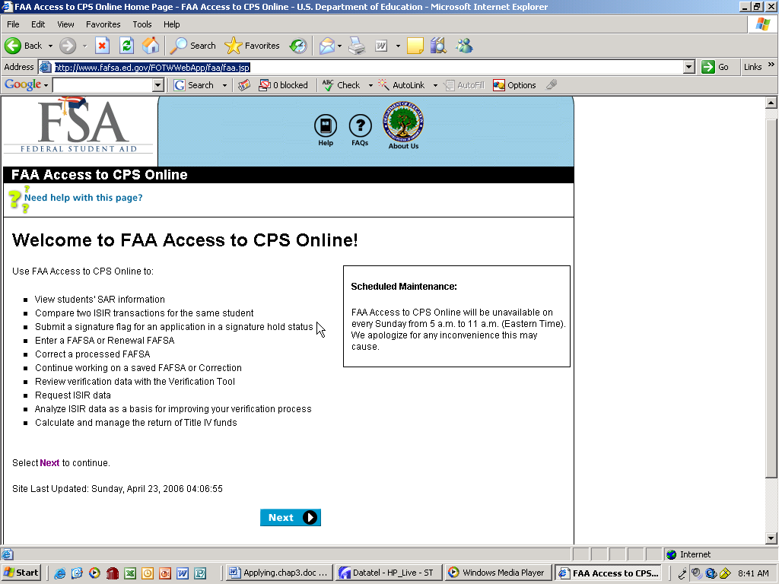  Enter YOUR login in the following page  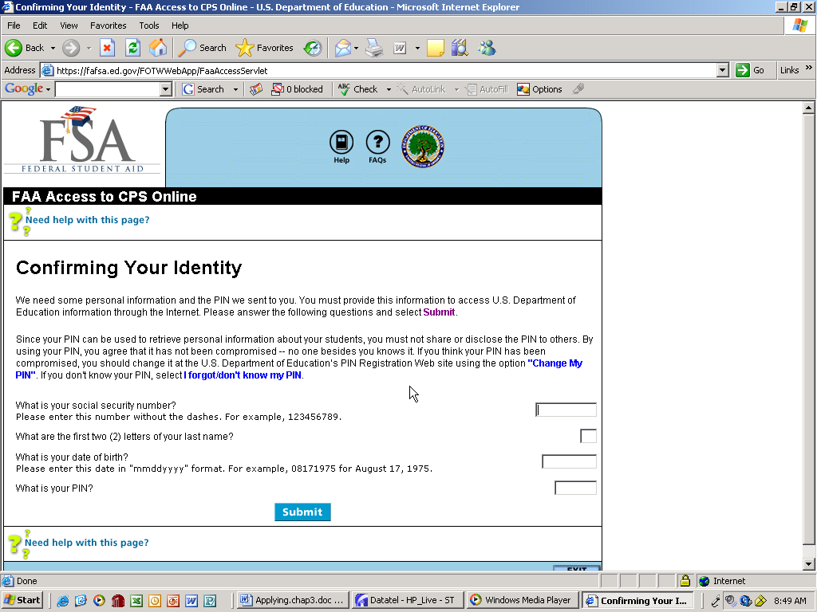  Social Security #  First 2 letters of last name  Date of birth*  Pin #**  [  *Date of birth is entered in the format MMDDYYY  **Pin #, this is number assigned to you by the Department of Ed when you’re assigned an account  Select “FAFSA Application” within the “Application Verification and Entry” section  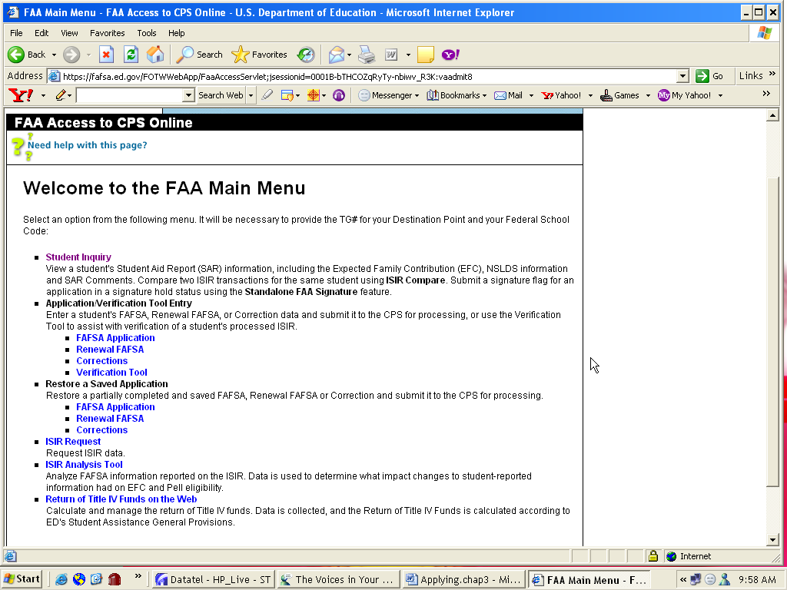  For the following screen you will need to know:  Reedley College’s TG# is TG “50253”  Reedley College’s Federal School Code is “001308”  The school year for which you are submitting a FAFSA  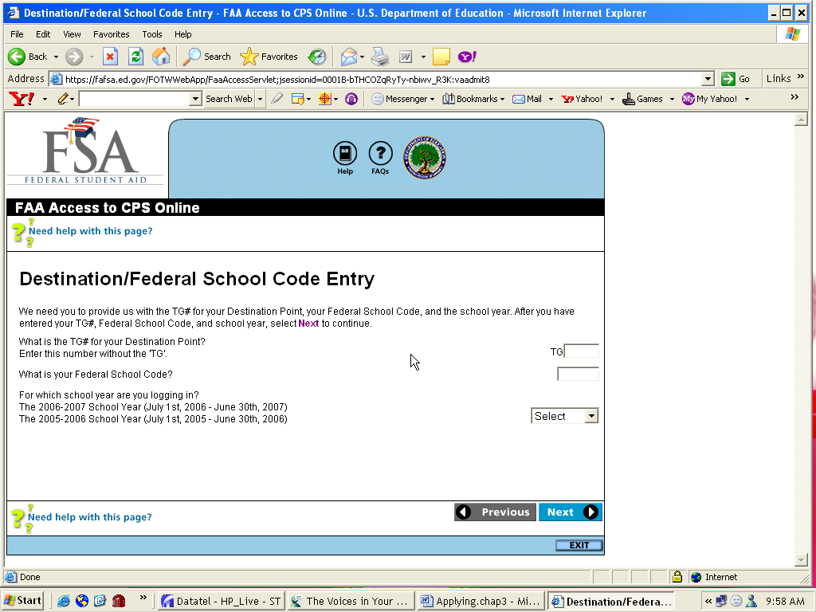  TG 50253  001308  2006-2007  [  Select “Next”  At the bottom of the following page we find the first section requiring student information.  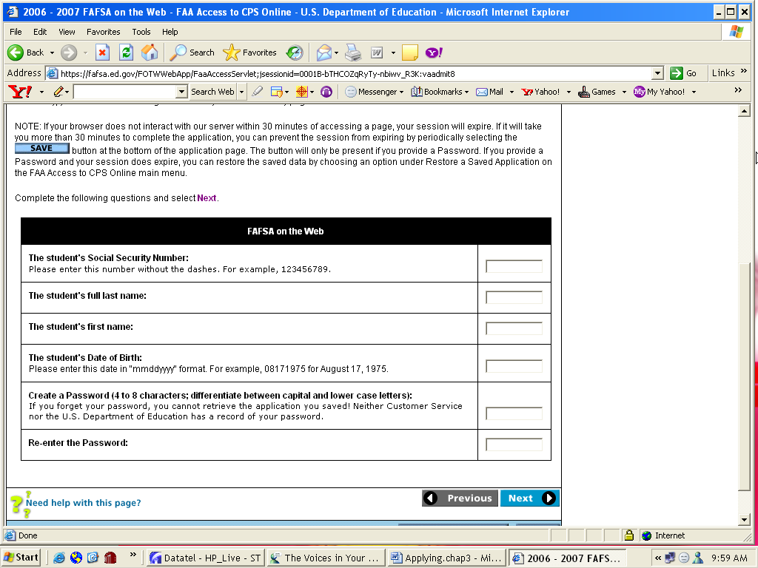  Students SSN  Last Name  First Name  Date of Birth*  Create a Password**  Re-enter the Password  [  *Date of Birth is entered as MMDDYYYY  **Password: we always use the students first name  Select “Next”  The next screen is where the students FAFSA information is input.  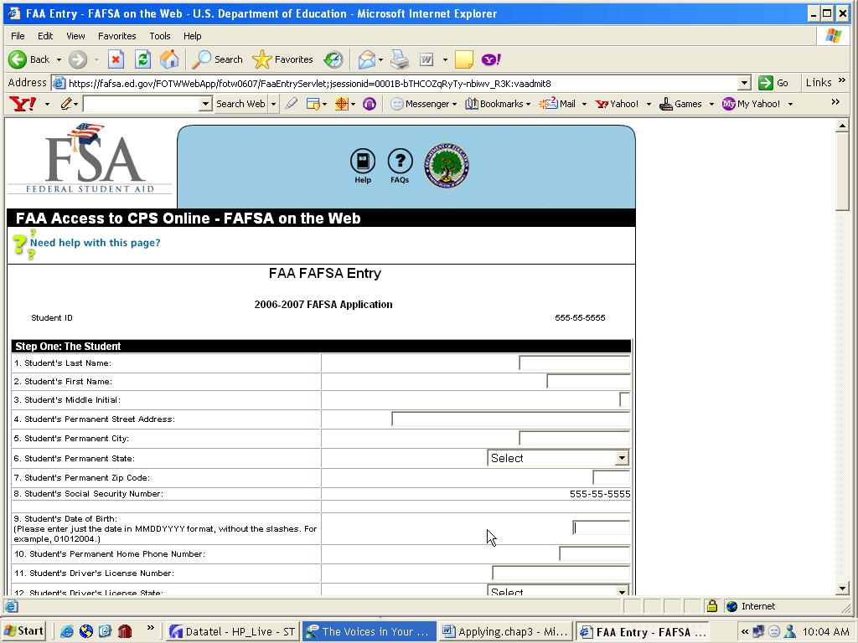  Fill in each question accurately.  When you are finished filling it all out, you will see a button at the bottom of the screen that says “Calculate EFC”  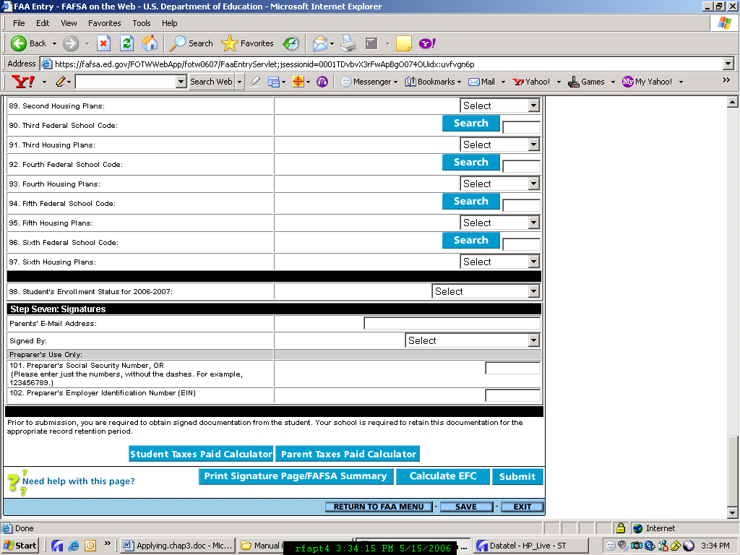  The next screen will recap everything that was just entered, as well as show you their EFC from that information.  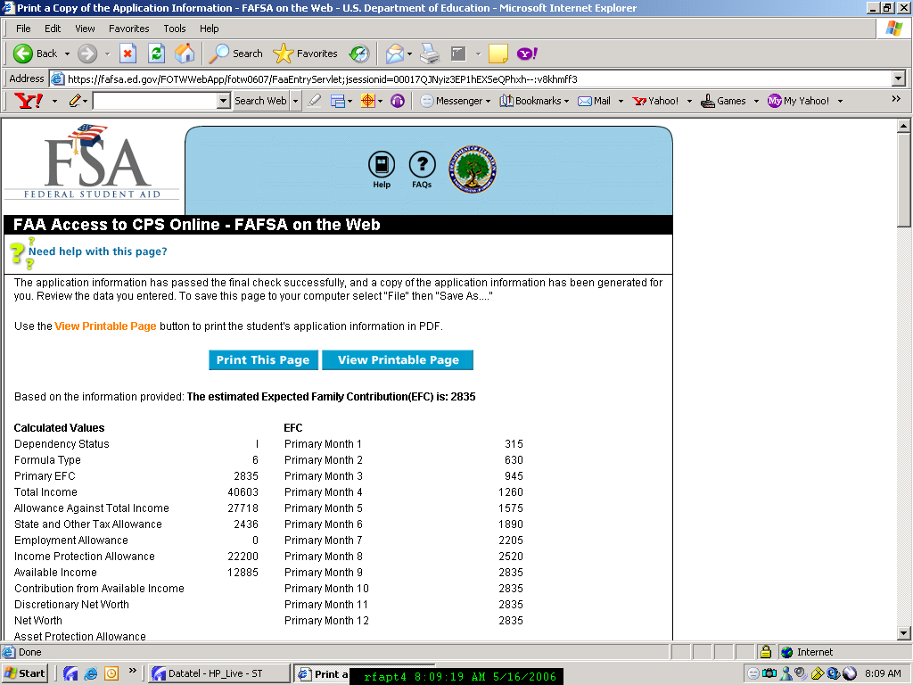  On this page is all of the information entered, at the bottom there are a two options. If there is an error in the information select “Go To Form” and correct the mistake(s) (make sure to check SSN, name and DOB).  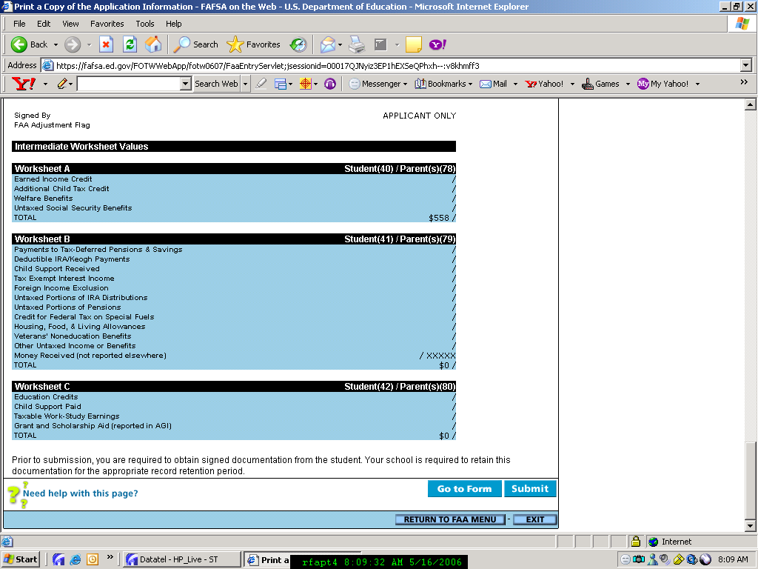  If not, “Submit”  Choosing to “Go to Form” will take you back to the previous screen to correct the information, then continue from there and “Submit” the next time around.  Choosing to “Submit” will produce the final screen. This is the Confirmation Page.  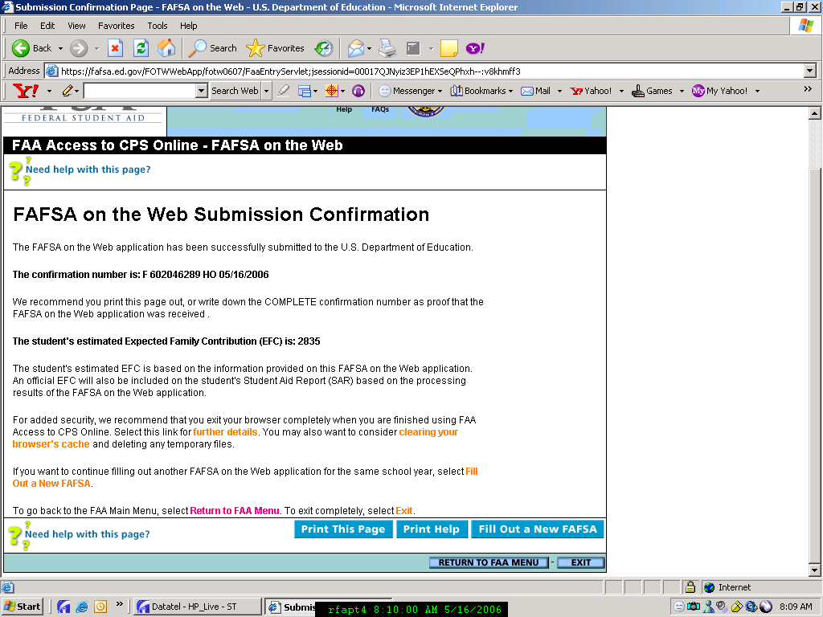  Print this page.  To continue processing additional, after printing the Confirmation Page, click “Fill Out a New FAFSA”. This will produce the screen where you enter the student’s information before beginning their application.  When Stage Zero’s come back:  - Double check FAFSA’s with the names on the printouts to make sure all of the apps came back okay.  - File all FAFSA’s in drawer.
3.4 | Additional Document and Information Requests  Letters are sent to eh students to request additional documents needed to complete the students’ files after the ISIRS are downloaded into Datatel. Failure to respond to the requests will result I the students’ files being retained in an incomplete status.  Initial review of the incomplete file and the process of completing Verification may result in requests for additional information being generated through the tracking system. Failure to respond to requests for additional information will result in the students’ files being retained in an incomplete status.  A file may be reactivated when the student supplies the additional information. The student’s files will be packaged in the appropriate priority relating to the time of file completion.
3.5 | Award Notifications  Notification of awards via an award letter begins once the students complete their files.  Notifications of awards via an award letter for students whom complete their files after the April 15th deadline and will continue on a rolling basis as files become completed and packaged.  Award notifications of eligibility for the Direct Loan will be made via an award letter upon certification of the loan.  Award notifications of eligibility for the Cal Grant will be made via an award letter upon certification of the grant.  Notification of revisions made tot eh student’s awards will be provided via a revised award letter.
3.6 | Intake Procedures  Document Tracking  - Retrieve the student record and direct access to CRI (CM Entry) and enter the student’ ID number.  - Identify the document received.  - Locate the document in the screen.  - Change the status of the document received to the appropriate setting.  - After all of the received documents have been recorded press [F10] to update and save the changes.  - Direct access to FMF and enter “ ‘the year” FILE ‘the date’ ‘your initials’ ”  (e.g. 0607 FILE 051106 MP)  *NOTE: if a file has already been entered omit step 6.  Adding a new document  - Retrieve the student record and direct access to CRI (CM Entry) and enter the student’s ID number.  - Identify the document received.  - Scroll down and set your cursor on the next available Communication Code Instance.  - Enter “…” and find the document received.  - Enter the document’s sequence number and press enter.  - Change the status of the document received to the appropriate setting.  - After all o the received documents have been recorded press [F10] to update and save the changes.  Mismatches  If the student has a mismatch we need to make copies of the documents we requested and posted in CRI. After the copies have been made change the status comment in CRI to received.  Comments  Comments need to be made every time there has been any type of work preformed on a student’s file. If comments are needed detail to STCM. Enter the comments in the “Need Analysis” section. Be sure to enter the new comment on top of the older comments.

Section # | Topic | Resources/  Citations
4.1 | Tracking In Datatel (UI)  All applicants will receive a Missing Information Letter (MIL), which will contain information regarding their FAFSA results and may or may not list requested documents. It is necessary to obtain any requested documents in order to review and package the student’s file and specifically for those flagged for verification or for citizenship, ATB, and Selective Service problems, etc.  The College has defined the documents that a student must submit and have created paragraph codes and brief description for each one in Datatel. Documents that are requested are based on CPS Comment Codes that are obtained from the imported ISIR. Rules are written (selection sets) in Datatel that link the CPS Comment Codes to the appropriate document tracking/paragraph codes.  *ISIR-Institutional Student Information Record.
4.2 | Sarafiles  Sarafiles, containing the ISIRs are sent from CPS loaded via Electronic Data Exchange, (EDE, Ed Express). They are now ISIR Files after they have gone through the loading process. ISIR Files are then processed in Datatel through four screens:  - GTA (Group Tracking Assignment) – Assign Tracks  - PCB (Processing Correspondence Batch) – Loads paragraph codes into IHS (Individual History)  - TPF (Transfer Processed File) – Export file for merge into letter  - Finally through CRA (Correspondence Request Assignment) – Loads document codes into each student’s file (the requested documents), which can be viewed in CM-Entry  Through this process letters are created for each student and on each letter are the requested documents and specific information in regards to that student’s FAFSA results.  It is possible that students will have a second, third, or fourth letter sent to them depending on how many ISIR transactions we receive from CPS. In these cases, the ISIR Files are run through GTA and CRA, action is to delete the current tracks and requested documents. The incoming transaction may have different CPS Comment Codes than the precious resulting in different documents needed or none at all. Once the previous tracks are deleted, we simply re-run the ISIR File through all four screens again (action ADD) assigning new tracks, new document codes, and producing a new updated Missing Information Letter.  HIS will always keep the entire history of each letter printed as far as what documents were assigned on each MIL processed. However, CM-Entry will only allow you to view the current requested documents that were assigned on the most recent letter printed.
4.3 | Paragraph Codes  Below is a list of all Paragraph Codes along with their brief Description. Each year the codes are updated, but the description should remain the same. These codes are viewed and loaded into HIS. Document codes, which are loaded into CM-Entry are the same with the exception of the “P” being a “C” after FD06 in the codes below. This is done to distinguish the difference between the two.  DOC CODE PARA TEXT 2006-2007  FD06P214  VET aka 214  - DD214 or other proof of veteran status  FD06P845  FNS aka 845  - The financial aid office must verify your eligibility with INS/no student action required at this time  FD06P<18  L18 aka <18  - If you are under 18 and still in high school, you are not eligible for Federal Aid  FD06PAPP  App  - Complete an Admissions Application at the campus you plan to attend  FD06PATB  ATB  - Ability to Benefit Test – Contact the Assessment Center for an appointment  FD06PBIR  BIR  - Birth Certificate or Naturalization Certificate  FD06PMAR  MAR  - Marriage Certificate, only if applicable  FD06PBOG  BOG  - If you are a California Resident, you are eligible for a Fee Waiver  FD06PPLI  PLI  - Parent Low Income Certification  FD06PDCD  DCD  - Dependent Care Expense Form, only if applicable  FD06PDFT  DFT  - Verification of cleared Student Loan Default  FD06PDOV  DOV  - Dependency Override Documentation  FD06PDRG  DRG  - Drug Conviction Worksheet – Regarding Question 31 on the FAFSA  FD06PFSZ  FSZ  - Clarify the number of people in your household  FD06PGRD  GRD  - If you do not have a Bachelors (4 year) Degree, review the comments on your SAR or contact our office for assistance  FD06PINS  INS  - Copy of your Permanent Resident Card (I-551, I-151) or arrival/departure record (I-94)  FD06PMAX  MAX  - Your Student Loan debt is over the federal maximum. You are ineligible to borrow under the Student Loan Programs  FD06PSLI  SLI  - Student (and spouse, if married) Low Income Certification  FD06POVR  OVR  - Submit proof that you have paid your Financial Aid Overpayment  FD06PPRS  - PRS  You may be ineligible for Financial Aid based on your incarceration. See your SAR for details or contact our office for assistance  FD06PPRB  PRB  - You must resubmit your SAR for corrections. Review the comments on your SAR or contact our office for assistance  FD06PREJ  REJ  - Your application has been rejected by the Processing Center. See your SAR for details or contact our office for assistance  FD06PSEL  SEL  - Proof of Selective Service Registration  FD06PSSN  SSN  - Copy of your Social Security Card  FD06PTXI  TXI  - Signed copy of your and your spouse’s, if you are married, 2005 Federal Tax Return (1040), all Schedules and W2 Forms  FD06PTXP  TXP  - Signed copy of your parent’s 2005 Federal Tax Return (1040), all Schedules and W2 Forms  FD06PVWD  VWD  - Dependent Verification Worksheet  FD06PVWI  VWI  - Independent Verification Worksheet
4.4 | General Letters and Tracking  Letters are sent upon receipt of any requested documents, after review of Satisfactory Academic Progress and after awarding has been done. Students will receive all letters applicable, based on certain criteria in their Financial Aid file, which is extracted through queries.  Financial Aid Probation Letter  Financial Aid Disqualification Letter  Over 90 Units Disqualification Letter  Award Letter  Revised Award Letter  BOG Only Award Letter  No Need Award Letter  FWS Award Letter  Appeal Approved Letter  Appeal Denied Letter  Return to Title IV Letter  For each of these letters a Letter Code and description is created in Communication Codes (CMC). Each time letters are printed the appropriate code is assigned to the student’s IHS screen by running a student’s SSN/ID or a save.list through CRG.  By running each student individually or in a save.list through CRG, we are able to assign which letter is being sent along with the printed date and action date.  Award letters, which are run through ALTR, are automatically coded if you enter the code in the appropriate field during the ALTR process.

Section # | Topic | Resources/  Citations
5.0 | Need Analysis & Professional Judgment  NEED ANALYSIS is the process of evaluating a student’s and/or family’s ability to contribute to the educational costs of the student. Reedley College subscribes tot eh principles and practices prescribed for need analysis by the Department of Education through the Financial Needs Analysis Methodology (FM) formula as calculated from the FAFSA the student submits.  The College routinely uses the FM formula and changes data, when appropriate, to match actual income or family demographic information if discrepancies of information are discovered through fie review or verification.  The College Datatel system is certified by the Department of Education. Therefore, when changes are made to a student’s or parent’s analysis of financial need, single data element changes resulting from receipt of corrected or updated information are entered and the FM formula is automatically recalculated to produce an approved, revised family contribution.  These data element changes are standardly defined and routinely applied through the College’s application of need analysis principles to ensure the accuracy of the FM formula and are described here as common changes to need analysis.  PROFFESIONAL JUDGEMENT is the process of reviewing an individual student’s unique circumstances and exercising the option to change the standards normally applied through the FM formula. Professional judgment changes are made for the purposes of determining eligibility for campus-based and Stafford programs only.  Actual changes to or overrides of FM are done on an individual , case-by-case basis, when, in the judgment of the Financial Aid Coordinator or the Financial Aid Assistants, FM does not realistically evaluate the student’s or family’s ability to contribute to the cost of education. All such changes are thoroughly documented in the student file and in the Datatel anecdotal comments.  While maintaining the flexibility to respond to individual student circumstances, the Financial Aid Office also strives for consistency in treatment of students with similar unusual circumstances. When unusual student cases arise, or students appeal award decisions, they are generally reviewed by the Coordinator and Financial Aid Assistants to ensure consensus is achieved and to foster consistency in future treatment of students with common sets of circumstances.  As a result, several triggers have been established to guide the financial aid staff in the treatment of common, unusual circumstances. Even though these triggers may dictate particular actions on the part of the Coordinator and Financial Aid Assistants, any deviation from the established standards of FDM are carefully documented in the student file and are reviewed on a case-by-case basis. Such triggers are described here as common use of professional judgment.
5.1 | General Rules of Need Analysis  In the file review process, all information on file for the student is checked for consistency and/or potential error. Common elements reviewed are:  - Edit comments on the ISIR  - Edit messages and assumptions on the ISIR  - Corresponding information on household size and number in college from current and previous year (if applicable) application.  - Consistency of income information from the base year to the projected year. If a substantial decrease is detected, the reviewer determines if the student/parents are eligible for special condition consideration and requests the appropriate documentation. (SEE: TRACKING)  - Consistency of student independent status information  - Consistency in reported untaxed income amounts and sources  - Explanations described under special circumstances.  - Consistency of reported prior schools attended  - Consistency of income and asset information with reporting on the 1040, if present  - Consistency of reported value and debt of home or other investments with 1040 Schedules, if present  If other supporting documents have been requested to verify financial or other information, data elements are routinely updated in Datatel to reflect accurate information.
5.2 | Common Changes to Need Analysis  When a student’s and/or parent’s 1040 is supplied whether for verification or voluntarily, data elements are always changed in Datatel to reflect actual information.  Generally, the parent or student 1040 will only be present when the student is a verification case. However, if it is supplied voluntarily it is reviewed for consistency as if it were a verification case. Review of the 140 may require the following changes be made in Datatel or further information be requested to clarify inconsistency of reported information.  - Confirm the consistency of AGI and taxes paid with FAFSA or SAR  - Check the exemptions against the number in the household  - Check for consistency of reported untaxed income  - Check untaxed contributions to IRA’s KEOGHs on the 1040 to be sure they are included as untaxed income on the application  - Check for Earned Income Credit on the 1040 and verify inclusion as untaxed income on the application  - Compare untaxed income reported on Verification Statement for verification cases or when discrepant information is discovered  - Check consistency of information on schedules filed  - If Schedule A is filed and the family reports exceptionally high medical and dental expenses not covered by insurance on the FAFSA or SAR, this amount should be reported on line 1 of Schedule A as the total of Medical/dental expenses not covered by insurance  - If Schedule A is filed and the family reports interest on mortgage payments, compare to the application to be sure the home is listed as an asset. If not, follow-up with the family. (NOTE: Small amounts of annual interest, less than $2000 annually, for example, usually denotes a high level of equity in the home)  - If Schedule B is filed and the family lists interest and dividend income, compare to the application to be sure assets other than a home are listed. If not, follow-up with the family. (NOTE: An estimation of the value of assets can be imputed by dividing the interest and dividend income listed by the current market interest rate. For example, .06)  If reported and/or documented income is unrealistically low (less than $1200) for an independent student without dependents, request a “Low Income Statement” and place on an At Home Budget if the student is living with parents or relatives and receiving substantive assistance form them. For Direct Loan, collect parental data and calculate a parental contribution to determine loan eligibility.  When a dependent student’s parents have joint custody of the student, use the income of the parent with whom the student lives or most recently lived to determine the parental contribution. Include support from the absent parent if support is indicated.  In verifying the income of divorced/separated parents:  - Ensure the primary parent’s (parent providing greatest amount of support) information is provided and,  - Ensure the stepparent information is included if primary parent is remarried.  Adjust the EFC for students attending less than or more than the full academic year by recalculating the contribution in Datatel.  If the student and spouse are both in college, divide the room and board component of the budget by half and include it as a resource for the student.
5.3 | Common Uses of Professional Judgment  (Campus Based and Direct Loan Only)  Changes in Dependency Status. An otherwise dependent student may be judged to be self-supporting when:  - Parents will not supply financial information for the student because of estrangement or other extremely adverse family situations. Document through interview with the student, a third party letter, Appeal petition, and request other documents as appropriate depending on the student’s circumstances.  - A student has been incarcerated, hospitalized, or in a rehabilitation center and cannot meet the minimum income requirements to establish self-supporting status. Document through interview with the student, a third part letter, Appeal petition, and other documents as appropriate depending on the student’s circumstances.  - A student is a recent refugee who is on general assistance. Document through interview with the student, a third part letter (can be from family member, and/or other documents as appropriate).  - A student who has been a Ward of the Court but whose court documentation expired at the age of 18. (NOTE: Be sure student is not living with parents.) Document with prior court documents, a third party letter, Appeal petition and explain age circumstances in the file.  - A student who has been a Dependent of the Court, proceed as in 3 above.  Changes in Income Used. When the income to determine eligibility is unrealistic given the student’s actual family or income circumstances, a base year change to the first calendar year in the award year income may be used or the EFC may be adjusted. For example:  When a student has terminated or reduced employment significantly to return to school, obtain Special Condition documentation and if one or more conditions are met, change the base year of calculation to the projected year for Pell. Document as a PJ change for campus-based aid in Datatel comments.  Extreme Hardship. Hardship cases that fall outside of those defined above are commonly referred to the Coordinator for review of appropriateness of calculated family contribution, budget used, or awards packaged.

Section # | Topic | Resources/  Citations
6.0 | Verification  Reedley College is governed by Title IV student financial aid regulations that require institutions to verify reported application data in some instances. To comply with these regulations and to ensure that applications with the greatest propensity for error are reviewed, and when necessary corrected, Reedley College has established the following criteria for selecting and verifying student application data.
6.1 | Who is Verified:  Reedley College will verify:  - All applicants selected for verification by the Central Processing Center (CPS).  - All applicants who have comment codes 156 and/or 157 (estimated tax information provided on FAFSA).  - All applicants who have one or more of the following reject codes: C, G, W, 1, 2, 10, 11, or 12.  - All applicants who have a member of the household attending Reedley College who were selected for verification (partial verification).  - All applicants providing conflicting information either verbally or through document submission.  Reedley College will also perform partial verification on independent applicants who report a total annual family income less than $5000 | See Appendix 6.1 - Comment Code guide
6.2 | Verification Exclusions:  Reedley College may choose to waive verification requirements for applicants whoa re unable to provide necessary documentation. These exclusions will be on an individual basis based only on extreme and extenuating circumstances. | (See SFA Handbook)
6.3 | Required Verification Items:  Federal regulations require that all CPS selected applications the following five items must be verified:  - Household size  - Number in college  - Adjusted Gross Income (AGI)  - US income tax paid  - Certain untaxed income and benefits  In addition, Reedley College may verify any data element for which a student provides conflicting information.  Reedley College may also inquire and verify asset and investment values including:  - Farm Value  - Business Value  - S Corporations  - Rental or Investment Property Value  - Checking, Cash, or Savings Account Value  Reedley College may verify all of the above elements for both CPS and campus selected applicants.  Reedley College completes partial verification for all independent applicants reporting a total annual family income of less than $5000. Applicants selected for partial verification will be required to provide an accounting of all types of income and benefits earned or received during the preceding tax year. Applicants will also be required to project all types of income and benefits expected to be earned or received during the current tax year. In the event that it is discovered that the applicant misreported information on his application that will change his EFC or dependency status the student may be selected for complete verification and all of the above listed verification data elements will be verified.
6.4 | Applicant Responsibilities:  Applicants selected fro verification must provide all required documentation for verification purposes prior to being disbursed any Title IV aid. For purposes for verification Reedley College uses the following documents and forms to collect all verification information:  - Dependent and Independent Verification Worksheets  - IRS Tax documents including, but not limited to, IRS forms: 1040, 1040A, 1040 EZ, Telefile Records, Tax Schedules, W2’s and IRS tax transcripts.  - Worksheet A, B, C  - Business Supplement  - Bank Statements  - Investment Account Statements  - Parent and/or Student Low Income Statements  - Other documents deemed appropriate by the financial aid office to collect required verification data.
6.5 | Required Documentation:  The following procedures outline how Reedley College verifies each required data element:  Household Size:  Dependent and Independent Verification Worksheets are used to collect the full name, age, and relationships of dependents living in the applicants or applicants parent’s household. If the number of individuals listed matches or is less than the number reported on the FAFSA then the college will consider the information to be accurate. If the number is larger than what was originally reported on the application, then the college will review each person listed and allow all individuals listed to be included in the household size if:  - a minor and were claimed in the preceding tax year  - a dependent sibling or dependent child under the age of 24  - an adult relative and were claimed in the preceding tax year  - has submitted a verified support statement  If the individual listed on the verification worksheet does not fall into one of the categories listed above then the college will request a support statement be provided from the individual listed on the verification worksheet. The support statement must include the following:  - Date the person began residing in the applicants residence  - Type and amount of all current income sources  - The length of time the individual expects to continue residing in the applicant’s household.  If the support statement indicates that the individual providing the support statement does not have a reliable and adequate income source then the college will allow that person to be included in the household size. The college will make this determination by comparing the income of the person providing support and the claimed dependent. To make this determination the Reedley College will employ the following formula:  Total family income/*number in household=support to each household member  *include the dependent in question  If the support to each house hold member is greater then the dependent in questions income then the dependent will be included in the household size.  Example:  Mary is a student at Reedley College. On Mary’s FAFSA she reported a household size of 4. Mary was selected for verification and on the verification worksheet reported a family size of 5. Upon reviewing the verification worksheet I was discovered that Mary included her grandmother in the household size. A support statement was requested from Mary’s grandmother. A review of the support statement indicated that Mary’s grandmother is receiving Social Security benefits in the amount of $985 dollars per month and income from her pension plan of $450 per month. Mary’s parent’s total family income is $30,000.  Mary’s grandmothers total annual income is $17,220. Since this is more than the calculated support to each household member ($6000) Mary cannot include her grandmother in the household size.  In the event that the dependent in question is a minor under the age of 18 then the support statement may come from the head of the house hold i.e. the applicant or one of the applicant’s parents. In this event further follow up and documentation may be required before allowing the dependent in question to be allowed in the house hold size.  Unborn children may be included in the household size if they are the student’s child (independent students) or the student’s parents’ child (dependent student) and they will be born before the end of the student’s enrollment period. Documentation to verify the unborn child’s due date may be required.  Number in College:  The verification worksheet will also be used to verify the number of household members in college. The college will always include the student and any siblings or dependents listed on the verification worksheet indicating that they are enrolled in college in the total number in college. If the applicant indicates that a parent is attending college then Reedley College may allow the parent to be included in the number in college. In order to be included the parent must provide proof that he or she is enrolled, at least half time, in a regular degree or certificate program.  Adjusted Gross Income and Income Tax Paid:  In order to verify these two data elements the college will collect signed copies of the applicant’s and when appropriate, the applicant’s spouses, or the applicant’s parents’ tax return for the appropriate tax year. In lieu of the tax payers signature Reedley College will accept tax returns containing at least one item from the “Name” list and at least on item from the “identification” list below  Name: and Identification:  Stamped Preparers SSN  Typed Employer Identification Number  Printed/Signed Preparer Tax Identification Number  The college will also accept a return mailed directly to the college form the IRS. The college will accept original or copied tax documents directly from the applicant unless the college has reason to believe that the information provided to the college form the applicant may be fraudulent, in which case the college will only accept tax documents mailed directly to the college from the IRS.  In the event that an applicant and their spouse or an applicant’s parents file separate tax returns they will be required to submit both tax returns. This requirement is true even if the applicant or the applicant’s parents were not married at the time the tax returns were filed.  In the event a dependent applicant submits a parent tax return on which the parent indicates that he or she filed single or head of household and the parent’s marital status is married then the college will require that the student also submit an acceptable tax return for the other parent. If the applicant states that the other parent did not file then the applicant may be required to provide proof of non-filing status from the IRS.  In the event an applicant submits a tax return on which the applicant indicates that he or she filed single or head of household and the applicant’s marital status is married then the college will require that the student also submit an acceptable tax return for the applicant’s spouse. If the applicant states that his or her spouse did not file then the applicant may be required to provide proof of the spouse’s non-filing status from the IRS.  Pursuant to the Higher Education Act, if an applicant’s parent is remarried after the date of application and before verification then the new step parent will be included in the household size but his or her income will not be included in the total household income.  Untaxed Income and Benefits:  The term “untaxed income” refers to any income excluded form federal income taxation under the IRS code. Reedley College verifies the following seven types of untaxed income:  - TANF (Temporary Aid for Needy Families)  - Social Security benefits  - Child Support  - IRA/Keogh deductions  - Foreign income exclusion  - Interest on tax free bonds  - Earned Income Credit  - Additional Child Tax Credit  Except for TANF benefits, some untaxed Social Security benefits, and child support these items will be verified from the tax return:  Social Security benefits (untaxed and unreported on a tax return) TANF, and child support received will be verified by applicant’s signed certification as reported on the verification worksheet. In the event the college has reason to believe that the information being self-certified is inaccurate it may request official documentation such as:  - TANF Statement  - Benefit statement form the Social Security Administration  - Copy of Support Statement (from divorce decree)  - Statement from the District Attorneys-Child Support Enforcement Division  - Tax form 1099 | See appendix 6.2
  Line Item (2005 tax year) | 1040 | 1040A | 1040ez
  AGI | 37 |  | 4
  Untaxed Social Security Benefits | 20a minus 20b |  | NA
  Income tax paid | 57 |  | 10
  Deductible IRA/SEP | 28 and 32 |  | NA
  Earned Income Credit | 66a |  | 8
  Tax Exempt Interest | 8b |  | NA
  Untaxed portions of IRS’s and Pensions | 15a minus 15b and 16a minus 16b |  | NA
  Adl. Child Tax Credit | 68 |  | NA
6.6 | Conflicting Tax Data:  In the event Reedley College has reason to believe that the tax documents submitted are incorrect or violates IRS tax code then the college may require the applicant or when applicable the applicants parent’s or spouse submit a valid tax return. Reedley College will request this is done in the following instances:  - The tax return accounts for income earned from more than one party and the two parties are not married.  - An applicant claims him or herself as a exemption on his or her tax return and the applicants parent(s) claim him or her as an exemption on their tax return.  - An applicant or applicant’s parent reports that they did not file but report an income that requires they file by IRS tax code.
6.7 | Time Period for Supplying Documentation:  Applicants must submit all required documentation by the last day of the last term in which they will be enrolled in during that particular academic year.  The college may choose to extend this deadline in certain instances. For students selected fro verification the deadline for submitting all required documentation will be printed on the student’s Missing Information Letter.
6.8 | Interim Disbursements:  The college will not make any Title IV aid disbursements, employ any student under the FWS program or certify any loan for an applicant selected fro verification from which the verification process is not complete.
6.9 | Tolerances:  Verification may sometimes uncover minor errors that may not affect the applicant’s eligibility. In these instances the college will provide for a verification tolerance.  This tolerance is $400 or less net change or if the change does not affect the applicant’s Pell eligibility. If a change in a verified data element is less than $400 and the EFC does not change to another cell on the Pell chart the college may opt to not make changes with CPS.  The above tolerance applies only to dollar items, therefore if the household size or number in college change then corrections will be made.
6.10 | Corrections:  In the event that corrections to the application data are required as a result of verification, Reedley College will make these corrections electronically for the student.
6.11 | Student Notification:  The college notifies students of verification requirements and the documents he or she is required to submit via a Missing Information Letter (MIL). Reedley College will send all applicants one MIL and may periodically choose to send subsequent reminder notices. If an applicant fails to submit the requested documentation his or her file will stay in an incomplete status until which time the applicant initiates contact with the financial aid office and submits all requested documentation.  No funds will be disbursed or award offered prior to the completion of verification.
6.12 | Referral Procedure:  The college will refer students who were over paid funds to the Department of Education as a result of R2T4 regulations, change in enrollment status, or who were disbursed funds and subsequently found to be ineligible.  R2T4:  Complete Withdraw:  In the event an applicant withdraws completely before the 60% date or receives all F’s in his or her classes Reedley College will review his or her file to determine if the applicant owes any money back. If it is found that an applicant withdrew form all classes prior to the 60% date of a semester and subsequently participated in an academically related college activity (such as a counseling appointment). Then Reedley College will consider this a resolved overpayment possibility and no further action will be taken. It is the applicant’s responsibility to provide Reedley College with proof of participation in an academically related college activity.  If it is discovered that a applicant withdrew before the 60% point of a semester and did not participate in an academically related college activity then Reedley College will do an R2T4 calculation to determine the amount of funds the applicant must pay back. Reedley College will send each applicant a letter informing them of the overpayment. These applicants will have 45 days from the date of the letter to repay the funds to the college. If the applicant fails to repay the funds within 45 days then the applicant will be referred to the ED for collections. Notice of the referral will be sent to the applicant.  Failing Grades:  If an applicant receives all F grades during a semester then he or she may be in overpayment based on R2T4 regulations. If it is discovered that a applicant received all F’s in his or her classes for any given semester then Reedley College may review course rosters to determine if the applicant stopped attending prior to the 60% point of the semester (time and staff permitting). If an applicant is found to have attended past the 60% point then the overpayment possibility is considered resolved. It is ultimately the student’s responsibility to provide documentation of attendance past the 60% point.  If it is found that an applicant did not attend past the 60% point then Reedley College will do an R2T4 calculation to determine the amount of funds the applicant must pay back. Reedley College will send each applicant a letter informing them of the amount they owe. These applicants will have up to 45 days from the date of the letter to repay the funds to the College. If the applicant fails to repay the funds within 45 days then the applicant will be referred to the ED for collections. Notice of the referral will be sent to the applicant.  Change in Enrollment Status:  If a student changes his or her enrollment status (adds ro drops units) after he or she has been disbursed financial aid funds then the students subsequent disbursement may be adjusted according to the students new enrollment status.  At the end of the semester Reedley College will review all disbursement records and compare them with each aid recipient’s enrollment status. If it is found that an applicant received aid based on 6 or more units and has dropped to a less than half time (LTHT) enrollment, Reedley College will calculate each applicant’s LTHT eligibility. If the applicant received more funds then they were entitled to receive then Reedley College will notify the applicant in writing of their overpayment. Reedley College will accept repayment of these debts at the college until September 30, of the following academic year. If a applicant does not repay the funds to the college by the deadline then Reedley College will refer the applicant to the ED for collections. Notice of the referral will be sent to the applicant.  Fraud:  The College may forward to the Department of Education the name, social security number, and other pertinent information of any applicant who has received funds based on false or incorrect information, or forged fraudulent documents, after the college has made a reasonable attempt to resolve the discrepancy.  The college may also refer applicants who provide fraudulent information to the Office of Inspector General and The Department of Homeland Security for applicants who provide false information regarding their citizenship or legal residency status.

Section # | Topic | Resources/  Citations
7.0 | Reporting Fraud  In accordance with Federal regulation requiring institutions to report individuals who purposely supply false or misleading information in order to receive student financial aid, Reedley College will report to the Department of Education’s Inspector General’s Office any individual committing fraud on an application for financial aid or any individual who fraudulently manipulates the financial aid programs or process for personal gain.  Cases of suspected fraud, including knowingly misrepresenting family or financial application information, purposeful certification of false statements as true and correct, or intentional falsification r misrepresentation on or alliteration of documents used in the financial aid process will be reported for possible collection of funds and/or prosecution.
7.1 | Procedure for Reporting Fraud  - Any staff member who becomes aware that a student and/or parent have purposely misrepresented facts relevant to the student’s financial aid application or have committed forgery or fraud will report such student or parent promptly to the Director of Financial Aid.  - The Director will follow up by scheduling an appointment with the student and/or parent to determine if misrepresentation was intentional and to determine if an over award was created.  - If fraud is established the case will be referred to the United States Department of Education Inspector General’s Office in accordance with 34 CFR Part 668.14 (g).  - If an over award was created as a result of fraud, or if student aid funds were received as a result of forgery, the Director of Financial Aid will arrange for collection of any over awarded or inappropriately received funds through the College’s Business Services Office and place a HOLD or seal the student’s file to prevent awarding of future funds until such over award is made in full. The college will post the over award to the United States Department of Education’s National Student Loan Data System (NSLDS) to prevent receipt of financial aid funds from any other institutions nation wide.

Section # | Topic | Resources/  Citations
8.0 | Student Budgets  Standard student budgets are developed by Reedley College to reflect actual/average costs a student pays for tuition and fees, books and supplies, room and board, miscellaneous/personal expenses and transportation while attending college. Student budgets are reviewed annually and updated as appropriate to reflect increases in student costs.  As a guide in developing student budgets that are modest but adequate to meet the annual expenses incurred by students, the College confirms its standard costs are in parity with guidelines for student budgets in the State of California by reviewing those published by the California Student Aid Commission.
8.1 | Budget Categories  When establishing total budget figures used in the determination of financial aid eligibility, the College considers students within certain like categories as follows:  - The living AT HOME budgets are constructed for students who live with parents and reflect a reduced room and board component assuming a portion of the student’s costs are provided by the parents.  - The living AWAY FROM HOME budgets are constructed for students who live away from their parents or in the on-campus residence hall.  - 2007-2008 standard nine-month Academic Year student budgets are:  - For the first time beginning with the 2007-2008 academic year, the BOG fee waiver is considered a header award. All other summer aid is still considered trailing awards from the previous award year except for fee waivers. The standard budgets for a student enrolled during the summer semester are listed below. The amount of the summer BOG waiver is added to the COA to off-set the summer BOG award, and to not negatively affect a student’s unmet need for the regular 9-month award year.  - Students receiving aid during the summer may be given an additional two (2) month allowance for costs incurred during the two (2) month Summer Session.  - Non-Resident tuition figures are added to the student budget for non-California residents. For the 2007-2008 academic year, non-resident tuition is $4844. This was calculated at 14 units per semester times $173.00 per unit times two semesters.
   | AT HOME |  | AWAY
  Tuition and fees | 588 |  | 588
  Books and Supplies | 1400 |  | 1400
  Room and Board | 3500 |  | 8500
  Misc/  Personal | 2472 |  | 2472
  Transportation | 1100 |  | 1100
  TOTALS | 9060 |  | 14060
   | AT HOME |  | AWAY
  Tuition and fees | 868 |  | 868
  Books and Supplies | 1400 |  | 1400
  Room and Board | 3500 |  | 8500
  Misc/  Personal | 2472 |  | 2472
  Transportation | 1100 |  | 1100
  TOTALS | 9340 |  | 14340
8.2 | Adjustments to Budgets  - All adjustments to budgets must be documented in the student’s file.  - Pell COA Adjustments may be made to a student’s budget on a case-by-case basis for determining eligibility for a Pell Grant. These adjustments may include:  - Dependent Care Expense Adjustment-  Increase budget by the actual costs of child care paid by either the student or by other resources or agencies. Student must submit a completed Child Care Expense Form. This type of adjustment is NOT recognized for campus based programs – only the Pell Cost of Attendance.  - Disabled Student Expense Adjustment-  Students must complete and submit the appropriate form self-certifying their additional expense. This type of adjustment is NOT recognized for campus based programs – only the Pell Cost of Attendance.  - Campus-Based Adjustments may be made to a student’s budget on a case-by-case basis to recognize unusual costs related to their education. This adjustment is generally made upon the student’s request and after eligibility has been determined for campus-based aid. The effect of these adjustments is usually to increase the student’s budget to allow additional outside resources, for federal work study, or for a student loan:  - Books and Supplies: Increase budget for students in majors with higher supply costs (for example, Police Academy, Career and Technology Center) to reflect actual documented costs required for their academic major.  - Computer Expenses: Increase budget by the expected cost of purchasing a computer. Student may submit a purchase e-quote or receipts of a computer the student purchased. Maximum adjustment is $2500.  - Child Care Expenses: Increase budget by the actual costs of child care paid less any amount paid by other resources or agencies. Student must provide receipts of expenses. Maximum adjustment is $ 6000.  - Loan Fees: Average amount of loan fees are added to the student’s borrowers COA.  - Housing expenses for students living with parents: Increase budget by the actual costs paid by the student for direct living expenses. This may include, with receipts, cancelled checks, or documented proof, rent/mortgage payments, taxes/insurance, or utilities.  - Other Adjustments may be made at the discretion of the Financial Aid Director as appropriate, to recognize particular unusual circumstances related to an individual student’s cost of attendance at the College.
8.3 | Cost of Attendance  - The components used to calculate a student’s Pell Cost of Attendance (COA) are the same as those used to calculate the COA for the other SFA programs. Each budget component in the Pell COA is always the amount for a full-time student for a full academic year.  - For students who are considered less than half time (less than 6.0 units), the Pell COA may only include the following budget components:  Tuition and Fees,  Books and Supplies,  Transportation,  Child Care Expenses, and  Dependant Care Expenses (if applicable)  - New HERA regulations allow us to include the Room and Board component in the Cost of Attendance for students enrolled less than half time (less than 6.0 units). This is limited to three semesters overall at a particular college, but no more than two consecutive semesters. During the Summer session, we will not process LTHT HERA adjustments.
8.4 | Costs waived or paid by other sources  - When a specific component of a student’s cost of attendance is waived or explicitly paid by another sources, special adjustments may be required for campus based aid.  - Residence Hall Advisors:  - Dept. of Rehab benefits:  - CalWORKs:  - Honors:  - Ag internships that include free housing:

Section # | Topic | Resources/  Citations
9.0 | Packaging Overview  Packaging is the process of putting various sources of aid the student is eligible to receive into one package and ensuring that the combination of all aid types doesn’t exceed the student’s need (cost of attendance minus family contribution).  To be complete for packaging, a student’s file must have all required documents, must have had verification performed (if required), must have all discrepant information resolved, must have had a needs analysis performed, and must have a remaining unmet need.  All financial aid applications are reviewed based on the student’s file completion date and awarded on a first-come, first-served basis. Awards are made to the students individually or in batch and packaged throughout the entire academic year.  Reedley College utilizes a Datatel Colleague’s automated packaging component which determines the appropriate award amount for Pell Grants, Board of Governors Fee Waivers, FSEOG, and FWS. Because Pell Grants awards amounts are fixed in statute, the Financial Aid Office develops formula packaging for FSEOG and FWS only. Formulas are reviewed annually and revised contingent on funding levels and historical usage of these campus-based aid sources.
9.1 | Packaging Order For 2008-2009  Known grant and scholarship funding from outside sources is packaged first. Need and eligibility for financial aid funds is determined in the following order:  1. BOGG A or B from BOGG application/FAFSA, or BOGG C if the student has any unmet need and has applied for financial aid.  2. Outside Grants such as Cal Grant, scholarships, BIA, etc., that the College has information the student has been awarded.  3. Pell Grants – based on the student’s EFC and Cost of Attendance  4. Federal Supplemental Education Opportunity Grant (SEOG) – if the student’s EFC is 0, is maintaining Satisfactory Academic Progress (Not on Probation), has a FAFSA process date prior to May 1, and the remaining unmet need after deducting all of the above awards is at least $600.  5. Federal Work Study – if the student’s maintaining Satisfactory Academic Progress (Not on Probation), has a FAFSA process date prior to May 1, answered “yes” to the interested in Federal Work Study question on the FAFSA, and the remaining unmet need after deducting all of the above awards is at least $2000.  6. EOPS – Book Voucher amounts posts upon notification from the EOPS Office  7. Direct Loan – amount of eligibility determined on a case-by-case basis for each individual student. Amount depends on Unmet need, type of loan requested, other aid awarded, grade level, and graduation date.
9.2 | Packaging adjustments  In some cases, additional grant or scholarship aid is awarded after a student is initially packaged and the student’s award package must be adjusted. The person entering the award is responsible for adjusting the other award(s) and notifying the appropriate person coordinating the fund of the adjustment. Awards must be adjusted in the following order:  Unsubsidized Direct Loan  Subsidized Direct Loan  Federal Work-Study  Supplemental Educational Opportunity Grant  Academic Competitiveness Grant  Cal Grant  Need-based scholarships  Awards must be adjusted equally between the fall and spring semesters unless all of the fall aid has already been disbursed.  If a student’s awards are adjusted, he will receive a revised award letter and explanation of the adjustment(s). At a student’s request, we may adjust the awards in a different order.  Cal Grant students should be properly advised of the limited availability of their Cal Grant award.  If a student has a Federal Work-Study award in “P” status, the award may be adjusted without notifying the FWS Coordinator.
9.3 | Packaging Deadlines  All financial aid funds are awarded on a rolling basis. A recommended Deadline of May 1 has been established as the date the Financial Aid Office begins to process and mail award letters.
9.4 | Award Notifications  Award notification letters are mailed to students on at least a weekly basis to inform students of their aid eligibility. Additional information regarding dropping classes, Return to Title IV repayment regulations and Satisfactory Academic Progress are also mailed with each Award Letter sent.
9.5 | Determining Eligibility for Summer School Pell Grant  Students who apply for a Pell Grant may be eligible to receive a Pell Grant during the summer at the end of the award year.  - Students must have a completed file.  - Students must have a Pell entitlement.  - Students must be enrolled in Summer School classes.  - Students have remaining Pell eligibility.  - Students must have been determined to be making Satisfactory Progress at the time they completed their file.  Using the financial aid information system (Datatel) a report (Query) is run to select students who meet all of the above criteria.  FAO staff determines remaining Pell eligibility by subtracting previously paid Pell from students Pell entitlement.  - FAO staff checks the Department of Educations National Website to determine if each student used any current year Pell Grant money at another college during the award year. Any Pell Grant money disbursed at another college is also subtracted form the students Pell Entitlement.  The amount of Summer School Pell that he student is eligible to receive is determined by the number of units that the student enrolls in during the summer vs. the remaining balance of Pell that the student is entitled to receive.  - The student will receive whichever is less:  Amount of Pell at students EFC for the enrollment status  Or  Remaining balance of Pell that has not been disbursed  The date of disbursement is determined by which summer school session(s) the student is enrolled in.  - The district has 2 or more summer school sessions.  - The student is not paid until they start their last session.  - This policy is to ensure that the student will not be overpaid  - If students who enroll in several sessions are paid during the first session may withdraw from subsequent sessions, thus receiving more Pell Grant money that they are due.  Students who increase units after receiving their Summer disbursement must notify the financial aid office if they wish to receive additional Pell.

Section # | Topic | Resources/  Citations
10.0 | Producing and Releasing Checks  Reedley College produces student financial aid checks from an internally controlled financial aid system ran on the District-wide Datatel Computer System. All disbursement dates are calendared in advance with consideration given for sufficient check preparation time. It is the College’s disbursement policy that the unit enrollment, captured the day the Business Office runs the Financial Aid Transmittal Process (FATP), determines the amount of funds that are processed for disbursement to the student, even though the actual disbursement date may be up to 10 days later.  The main grant program, Pell Grant, pays twice each semester with 50% of the semester award available the week before classes begin and the remaining balance available after the mid-point of the semester. The College pays other grants once per semester, e.g. Cal Grants, Loans, Supplemental Educational Opportunity Grants (SEOG), EOP&S, CARE, ACG, and SSS Grants. Several make-up disbursement dates are available each semester to allow for late applicants or classes that were added late.
10.1 | Recalculations  Since Pell Grant funds are disbursed twice a semester, this is the only grant re-evaluated for changes in unit enrollment. If students drops units after receiving the first disbursement of their Pell Grant funds, it is possible that they may be in repayment if they are in a lower payment category than full-time (i.e. three-quarter time, half time, less-than-half time).  All other grants are disbursed once a semester. Loan funds, ACG, and SEOG funds are not subject to a unit re-evaluation, but a final unit evaluation does occur at grading. Cal Grants are re-evaluated every disbursement to see if there was any late adds into classes. Any students determined to be “retroactively” withdrawn may be put into repayment if they were actually not in an eligible payment status when the funds were FATP’d by the Business Services Office.  Depending on the loan period, some loans are disbursed twice a semester and some once per semester.
10.2 | Check Production  Actual production of checks is accomplished with much interaction between the College Financial Aid Office and the College Business Services Office (BSO).  - The Financial Aid Office is responsible for awarding the program(s) (federal and state grants, loans, etc.) in Datatel.  - The BSO is responsible for actually posting the payments, printing the checks, crediting accounts, and mailing the checks to students. BSO will net checks if the student owes a college debt, e.g. tuition, child lab school fees, dormitory or meal plan charges, etc.
10.3 | Establishing the Academic Year Payment Schedule  The award year check disbursement schedule is created in January/February in preparation for the upcoming school year. The Financial Aid Office and the Business Services Office work closely in establishing a 12-month payment schedule. Each semester’s start date, recess, holiday, drop date and end date is taken into consideration when creating the payment/disbursement schedule.  A copy of the 2007-2008 Financial Aid Disbursement Schedule is attached.
10.4 | Check Disbursement  Student checks are mailed to the address on file in the Name and Address (NAE) screen of the Datatel. If the student lives in the Residence Hall, he or she must pick up their check at the Business Services Office. Students bear the sole responsibility to keep their address current through the Admissions and Records Office. Checks that are not cashed are staled dated and voided per regular business practices.

Section # | Topic | Resources/  Citations
11.0 | Award Maintenance  When a student is originally awarded financial aid, the Financial Aid Office sends the student an Award Letter/Notification (see enclosure). Along with the award letter, there are inserts enclosed explaining how to prorate grants and what happens to a student if he/she completely withdraws form classes.  A variety of circumstances may necessitate a change to an award amount. Each time financial aid is awarded or revised, an Award Letter/Notification is sent toe h student to let the student know what changes have been made in their financial aid package.
11.1 | Changes in Enrollment Status  All student awards are awarded with the assumption that the student will attend Reedley College full-time (12 or more units).  If a student were awarded a Pell or Cal Grant, recalculation will occur if that student is enrolled in less than twelve units. The following is an example of recalculation based on the maximum amount of Pell or Cal Grant a student can receive in a semester. The amount of Pell or Cal Grant awarded is based on the individual student’s EFC.  Pell and Cal Grants are prorated prior to disbursement; no actual adjustments are made to the student’s award. The students units are cross-referenced with the student’s award amount to determine how much of the award should be disbursed for that particular grant run.  Most students receive their Pell Grant in two (2) disbursements: 50% during the beginning of the semester and 50% after the midpoint of the semester. If a student is being paid after the midpoint, then he/she will receive 100% of their Pell Grant is one disbursement.  If a student has a change in attendance before the second disbursement, their Pell Grant will be adjusted accordingly. For example, a fully eligible student with 12 units would receive $1000 for their first disbursement. If the same student dropped to half time, their semester eligibility would be $1000. Since they were paid $1000 during the first half of the semester, they would not be eligible for additional Pell Grant monies. A drop in units may result in overpayment (see overpayments).
  Recalculation Table | Full Time (12+ units) | ¾ Time  (9-11.5 units) | ½ Time  (6-8.5 units) | <1/2 Time  (.5-5.5 units)
  Percent of eligibility | 100% | 75% | 50% | Varies
  Pell Grant Available | $2000 | $1500 | $1000 | $319
  Cal Grant Available | $776 | $582 | $388 | Ineligible
11.2 | Changes in Cost of Attendance  All students are assigned an average budget depending on their housing code. Students who report they live with their parents have a 9-month budget of $6900. Students who report they live on- or off-campus have a 9-month budget of $11254. Any student who applies for financial aid and leaves their housing code black, regardless of their dependency status, is assigned a with parent budget of $6900.  Changes in a students budget are made for the following reasons:  - Loan Fees: Each time a student is awarded a Direct Loan, 3% of the award is added to the budget to compensate for loan fees, which are deducted from the award prior to disbursement. Loan Fees are added to the INB screen, under Bgt Adj (budget adjustments).  - Dependent Care Expenses: An adjustment can be made to a budget if a student, or someone on the student’s behalf, pay child or dependent care expenses while the student is in class, studying, completing field work or internships, or commuting to and from class. Students may obtain the Child/Dependent Care Expense Form from the FAO (see enclosure). Adjustments are made to the INB screen, under Bgt Comp (budget composition).  If the student pays child/dependent care expenses and can prove that they alone cover these expenses, then a maximum of $1000 can be added to the INB screen under Bgt Adj.  - Disability Expenses: An adjustment can be made to a budget if a student pays disability expenses to help the student attend college. Disability expenses include special services, personal assistance, transportation, equipment, and supplies, which are not covered by insurance or other agencies. Students may obtain the Disability Expense Form from the FAO (see enclosure). Adjustments are made to the INB screen, under Bgt Adj. The adjustment is made based on the student’s total disability expenses or $1000, whichever is less.  - Federal Work Study (FWS) Header and Trailer Adjustments: Adjustments are made in the INB screen under Bgt Adj. for FWS students who work during the summer. Header adjustments are made for students who work between July 1st and the first day of school; trailer adjustments are made for students who work between the last day of school and June 30th. All adjustments are made by the FWS Coordinator, who determines which type of adjustment the student is eligible for (see enclosure).  - Computer Expenses: If a student purchases or plans to purchase a computer during the school year, an adjustment can be made to the student’s budget. In order to qualify, the student must bring in an estimate or actual receipt showing how much the computer costs. An adjustment is then made to the INB screen, under Bgt Adj. The adjustment is for the value of the computer or $2000, whichever is less.
11.3 | Adjustments Resulting in Changes to Family Contribution (FC)  Because verification is complete prior to awarding and disbursing any type of aid, changes to the student’s Family Contribution (FC) are limited to the following:  - Special Circumstances: If the student’s financial situation has changed since the student applied for financial aid, a Special Circumstance Request can be filed (see enclosure). Special Circumstance Requests are available in the FAO. Documentation must be provided to confirm the change that has occurred. If the student’s income has changed enough to make a difference in the FC, then corrections are made and the Pell is adjusted accordingly.  - Verification Errors: If the FAO did not perform verification correctly, then adjustments are made to correct the student’s information and the FC is recalculated. An increase or decrease in the FC is reported through corrections and the Pell is adjusted accordingly. An increase in the FC may result in overpayment (see overpayments).  - Erroneous Information: If the FAO is presented with information that was not originally reported on the application, the information is then updated. All information can be updated, the only changed that cannot be made is to change the student’s or parent’s marital status form unmarried to married. A student or parent can change their marital status from unmarried to married only if the student can prove that he/she was married before the application was filed.  All changes made after the student’s file is complete must be verified through the FAO. Documentation must also be provided at the FAO’s request. For example, a student or parent who becomes separated after filing their application can update their status to separated/divorced by filing a Special Circumstance Request, with documentation, in the FAO.

Section # | Topic | Resources/  Citations
12.0  12.1  12.2  12.3  12.3.1  12.4  12.5  12.6  12.7  12.8 | Financial Aid Satisfactory Academic Progress Policy  Federal and state regulations require that all students maintain satisfactory academic progress in order to be eligible to receive financial aid. The purpose of this requirement is to encourage all students to progress steadily at a reasonable rate toward graduation, transfer, or completion of their educational goal.  In order to comply, all financial aid recipients attending State Center Community College District - SCCCD will have their academic progress monitored at the end of each year following spring semester grading. If the initial funding occurs after July 1st, all subsequently completed and graded semesters will be included in the evaluation. Academic transcripts for SCCCD students include all courses taken at Fresno City College, Reedley College; the Clovis, Madera, Oakhurst and Willow-International Centers; and any other District site.  All previous periods of enrollment will be used in determining satisfactory academic progress, regardless of whether or not financial aid was received.  All financial aid programs require recipients to maintain satisfactory academic progress EXCEPT the Board of Governors Enrollment Fee Waiver Program and certain scholarships.  Academic Requirements  Students must meet ALL of the following requirements before being considered for financial aid:  - Be enrolled in and attending an eligible program for the purpose of completing an AA/AS degree, transfer requirements, or an approved certificate program.  - Receive credit for at least 67% of the total cumulative units attempted.  - Maintain the minimum cumulative Grade Point Average (GPA) requirements as follows:  - Completed less than 90 cumulative units.  - If all classes are taken on a credit/no-credit basis, the GPA requirement will not apply. Only units attempted and completed will be evaluated for percentage of completion.  Incoming Transfer Students  - All college work, regardless of transferable equivalencies, will be reviewed for units attempted but will not be included in the cumulative GPA calculation.  - The Financial Aid Office reserves the right to require official academic transcripts from all prior colleges, universities, and vocational schools attended before determining financial aid eligibility.  - The Admissions and Records Office at the student’s home college will determine the number of transfer units acceptable toward degree/certificate.  Withdrawals, Incompletes, and No Credit/Failed Courses, Report Delayed and Repeats  - Grades of “W”, “I”, “NC”, “F” and “RD” are considered unsuccessfully completed. Therefore, no credit is given for these classes.  - If a student withdraws from all classes during a semester when aid is received, the student may be required to repay all, in the case of non-attendance (no-shows), or a portion of their financial aid received.  Repeats  - Students may, under the conditions of the “Repetition of Courses Successfully Completed” in the college catalog, repeat courses for which they may again receive financial aid.  - When a student repeats a course, the highest grade earned is counted in the calculation of the cumulative GPA.  - When a student repeats a course, each time a course is taken counts as an attempt, but only the first time a passing grade is received is counted as a completion when determining a student’s completion rate.  Disqualification  - A student will be placed on Financial Aid Disqualification if he does not meet the academic requirements outlined in Section I2.1 items 1-5 for two or more semesters at SCCCD. The student is not eligible to receive financial aid when on disqualification status except for a Board of Governors Enrollment Fee Waiver, if eligible.  - If the student had mitigating circumstances beyond his control that prevented him from making satisfactory progress, he may submit a written appeal.  Appealing for Financial Aid  - A student may appeal after financial aid has been denied by completing the following:  - Obtain an appeal form at the Financial Aid Office and complete the student section of the appeal form.  - Make an appointment with an Academic Counselor for a Student Educational Plan (SEP).  - Submit the completed appeal to the Financial Aid Office.  - The appeal will then go to the Appeal Committee, which will review the student’s appeal form, academic records, and financial aid records in order to make a decision.  - The Appeal Committee meets on a weekly basis, but meetings are subject to change. The student will be notified by mail of their decision.  Reinstatement of Financial Aid After Disqualification  A student’s financial aid will be re-instated under the following conditions:  - The student submits an appeal form and the appeal is approved by the Financial Aid Appeal Committee.  - The student who had incomplete grades successfully completes the coursework and is now making satisfactory progress.  - The student achieves satisfactory academic progress during a subsequent semester.  Remedial/Non-Degree Applicable and ESL Classes  Remedial/Non-Degree applicable and ESL classes are numbered 200 and above. Additional details regarding these types of classes can be found in the college catalog.  - Up to 30.0 units of remedial/non-degree applicable coursework are excluded from the cumulative units attempted.  - All English as a Second Language (ESL) units are excluded from the cumulative units attempted.  Career and Technology Center (CTC)  Fresno City College offers special open entry programs that measure progress in clock hours. Students who have completed a Career and Technology Center Program will have the following units counted toward the 90.0 unit maximum.  - 600 Hour Program = 16.0 units  - 900 Hour Program = 24.0 units
  Total Units Completed | Minimum Cumulative GPA
  0.0-29.9 | 1.50
  30.0-44.9 | 1.75
  45.0+ | 2.00

Section # | Topic | Resources/  Citations
13.0 | Recalculation and Repayments  There are many different types of repayments and recalculations that are made throughout the semester to see if a student is required to repay funds, such as:  - No-show drops  - Late drops (retro-active)  - Drops to less than half-time  - Complete withdrawals  - 100% unsatisfactory grades (such as F, W, IP, X, NC, etc.)  When a student withdraws from the College and we determine that they are a “no-show” drop in all of their classes, they are billed for 100% of the financial aid received. A “no-show” drop is when the student never attends one single day of class. The student owes back any grant monies received directly to the College.  When a student withdraws from the College and we determine that they did attend at least one class but ceased to be enrolled prior to the end of the term, a financial aid “Return to Title IV Funds” calculation is required. A “Return to Title IV Funds” calculation is also performed on students who do not successfully pass at least one class.  When a student stays enrolled in class(es) but has a reduction in units, they are evaluated for repayment of funds. It is possible for a student to owe back funds more than once a semester. For example, a student can be in repayment for dropping to less than half-time during a semester, and then be in repayment again based on a “Return to Title IV Funds” for not passing the class for which he or she remained enrolled.
13.1 | Identifying and Calculating Return to Title IV Funds  Within 30 days of grades officially posting, the Financial Aid Office identifies and notifies students who withdrew from 100% of their classes AND students who did not successfully complete at least one class to see if the student or the college owes back Pell, SEOG, Direct Loan, and/or ACG funds. These funds are due within 45 days of determining how much the student and/or college must return. Any unpaid student funds are referred to Debt Collection Service after the 45 day deadline expires.  The Financial Aid Office returns institutional debts for these students within 45 days of identifying these students.
13.2 | Identifying Repayments  Students are put into repayment throughout the year depending on the reason for repayment. Students who withdrew from 100% of their classes and never attended a day of class are billed within 45 days of the start of the semester. Students who were paid Pell funds at half-time status or higher and drop to less than half-time by the 50% point of the semester are billed during the 12th week of school. Once the semester ends and grades officially post, the Financial Aid Office again reviews all students who were paid Pell Grant, Direct Loan, and ACG funds to verify that the student was paid at the correct enrollment payment status.  Students are also put into repayment for other reasons such as being paid financial aid at more than one college, student or college errors, etc. these types of repayments are reviewed on a case-by-case basis and any unpaid balance(s) can result in referral to the federal Debt Collection Service or our local debt collection agency.

Section # | Topic | Resources/  Citations
14.0 | Fund Management and Reconciliation  Federal regulations require that financial aid program expenditures be closely monitored and accurately reported. Reedley College monitors total disbursements on at least a monthly basis and reconciles expenditures with the College Business Office.  The Financial Aid Office receives by-student and by-program summary expenditure reports for Pell and FWS each month or more often at the beginning of the academic year. FSEOG expenditures are reconciled by the Business Office to include cancellations and recoveries. The Financial Aid Office uses these reports to monitor gross expenditures in the financial aid programs. Final reconciliation of fund accounts is done in coordination with the Business Office from net expenditures that reflect cancelled checks, refunds, and repayments.
14.1 | Notification of Annual Allocation for Campus-Based  The College receives a tentative allocation of funding levels for the FSEOG and FWS programs in February of each year as a result of the FISAP filed the previous September.  - The allocation for FSEOG has increased slightly each year to its 2006-2007 level of approximately $284,338.  - The allocation for FWS has remained relatively stable and is currently funded at approximately $311,834 for 2006-2007.  From the tentative allocation, the College can begin determining packaging parameters for the subsequent award year.  Final allocations are received in April or May proceeding the award year. Typically, any change form the tentative to the final allocation is small and is an increase.  Allocations for FSEOG and FWS represent a finite amount of federal funding that has been reserved for the College through a letter of credit. Funds are drawn down from the federal account by the District Accounting Office to cover expenditures as they occur.
14.2 | Notification of Annual Authorization for Pell  Annual Pell Grant funding is provided via an Authorization Letter that initially reflects a amount representing approximately 2/3 of the prior year expenditures.  - The Pell Authorization allows the College to draw down an initial amount of Pell to pay students prior to submitting payment voucher information to the Pell Processor.  - As additional payment document information is submitted for students through the electronic reporting process, the Pell Authorization is increased to reflect actual payments to date and future expected payments for those students.  The Pell Authorization indicates amounts reserved for the College through a letter of credit that may be drawn from the federal account to cover expenditures as they occur.  The Pell Authorization has no ceiling amount and will always cover total expenditures on valid ISIRs. However, if ISIRs are submitted late in the academic year, the College may be forced to advance Pell payments to students form institutional funds until reporting for Pell catches up with actual payments.  Pell Grant expenditures normally approximate $9 million annually.
14.3 | Notification of Authorization for Cal Grant  The College participates in the Cal Grant Regular Alternative Disbursement System whereby it receives funds for Cal Grant recipients directly from the California Student Aid Commission and disburses those funds to the students on scheduled payment dates.  Monthly Cal Grant payment rosters are received from Cal Grant showing Reedley College’s students who have been awarded Cal Grant. Financial Aid Assistant I goes through the roster and indicates paid for each student that is to be paid by Reedley College. Cal Grant sends money to cover the expenditures to students. After each payment is voided an updated roster is sent to Cal Grant to indicate any changes such as a student receiving less money than was originally sent to Cal Grant. The Accounting Clerk III keeps track of what has been accepted by Cal Grant from the original roster and any adjustments that have been made. If Cal Grant has sent too much money to Reedley College it must be returned at the end of the year and the money being returned must be identified by student.  Cal Grant B & C expenditures normally approximate $1,000,000 annually.
14.4 | Accounting for Expenditures  Because Campus-based are limited to the total amount of the final allocation, the Financial Aid Coordinator must make initial awards in an amount that, after taking into account the normal usage variations that result form enrollment changes, lack of progress, and students not using or under-utilizing awards, will result in as close to a 100% expenditure from the FSEOG and FWS programs as possible. To arrive at 100% usage, the Coordinator awards:  - 115% of the FSEOG allocation after deducting the %5 administrative allowance. Awards are monitored following each disbursement and additional awards made to students assigned to waiting priorities if funds are available.  - 200% of the FWS allocation minus the 5% administrative allowance and minus a $15,000 reduction for the Job Location and Development Program. FWS usage is monitored on a payroll by payroll basis by the Coordinator and new awards made if under-utilization seems apparent.  - Up to 10% of FWS or FSEOG may be transferred and spent in the other program. Up to 10% of FWS may be carried forward to spend in the subsequent award year or carried back form the subsequent year to use in the current year. These mechanisms are used to balance accounts when under or over-utilization occurs in either program.  Accounting for Pell is done on a reporting basis through the normal reporting cycles required for the Pell program. Because there is no ceiling on Pell expenditures, award adjustment ins done only to reflect changes in enrollment status.  Accounting for Cal Grant is done through a reconciliation report submitted to CSAC at the end of each quarter. Reconciliation is done on a semester by semester basis a Financial Aid Assistant I.
14.5 | Annual Reporting (FISAP)  The FISAP (Fiscal Operations Report and Application for Funds) is filed annually to account for prior year expenditures and to request funds for the subsequent year in the FSEOG and FWS programs. The FISAP is filed electronically by submitting all required data elements to the Department of Education on a floppy disk in September of each year.  Final expenditures for FSEOG and FWS are provided by the College Business Office. The Accounting Clerk III and the Coordinator complete the program pages for those programs and the Summary of Expenditures.  The Application for funds and Grid and are completed by the Coordinator of Financial Aid and the Accounting Clerk III.  - The Application for funds is determined by the potential for usage as calculated by the Coordinator. The Coordinator normally requests a 50% increase for FSEOG and a 50% increase for FWS.  - The Grid, which reports student applicants in income category by independent and dependent student status, is completed from a report generated through Datatel. The report selects aid applicants who have attempted at least one unit during the academic year.  Tuition and fee amounts are provided by the District Accounting Office. Total enrollment figures are provided by Information Systems.  State Scholarships and Grants include reconciled expenditures for Cal Grant B & C and BOGG. Final figures for Cal Grant B & C are obtained from the Datatel system. Final expenditures for Scholarships and BOGG are obtained from the Information Systems.  Total Pell Grant is the reconciled Pell expenditures for the year as reflected on the August 15 IPS. Any subsequent changes to the Pell expenditures must be submitted on the final report due in September.  Administrative allowance is calculated at the beginning of the award year and adjusted to reflect actual expenditures at the time the FISAP is completed. Administrative allowance funds are drawn for the programs on a by-usage basis, finalized after the completion of the FISAP and deposited in the College General Fund to support the operating budget of the Financial Aid Office.

Section # | Topic | Resources/  Citations
15.0 | Financial Aid Transcript Requests and Requirements  Due to the implementation of the United States Department of Education’s (USDE) National Student Loan Database System (NSLDS) colleges nationwide are no longer required to send or receive paper financial aid transcripts (FAT).  Each student’s financial aid history will be available on his or her financial aid output document. The student’s output document can be in paper or electronic format. The paper format is known as the Student Aid Report (SAR). The SAR includes not only the student’s data from their FAFSA, but their financial aid history from all post secondary institutions they have attended.  The NSLDS program provides “on line” Internet capability to look up an individual student’s current and prior year(s) financial aid history:  - Pell Grant Payment Information  - Student Loan Payment Information  - Overpayment History (student owes money back)  - Enrollment History
15.1 | NSLDS Student Transfer Monitoring Process  Effective July 1, 2001 a new law (34 CFR 668.19) came into effect that schools are no longer required to obtain a paper Financial Aid Transcript (FAT), or respond to another school’s request for an FAT for any transfer student, including mid-year transfers, Instead, NSLDS will provide financial aid history information for mid-year transfers.  - The college must inform NSLDS about all mid0year transfer students (students who transfer from one school to another during the same year), by entering student identifiers and other information on the Transfer Monitoring pages at the NSLDS web site (www.nslds.ed.gov) or by sending a batch file with that information to NSLDS. Under either of these processes, the school provides NSLDS with the following information for each of its mid0year transfer students:  -Social Security Number  -First and Last Name  -Date of Birth  -Enrollment Begin Date  -Monitor Begin Date  - When the college informs NSLDS of a mid-year transfer student, the student is added tot eh school’s “monitoring list” in NSLDS. NSLDS begins to monitor the student on the Monitor Begin Date and continues to monitor the student for 90 days after the student’s Enrollment Begin Date. At the end of the monitoring period, NSLDS will automatically remove the student form the monitoring list. The college can delete a student form the monitoring list only if the student will not enroll at the school or otherwise will not receive Title IV aid from our college.  - When NSLDS, through its “Monitoring” process determines that new information could affect the eligibility of a student it will alert the school by including the student, and information about the change, on the school’s Monitoring Alert list (web page) or by sending the college a Transfer Monitoring Alert File if the college chose to receive our alerts via the batch process. This Transfer Monitoring Process will not alert a school of loan defaults or overpayments.  - For each Alert the school receives from NSLDS, the college must review the student’s updated financial aid history information to determine if the new information affects the student’s eligibility for Title IV aid. The college must do this before making any further disbursements of Title IV aid to the student. If the college receives an Alert after making a disbursement, it must determine whether the updated information affects the student’s eligibility for that disbursement or any subsequent disbursements, and if necessary, take corrective action. Corrective action may include canceling or adjusting future disbursements, or reporting and resolving overawards.
15.2 | Summary  The new regulations regarding Transfer Monitoring that became effective on July 1, 2001 (34 CFR 668.19) as published in the Federal Register on November 1, 2000, require the school to:  - Inform NSLDS of its mid-year transfer students.  - Wait at least 7 days after informing NSLDS before disbursing Title IV aid to those students so that NSLDS can perform its monitoring function.  - Access any Alerts sent to the school by NSLDS as a result of the monitoring function.  - Review the mid-year transfer  - Make any necessary adjustments to scheduled disbursements.  - Determine if the student is responsible for repaying any Title IV aid that was disbursed prior to the school’s receipt of the revised history.

Section # | Topic | Resources/  Citations
16.0 | Default / Consolidation / Delinquencies Procedure  Reedley College utilizes institutional computer software Datatel and data collected by NSLDS to verify student loan status. The NSLDS prescreening function enables FCC to electronically receive data about prior Title IV aid recipients. This information is used to determine eligibility of Title IV applicants. The prescreening process allows the Central Processing System (CPS) to scan the NSLDS active database and identify individuals who have defaulted on an existing Title IV loan, and also the amount of aid received for a single year or, cumulatively, under a given loan program.
16.1 | Defaults  A student is not eligible for student financial assistance, except a Board of Governors Fee Waiver (BOGFW), if he or she is in default on a federal loan. If the student has defaulted but repaid the loan in full, the student is eligible for all federal funds, except a federal student loan. Before the school pays the student who is in default, it must receive a written statement form the holder of the loan stating that the student has made satisfactory repayment arrangements. A borrower who ahs made “satisfactory arrangements to repay” a defaulted loan re-establishes his or her eligibility to apply for federal student aid. “Satisfactory arrangements to repay” is defined in the November 30 Final Rule as the “establishment of a new written repayment agreement and the making of one payment each month for six consecutive months.”
16.2 | Consolidation  Loan consolidation enables a borrower who has defaulted to regain eligibility and receive financial assistance. The Higher Education Act (HEA) provides for a loan consolidation program under both the Federal Family Education Loan (FFEL) Programs and the Direct Loan Programs. Under these programs, a borrower’s loans are paid off and a new consolidation loan is created. Three voluntary, on-time, consecutive monthly payments under a “satisfactory repayment arrangement” are required to consolidate a defaulted loan. A borrower can also consolidate a defaulted loan without having to make three required payments, if he or she agrees to repay the Consolidation Loan under an income-sensitive repayment plan.
16.3 | Delinquencies  The College uses NSLDS for borrower tracking and the “Direct Loan—Delinquency Borrower Report” developed by the U.S. Department of Education to monitor delinquent borrowers. The report provides a detailed listing of students who have student loans from the Department of Education that are in a delinquency status. Monthly reports are generated by DOE and reviewed by RC staff to identify students who are more than 60 days delinquent. These borrowers are given high priority and contacted by telephone and postal mail to provide information regarding options to avoid default and the consequences of defaulting on the loan.

Section # | Topic | Resources/  Citations
21.0 | Board of Governors Fee Waiver (BOGFW)  The BOGFW is a grant to waive enrollment fess for California community college students who meet eligibility requirements for receipt of the grant. There are three types of BOGFWs:  BOGFW A: A student qualifies if s/he or a parent (if dependent) receives:  - AFDC/TANF or  - SSI/SSA or  - General Assistance/Relief  Verification of receipt of the above benefits must accompany the BOGFW. The Verification of receipt of the benefits must be dated within 30 days of the students’ enrollment for the period covered by the BOGFW.  BOGFW B: A student qualifies if the student’s income or the parent’s income (if dependent) for the previous calendar year falls below the minimums established based on the size of the family. (See BOGFW application <EXHIBIT A>). Income level for BOGFW Is based on the self-report of the applicant.  BOGFW C: A student who does not meet eligibility requirements for BOGFW A or BOGFW B above, qualifies if s/he has completed a FAFSA and has a remaining need of at least $1 upon calculation of the budget and EFC after the FAFSA has been processed by the Federal Student Aid Program or calculated “in-house” by the financial aid office staff.  Fee waivers cover the amount of enrollment fess assessed. Miscellaneous student fees such as parking and Student Body fees are not included in the waiver. However, students who qualify for BOGFW are also exempt for the student health fee.  To apply for BOGFW A or B, students must complete the BOGFW application, sign the certification and have their parent(s) sign (if dependent) and submit the application to the Financial Aid Office. Students who wish to qualify under BOGFW C must have a Free Application for Federal Student Aid (FAFSA) on file in the Financial Aid Office demonstrating eligibility for any financial aid (i.e., have any unmet need). Students who qualify for BOGFW A & B are encouraged to file a FAFSA for Pell Grant if they will enroll in at least 1 unit and have not already made application.  BOGFW A’s, B’s AND C’s are packaged at the time the application is received from the student and the paper application with accompanying documentation, if required, is filed separately for audit purposes. All BOGFW awards are made for the full year or for remaining terms (through Summer) following determination of eligibility. Students apply for BOGFW by the last day of the academic year will have their accounts credited retroactively for any term of enrollment during the academic year.
21.1 | Processing the BOGFW Fee Waiver  If a student submits a completed BOGFW application to he FAO, the following is done:  - If BOGFW A – Independent applicant, the FAO checks the Dependency Standards to ensure that the student is Independent by the BOGFW method and the student has completed the student’s Methods A certification and has signed the application. FAO checks the verification of receipt of one of the types of benefits listed in acceptable documentation, i.e., Notice of Action, copy of SSI Check or Certification form the California Department of Veterans Affairs or the National Guard Adjutant General in the student’s name for the current or previous month is acceptable documentation. FAO makes a copy of the documentation to attach to the application.  - If BOGFW A – Dependent applicant, the FAO checks the Dependency Standards on the application to ensure the student is Dependent by the BOGFW method and that the parent has completed the parent’s Method A certification, and checks to be sure the parent has also signed the application. FAO checks the verification of receipt of one of the types of benefits listed in acceptable documentation, i.e., Notice of Action, copy of SSI Check or a Certification from the California Department of Veterans Affairs or the National Guard Adjutant General in the student’s name for the current or previous month is acceptable documentation. FAO makes a copy of the documentation to attach to the application.  - If BOGW B – Independent applicant, the FAO checks the Dependency Standards to ensure that he student is Independent by the BOGFW method and confirms that the student qualifies based on total income when compare dot eh students family size. The FAO will make sure Certification is signed and may require documentation consisting of the student’s 1040 or Income Certification Form if the student did not file a 1040.  - If BOGFW B – Dependent applicants, the FAO checks the Dependency standards to ensure that the student is Dependent by the BOGFW method and confirms that the student’s parent(s) qualify based on total income when compared to the student’s parent’s family size. The FAO will make sure Certification is signed by both student and parent and may require documentation consisting of the parent’s 1040 or Income Certification Form if the parent did not file a 1040.  - If BOGFW C Applicant, the student has completed a FAFSA and has submitted a signed FAFSA directly to the financial aid office of the college of attendance where all data is entered by FAO and calculated to determine unmet need to determine BOGFW eligibility. Upon calculation, if the student has at least one dollar of unmet need (budget minus the EFC) a BOGFW is packaged for the student.  For BOGFW A & B, the “Office Use” section of the application is completed signed and dated, and the paper application is filed alphabetically in the annual BOGFW file.  All students who have applied for financial aid using the FAFSA are awarded a BOGFW when the electronic Institutional Student Information Record (ISIR) is received from the Central Processing System (CPS). Based on this preliminary data, a BOGFW B or C is automatically awarded through the draw down process to the financial aid award program The BOGFW award is then “pulled across” once per week by the Business Services Office, which, in turn, waives the students’ enrollment and health fees. Students who are awarded a BOGFW in this manner are then notified of their eligibility through the initial Missing Information Letter, which is sent to the student when notifying them that we have received an electronic transmission of their application and, if required, a request for the documents necessary to complete their file.  - Since the BOGFW application dependency status questions differ form the FAFSA due to two additional questions that allow the student to be Independent even though they would not be considered Independent for Federal purposes, additional steps must be taken to ensure that he student will receive the appropriate BOGFW by awarding BOGFW A or B base don the dependency status on the BOGFW application.  - Compare the dependency status as determined from the BOGFW application against dependency status on the output document form the processed FAFSA.  - If the student is dependent according to the BOGFW criteria, compare the type of BOGFW assigned to the student against the type of BOGFW assigned through e draw down process form the Federal Government.  - If the student is eligible for a BOGFW through the Chancellors application but is not eligible for a BOGFW through the Federal output document, the student is awarded the BOGFW regardless of the outcome of the Federal output document.  - If the student is eligible for a different BPGFW type (A or B) through the Chancellors application as compared to eh BOGFW type (A or B) assigned through the Federal output document, the student is awarded the BOGFW type (A or B) regardless of the outcome of the Federal output document.
21.2 | Reporting for BOGFW  A Management Information System (MIS) Report is compiled by the District Information Systems and filed with the community college Chancellor’s Office by October 1 of the academic year following the award period.  An Expenditure Report is completed by the Financial Aid Office Director and sent to Chancellor’s Office by October 25 of the academic year following the award period.

Section # | Topic | Resources/  Citations
22.0 | Federal Supplemental Educational Opportunity Grant (FSEOG)  The Financial Aid office makes awards from the FSEOG program to students who meet priority application deadlines and who demonstrate exceptional need. All eligible students are assigned to a Priority Packaging group based on the date of receipt of the Financial Aid Data Sheet and any supplemental documents. Students are packaged on a first-come, first-served basis, lowest to highest EFC, as long as funds remain.  Awards range from $300 to $600 annually and are awarded to he highest need students after eligibility for BOGG, Pell Grant, and other outside grant and scholarship awards are determined. Because funding is insufficient to make awards to all eligible students, highest need students are prioritized first by lowest to highest Pell Grant EFC. Funds are rarely sufficient to make awards to students who have higher than a zero EFC. Within the zero EFC category of students, awards are made first to students whose family contribution is zero.  The College has Title III developing institution designation granted by the Department of Education and is exempt form matching requirements on FSEOG.
22.1 | Packaging Parameters for FSEOG 2006-2007  The packaging formula for SEOG was developed to support both federal and institutional principles for awarding this grant funding source. These include:  - FSEOG awards are made to students with the lowest to highest EFC’s within each packaging priority until funds are expended. Priority for awards is given first to students who are Pell Grant eligible.  - Priority within Pell Grant eligible students is given to students with the lowest, or zero EFC’s. Priority within Pell Grant zero EFC’s is given first to students with family contributions of $0.  - Awards from FSEOG are made up to a fixed annual maximum of $600.  - Minimum awards are $300.  - Awards may not exceed the remaining unmet need after determination of Pell, BOGG, and other grant and scholarship funding.  In the vent that funding is available to award FSEOG to all eligible students within the first priority group who are Pell eligible, the College will continue to award FSEOF to students within the first priority who have lowest to highest unmet need until funds are expended.  In the event that funding is available to award FSEOG to all students who meet the first priority deadline, the College will continue to award FSEOG to students with lowest to highest EFC’s and who are Pell eligible who did not meet the priority deadline until funds are expended. Priority is given based on the chronological order of file completion.  Fun balances are reviewed on a monthly basis and new awards made on the priorities described in the above sections to the extent that funds are available.

Section # | Topic | Resources/  Citations
23.0 | Federal Work Study Program  Federal Work Study (FWS) is a campus-based financial aid program funded through the federal government. The program grants eligible students a yearly stipend that they may earn by working on or off campus for an approved employer. Student participation in the program is dictated by carious federal and State Center Community College District (SCCCD) policies.  The goal of the FWS program is to provide students the opportunity to gain invaluable work experience in an environment where their education remains their primary focus. The program also provides the campus and non-profit community organizations capable and eager student employees at no cost.  Students who participate in the FWS program at Reedley College do so in one of three ways. The majority of FWS students participate via an on-campus placement. These students work as instructional or departmental assistants.  Federal Regulations require that at least 7 percent of available FWS funds be awarded to students working in a community service capacity. These students are placed on or off campus with a non-profit organization. Emphasis for off campus community service placement is in areas of childhood literacy and math tutoring.  Students may also participate in the program via an employee subsidy. These students work on campus and have a percentage of their pay subsidized through another program or department. The majority of students who fit into this category have their pay subsidized through the Cal WORKS program.
23.1 | Student Participation  Students’ participation in the FWS program is dependent on each student meeting federal and district qualifications.  Students must meet all federal financial aid eligibility requirements and be eligible for financial aid in order to participate in the FWS program. Students must also have unmet financial need as determined by the Financial Aid Office. In addition SCCCD has implemented the following regulations that a student must meet in order to participate in the program:  - Students must be making Satisfactory Academic Progress as defined by the Financial Aid Satisfactory Academic Policy for SCCCD.  - Students must be enrolled in and maintain at least 6 units of active enrollment.  Students who meet eligibility requirements are awarded FWS based on the date they submitted their Free Application for Federal Student Aid (FAFSA). Students are notified of their FWS award via an award letter and are given instruction on job placement.  Federal regulations specifically state that FWS funds must be awarded in a manner that is fair and uniform and insures that all students have equal access to the program. Therefore we will not be able to honor requests from supervisors for specific students to fill positions. If a student who has not been awarded FWS expresses an interest to participate in the FWS program he or she may request to placed on a waiting list.
23.2 | Responsibilities  A successful FWS program requires the cooperation and coordination of several individuals and offices. The following outlines each office or individuals responsibilities.  - The Financial Aid Office (FAO)/FWS Coordinator; The FAO/FWS Coordinator is responsible for:  - Determining student eligibility and making Federal Work Study awards.  - Conducting orientation workshops with award recipients.  - Facilitating job placement for each FWS award recipient  - Collecting, verifying, and processing all required district employment paperwork.  - Monitoring student’s monthly earnings and providing employees and employers with quarterly status reports.  - Monitoring student’s academic progress each semester.  - The Business Service’s Office (BSO); The BSO is responsible for:  - Producing and distributing monthly time sheets for FWS employees.  - Collecting and processing monthly time sheets.  - Disbursing payroll checks on the 10th of each month. In the event that the 10th falls on a weekend or holiday the BSO will disburse checks on the business day immediately preceding the pay date.  - Hiring Supervisors; Each Hiring Supervisor is responsible for:  - Providing students with departmental employment standards and the specific duties.  - Ensuring that students do not work prior to receiving an official start date from the FWS Coordinator; any hours worked prior to receiving an official start date will be charged to the department’s budget.  - Monitoring student hours to ensure that the student does not exhaust their FWS award prior to the end of the academic year.  - Maintaining a detailed record of all dates and times each FWS student worked, and insuring that those hours are reflected on each student’s monthly time sheet.  - Insuring that students are not scheduled to work during hours when they are scheduled to be in class.  - Submitting monthly time sheets to the BSO by the indicated monthly due date.  - Follow the FWS Reassignment Policy.  - Student Participants: Students Participating in the FWS program are responsible for:  - Maintaining Satisfactory Academic Progress as outlined by the Financial Aid Satisfactory progress Standards; failure to do so will result in loss of eligibility in the FWS program.  - Maintaining at least 6 units of active enrollment at all time; failure to do so will result in suspension from the programs until 6 units of active enrollment are achieved.  - Attending a FWS Orientation.  - Providing an accurate class schedule to the employer and reporting changes to the student’s class schedule immediately.  - Not working when scheduled to be in class; this violates deferral regulations and will result in dismissal form the FWS program.  - Following all departmental rules and regulations.  - Accurately report all hours worked on the monthly time sheet and submit completed timesheets to he supervisor when due.  - Working with the supervisor to monitor monthly earnings to ensure that the student’s award is being managed in a manner that will allow the student to work for the entire academic year.  - Providing proper notification to the supervisor if the student is requesting reassignment or changing work location.  - The SCCCD Payroll Office; The SCCCD payroll office is responsible for:  - Providing monthly labor distribution reports to the FWS Coordinator.  - Posting year to date earnings to they AIDE screen in Datatel.  - Producing Monthly paychecks and routing them to the appropriate campuses for distribution.  - The SCCCD Accounting Office; The SCCCD Accounting office is responsible for:  - Providing the institutional match for the FWS program.  - Making Accounting adjustments to the FWS account for monthly payroll, and administrative allowance.
23.3 | FWS Hiring and Job Placement  Once a student is awarded FWS, the student will be notified of his or her award in their financial aid award letter. In the award letter, the student will be given instructions to attend a FWS orientation workshop. Once the student has attended the workshop, he or she will make an individual appointment with the FWS coordinator to search job announcements and begin all necessary SCCCD employment paperwork.  Students who search the current job announcements and locate a job in which they are interested will be given an Interview Referral for each announcement they wish to respond to. It will then be the student’s responsibility to contact the person indicated in the announcement and set up an interview.  After the interview, the employer should return the Interview Referral to the FWS coordinator. The employer should also notify the student of their decision. If the employer chooses to hire the student, the FWS coordinator will contact the student to request that they come in to the Financial Aid Office to complete the SCCCD employment package.  The FWS Coordinator will forward the FWS Placement Form/Contract and MAGIC form to the hiring supervisor for signatures. Once the FWS coordinator has received all documents necessary to complete the SCCCD employment package, the FWS Coordinator will notify the employer via email of the student’s official start date. Students may begin working anytime AFTER this start date.  Instructors, departments, or non-profit organizations wishing to hire a FWS student should complete a Federal Work Study Job Announcement, secure necessary signatures and return it to the Financial Aid Office.
23.4 | Monitoring Hours  The Federal Work Study Coordinator will monitor student’s earnings and send quarterly earnings reports to students and supervisors. These reports will indicate the student’s total award, earnings to date, remaining funds available, and the recommended hours per week. These reports are provided as a courtesy. It is ultimately the responsibility of the student and the students’ supervisor to manage the students’ award in a way that will allow the student to work throughout the entire academic year.  If a student earns more than the y are awarded, the earning in excess of the award will be charged to the hiring supervisors department budget.
23.5 | Termination/Reassignment  Students participating in the FWS program are expected to treat their assignments as they would any job. If an employee’s behavior or actions are, at any time, unsatisfactory the employer may terminate their employment.  Students who are terminated for poor work performance will be given one opportunity to be reassigned. If they are terminated form their second work location, they will lose their eligibility to participate in the FWS program.  If the employer chooses to terminate an employee for any reason, the supervisor will need to advise the FWS employee of his or her decision and complete a FWS Employee Termination Report and return it to the Financial Aid Office.
23.6 | Rehiring Current FWS Students  Students who are currently participating in the FWS program and wish to be considered for a FWS funding during the upcoming academic year must do the following:  - Submit a FAFSA or renewal FAFSA to the federal processor no later than March 2nd.  - Complete their financial aid file with Reedley College Financial Aid Office no later than April 16th. Students must continue to be eligible for financial aid in order to be considered for continued funding.  - Complete all re-hire paperwork and requirements by May 15th.  - Be enrolled in at least 6 units for the upcoming fall semester.  A renewal reminder will be sent to students in February. Students who meet these deadline dates and requirements will have their FWS award provisionally renewed.  Once spring grades are available, the FWS Coordinator will evaluate each student’s academic transcripts to determine if the student has made satisfactory academic progress. Those who have made satisfactory academic progress will be allowed to continue to participate in the FWS program. Students who did not make satisfactory progress will be notified of their termination from the program.
23.7 | Semester Academic Progress Checks  To insure that a student’s employment is not interfering with their education the FWS Coordinator will monitor student grades at the end of each semester. The FWS Coordinator will contact those students and supervisors of students who are not making satisfactory academic progress. These students will be permitted to continue to participate in the FWS program on a conditional basis. If the student does not make satisfactory academic progress for a second consecutive semester, the student’s participation in the program will be terminated.
23.8 | Loss of Program Participation  Reedley College’s participation in the FWS program is granted by the United States Department of Education. As such Reedley College is required to follow specific federal laws and regulations. The policies of the FWS program at Reedley College where developed to insure that the college adheres to all governmental regulations. Failure to abide by the federal regulations may result in the loss of FWS program participation.  It is imperative that all FWS employers adhere to all policies outlined in this handbook. It is also the supervisor’s responsibility to ensure that student employees know and understand their rights and responsibilities as a FWS student. Habitual disregard to the policies outlined in this handbook will result in the loss of departmental or individual participation in the FWS program.
FORMS THAT FOLLOW
- Federal Work Study Contract
- CalWorks/Federal Work Study Contract
- Federal Work Study Job Announcement
- Federal Work Study Interview Referral
- Federal Work Study Termination Report
- Time Sheet

Section # | Topic | Resources/  Citations
24.0 | The CALIFORNIA STUDENT AID COMMISSION hereinafter referred to as CSAC or the Commission, administers the Cal Grant and Child Development Teachers Grant programs. Although once a small state agency, the Commission has become a highly complex financial aid organization. As the principal state agency responsible for administering financial aid programs for students attending public and private universities, colleges, and vocational schools in California, the Commission has never wavered from its central mission—making education beyond high school financially accessible to all Californians.
24.1 | CAL GRANT PROGRAM
24.1.1 | CAL GRANTS A, B, C  Students who complete and mail a FAFSA before the March 2, deadline will automatically have their information sent to CSAC for consideration of Cal Grant A, B, or C.  Students who attend a California Community College and miss the March 2nd deadline have until September 2 to apply for a competitive Cal Grant A or Cal Grant B award.
24.1.1.1 | The CAL GRANT A program pays tuition and fee costs with a range from $2,772 to $9,708 per academic year at a private or four year college or university. Since no tuition is charged to California residents attending community colleges, no Cal Grant A payments will be made to students attending Reedley College. Students who win a Cal Grant A award can attend Reedley College and place their Cal Grant A in a “reserve” status which preserves the grant until they transfer to a four year school, provided they transfer two years after notification of the Cal Grant A award. Cal Grant A provides assistance to students from low and middle income families in meeting tuition/fee costs.  Selection is based on strong academic ability resulting in a GPA of at least a 3.0 or better and financial need. New grants are awarded to first, second, and third-year students with the minimum course work length of two academic years and can be renewed for an additional three years provided continued financial need is demonstrated. All applicants must file the FAFSA with the federal processor and send a completed GPA Verification Form (initial applicants only) to the Commission by the appropriate deadline.
24.1.1.2 | The CAL GRANT B program is intended to help low income students from economic, social, and educationally disadvantaged backgrounds that would not be able to attend postsecondary school or college without aid. New awards are available only to students who have completed no more than one full-time semester, two quarters, 16.0 cumulative units or equivalent of college work. Cal Grant B awards at the Community College level are up to $1,551 per year renewable for three subsequent years. Some special Cal Grant B grants are awarded to students who are transferring from a community college to a four-year college in the fall term.  Selection is based on GPA and financial need. All applicants must file the FAFSA with the federal processor and send a completed GPA Verification Form (initial applicants only) to the Commission by the appropriate deadline.
24.1.1.3 | The CAL GRANT C program provides tuition, fees, books and supply costs for a student in an occupational/career training program. Low and middle income students enrolled at a California Community Colleges, independent college or private postsecondary school in a program from four to 24 months in length may qualify. A Cal Grant C is not available to students pursuing a transfer program leading to a bachelor’s degree. Cal Grant C awards at the Community College level are $576 per year, renewable for one subsequent year.  Selection is based on GPA and financial need. All applicants must file the FAFSA with the federal processor and send a completed GPA Verification Form (initial applicants only) to the Commission by the appropriate deadline.
24.1.2 | Application Process  The application process begins on January 1. Students applying for a Cal Grant must complete the new year’s FAFSA and submit it to the federal processor between January 1st and the September 2nd postmark deadline. New applicants must also send a completed GPA Verification Form by the appropriate deadline. The California Student Aid Commission will consider all students who met the deadline and completed the Cal Grant portion of the FAFSA and identify the most beneficial Cal Grant for the student on the award notification sent directly to the student. The Commission will select the winners and will notify the students directly of their eligibility in spring and summer preceding the award year.
24.1.3 | College Notification of Awards  The Commission notifies the College of those students who have been selected to receive a Cal Grant.  Reedley College receives notification of student eligibility for Cal Grant from CSAC via the award rosters on WebGrants starting in the spring prior to the award year and continuing throughout the award year. Rosters indicate the student, student’s social security number, program, amount of award, and length of eligibility.
24.1.4 | Processing the Initial Grant Payment Rosters  The grant payment rosters are available on the Internet at a secured site called WebGrants. By logging into the secured site, the roster can be downloaded and printed. The roster contains such information as student’s name, social security number, program type (A, B, or C), amount of grant and whether the student is receiving a renewed Cal Grant or if they are a first year recipient.  1. Information is coded into the Reedley College financial aid software system (Datatel) for each student on the initial rosters each month until after the roster that authorizes funding is posted. Each time the roster information is posted the date is updated in Datatel, which will then allow determination of those students who are subsequently withdrawn (because their date is not updated). The Datatel coding enables the college to run a query, which gathers information and creates a spreadsheet from which eligibility can be checked. The query sorts groups of students together by the type of Cal Grant they received, such as Cal A, First Time Cal B, Renewal Cal B, and Cal C.  2. From the generated list, students are reviewed to see if they are eligible to receive the Cal Grant that they have been awarded. Those students who cannot have the grant, are then coded in Datatel as ineligible and the reason why. The list is then generated again and those that have not been deemed ineligible have their Cal Grant awards posted to the packaging screen.  Reasons for determining a student to be ineligible are:
  Cal Grant A | Cannot be used at a Community College
  Cal Grant B | First time recipients cannot have completed more than one full-time semester before the award year in which they received
  Cal Grant B | Renewal students who have no unmet need cannot receive their Cal Grant
  Cal Grant C | Students who are not enrolled in a Vocational Program cannot receive their Cal Grant
  Cal Grant B or C | All students on the roster cannot have their Cal Grant unless they have completed a FAFSA, and have a completed file that indicates that they have met requirements for citizenship, high school graduate or equivalent, satisfactory academic progress, selective service (males only), defaulted loan or grant overpayment
24.1.5 | Processing Subsequent Payment Rosters  Once the information from the roster, which officially authorizes funding, is coded, only students identified as new or changed on subsequent rosters are coded into the Datatel system.
24.1.6 | Posting Payments to Datatel  - Once the roster that officially authorizes funding is coded and all students on the spreadsheet created by the query have been checked for all eligibility requirements, the coding is changed to indicate that the student is ready for payment.  - Students coded as ready for payment are batch packaged regardless of enrollment status since payment rules are stet up to pay if the student is enrolled in at least 6.0 units and is also set up to prorate based on the number of units the student is enrolled in at the time the checks are created.  - All students ready for payment by the end of August are scheduled for payment in September and February (one-half of annual amount each payment), thereafter, each time a new student is added to the roster a new spreadsheet is created and all students who have not received payment but have been determined to be eligible are reviewed for payment each subsequent month.  - Students who become eligible for payment after the batch packaging process is completed are individually packaged.
24.1.7 | Student Notification of Cal Grant Payment  - Once the batch packaging is completed, the student is notified via a financial aid office award letter regarding the addition of the Cal Grant to their aid package.  - After students are individually packaged each month, the student is notified via a financial aid office award letter regarding the addition of the Cal Grant to their package.  - Students who have been determined to be ineligible for the Cal Grant are notified via financial aid office correspondence regarding their ineligibility and reason for determining ineligibility, thus providing the student with a means of contact with the college for a possible resolution of the problem.
24.1.8 | Posting Payments to WebGrants  - In September, the query that indicates Cal Grant eligibility is used to post payments and unmet need (for renewal Cal Grants only) to WebGrants, even before the actual payment has been made.  - Due to the availability of many short-term classes and the potential for students to add mid-semester classes, the college post full-time payments to WebGrants in August, for students who are eligible to receive payment and are enrolled in at least 1.0 unit, thus reporting the maximum estimated payment in a timely manner.  - After the actual disbursements in September and February, WebGrants is updated with the actual disbursement information together with Commission provided codes indicating reasons for the change in the disbursement amount (TT, HT, and NS indicating change in enrollment status at the time the check is created), which may result in an overpayment to the college, however, this overpayment will be used to disburse to students who are added to the monthly rosters and if all of the money received from the Commission is not used, it is returned along with any interest earned to the Commission by the end of the next calendar year.
24.1.9 | Processing the Accept/Reject Reports  - After the payments are posted to WebGrants, the college receives an Accept/Reject report, which indicates which payments have been processed and which payments have been rejected.  - The report is reviewed thoroughly to work out any details that can be resolved so that the Commission will accept the payment and if no resolution can be found, the student is notified that they must repay the money that they received.  - Students found to be in repayment will not have their payment posted to WebGrants and this debt becomes an institutional debt.
24.1.10 | Reviewing the Payment Activity Report  The Commission provides a Payment Activity Report that indicates the amount of money the Commission has sent to the college and the total disbursements reported to the Commission by the school via WebGrants.  - The report is used to compare the recorded payments in the Datatel system, during the academic year to determine accuracy and to determine whether or not additional funds will be necessary before disbursing subsequent checks after the September payment.  - If it appears that additional funds will be needed, any additional payments expected are posted to WebGrants before the actual disbursement in order to draw down funds necessary to make those disbursements. Only payments for students who are eligible and are enrolled in at least 1.0 unit are pre-posted and no payments are pre-posted unless the college has determined that the student is very likely to receive the grant.  - A copy of the Payment Activity Report is also sent to the Business Services Office to inform them of impending shortages and to keep the business office updated for account management purposes.
24.1.11 | Processing the Unable to Determine Renewal Eligibility Report  In July of each year, the Commission provides a report that lists students who have been awarded a Cal Grant but have not had a payment or other non-payment activity reported during the previous year.  - The report is reviewed and compared with the information coded in Datatel to determine whether or not a payment or non-payment activity should have been reported.  - Students who did not attend the college during the previous award year and have no indication of attendance in the subsequent award year are not updated to the WebGrants system.  - Students who did not attend the college during the previous award year and do have indication of attendance in the subsequent award year are contacted to ask if they would like to apply for a leave of absence, and if so, post the leave of absence to WebGrants.  - After reviewing the Query created in Datatel, students who had no payment posted but were enrolled in at least 6.0 units are identified and the reason for non-payment is posted to WebGrants.  - enrolled but not making satisfactory progress  - enrolled but not a high school graduate  - enrolled but not a citizen or eligible non-citizen  - enrolled but wising a leave of absence  - enrolled but ineligible for the B or C program due to excess units for a new Cal B or non vocation course for Cal C
24.1.12 | End of Year Reconciliation  Using the Commission’s most current Payment Activity Report, any unprocessed Accept/Reject Reports, the Unable to Determine Renewal Eligibility Report together with the college spreadsheet created from the Query created in Datatel and a spreadsheet also created in Datatel which indicates Cal Grant disbursements by term, all disbursements and non-disbursement activity are reconciled after the award year in July.  - When the disbursement total indicated in the college financial aid software system equals the disbursement reported on the Payment Activity Report, by term, our records are considered to be reconciled.  - Any shortage of funds will be sent to the college within a month.  - Any overage will be billed to the college in December after the end of the award year, or after the college business office reviews and compares the Monthly Activity Report to the disbursements in Datatel. The Business Services Office is responsible for returning the funds along with any interest earned on the account.
24.2 | Child Development Teachers Grant
24.2.1 | The CHILD DEVELOPMENT TEACHERS GRANT program encourages college students to enter the field of early childhood education. The program is supported by federal funds and is subject to the availability of federal resources each year. The student may receive an award amount of up to $1,000 per year and it is renewable for one year after the initial award year.  Each year the Commission selects up to 100 outstanding college students who are pursuing a child development permit at the teacher, site supervisor, or program director level. Participants must agree to maintain full-time employment in an eligible California Children’s Center for one year, for each year the grant funds were received.
24.2.2 | Application Process  The application process starts on January 1st and ends on the May 15th deadline.  - Students may obtain and return the application for the Child Development Teachers Grant at the child development office on the campus by the May 15th deadline.  - Once the application is returned to the Child Development Teacher Site, the school or employer must nominate the student in order for the student to be considered for the grant.
24.2.3 | College Notification of Awards  The Commission notifies the College of those students who have been selected to receive a Child Development Teachers Grant.  - The first indication that the college receives is a copy of an Award Notice sent to the student(s). The student’s copy of the Award Notice supplies information such as: student’s name, social security number and award amount.  - The Award Notice sets out in detail all requirements and gives the opportunity to the student to decline the offer.  - If the student accepts the offer, the student is directed to sign and return, to the Commission, the Service Commitment Agreement enclosed with the Notice.
24.2.4 | Processing the College Copy of the Award Notice  Upon receipt of the copy of the students Award Notice, the college prepares to receive and disburse the anticipated checks.  - The college sets up a General Ledger Account for the grants and inputs an amount equal to the total amount of awards for students who receive the Award Notice.  - The grant is packaged individually for students after checking to make sure the student’s file is complete, the student is making satisfactory progress, is a U.S. Citizen or eligible non-citizen, is free from any obligation to repay state or federal grants, and is not in default on any state or federally insured educational loan.  - The grant is put to pending status until the check(s) have been received.
24.2.5 | Processing the Payment Roster  Once the students return their acceptance, the Commission forwards a Payment Roster and checks to the College.  - Once again, the College checks to make sure that the student meets all eligibility criteria, plus checking to be sure that the student(s) is enrolled in a minimum of half-time status for the term.  - The college notifies those students, who meet the eligibility criteria, to go to their Business Services Office to pick up the check within 15 days.  - The checks are sent to the Business Services Office along with a message to return any undeliverable checks along with the signed check roster to the Financial Aid Office within 19 days to allow time to process the return of the undeliverable checks and payment roster within the 21-day Commission deadline.
24.2.6 | Returning Undeliverable Checks and Payment Roster  Once the roster and any undeliverable checks have been returned to the Financial Aid Office, the roster and checks are returned to the Commission.  - Reason for non-payment is indicated on the payment roster; the roster is signed and readied for return. Copies of the Payment Roster and undeliverable checks are made for the college records.  - The Payment Roster and any undeliverable checks are returned to the Commission within 21 days of receipt of the roster checks.  - The pending status in the Datatel packaging system is changed to Active and the amount of the check is posted as disbursed for those students who receive a check.  - The Child Development Teacher’s Grant award amount is reset to 0 for those students whose check is returned to the Commission.

Section # | Topic | Resources/  Citations
25.0 | Federal Direct Loans  Reedley College participates in the William D. Ford Federal Direct Loans Program. Student loans are meant to provide an alternative source of funding to students who demonstrate need for aid beyond federal and state grants and scholarships. Reedley college considers Direct Loans as a supplement to the student’s award package; therefore, the student must personally request loan monies through the Financial Aid Office.  All new and prior Direct Loan Borrowers must attend an Entrance Counseling Workshop prior to disbursement of loan funds. Reedley College disbursed loan funds to 320 students during the 2001-2002 school year. All students are limited to $6,125 loan monies outstanding, including loans outstanding from other colleges. The reason for limiting the amounts to $6,125 instead of the Direct Loan Program Undergraduate Loan Maximums ($23,000 for dependent students; $46,000 for independent students) is that Reedley College does not want to hinder a student’s loan eligibility at a University or Private College.
25.1 | How to Request a Loan  Student loan sign-ups begin the second week of the semester. In order to sign up for a student loan, the student must meet the following criteria:  - Have a Reedley College location  - Have a complete financial aid file (Financial Aid Decision = RP)  - Meet the Satisfactory Academic Guidelines set by the Financial Aid Office OR file an appeal and have it approved by the Appeals Committee  - Not have a previous or current defaulted loan(s) (even if the loan was resolved or paid in full)  - Be enrolled in and attending at least six (6) non-remedial and non-ESL classes  - Have unmet need (for Subsidized loans only)  - Attend Entrance Workshop administered by Reedley College or North Centers  The student must be present to sign up for an Entrance Workshop, while in the Financial Aid Office the student is given a packet of information for review (see enclosures). Included in the packet are: Entrance Counseling Guide for Borrowers, Federal Direct Loan Questionnaire, Federal Direct Loan Pre-Test, Direct Loan Borrower’s Instructions, Entrance Counseling Online Instructions, and the William D. Ford Federal Direct Loan Program Borrower’s Rights and Responsibilities. The student is expected to turn in the Federal Direct Loan Questionnaire while signing up for the Entrance Workshop. The information reported on the questionnaire is used to determine loan limits and authorized Reedley College to send the anticipated disbursement information to the Loan Origination Center. Before the student leaves the office, the student is given the date and time of the workshop and is explained the terms of the loan (see enclosure).
25.2 | Loan Setup  After the Direct Loan Questionnaire is filled out and turned in, it is then given to the loan coordinator who uses the information reported to setup the student’s loan. The following information is reviewed before certifying a student loan:  - Satisfactory Academic Progress  - Current class schedule  - NSLDS current balance and status  Make sure student has correct budget according to address on questionnaire – don’t change from w/parents to on or off campus without proof! It is o.k. to change a budget from blank the correct budget without documentation. Budget changes are made in the RS02 screen, then the budget is recalculated in the INB screen.  Fill out worksheet (see enclosure) to determine how much loan monies to fund:  - Grade level:  0 units complete = 1st year never attended  .5-29.5 units complete = 1st year attended before  30+ units = 2nd year student  - If student indicates they will graduate in December (fall only loan), amount approved must be PRORATED according to the units they are enrolled in.  - Unmet need (Uneed): get form top right corner of AIDE print out for full year loan; use worksheet to calculate a 1-semester loan.  1 semester budget 5 mo, 1 term, 12 hours =  1 Semester EFC  - Fund all students for a subsidized loan first. If student does not have enough UNeed for a subsidized loan and requests an unsubsidized loan, the amount you fund in unsubsidized loans must not exceed student’s EFC.  - If the student requests to get the max amount in loans and does not have enough Uneed, determine the amount to fund with the following formula:  Uneed % .97 = true UNeed  - Certify loan for whatever amount is lowest – loan amount requested, remaining eligibility, or grade level max.  - Loan fee for budget adjustment:  Loan amount certified x .03 = loan fee  The information from the worksheet is then input to Datatel:  - Before funding loan, check STCM for any important comments  - Go to AIDE, add loan to awards (sub = RFDSL, unsub = RFDUL). Put amount you are funding for and leave in “P” status. Make sure the amount you are funding is in the correct semester(s).  - Detail into loan, go to the DLA screen:  - #2: Loan Period Code: The codes are as follows, hit shift + F4 to delete current code and add the new code (the codes are the same in EDExpress and Datatel):  21 = Full Year Oct 10 / Mar 6  22 = Full Year Nov 7 / Mar 6  23 = Full Year Nov 21 / Mar 6  24 = Full Year Mar 6  25 = Full Year Apr 3  26 = Full Year Apr 24  27 = Fall Only Oct 10 / Nov 7  28 = Fall Only Nov 7  29 = Fall Only Nov 21  30 = Spring Only Mar 6 / Apr 3  31 = Spring Only Apr 3  32 = Spring Only Apr 24  - #6: 0 = First year, never attended, 1 = First year attended before, 2 = Second year  - #7: N = no default, get from NSLDS printout  - Detail into #20 (Disbursements): #7: Make sure that student has two disbursements, one for fall and for spring, two for fall, or two for spring. Change dates if necessary (dates are not disbursement dates, they are dates that won’t allow loan to be disbursed/checks printed until after that date has passed).  - Print two copies of the AIDE screen with loan (one for student, one for file).  The information used to set up the loan in Datatel is then used to populate EdExpress. While in EdExpress, the following steps are performed (see enclosures):  - Bring up student in Express, make any address updates on demo tab  - Go to loan tab and hit the + sign on toolbar to add a loan:  - S = Subsidized loan, U = Unsubsidized loan  - School Code: should be present OR click on ellipsis for code (G01308)  - Loan period codes: Put code # and hit OK OR click on ellipsis for codes (codes in EdExpress correspond with codes from Datatel)  - Type in loan amount approved  - Borrower loan default / grant overpayment – No (from NSLDS page)  - College Grade Level: 0 = 1st year never attended, 1 = 1st year attended before, or 2 = 2nd year. Hit save to save record, then hit the $ sign to set up disbursements.  - Click the Disbursement tab; make sure dates match what the actual disbursements are going to be.  - If funding sub and unsub: Follow the above steps twice (once for sub, once for unsub). When it’s time to print the promissory note, EdExpress will prompt you to link loans together so that you will only need 1 promissory note for both loans IF you print the promissory note in batch.  - To print a single award letter: Go back to the Loan tab, hit print, OK, OK to print promissory note (make sure there are some promissory notes in the printer)  - To print multiple award letters: with student records closed, click on Print, Direct Loan, Report Type: Promissory Note – Sub/Unsub, Click on Multiple, then on the SSN File click on the ellipsis and enter all Social Security Numbers you want to print promissory notes for. Sort Order = Last Name, then hit OK until award letters print.  - Attach 1 copy of the AIDE screen to the paperwork used to set up the loan, then attach 1 copy of the AIDE screen with the loan to the promissory notes; give the notes to whoever is doing the workshop.  After all information has been in input to EdExpress, the loans must be originated so that the Loan Origination Center can review our potential borrowers and confirm whether or not we are authorized to award them a student loan. In EdExpress, hit Export, click on direct loan tab, click on LOC Full Origination Sub / Unsub, hit OK, then write down file name and batch ID on transmittal log. Then transmit file in Edconn32.
25.3 | Entrance Workshop  Entrance Workshops are held throughout the semester (see enclosure). Students are expected to be on time with their pretest or printout form the online test ready ahead of time. Make-up workshops are held after the original workshop, usually that same week. Make-up workshops are announced as they are stet up; therefore, the dates are not published along with the regular workshop dates. The students who attend the make-up workshops are held to he same standard as those who attended the regularly scheduled workshop.  While at the Entrance Workshop, the following information is reviewed.  - Introduce myself and what we are going to go over  - Pretest  - Additional information in Counseling Guide  - Upfront rebate  - Mandatory loan management session  - Sign notes  - Review Pretest  - Refer to key (see enclosure)  - Additional info in counseling guide:  - Subsidized loans don’t accrue interest until you enter repayment. They also do not accrue interest during in school, grace period, or during deferments. Unsubsidized loans accrue interest the day your loan is disbursed until the day it is paid in full.  - Unsubsidized loans capitalize interest, which means adding interest to the total amount borrowed  - Must pay back regardless of educational outcome  - Average payments $50-$100, average indebtness $6125.  - Still have time to cancel or lower loan amounts up until the time you cash the check  - Disclosure statement will come in mail since promissory note doesn’t have loan amount, feeds, or other information (gave AIDE screen print for now)  - Up front Rebate:  - There is an initial 3% processing fee on all loans, which means you will receive the awarded amount minus 3%.  - As an incentive for students to maintain their loans, the Department of Education will rebate 1.5% of your loan to you (will actually get your awarded amount minus 1.5%)  - If you don’t make your monthly payments on time, the 1.5% rebate you received will become due  - Loan management session  - Attendance is mandatory, will go into detail about deferments, forbearances, consolidation, etc.  - Will send letter letting you know when it is  - Signing the promissory note  - It is a legally binding contract between you and the Department of Education, contains terms of loan and repayment info on back  - Keep one copy for yourself  - All information must be filled out in ink  - Make sure pre-printed address is where you can be found once you leave school  - Initial all changes  - Write down two separate references with relationships and full addresses  - Don’t forget to sign with same name on promissory note (no nicknames)
25.4 | When the Workshop is Over  When the workshop is over, all information is taken to the Financial Aid Office. The pre-tests are checked for missed questions and the promissory notes are checked for blank responses, missing signatures, missing initials on changes, and they are checked to make sure that he student used ink instead of pencil. The following changes are made in Datatel:  - Go to AIDE, change loan status from “P” (pending) to an “A” (accepted)  - Detail into loan, go to DLA screen and enter date promissory note was signed on #10  - Detail into Oth (in AIDE screen) and scroll own to INB (Individual Need and Budget). Detail into Bgt Adg and add LNF (loan fees). Type in the loan fees tint eh first two columns in Bgt Adj. The Loan fees can be found on the worksheet behind the Direct Loan Questionnaire.  - If student did not go to workshop, delete loan in AIDE, make sure you don’t add loan fees since there is no loan. The paperwork is then filed away until he end of the year, when it is batch deleted in EdExpress UNLESS the student signs up for another workshop.  The following functions are performed in EdExpress:  - Enter student’s social security number, update demographics on demo tab if necessary  - Go to loan tab; put correct Signed Note Received Date from Promissory Note. MPN status will update to S (signed)  - Save and close the student’s record  If student did not go to the workshop, leave all info in EdExpress and it will be batch deleted later on in the year.  All changes made to the student’s demographics or loan must be transmitted to the LOC. Before sending a change record, make all changes to loan in EdExpress. In EdExpress hit Export, click on direct loan tab, click on LOC Change, OK, write down file name and batch ID on transmittal log. Then transmit file in Edconn32.  After all notes have been tagged in EdExpress, they must be manifested. To print manifest, you must do the following:  - In Express hit Print, Direct Loan, Report = LOC Manifest Sub / Unsub  - Sort Order = Last Name  - Inactive Loans? Uncheck box  - Hit OK and print manifest  A copy of the manifest is kept for the Loan Coordinator and the original is sent to the LOC, along with all of the promissory notes. The manifest is sent by certified mail to the LOC. Two copies of the student’s promissory note are kept in the office: One for the student’s file, and one for the Loan Coordinator’s records.  All records that are sent to the LOC receive acknowledgements. The following direct loan records are imported form EdConnect into EdExpress:  - DIWR (30 day warning report)  - DIOC (change origination acknowledgement)  - DIPA (promissory note confirmation)  - DISF (full summary Stafford)  After importing files into EdExpress, print a copy and keep for future reference. Any errors must be resolved when the record is received.
25.5 | Notification of Funds  When the student’s loan is originate din EdExpress, the information is reviewed and processed by the Loan Origination Center (LOC). They in turn send the student a Disclosure Statement, which includes anticipated disbursements. The actual disbursements are on the student’s Award Letter, generated after the loan has been accepted in AIDE.
25.6 | Rejects and Appeals  All rejected student loan applicants receive a reject letter (see enclosure) sent by Reedley College Financial Aid Office. The following reject reasons are eligible for an appeal:  - Over 90 units complete  - Financial Aid Probation / Disqualification  - Over $6,125 loan limit  - In less than 6 non-remedial non-ESL units  - Defaulted on prior student loans  The student must make a formal appeal to be reviewed by the Appeals Committee. Appeal forms are available in the Financial Aid Office (see enclosure).  The student’s loan disbursement can be held even if the student attended an Entrance Counseling Session for one or more of the following reasons:  - The student failed the Direct Loan Pre-test. A reject letter, a copy of the original pre-test, and a copy of a blank test is sent to the student. The student must bring in a copy of a correct test before receiving any loan monies.  - The student did not sign or initial changes on the promissory note. The student is sent a reject letter. The student must come into the office to correct any problems with the promissory note.  - The promissory note is incomplete. Any problems with the references can be resolved over the phone. If the Financial Aid Office Staff is unable to contact the student over the phone, then the student is sent a reject letter.  The check will print and be held by the Business Services Office until the student resolves the problem.
25.7 | Exit Interview  All students who receive a Direct Loan are expected to attend an Exit Interview session before they graduate, withdraw, drop to less than six units, or stop attending classes. At the workshop, the student is given an Exit Guide for Borrowers, Student Loan Repayment Chart, and the instructions to do the Exit Counseling Online (see enclosures). The following information is reviewed during an Exit Counseling Session:  - Introduce myself and what we are going to go over:  - Project monthly payments  - Different repayment options  - Deferment, forbearance, cancellation  - Consolidation  - Debt management  - Default  - Keeping in touch with lender and SPA Ombudsman office  - Project Monthly payments  - Refer to Student Loan Repayment Chart (see enclosure)  - Refer to the different types of Repayment Plans  - Income Contingent Repayment  - Standard Repayment Plan  - Graduated Repayment Plan  - Extended Repayment Plan  - Deferments  - Temporary postpones payments on your loans, interest is not charged if you have a subsidized loan  - Many different reasons, most popular is being in school at least 6 units  - Forbearances  - Temporary postponement or reduction of loan payments for a limited and specified period of time  - Requires documentation  - Interest will be charged an dif left unpaid, it will be capitalized  - Discharge / Cancellation  - Releases you from obligation to repay your direct loans  - Become permanently and totally disabled, school closed, given with out your approval, bankruptcy (not all cases), or you die  - You CANNOT discharge loan because you didn’t graduate, didn’t like your major, or if you didn’t get a job  - Debt Management  - May qualify for repayment assistance from state or local agencies, your employer, private organizations, military, BUT YOU ARE PRIMARILY RESPONSIBLE  - Set up a budget and repayment plan that will work for you  - Keep records up to date  - Consolidation  - Most federal loans can be consolidated  - All four repayment plans are available  - Makes loans easier to manage  - Can help you resolve a defaulted loan under Income Contingent Repayment Plan  - Default  - Most serious consequence of becoming delinquent  - Occurs when you become 270 days delinquent  - Will get warning notices  - Many negative effects  - Keeping in touch with lender and ombudsman  - Loan will always be held by Dept of Ed and handled by Loan Servicing Center  - Reedley College will always help even if you stop attending  - For loan disputes contact Ombudsman 1-877-557-2575
25.8 | Default Prevention  A separate chapter on Cohort has been set up to explain Reedley College’s default prevention plan. Proactive actions are taken during the Entrance and Exit Counseling Sessions. The Financial Aid Office helps all Reedley College students manage their loan debt and provides lender and guarantee agency information for student in default. We also keep all Direct Loan Forms on hand and up-to-date.
25.9 | Enclosures

Section # | Topic | Resources/  Citations
30.1 | Internal Office Procedures-General Instructions  Division of Duties – The clerical staff is responsible for a number of duties and those are divided up between the Office Assistant I/II, the department Secretary, the OA III, and the District Administrative Aide. The Director or Manager for each location in the district is responsible for dividing up and assigning those duties at his/her location. This section will only deal with a composite of those duties and how to perform them and not the assignments.  A list of the duties is as follows:  - Pick up and deliver U.S. mail and intra-district mail to the mail room  - Sort all incoming mail and direct to the addressee  - Calendar meetings, appointments and events on the manager’s calendar  - Take a monthly inventory of regularly used office supplies  - Order office supplies through the Office Depot online ordering  - Initiate requisitions for items that cannot be ordered through Office Depot and for service through vendors or independent contractors  - Make arrangements for meetings and workshops  - Take minutes of staff meetings, lead’s staff meetings, and any other meetings conducted by the director/manager/dean; and transcribe, duplicate, and distribute the finished copy to attendees of the meeting  - Assist, type, and track Travel or Conference Requests for the staff  - Type letters, memos, reports, employee evaluations, etc. for the manager and staff  - Set up and maintain a filing system for the office  - Maintain personnel files for all employees  - Monitor and collect monthly time sheets, monthly mileage reports, and overtime sheets for the hourly staff as well as the permanent staff, obtain necessary signatures, make copies for files, and forward to appropriate office  - Track budget and make monthly reports to the director/manager/dean  - Send out a daily absence report (email) of employees that are out of the office for all or part of the day  - Make corrections to the Policy and Procedure Handbook as needed  - Assist staff with any clerical needs
30.2 | Filing System  There are many different filing systems. The system that is chosen should be as simply as possible, one that anyone can understand with minimal direction. The following is the system that is used in the District Financial Aid Office.  Master Current Files – Most documents should be filed in the Master File alphabetically. These files include such things as agendas and minutes of committee meetings, financial aid programs, other campus and district programs, publications, state and federal financial aid associations, etc. The current year and the previous year should be kept in the Master Current File. Each file should have a separate hanging file. The hanging file should have the name of the file only, and inside the hanging file should be 2 manila file folders with the name and year, one for the current year and one for the previous year.  EXAMPLE:  Hanging File – Diversity Committee  Manila folders – Diversity Committee Diversity Committee  - 2001-2002  The current manila folder should be in the front. At the end of the fiscal year (June 30), the previous year’s file would be taken out and placed in the old master files and a new file folder would be made for the new year.  Old Files – There are a few files that should be maintained separately from the Master Files  Budget Files – See Datatel and Tracking Budget section 30.7, subsection Excel Spreadsheets for directions on setting up budget files.  Personal Files – There should be a file for each person who is currently working in the office, including permanent staff, temporaries and students. These files should be kept in a locked cabinet separate from the Master Files. All personal information should be kept in the individual’s file, such as initial paper work, absence slips, overtime sheets, commendation letters, reprimands, etc. When the employee terminates, the file should be removed from the current files and placed in an inactive personnel file. These records should be kept for 7 years after termination and then shredded.  Forms Files – A separate file for blank forms is kept in the file drawer of the Administrative Aide’s desk. These are frequently used forms and this file is kept in the desk file drawer for convenience. Copies of the completed forms can be kept in the same hanging file or in the Master File. File folders with dates are not necessary for the blank forms.  Frequently Used Files – Files that are used frequently are also kept in the desk file drawer for convenience. Examples of these files are incoming memos, outgoing memos, calendar items, mailing labels, salary schedules, general staff information. These files are a matter of personal preference. They can also be kept in the Master File.
30.3 | Office Supplies  Most office supplies can be obtained form Office Depot online ordering. The District Office Purchasing Department oversees this procedure. Whoever is designated to be responsible for ordering will need to email the designated person in Purchasing (with the approval of the department budget manager) with a request for a login and password. At least 2 persons from the clerical staff should be authorized and trained in this procedure. There are 2 authorizations available: direct and indirect. Direct authorization is when the authorized person can directly place an order with no other authorization. Indirect is when the authorized person can place the order, but it must be approved by the budget manager before it is electronically transmitted.  PROCEDURE: Go to the web site address: http://bsdnet.officedepot.com. After entering your login and password, click on “Start Shopping”. This will take you to the Bulletin Board page, where any new notices will be posted regarding products, ordering procedures and the like. Press “Continue”. This will take you to the main page. From here you can access may different functions:  Order History and Tracking – This gives you a record of every order you have placed, the items that were ordered and the dollar amounts of each item and total order.  Account Center—This gives you information on the District account that you’re ordering is charged to, the beginning allocated amount, the amount used to date, and the balance of funds available. If you run out of funds during the year, request via email (to the designated person in Purchasing) to transfer more funds into the account. The email message must include the campus, department, the account number, and amount you want transferred into the Office Depot account.  Ordering – You can order by Item number (a 6 digit number [000-000]), which can be found in the catalogue, by entering your product name in the “Search For” box, or by accessing “My Saved Lists”. “My Saved Lists” are lists that you can develop for products that you use on a regular basis (e.g. Paper Supplies, Computer Supplies, General Office Supplies, etc.) You can add to these lists as needed. When ordering, select items in one of these 3 ways and add to your “Cart”. When all items have been added to your cart, follow the instructions to complete the order. Log out. Orders are usually delivered to your office the next working day.  Purchasing Supplies/Services that are not provided by Office Depot should be ordered on a Requisition. See “Requisition” section 30.6.
30.4 | Forms  ***NOTE: COPIES OF ALL COMPLETED FORMS SHOULD BE MADE BEFORE FORWARDING THEM TO THE APPROPRIATE DEPARTMENT.  There is no central location for obtaining forms. On the FCC campus, many of the forms are available in the President’s Office, the Mail Room, or Production. If unsure where the form is located, contact the department that originates the form. If the form is a single bond paper copy, a master copy should be kept in the office files and the clerical staff can make copies as needed, being careful to use the same color paper as the original form. In order to ensure the quality of the form, do not make copies of copies of copies if you can avoid it.  Forms that are unique to SCCCD are available at no charge from designated areas on each campus and/or the District Office. The more commonly used district and campus forms and where to obtain them from are listed on the following chart:  NCR – No carbon required paper, each copy is a different color. Typically the top is white, followed by yellow, pink and goldenrod.  ABSENCE FORMS (Classified and Certified) – Any off-duty day that is noted on the monthly time sheet must be accompanied by an Absence Form, designating the reason for the absence. NOTE: Vacation days, comp days, jury duty, military leave and any other absence that is known and planned for in advance, requires an Absence Form submitted to and approved by your supervisor prior to the absence. If you are attending a conference or seminar, you must submit a Travel or Conference Request, not an Absence Form.  BUDGET/EXPENDITURE TRASNFER FORM – This form is used by budget managers and the clerical staff who track budget. Its purpose is to transfer either expenditures or money from one object code to another to cover expenses. Follow the instructions on the form for the different procedures in the handling of budget transfers and expenditure transfers.  CONTRACT UNER $1000.00 and CONTRACT OVER $1000.00 – Any time you wish to enlist the services of someone outside the district payroll, you must complete a contract. There are 2 separate contracts, one for over $1000.00 and one under $1000.00. The contract for under $1000.00 is a relatively simple, one-page document. There are some government forms that also need to accompany the contract which deal with his status as an independent contractor. If this is a person whose services are required more than once a year, the supplemental government forms only need to be filled out at the beginning of each calendar year. SUGGESTION: Keep copies of all of these forms and with each new contract include a copy of the supplemental government forms. The contracts can be obtained form the D.O. Executive vice Chancellor of Business. The supplemental government forms can be obtained from FCC Administrative Services.  The contract for over $1000.00 is a 4-page much more complicated contract with a high liability insurance requirement. It is suggested to contact the Office of the Executive Vie-Chancellor, Business, before entering into this contract, for assistance on the legalities. It must also be signed by him before it is a legal contract.  FACILITY REQUEST – In most cases when you need to reserve a room or space (outside included) for a meeting or event, it is necessary to complete a Facility Request to secure the room. Before complete the form, call the Business Facilities Assistant Administrative Services to check the availability and to make sure if a Facility Request is necessary. A sample form with instructions is attached, however, if you have questions call the Business Facilities Assistant. It is important to note that the request needs to be received by the Business Facilities Assistant at least 10 days prior to the event.  FEDERAL WORK STUDY JOB ORDER FORM – If you have need of a Federal Work Study student worker, fill out eh order form as completely as possible, being very specific in your job description and requirements if you need special skills (e.g. accounting skills, computer repair skills). There is no place on the form for a supervisor/manager signature; however, you need to have his/her signature of approval before forwarding the request to Job Placement.  INTERNET and E-MAIL AUTHORIZATION FORM – When a new permanent employee is hired, this form needs to be filled out and forwarded to the appropriate department. Each campus and center has a slightly different form and a different color (see Appendix). The main difference is in the routing of the form after it leaves the Financial Aid Office, and that is explained on the form itself. The User only fills out the top section, signs it and returns it to the clerical staff, who obtains the supervisor/manager’s signature and forwards it on.  KEY AUTHORIZATION FORM – Any time a new permanent classified professional begins work in the department, the Key Authorization Form needs to be completed to issue them a key to the outside door. The form needs to be signed by the manager and taken, by the employee getting the key, to the Administrative Assistant in Administrative Services to obtain the key.  MAINTENANCE SERVICE REQUEST – Any repairs or additions to the building must be requested on an MSR. The form is self-explanatory. The budget object code is 95225. NOTE: if the request is a repair to an existing item, there is no charge to the department and a budget number is not necessary (e.g. broken door locks, shelving that is attached to the wall that is falling down, damage to walls, windows or floors). If the request is for a new addition or new construction, then there is a charge and a budget code must be included along with a budget print out (see Budget section). The forms should be signed by the department manager and forwarded to District Operations. If there is going to be a charge, the request should be forwarded to the budget manager (dean of Student Services) prior to being sent to District Operations.  MONTHLY MILEAGE REPORT – If your job requires you to use your own vehicle while traveling to another site, or picking up and delivering supplies, you will be reimbursed at he rate of $0.445.mile (for 2005-2006 academic year). Each employee must fill out a Monthly Mileage Report to report he number of miles traveled in the month, being careful to note the destination and the reason for the travel. The report should be submitted at the end of each month with no more than the current month on the report. The number of miles need to be tallied and multiplied by the per mile rate for a total dollar amount. The budget number that is to be charged to should also be included. The form needs to be signed by the department manager and forwarded to the budget manager of the area (Dean of Student Services). It will then be forwarded tot eh District Office. Checks are cute and mailed to the address that is noted on the form.  OVERTIME FOR PAY/OVERTIME FOR COMP TIME – Any time an employee works over their regularly scheduled 8 hours a day or 40 hors a week, it is considered overtime. Compensation of this time is figured at time and a half, whether taken as pay or as compensating time off. ALL OVERTIME MUST BE AUTHORIZED IN ADVANCE OF THE TIME WORKED BY THE DEPARTMENT MANAGER. The employee must fill out the appropriate overtime sheet and submit it at the end of the pay period for hourly employees to the clerical staff in charge of time sheets. That person will obtain the department manager’s signature for all hourly and overtime time sheets. They are then forwarded on to the budget manager (Dean of Student Services). NOTE: Overtime, in any one month, can be split between comp time and pay. Both are compensated at time and a half.  PERSONNEL REQUISITINO (FCC) – This form is used for hiring hourly worker, such as student aides (not Federal Work Study) and provisional employees. Authorization from the Director of Classified Personnel must accompany the request, along with the Demographic Form, and receipts for the tuberculosis test and viewing of “The Right to Know” video. The prospective employee should hand carry this paper work to Administrative Service for final processing. They should be advised that they will need to show their Social Security card, a picture ID, be prepared to complete a W-4 form, and sign a few other miscellaneous forms. The new employee should then bring back an authorization to work form with a date that states when they may begin work.  PRIVACY REQUEST FORM – Employees have privacy rights under the California Public Records Act (CPRA). CPRA states that employee home addresses and home telephone numbers are not public records and are not subject to public inspection, except they may be disclosed to (1) an agent or family member, (2) an officer or employee of another school district when needed in performing official duties, (3) employee organizations…, (4) or an agent or employee of a health benefit plan which provides health services to District employees and heir enrolled dependents… However, any employee may make a written request to the District to withhold the release of his or her home address or home telephone number to the above listed sources by identifying them on the Privacy Request Form. This written request must be made annually. The form itself provides more detailed information. Fill out and return the bottom portion only to SCCCD Human Resources Office.  PRODUCTION REQUEST (FCC) – Production requests should be sent to the Production department accompanied by the half-sheet request form. Duplicating jobs of approximately 100 or less can be done on the office copier. Orders that require special paper (e.g. NCR, card stock), or special treatment such as 3-hole punch, spiral bound books, or special cutes (quarter sheet, half sheet) should be sent to the Production department. The form is self-explanatory. Originals should be clean, white paper printed on one side, with no paste0ups, and not on 3-hole punched paper. Do not request different colors and types of paper on one print order. For booklets that are to be printed with pages back-to-back, but also have some one sided pages (e.g. title pages or last page of booklet), remember to put a blank piece of paper behind all one sided pages. Consecutively number all pages on the back of the paper if they are not already numbered on the front. SUGGESTION: Print one copy of the booklet on the office copier to make sure that the front and back sequence is correct. If you have a booklet that involves a different color and type of paper for the cover than the contents, make two separate orders and attach a sample booklet to both of the orders.  PUBLICATION REQUEST FORM (Public Information Office) – The Public Information Office can assist you in more complicated printing projects, such as brochures, catalogues, and posters that us the four color printing process, photos, special graphic layout and artwork. There are also specific rules on how the logo is used. See the Graphic Standards Manual in the Appendix. Their work order form is self-explanatory. They will fill in the job ticket number. It is also suggested that you call them to discuss your project when you begin planning. If you are using school or district logos, be sure to check the Graphics Standards Manual in the Appendix. There are strict guidelines for the use of logos. This form can also be used if you have a News Release and/or Public Service Announcement.  REQUISITION – See section 30.6  TECHONOLOGY REQUEST (FCC) – When ordering any kind of computer hardware, a Technology Request should be completed by the Programmer Analyst before the Requisition is initiated. The Library Resource Center (FCC) will analyze the needed equipment and research the best vendor and best brand name. They will return a sample requisition, which you can use to complete your requisition. The Technology Request must accompany the Requisition.  TIME SHEETS – A time sheet for permanent Classified Professionals is provided by Administrative Services (FCC) at the beginning of each month. The Clerical staff will post this in a common area of the office where all employees sign in each day (arrival time and departure time). If the employee is on an off-duty day the following codes should be used:  - S – Sick day  - V – Vacation Day  - J – Jury Duty  - M – Military Leave  - P – Personal Necessity  - B – Bereavement  - C – Comp Day  - W – Time off without pay  If an employee is off-duty for part of a day, the hours worked as well as the code should be written in the same day.  TRANSPORTATION REQUEST – There are cars, vans, and buses available for travel to seminars, workshops, conferences and any other district business. Check with the District Operations Office first for availability of desired vehicle. This must be followed up with a completed and signed Transportation Request to secure the reservation. Information on the form should include requestor’s name, department, division, extension number, purpose of trip, destination, date and time of departure and return, name of driver(s) and all passengers, along with emergency phone numbers. The driver(s) of the vehicle should make an appointment with District Operations to verify their Driver’s License and driving record no later than the day before your use of the vehicle. Vehicles are not to be used for any personal reason. If you are leaving before office hours (e.g. 5:00 a.m.), you may pick up the keys the day before, but you cannot pick up the vehicle until the morning of the trip. The same holds true with returning the vehicle. If you arrive back the district after hours, park the vehicle in the lot and drop the keys in the drop box near the fuel pumps at plant facilities.  TRAVEL OR CONFERENCE REQUEST – See Section 30.5.  TRAVEL REQUEST EXPLANATION FORM – This is a cover sheet for the Travel or Conference Request that is required by Administrative Services on the FCC campus. It recaps the basic information and asks for “Reasons for Travel”. The categories to select from are listed on the reverse side of the form.  CONDITIONS FOR REQUESTED TRAVEL – This form accompanies the Travel or Conference Request form. This form is only for Classified Professionals and basically is an agreement that the employee will not charge the district overtime for time spent at the conference that exceeds the 8 hour day or occurs on the weekend.  WORK ORDER FOR BUSINESS CARDS, WORK ORDER FOR STATIONERY AND ENVELOPES, WORK ORDER FOR SPECIALTY PRINTING – There are 3 different forms for special printing, all with the same format. The directions for each form are on the form itself. The Work Order for Specialty Printing would include order that require different ink colors, over sized paper (e.g. 11” X 17”), or special order paper. It is advisable to check with the Production Manager regarding their capabilities and time lines when you begin planning your project. For more sophisticated print requests contact he Public Information Office for printing outside the District. If you are using school or district logos, be sure to check the Graphics Standards Manual in the Appendix. There are strict guidelines for the use of logos.
  Name of Form | Type/Color of Paper | Source | Campus
  Absence Form Certified Personnel | NCR-4 part (blue) | FCC President’s Office | All
  Absence Form Classified Personal | NCR-4 part | FCC Admin. Services | All
  Budget/Expenditure Transfer | NCR-3 part (numbered) | D.O. | All
  Conditions for Requested Travel (classified) | Bond-yellow | Office of Instruction | All
  Contract (over $1000) | Bond-white (4pages) | D.O. | All
  Contract (under $1000) | Bond-white (1 page) | D.O. | All
  Facility Request | NCR-5 part | FCC Admin. Services | FCC
  Federal Work Study Job Order Form | Bond-white | FCC Job Placement | FCC
  Internet and E-mail Authorization Form | Bond-yellow (FCC) | D.O. Info. Systems | All
  Key Authorization Form | Bond-blue | FCC Admin. Services | FCC
  Maintenance Service Request (MSR) | NCR-3 part | District Operations | All
  Monthly Mileage Report | Bond-white | Computer | All
  Overtime for Comp Time | Bond-green | D.O. Payroll | All
  Overtime for Pay | Bond-pink | D.O. Payroll | All
  Personal Requisition | NCR-2 part | FCC Admin. Services | FCC
  Privacy Request Form | Bond-white | D.O. Human Resources | All
  Production Request (general printing) | NCR-2 part (half sheet) | Production | FCC
  Publication Request Form (Public Information Office) | Bond-white (2 sided) | FCC PIO | FCC
  Requisition | NCR-3 part (numbered) | FCC President’s Office | All
  Technology Request | NCR-3 part | FCC Library Resource Center | FCC
  Time Sheets for permanent classified | Computer paper | Provided monthly by payroll | All
  Transportation Request | NCR-4 part | District Operations / All Production | All
  Travel or Conference Request | NCR-4 part (numbered) | FCC President’s Office | All
  Travel Request Explanation Form (cover sheet) | Bond-blue | FCC Office of Instruction | FCC
  Work Order for Business Cards | NCR-3 part (full sheet) | FCC Production | FCC
  Work Order for Specialty Printing | NCR-3 part (full sheet) | FCC Production | FCC
  Work Order for Stationary & Envelopes | NCR-3 part (full sheet) | FCC Production | FCC
30.5 | Travel or Conference Request Procedure  The whole process form beginning to end can take as long as 6 weeks, begin early. Any time an employee attends a conference or seminar that is off-campus and whether or not there is a charge, a Travel or Conference Request form must be submitted. This includes one day or ½ day seminars within the same city as the employees normal work site. NOTE: if being off campus is part of that employee’s regular and normal duties, a T&C is not necessary (e.g. the outreach assistant who regularly travels to high schools in the area for presentations).  The clerical staff will assist all employees with typing their Travel or Conference Requests, tracking them and issuing Requisition for the items that can be prepaid. Each staff member must, however, produce sufficient back up information for the clerical staff. The traveler should do the following things before submitting their request to the clerical staff:  - Obtain verbal authorization to attend the seminar/workshop/conference from the manager of your department.  - Make your hotel reservation, using your credit card to secure the room. (Most hotels will not make a reservation for you without a credit card or check in advance). Make sure to obtain the confirmation # and the name of the person who confirmed your reservation. You also need to provide the clerical staff with the hotel name and address.  - Make your reservation for the conference and also provide the clerical staff with an email confirmation if one if provided. Most conferences accept registration on-line. Some may not confirm it without payment, and in that case provide the clerical staff with a registration form and deadline.  - If you are flying, call Mark Lewis Travel for a quote. DO NOT MAKE RESERVATIONS AND DO NOT PQY FOR IT WITH YOUR OWN CREDIT CARD. THE DISTRICT WILL NOT REIMBURSE YOU. Just obtain a quote and give the clerical staff this information.  - When you have completed the above items, give the clerical staff all of this information, plus your SSN# and where you want your reimbursement check mailed. Include a copy of the conference/seminar brochure and a conference schedule. More information is better.  The following is step-by-step instructions for the clerical staff on how to fill out the form, the attachments that are necessary, and the paths that the forms must travel for approval signatures.  Name and SSN#: The top portion of the T&C should be filled out with the person’s name and SSN# that is doing the traveling.  Reimbursement Check Mailed To: The address the person wants his reimbursement check mailed to should be filled in. You may have it mailed to your home. If you want to pick it up at work, “FCC Business Office” is sufficient.  Title of Activity, Location, Hotel, City & State: Continue to fill in the title of the activity, location, hotel, city and state.  Activity Date & Dates Away From Site: The “Activity Date” is the actual beginning and end dates of the conference. The “Dates Away From Site” means the actual date that you leave your work site to travel to the conference through the last date that you are absent from duty. For conferences that are a long distance away this could mean up to 2 days longer than the dates of conference.  Budget Number: A budget number must be included only if there are charges to the district. The object code is 95310. It is possible to have 2 budget numbers if funds are coming form 2 different sources (e.g. ½ form Classified Senate, ½ from the department budget). Be sure to specify the exact dollar amounts and the department name or budget manager for each budget number.  Maximum Allowed: If an amount is entered here, then no matter how many unforeseen charges occur, you can only be reimbursed up to the maximum amount. SUGGESTION: Leave this box black, unless the budget manager wishes to have you insert an amount.  Pre-Event Approval: (below the first heavy black line) Skip this section when initially filling out the form and go to the Expense Detail section (below the second heavy black line).  Expenses: Fill out only the first two columns at this point. In the first column, “Est. Cost”, list all of your known and estimated expenses. Conference Registration, hotel cost, and airfare*** are known costs and can be prepaid. Enter those 3 items in the “Est. Cost” and the “Advances” columns. Everything else is a variable and should only be entered in the first column, “Est. Cost”. These expenses will not be prepaid. They will be reimbursed when you return from your trip. YOU WILL BE REQUIRED TO BRING BACK RECEIPTS FOR ALL EXPENSES. Even though your hotel may be prepaid, you still need to bring back the receipt (originals only).  If you are driving, use www.mapqust.com on the Internet to find out the mileage (don’t forget to count both directions). The current rate is $0.445/mile (2005-2006 academic year). This usually increases each year. Watch for memos from the District Office advising you of the new rates each January.  Total the first two columns. Do not fill out the bottom section at this point. Have the traveling person sign the form on the last line of the first section. Have the Supervisor/Manager sing in the first box in the Pre-Event Approval section. Attach all of the back up information behind the Travel or Conference Request along with a Datatel “Account Balance Inquiry”, (see directions in the Datatel section 30.7). Place the blue Travel Request Explanation Form on top and the yellow Conditions for Requested Travel on the bottom. MAKE COPIES OF EVERYTHING. Staple all the originals together and forward the package to he Dean of Student Services. Staple all the copies together and place in your Travel or Conference Pending file.  SUGGESTION: This is a pre-numbered form and it is helpful to keep a log in Excel of each form – the form #, the traveler’s name, the name of the conference, the dates of travel. Dates initially submitted, date returned to office, date Requisitions are submitted and any other information that help in the tracking.  After signing, the Dean of SS will forward the package to the appropriate offices for signature(s). You should be aware of this path, because there are cases where you need to track it down, or instances when it is a rush and needs to be walked through he signature maze. After leaving the Dean of SS office, it then goes to the Dean of Instruction. If travel is within the state of California, that is the last signature required. They tear off the top white copy of the T&C and return the remaining documents to the person traveling. If the travel is out-of-state, then it has to have the College President’s signature and the Chancellor’s signature in addition to the others already stated. After leaving the Chancellor’s Office, it is then returned to the President’s Office who returns it to the person traveling. The traveler should be instructed that when they receive the package, they should return it to the clerical staff member who is handling it. It takes about one week for intrastate travel requests and about 2 weeks for interstate travel.  At this point, requisitions should be initiated for the conference registration and one for the hotel (see directions for Requisitions). A copy of the signed Travel or Conference Request, the back up information, and a budget print out should be attached to each requisition. The department budget manager needs to sign it. MAKE COPIES OF EVERYTHING FOR YOUR FILES. Forward to the division budget manager (Dean of Student Services). From there, they will forward it to the College Business Manager for his signature, then to the District Office Purchasing Department. Hey will in turn issue Purchase Orders; and Accounts Payable will issue checks, mail them or hold them for pick up, whichever is indicated on the requisition. If there is time, it is recommended to have them mailed. If time is short (less than 2 weeks), it is recommended that the clerical staff or the traveler pick them up and hand deliver them when he arrives at the conference.  ***AIRFARE – Do not initiate a requisition! Call the travel agency (Mark Lewis Travel) and give them the number of the signed Travel or Conference Request, in addition to the days and times you want to travel. They will make the reservations and contact District Office Purchasing for the payment of the tickets. They will send you an itinerary with the cost of the trip included. YOU MUST SAVE YOUR TICKET STUBS AND SUBMIT THOSE WITH YOUR OTHER REVEIPTS AT THE CONCLUSION OF YOUR TRIP.  REIMBURSEMENTS AFTER THE TRIP  Expense Detail Report: Using all of your receipts, fill out the Expense Detail portion of the T&C. Fill in the dates at the top of the columns that are labeled with the days of the week. Fill in the amounts in the appropriate day column of ONLY the out-of-pocket expenses for which you need to be reimbursed. For amounts that are difficult to separate by day, put the entire amount in the last day of your tip. It is recommended to bring back receipts for your meals, or if you were not able to obtain them, you can use the maximum amounts set by the District Office. It also must be understood that if you go over these amounts, even with a receipt, the maximum the District Office will reimburse you for is the standard amount. Currently (2002), the maximum amounts are: breakfast -- $7.00, lunch -- $9.00, dinner -- $19.00. NOTE: If you are attending a local seminar/conference, the District will not pay for meals, lodging or mileage. They will only pay for registration fees.  Total all the columns (Sun. through Sat.) and enter the grand total in the Total Itemized Expenses Paid By Employee. Answer the questions on the bottom portion of the request: the time and date of departure and return, and check off the receipts that you have included. The employee signs it and the department supervisor. MAKE COPIES OF EVERTHING! Also make sure that there is an updated budget printout attached. Send the package to the division budget manager. That office will then forward it to the College Business Manager for signature, and then it is forwarded to the District Office for the reimbursement check to be processed. It will then be mailed to whatever address the traveler indicated at the top of the form.
30.6 | Requisitions  For supplies and services not provided by Office Depot, a Requisition should be submitted. A requisition is a request for D.O. Purchasing to issue a Purchase Order. Purchase Orders are like a line of credit with a vendor for the stated amount. When the vendor files the order, they will generate an invoice, which should be sent to D.O. Accounts Payable for payment. If the vendors send the invoice to you, forward it to D.O. Accounts Payable.  There are two kinds of purchase orders one for a single specific order with a specific amount; and the other one is a Blanket Purchase Order. If you have numerous anticipated purchases from a single vendor during the course of the year, you can estimate the amount that you will need to order and request a Blanket Purchase Order to cover all of the items. As the items are needed, the authorized purchasers listed on the Blanket P.I. can order the items, either over the phone or by taking a copy of the P.O. to the store. A running record should be kept of all purchases and the remaining balance, being careful not to exceed the total amount authorized. (See Appendix – Blanket Purchase Order Summary Sheet)  INSTRUCTIONS FOR FILLING OUT AND ROUTING A REQUISITION  Top Portion  First Line – Fill in the campus (FCC, RC, MC, OC, CC), vendor number and the name of the requestor (department budget manager). The vendor number can be located in Datatel. (See Datatel section 30.7 – Vendor Maintenance)  Second Line – Classification is the budget number that you want the expense charged to. Approved/Budget Manager is the division budget manager. Type their name in and they will also sign in the same space later. The Date is the date the request is initiated and the Required Date is the date you need the goods or services. Allow 2 to 4 weeks for the Purchase Order to be issued.  Third Line – Suggested Vendor is the company that you want to order from. Enter their name, address, and if it is a new vendor, the telephone number. At times, Purchasing will issue a P.O. using another vendor. It is the job of Purchasing to find the product that you order for the best price.  Middle Portion (below the double line):  Item No. – Each item that you are ordering should be consecutively numbered (1, 2, 3…)  Quan. – The quantity or number of each like item that you wish to order, based on the type unit.  Unit – If the item you are ordering is a single item, enter “each”, if there are several items in a box then enter box. If you are ordering out of a catalogue, they will list what the unit is. (e.g. If you want to order 12 pens and there are 12 pens in one box for one price, you would enter 1 in the quantity column and box in the unit column – do not order 12 or you will receive 12 boxes for a total of 144 pens.)  Description – Describe the item as completely as possible and include any order numbers or manufacturer’s numbers for clarification. Skip down a few lines and type in “Invoice Approval” and your name or the person’s name that tracks the budget. If it is a request for a Blanket P.O., you need to list all of the authorized purchasers (usually the manager, the person(s) who will be purchasing the items and yourself).  Unit Price – The unit price is the cost of one unit.  Amount – The amount is the quantity times the unit price.  Sales Tax – Calculate the sales tax using the current rate. If unsure of the rate, check with the District Office, Purchasing or Accounts Payable. Currently the sales tax rate is 7.975% for 2006. If you are purchasing items form a state other than California, the vendor may not charge tax. However, you must still include it because Accounts Payable will still have to pay it and your account will be charged for it. There are no taxes for services. If you have a repair man come to your office to repair a typewriter or a printer for instance, there will be no tax for the labor; however, there will be tax on any parts that are needed.  ****Also add in any shipping, handling, or freight charges if you have them. If you don’t know, Accounts Payable will add them when the invoice is received from the vendor. It is permissible to go over the total amount of the requisition by 10%.  When the Requisition is completely filled out, obtain the signature of the department’s budget manager. Attach any back up information you have – estimates, contracts, Technology Requests, T&C’s, etc. Also attach a budget print out to show that there is enough money in the account to pay for the requested items. MAKE COPIES OF EVERYTHING. Staple the copies together and file in your budget information file. Staple the originals together and forward tot eh division budget manager or signature. Their office will in turn forward it to the College Business Manager for signature, and then to District Office Purchasing where they will issue a Purchase Order against the Requisition.  Purchasing mails the original copy (top white copy) of the Purchase Order to the vendor and the yellow copy is mailed to the department originating the request. Whet eh vendor receives the Purchase Order, they should fill the order. If you have not received the order within approximately 2 weeks, call the vendor to verify that they received the purchase order and are filling it. At times you will receive the green copy of the Purchase Order, as well as the yellow, withy a stamp stating “Goods Received and Verified”, with a place for you to sign and date it. Do not sign this until you have received everything that you ordered on the Purchase Order and nothing is damaged. When the order is complete, sign and date it, MAKE A COPY FOR YOUR FILES, and send the green copy to District Office, Accounts Payable. You may also receive an invoice for the same order (if the green form is not returned quickly) with a stamp stating the same, “Goods received and verified”. Sign and return to Accounts Payable. You will not be charged twice! File the copy with your original requisition, the yellow copy of the Purchase Order, any back up information, and the invoice.
30.7 | Datatel and Tracking Budget  Datatel is the database computer program used by the entire district for numerous things. Admissions/Records and Financial Aid use Datatel for all student demographic information, academic records, transcripts and financial aid records. Students’ grades are entered by the instructional division offices each semester. This is the student side of Datatel (ST).  All the financial information and budget activity is also recorded in Datatel on the financial side (CF). This section will only deal with the financial side of Datatel.  The District operates on the fiscal year, beginning July 1 of each year and ending June 30 of the following year.  The budget accounts that the FCC clerical staff tracks and uses for administrative costs are as follows:  11_20_1220120_9XXXX_XX0 – District Budgeted fund from the general fund of the state  11_20_1220120_9XXXX_XX2 – (PFE) Partnership for Excellence funds  12_20_1220120_9XXXX_FD0 – Federal funds form Pell Grants, SEOG & FWS  12_20_122020_9XXXX_CA0 – (BFAP) State funds based on ???  These accounts are only concerned with payroll and expenses/services for the running of the office. There are also accounts for students awards, which are reconciled by the Account Tech and Financial Aid Assistants, and will not be dealt with in this section.  FD0 funds will roll over to the next year if not completely expended by the end of the fiscal year. XX0, XX2, and CA0 will be zeroed out at the end of the year and any money remaining in the account will be forfeited.  Datatel Reports  There are many areas that are listed under CF. The following areas are the only ones that you need to be concerned with. Many of the areas listed have restricted use by employees working in the District Office or the campus business offices, who input the information. Your responsibility does not include input of any kind. You will only be accessing areas for information and running reports. The following is a list of all the reports and their codes that you will need:  GL – General Ledger  GLB – Budget Reports  GLBA – Budget to Actual Report  GLSA – Summary Account Availability  GLBS – Budget Status Report  ACBL – GL Account Balance Inquiry  AHST – Account History Inquiry  ENCI – GL Encumbrance Inquiry  PU – Purchasing  VEN – Vendor Maintenance  VEIN – Vendor Inquiry  REQ – Requisitions  RINQ – Requisition Inquiry  POM – Purchase Orders  PINQ – Purchase Order Inquiry  BPM – Blanket Purchase Order  BINQ – Blanket Purchase Order Inquiry  TERMS:  Before getting stated with actual budget reports, it is necessary that you understand a few terms.  Account – 11_20_1220120_9XXXX_XX0 This is the whole account number, including all object codes.  Budget Year – You must be familiar with the term “budget year”. The “Budget Year” is always the ending year (e.g. 2005-2006 is budget year 2006), unlike the financial aid year, which is always the beginning year (e.g. 2005-2006 is financial aid year 2005).  Object Codes – 11_20_122010_9XXXX_XXX0. Object codes designate categories of spending. The following are a few examples:  Office supplies – 94410  Other supplies – 94490  Travel/Conference – 95310  Repair and Maintenance – 95225  Major divisions of object codes:  91000 and 92000 series – payroll accounts including overtime  93000 – payroll benefits  94000 series – supplies  95000 series – services  96000 series – new construction  Allocated Budget – The original amount of funds placed in each object code at the beginning of the fiscal year.  Budget Transfer – Money that is transferred from one object code to another.  Expenses – Any money that is spent.  Encumbrance – Money that you are planning to spend, but has not yet been actually spent.  Unexpended Balance – The balance after what you have actually spent.  Unencumbered Balance – The balance after what you have actually spent and what you are planning to spend.  DIRECTIONS FOR RUNNING DATATEL REPORTS  Your manager/director/associate dean will need to request access to Datatel for you (CF Inquiry screens) from the District Office Information Systems (IS). You will be given a login and password. This is your personal login and password. Do not share it with anyone else.  To use Datatel, double click the icon on your desktop. Type in your login and password [Enter]. The screen shown below will appear. If the ST student screen appears, click on Apps in the menu bar, and then on CF.  The + in front of the file folder means by clicking on the folder there are more menu choices. The main folders are on the left side. If you select (click on) any folder on the left, the contents of the folder appears on the right. If you double-click on any folder with a + sign in front of it, the contents appear below the folder as well as on the right side of the screen. In the example below, on the left side PU – Purchasing is highlighted. The contents of ht PU folder are listed on the right. The first five entries on the right are folders, which by clicking on them you would find more selections.  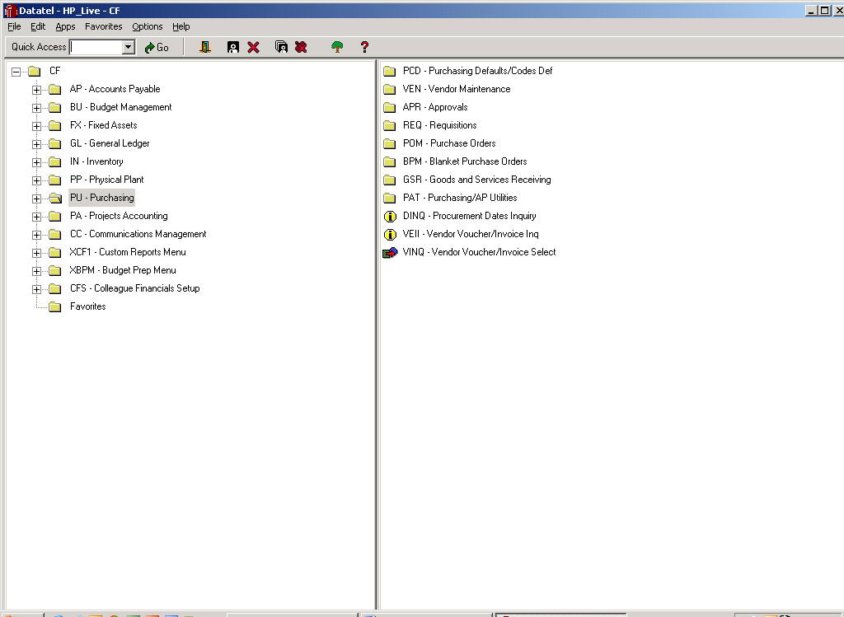  GLBA – Budget to Actual Account  This report will give you a one-line report of each object code in the account: allocated budget (the amount you begin the year with), actual (money you have spend), % used, and the available amount.  Directions fro running the GLBA report:  - Click once on [GL]  - Click once on [GLB]  - Click twice on [GLBA]  - Fiscal Year: 2003  - Skip to Include Accounts that have: Type A (All Statuses)  - Skip to GL Account Definition: Click the diagonal down arrow  New Screen  - Select/List: Click on diagonal down arrow  New Screen  - Type I [ENTER]  - Fund Group: type 11 or whatever first 2 numbers or your account are [ENTER] [ENTER]  - Type I [ENTER]  - Location Group: type 20 or whatever your location is (RC – 30, NC – 50, FCC – 20) [ENTER]  - Type I [ENTER]  - Division, Dept., Unit: type 122010 [ENTER] [ENTER]  - Type I [ENTER]  - Object Code: type 9 (This will give you al lthe object codes. If you want only one put in the complete number.) [ENTER] [ENTER]  - Type I [ENTER]  - Source: type XX0 (zero not the letter “O”) (other source codes you might see are FD0, LT0, CA0)  - Press [F10] then [ENTER] [ENTER] [ENTER]  New Screen  - Your cursor is in Sort box: Click on the diagonal down arrow  - Hold down the [CTRL] button and press [DELETE]. Repeat until you have deleted GLS.BUDGET.OFFICER  - FUND is now highlighted. Move your cursor over to the right to Break and type Y (yes) [ENTER]  - Press [F10] [ENTER] [ENTER] [ENTER] this takes you back to the original screen  - Type D for Detail instead of S for Summary [ENTER]  - Proceed with Report: type Y (yes) [ENTER] [ENTER]  New Screen (Print Screen)  - Change P to H  - Go to Other Options: make sure that NFMT is typed in as one of the options, if not, put it in.  - Press [F10] [ENTER]  New Screen  - Change nothing [ENTER] [ENTER]  New Screen  - [ENTER]  - When you see browse files, wait until your report appears. This can take a few seconds. You can observe the report on screen and stop here, or if you want to print it, continue.  - At the top of the page you will see a printer icon.  - Click once  - Change to landscape  - Click on Font button  - Change font to Lucida Console, size 9  - Press okay. Press okay again  See a sample of the GLBA report in the Appendix.  GLSA – Summary Account Availability  This report looks similar to the GLBA report, but it includes Encumbrances in addition to Actuals. An encumbrance is money that you have committed to spend, but have not yet spent it (e.g. if you have a Blanket Purchase Order for $500.00 and you have spent $100.00, your actual is $100.00 and your encumbrance is $400.00). The available balance reflects this as money already spent.  The directions for running this report would be the same as GLBA, starting with GL, GLB, GLSA.  See sample of the GLSA report in the Appendix.  GLBS – Budget Status Report  This report is a detailed report of all activity on the entire account. It can be several pages long. This is the report you will use for reconciling your excel accounts with what the district shows.  Directions for running the GLBS report:  - Click once on [GL]  - Click once on [GLB]  - Click twice on [GLBS]  - Fiscal Year: 2003  - Change the S to D for detail  - Skip to GL Account Definition  - Follow directions for GLBA – steps 6 through 22  - Type Y (yes) to proceed with report [ENTER] [ENTER]  New Screen  - Follow directions for GLBA – steps 25 though to the end.  See a sample of the GLBS report in the Appendix  ACBL – Account Balance Inquiry  This report is one page and gives a recap of your allocated budget, actuals, encumbrances, unencumbered balance and available funds. This is the report you should run to attach to Requisitions and Travel or Conference Requests for proof of sufficient funds.  - Click on GL – General Ledger  - Double click on ACBL  - GL Account Look up: Type in complete account number with no dashes or spaces – remember the last digit is a number not a letter [ENTER]  - Fiscal Year: Type in the 4 digit year [ENTER]  - To print, press Print Screen. If you do not have this feature, hold down Alt and press Print Screen. Nothing appears to happen. Open up a new Word document. Hold down Ctrl and press V. This will paste it to your word document and then you can proceed to print it in the usual manner.  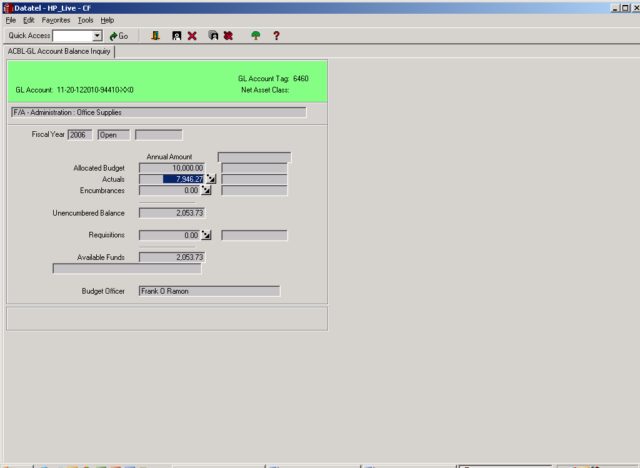  AHST – Account History Inquiry  This report is one page and gives you the same information as the ACBL plus the two prior years. Use the same directions as for the ACBL.  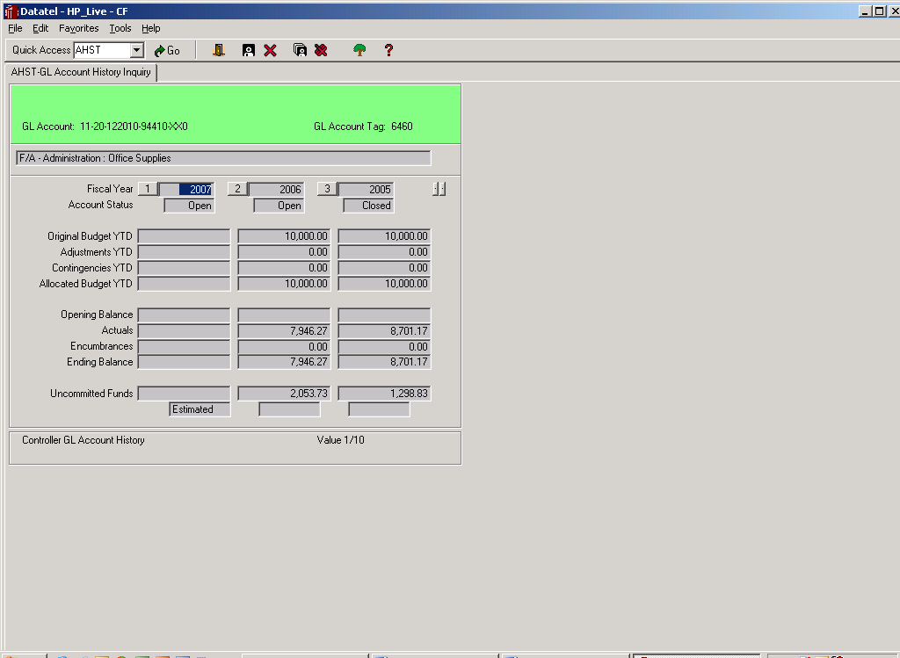  ENCI – GL Encumbrance Inquiry  This report will list all the current open purchase orders that you have for the requested object code. Use the same directions as for the ACBL. The following example shows that in the office supply account there are 4 active purchase orders: Starting from the left column to the right, it lists the purchase order number the date issued, the vendor’s name, and the amount still available. By pressing the diagonal down arrow on any one of the entries you can retrieve more information.  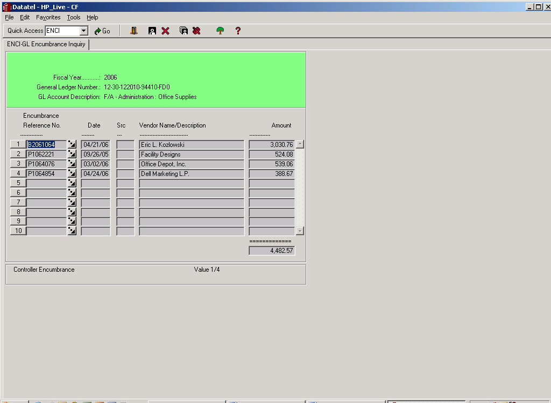  PU – Purchasing  There are several inquiries in the PU – Purchasing section that may be helpful.  VEN – Vendor Maintenance  VEIN – Vendor Inquiry  If you need to find the vendor number for a requisition, click into this inquiry and type in the vendor name. It will show the name, address and vendor number. Type in the number of the entry [ENTER] and you can research all the activity they have had with the district, going back to previous years.  REQ – Requisitions  RINQ – Requisition Inquiry  If you need to track down the status of a requisition you can enter the requisition number and find out if a purchase order has been issued against it.  POM – Purchase Orders  PINQ – Purchase Order Inquiry  If you need to research information about a certain purchase order, enter the number and research the information you need.  BPM – Blanket Purchase Orders  BINQ – Blanket Purchase Order Inquiry  This inquiry is for blanket purchase orders only, but works the same as POM.  There is a huge amount of information that can be gleaned from these inquiries. You need to go into each one and explore what is there by detailing in, using the diagonal down arrows.  EXCEL SPREAD SHEETS  Tracking budget is similar to balancing your checkbook and reconciling it to your bank statement. Your checkbook register would be the records you keep for every requisition you initiate; your bank statement is the reports you run in Datatel.  Set up a file for each object code within each account as previously described in the filing system section. Object codes are the same in every account (e.g. 94410 is always Office Supplies, 95225 is always Equipment Repair). After your hanging files are set up, make a header sheet for each object code (see Appendix for samples).  As you initiate requisitions for each object code, place the copy of the requisition and any back up information in a sheet protector. File it in the appropriate object code after listing the information on the object code header sheet. When you receive the invoice, put a copy in the sheet protector along with all of your other documents for each vendor. Write the total amount of the invoice on the face of the Purchase Order. It is quite often not exactly the same as the original amount listed.  If you have a Blanket Purchase Order that will have numerous purchases, make a Blanket Purchase Order Summary Sheet and place it in the sheet protector on the back side of the Purchase Order, with a running account of purchases and available balance (See sample in the appendix).  The purchases to date should be transferred to the Object Code header sheet. In turn the total for each object code should be transferred to the Budget Account Summary Sheet. See the Appendix for a flowchart and samples of the 3 Excel spreadsheets.  Each account should have a separate file. They can be kept in binders, the plastic file boxes, or in a regular file drawer. The Administrative Aid keeps them in a plastic file box with handle for easy transport. There should be a hanging file for each budget code.  Example: 94410 – FD0  Office Supplies  Only the current year is kept in the file box. The previous years are kept in the Master File.

Section # | Topic | Resources/  Citations
31.1 | Consortium Agreements within State Center Community College District  TBD
31.2 | Consortium Agreements with other post-secondary institutions  Reedley College participates in Consortium Agreements only in the capacity of being a host institution.  If you are enrolled in a degree or certificate program at another post-secondary institution and wish to take credits at Reedley College to be transferred to your home school, you need to initiate the process at your home school’s Financial Aid Office.  - Your home school will request that we, your host school, sign a document agreeing not to award you financial aid.  - Your home school will calculate and disburse financial aid funds to you for those programs for which you meet aid eligibility.  - You are responsible for payment of all charges at your host school.  - You may be required to provide your home school an official transcript of satisfactory completion of the course(s) taken.  - Consortium Agreements are processed on an individual student-by-student basis and are subject to approval based on institutional eligibility, courses taken, and timing of the requests.
31.3 | Format and Content of a Consortium Agreement  The following information should be included in all consortium agreements:  - Identification of the school granting the degree or certificate;  - The student’s tuition, fees, and room and board costs at each school;  - The student’s enrollment status at each school;  - Identification of the school who will be responsible for disbursing aid and monitoring student eligibility;  - The procedures for calculating awards, disbursing aid, monitoring satisfactory progress, keeping records, and returning funds in the event the student withdraws

