## NR 6 DENDROLOGY Syllabus

## Course 56486 for Spring 2021

3 units

## Lecture Tuesday 4:00PM - 4:50PM, FEM, Room 8

## Lab Friday 09:00AM - 12:50PM, FEM, Room 8

Plus Some Required Activity and Field Trips

Instructor: Kent Kinney

## Office FEM10

## Phone: (559) 638-3641 Ext. 3275 Email: [kent.kinney@reedleycollege.edu](mailto:kent.kinney@reedleycollege.edu)

Office Hours: T 9:00 AM-10:00 AM and W 11:00 AM-12:00 AM

VIRUS WARNING- BECAUSE OF SERIOUS RISK OF COVID 19 VIRUS TRANSMISSION ALL PERSONS ARE EXPECTED TO ABIDE BY SAFETY PROTOCOLS AT ALL TIMES THROUGHOUT THE SEMESTER

DO NOT ATTEND ON-CAMPUS CLASSES IF YOU ARE ILL, IF YOU HAVE SYMPTOMS OF INFECTION OR HAVE BEEN IN CONTACT WITH ANYONE BELIEVED TO BE INFFECTED WITH COVID 19

You are required to wear a cloth face covering over your mouth and nose while in face-to-face portions of this class and while inside of school buildings, near the entry doors and when outside but near other people. You are required to wear facial coverings during laboratory exercises whenever other people are present in your area.

The instructor wishes to make safety a priority. Your grade will not be reduced if you communicate to the instructor regarding your hardship due to COVID-19.

**Books:**

Hardin 2001 Textbook of Dendrology – **Required**

Stuart2001 Trees and Shrubs of California -- **Required**

Elpel 2006 Botany in a Day -- **Required**

Paruk 1997 Sierra Nevada Tree Identifier -- **Optional**

Gerstenberg 1983 Common Trees and Shrubs of the Sierra Nevada -- **Required**

Schoenherr 1992 A Natural History of California – **Optional**

Jepson 1993 The Jepson Manual Higher Plants of California - **Optional**

**Course Objectives**

 1. Identify the common community types of the Western United States with particular emphasis on California.

 2. Research a specific plant and produce a visual exhibit and written report.

 3. Use library, Internet, and other resources including computers to research and write a scientific paper illustrating the life history and identification of an assigned tree or shrub species.

 4. Create an herbarium of native plants.

 5. Use dichotomous keys and typical field guides to identify plants.

 6. Use scientific names of common plant species.

 7. Identify the major tree and shrub species important to forestry in California.

|  |  |
| --- | --- |
| **CSLOs** | |
| **NR-6 SLO1: Define and distinguish between common forest community types of the Western United States.** |  |
| **NR-6 SLO2: Differentiate between species with similar morphology.** |  |
| **NR-6 SLO3: Identify native tree and shrub species of California.**  **Course Outline**  1. Introduction    a. Tree and plant morphology    b. Stems and leaf arrangement    c. Fruit and cones    d. Root types and functions  2. Tree and plant physiology    a. Growth    b. Reproduction    c. Photosynthesis    d. Nutrient and water uptake  3. Classification    a. Naming plants (genus and species)    b. Using plant keys  4. Plant communities of California    a. Klamath region    b. Pinyon-juniper    c. Sub-alpine forests    d. Red fir/lodgepole    e. Redwood forest    f. North coast coniferous    g. Douglas fir forest    h. Closed cone forest    i. Valley riparian    j. Foothill woodland    k. Chaparral    l. Mixed conifer    m. Giant sequoia groves  **Lab Outline**  1. Leaf and twig morphology 2. Tree species report and exhibit 3. Reproductive morphology 4. Plant keys 5. Pinaceae identification 6. Pressing and mounting plant collections 7. Cupressaceae identification 8. Valley riparian field trip 9. Redwood forest biome identification    a.  Field trip 10. North coast coniferous forest 11. Douglas fir forest    a.  Field trip 12. Closed cone forest 13. Foothill woodland    a. Foothill woodland field trip 14. Chaparral    a. Chaparral field trip 15. Mixed conifer    a. Mixed conifer field trip 16. Red fir/lodgepole    a. Red fir/lodgepole field trip 17. Plant collection assessment |  |

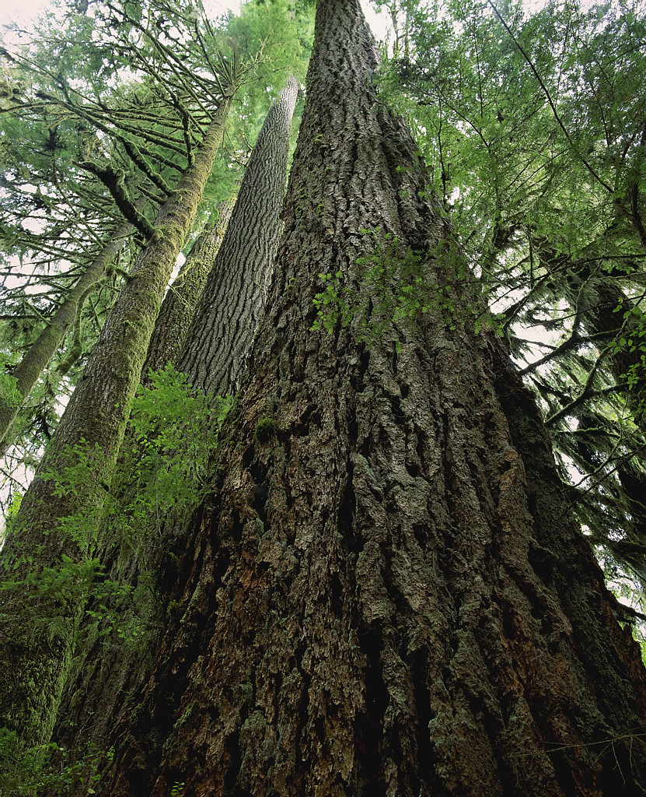

##### Tentative Schedule

|  |  |  |  |  |
| --- | --- | --- | --- | --- |
|  |  |  | **Tuesday/Friday Lecture** | **Lab** |
| Week 1 | 1/12 | T | Orientation |  |
|  | F | Nomenclature | Assignment of Projects and Collecting Plant Specimens |
| Week 2 | 1/19 | T | Morphology ONLINE |  |
|  | F | Leaf and Twig Morphology | Leaf and Twig Lesson FFA NR Contest Setup |
| Week 3 | 1/26 | T | Classification ONLINE |  |
|  | F | Plant Keys | Plant Keys |
| Week 4 | 2/2 | T | Plant Families ONLINE |  |
|  | F | **Flash Cards Due** Name Quiz | Field Trip 1, Kings River Riparian Reedley Campus/KR Greenbelt Park |
| Week 5 | 2/9 | T | Habitat and Range Exam Preview ONLINE |  |
|  | F | Holiday | Holiday |
| Week 6 | 2/16 | T | Exam 1 Tuesday ONLINE |  |
|  | F | Foothill Woodland | Exam review/**\*Species Exhibit Due and Presented** |
| Week 7 | 2/23 | T | Variation/ Plant Families Exam ONLINE |  |
|  | F |  | Field Trip 2, Foothill Woodland |
| Week 8 | 3/2 | T | Reproductive Morphology ONLINE |  |
|  | F | Field Trip | Field Trip 3, Chaparral |
| Week 9 | 3/9 | T | **Exam 2** |  |
|  | F | Exam Critique | Cone Identification |
| Week 10 | 3/16 | T | Lower Montane Biome |  |
|  | F | Field Trip | Field Trip 4, Lower Montane |
| Week 11 | 3/23 | T | Upper Montane |  |
|  | F | Plant ID Test 1 | Plant ID Test 1 FFA Forestry Competition Setup |
| Spring Break | 3/30 |  |  |  |
|  |  |  |  |
| Week 12 | 4/6 | T | Southern California Species |  |
|  | F | Field Trip | Field Trip 5, Upper Montane |
| Week 13 | 4/13 | T | **Show Plant ID PowerPoint Presentation** | Plant ID PowerPoint Due |
|  | F | Native Riparian Plant ID | RC Riparian Biome Restoration NR 116 |
| Week 14 | 4/20 | T | Cone Identification Test |  |
|  | F | Field Studies NR 110/116 | Sequoia Lake NR 110/116 |
| Week 15 | 4/27 | T | Coastal Biomes |  |
|  | F | ID Review for Lab Final |  |
| Week 16 | 5/4 | T | Desert  Biome | **\*Plant Collection Due** |
|  | F | Fieldtrip | Field Trip 6, Coastal Biome |
| Week 17 | 5/11 | T | Review for Lecture Final Exam |  |
|  | F | **Plant Final** | **Plant Final Identification** |
| Week 18 | 5/18 | T | **Final Written Exam Tuesday @ 4:00** |  |

**Attendance and Grading Policy:**

The success of any class depends on the presence and active participation of each student; therefore, you are expected to attend every class. **If you miss class more than 6 times during the semester (without a valid reason) you may be dropped from the course**. Examination grades may be based on a curve and final grades will be assigned based on a straight percentage system according to the following scale:

|  |  |
| --- | --- |
| **Course Grade** **Cumulative Percent**  A 90-100  B 80-89  C 70-79  D 60-69  F < 59 | Breakdown of Grades Percent  Midterm Exam I 10  Midterm Exam II 10  Plant Collection 20  Species Exhibit & Report 10  Plant ID Final 25  Lecture Final 15  PowerPoint ID Presentation 5  Flash Cards 5  Extra Credit 5 |

**Student Conduct Standards:**

Reedley Student Conduct Standards shall be observed. A student may be disciplined utilizing the procedures set out in Administrative Regulation 5520 related to college attendance or activity.

**Field Trips**:

There may be several required field trips taken during the semester. These trips will generally be taken during scheduled lab times but we **may** **sometimes need to leave prior to or return to campus after the scheduled class time**. You should make every effort to coordinate in advance with your other teachers if this occurs.

If you do not attend a fieldtrip that occurs outside of a regularly-scheduled laboratory or lecture you will be expected to submit an alternate assignment.

**Always come prepared to go outside during lab. “Being Prepared” means to wear hiking boots or work boots, wear long pants, and to bring other items such as water, bug repellent, rain gear (even if there is a slight chance of rain), warm cloths, and a plant collection bag and hand shears.**

**Required material and equipment:**

You will need botany paper and mounting supplies for an herbarium plant collection. You should have hand shears to collect plant samples and a large plastic bag on all field trips.

**Accommodations:**

If you have a need for an academic accommodation or materials in alternate media (i.e., Braille, large print, electronic text, etc.) per the Americans with Disabilities Act(ADA) or Section 504 of the Rehabilitation Act, please contact me as soon as possible.



NR 6 – **Dendrology Species List for Pinophyta (Gymnosperms)**

|  |  |
| --- | --- |
| **FAMILY: TAXACEAE**  California nutmeg (*Torreya californica*)  **FAMILY: PINACEAE**  White Fir (*Abies concolor*)  Red Fir (*Abies magnifica*)  Grand Fir (*Abies grandis*)  Noble Fir (*Abies procera*)  Subalpine Fir (*Abies lasiocarpa*)  Bristlecone Fir (*Abies brachiata*)  Balsam Fir (*Abies balsamea*)  Deodar Cedar (*Cedrus deodora*)  Western Larch (*Larix occidentalis*)  Tamarack (*Larix laricina*)  Sitka Spruce (*Picea sitchensis*)  Colorado Blue Spruce (*Picea pungens*)  Engelmann Spruce (*Picea engelmannii*)  Weeping Spruce (*Picea breweriana*)  Black Spruce (*Picea mariana*)  White Spruce (*Picea glauca*)  White-bark Pine (*Pinus albicaulis*)  Limber Pine (Pinus flexilis)  Western White Pine (*Pinus monticola)*  Sugar Pine (Pinus lambertiana)  Rocky Mountain Bristlecone Pine (*Pinus aristata*)  Great Basin Bristlecone Pine (*Pinus longaeva*)  Foxtale Pine (*Pinus balfouriana*)  Torrey Pine (*Pinus torreyi*)  Lodgepole Pine (*Pinus contorta*)  Bishop Pine (*Pinus muricata*)  Single-Leaf Pinyon (*Pinus monophylla*)  Colorado Pinyon (*Pinus edulis*)  FAMILY: PINACEAE Continued:  Four-Needle Pinyon (*Pinus quadrafolia*)  Ponderosa Pine (*Pinus ponderosa*)  Jeffrey Pine (*Pinus jeffreyii* )  Washoe Pine (*Pinus washoensis*)  Grey (Digger) Pine (*Pinus sabiniana*)  Coulter Pine (*Pinus coulteri*)  Monterey Pine (*Pinus radiata*)  Knobcone Pine (*Pinus attenuata*)  Western Hemlock (*Tsuga heterophylla*)  Mountain Hemlock (*Tsuga mertensiana*)  Douglas Fir (*Pseudotsuga menziesii*)  Bigcone Spruce (*Pseudotsuga macrocarpa*) | **FAMILY: CUPRESSACEAE**  Giant Sequoia (*Sequoiadendron giganteum*)  Coast Redwood (*Sequoia sempervirens*)  Dawn Redwood (*Metasequoia glyptostroboides*)  Bald Cypress (*Taxoidium distichum*)  Monterey Cypress (*Hesperocyparis macrocarpa*)  Piute Cypress (*Cupressus nevadensis*)  Common Juniper (*Juniperus commonis*)  Sierra Juniper (*Juniperus occidentalis*)  Utah Juniper (*Juniperus osteosperma*)  California Juniper (*Juniperus califomica)*  Eastern Red-cedar (*Juniperus virginiana*)  Incense-cedar (*Calocedrus decurrens*)  Western Red-cedar (*Thuja plicata*)  Northern White-cedar (*Thuja occidentalis*)  Port Orford-cedar (*Chamaecyparis lawsoniana*)  Alaska-cedar (*Chamaecygari nookatensis*)  Atlantic White-cedar (*Chamaecyparis thyoides*) |





Dendrology Plant List

Name _______________________________________

2021 Edition

*Abies bracteata*

Bristlecone fir

t

*Mimulus aurantiacus*

Northern monkey flower

*Abies concolor*

White fir

t

*Mimulus longiflorus*

Bush monkey flower

*Abies magnifica*

Red fir

t

*Nicotiana glauca*

Tree tobacco

*Acer macrophyllum*

Big leaf maple

t

*Pinus albicaulis*

Whitebark pine

t

*Acer negundo*

Box Elder

t

*Pinus attenuata*

Knobcone pine

t

*Acmispon glaber*

*(Lotus scoparius)*

Deer weed

*Pinus balfouriana*

Foxtail pine

t

*Adenostoma fasciculatum*

Chamise

*Pinus contorta*

Lodgepole pine

t

*Aesculus californica*

California buckeye

t

*Pinus coulteri*

Coulter pine

t

*Alnus rhombifolia*

White alder

t

*Pinus flexilis*

Limber pine

t

*Alnus rubra*

Red alder

t

*Pinus jeffreyi*

Jeffrey pine

t

*Apocynum spp.*

Dogbane

*Pinus lambertiana*

Sugar pine

t

*Arbutus menziesii*

Pacific madrone

t

*Pinus longaeva*

Bristlecone pine

t

*Arctostaphylos nevadensis*

Pinemat manzanita

*Pinus monophylla*

Single-leaf pinyon

t

*Arctostaphylos patula*

Green-leaf manzanita

*Pinus monticola*

Western white pine

t

*Arctostaphylos viscida*

White-leaf manzanita

*Pinus ponderosa*

Ponderosa pine

t

*Artemisia douglasians*

Mugwort

*Pinus radiata*

Monterey pine

t

*Artemisia spp.*

Sagebrush

*Pinus sabiniana*

Gray pine,

Foothill p., Ghost p.

t

*Asclepias spp.*

Milkweed

*Pinus washoensis*

Washoe pine

t

*Baccharis pilularis*

Coyote brush

*Platanus racemosa*

Western sycamore

t

*Baccharis salicifolia*

Mulefat

*Polystichum spp.*

Swordfern

*Berberis aquifolium*

Oregon Grape

*Populus balsaniferia*

Black cottonwood

t

*Berberis dictyota*

California mahonia

*Populus fremontii*

Fremont cottonwood

t

*Betula occidentalis*

Water birch

t

*Populus tremuloides*

Quaking aspen

t

*Calocedrus decurrens*

Incense cedar

t

*Prosopis spp.*

Mesquite

t

*Calycanthus occidentalis*

Spicebush

*Prunus emarginata*

Bitter cherry

*Carex spp*

Sedge

*Prunus subcordata*

Sierra Plum

*Carpenteria californica*

Carpenteria /

Tree Anemone

*Prunus virginiana*

Choke cherry

*Ceanothus cordulatus*

Mountain whitethorn

*Pseudotsuga macrocarpa*

Bigcone Douglas-fir

t

*Ceanothus cuneatus*

Buckbrush

*Pseudotsuga menziesii*

Douglas fir

t

*Ceanothus fresnensis*

Fresno mat

*Pteridium aquilinum*

Brackenfern

*Ceanothus intergerrimus*

Deer brush

*Quercus agrifolia*

Coast live oak

t

*Ceanothus leucodermis*

Chaparral whitethorn

*Quercus berberidifolia*

Scrub oak

*Ceanothus parvifolius*

Littleleaf ceanothus

*Quercus chrysolepis*

Canyon live oak

t

*Ceanothus thyrsiflorus*

Blueblossom ceanothus

*Quercus douglasii*

Blue oak

t

*Cephalanthus occidentalis*

Button brush

*Quercus garryana*

Oregon White Oak

t

*Cercis occidentalis*

Western redbud

*Quercus kelloggii*

California black oak

t

*Cercocarpus betuloides*

Birchleaf

Mountain-

Mahogany

*Quercus lobata*

Valley oak

t

*Chamaebatia foliolosa*

Bear clover

*Quercus vaccinifolia*

Huckleberry oak

*Chrysolepis chrysophylla*

Golden chinquapin

*Quercus wislizinii*

Interior live oak

t

*Chrysolepis sempervirens*

Bush chinquapin

*Rhamnus crocea*

Redberry

*Chrysothamnus nauseosus*

Rabbitbrush

*Rhododendron columbianum*

Western Labrador Tea

*Cornus nuttallii*

Pacific dogwood

t

*Rhododendron occidentale*

Wesern azalea

*Cornus sericea*

Creek dogwood

t

*Rhus ovata*

Sugar Bush

*Corylus cornuta*

California hazelnut

*Rhus trilobata*

Skunk Bush

*Hesperocyparis macrocarpa*

Monterey cypress

t

*Ribes spp.*

Currant

*Dendromecon rigida*

Bush poppy

*Ribes spp.*

Gooseberry

*Equisetum spp.*

Horsetail

*Rosa californica*

Wild rose

*Eriogonum spp.*

Buckwheat

*Rubus discolor*

*(not native)*

Himalayan blackberry

*Eriodictyon californicum*

Yerba santa

*Rubus parviflorus*

Thimbleberry

*Eriophyllum confertiflorum*

Golden yarrow

*Rubus ursinus*

California blackberry

*Frangula californica*

California coffeeberry

t

*Salix scouleriana*

Scouler Willow

t

*Fraxinus dipetela*

Flowering Ash

t

*Salix laevigata*

Red Willow

*Fraxinus latifolia*

Oregon ash

*Salix gooddingii*

Black Willow

t

*Fremontodendron californicum*

Flannel bush

*Salvia spp.*

Sage

*Garrya spp.*

Silktassel

*Sambucus nigra spp. caerulea*

Blue elderberry

*Helianthus annuus*

Common sunflower

t

*Sambucus racemosea*

Red elderberry

*Heteromeles arbutifolia*

Toyon

t

*Sequoia sempervirens*

Coast redwood

t

*Juglans californica*

California Black Walnut

t

*Sequoiadendron giganteum*

Giant sequoia

t

*Juncus spp*

Rush

*Staphylea bolanderi*

California bladder-nut

*Juniperus californica*

California juniper

t

*Symphoricarpos spp.*

Snowberry

*Juniperus communis*

Common juniper

*Taxus brevifolia*

Pacific yew

t

*Juniperus occidentalis*

Sierra juniper

t

*Torreya californica*

California nutmeg

t

*Keckiella breviflorus*

Bush beard-tongue

*Toxicodendron diversilobum*

Poison oak

*Notholithocarpus densiflorus*

Tan oak

t

*Tsuga mertensiana*

Mountain hemlock

t

*Larrea tridentata*

Creosote Bush

*Typha spp.*

Cattail

*Lonicera spp.*

Honeysuckle

*Umbellularia californica*

California laurel

t

*Lupinus albifrons*

Silver lupine, Bush l., Tree l.

*Urtica spp.*

Stinging Nettles

*Marah spp.*

Man-root/Wild cucumber

*Vitus californica*

California wild grape

*Mentzelia lindleyi*

Blazing Star

*Woodwardia fimbriata*

Giant Chain Fern

*Yucca spp.*

Yucca

NR 6 – **Dendrology Species List for Pinophyta (Gymnosperms)**

|  |  |
| --- | --- |
| **FAMILY: TAXACEAE**  California nutmeg (*Torreya californica*)  **FAMILY: PINACEAE**  White Fir (*Abies concolor*)  Red Fir (*Abies magnifica*)  Grand Fir (*Abies grandis*)  Noble Fir (*Abies procera*)  Subalpine Fir (*Abies lasiocarpa*)  Bristlecone Fir (*Abies brachiata*)  Balsam Fir (*Abies balsamea*)  Deodar Cedar (*Cedrus deodora*)  Western Larch (*Larix occidentalis*)  Tamarack (*Larix laricina*)  Sitka Spruce (*Picea sitchensis*)  Colorado Blue Spruce (*Picea pungens*)  Engelmann Spruce (*Picea engelmannii*)  Weeping Spruce (*Picea breweriana*)  Black Spruce (*Picea mariana*)  White Spruce (*Picea glauca*)  White-bark Pine (*Pinus albicaulis*)  Limber Pine (Pinus flexilis)  Western White Pine (*Pinus monticola)*  Sugar Pine (Pinus lambertiana)  Rocky Mountain Bristlecone Pine (*Pinus aristata*)  Great Basin Bristlecone Pine (*Pinus longaeva*)  Foxtale Pine (*Pinus balfouriana*)  Torrey Pine (*Pinus torreyi*)  Lodgepole Pine (*Pinus contorta*)  Bishop Pine (*Pinus muricata*)  Single-Leaf Pinyon (*Pinus monophylla*)  Colorado Pinyon (*Pinus edulis*)  FAMILY: PINACEAE Continued:  Four-Needle Pinyon (*Pinus quadrafolia*)  Ponderosa Pine (*Pinus ponderosa*)  Jeffrey Pine (*Pinus jeffreyii* )  Washoe Pine (*Pinus washoensis*)  Grey (Digger) Pine (*Pinus sabiniana*)  Coulter Pine (*Pinus coulteri*)  Monterey Pine (*Pinus radiata*)  Knobcone Pine (*Pinus attenuata*)  Western Hemlock (*Tsuga heterophylla*)  Mountain Hemlock (*Tsuga mertensiana*)  Douglas Fir (*Pseudotsuga menziesii*)  Bigcone Spruce (*Pseudotsuga macrocarpa*) | **FAMILY: CUPRESSACEAE**  Giant Sequoia (*Sequoiadendron giganteum*)  Coast Redwood (*Sequoia sempervirens*)  Dawn Redwood (*Metasequoia glyptostroboides*)  Bald Cypress (*Taxoidium distichum*)  Monterey Cypress (*Hesperocyparis macrocarpa*)  Piute Cypress (*Cupressus nevadensis*)  Common Juniper (*Juniperus commonis*)  Sierra Juniper (*Juniperus occidentalis*)  Utah Juniper (*Juniperus osteosperma*)  California Juniper (*Juniperus califomica)*  Eastern Red-cedar (*Juniperus virginiana*)  Incense-cedar (*Calocedrus decurrens*)  Western Red-cedar (*Thuja plicata*)  Northern White-cedar (*Thuja occidentalis*)  Port Orford-cedar (*Chamaecyparis lawsoniana*)  Alaska-cedar (*Chamaecygari nookatensis*)  Atlantic White-cedar (*Chamaecyparis thyoides*) |

