STEM/Transfer Center
Field Trip

UC Berkeley
Friday, October 22, 2010

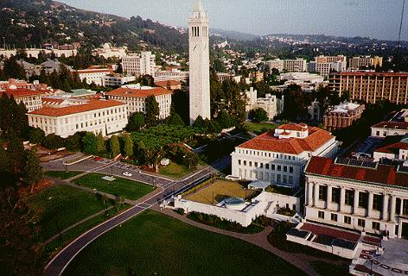

- SEATING IS LIMITED.
- $5.00 fee (Refundable)
- Each student must sign contract and provide emergency information

For more information or to sign up:
At Reedley College, come by or call the Transfer Center at 638-3641 ext. 3234.
At Willow International, contact Tasha Hutchings at 325-5200 ext.5304.
At Madera Center, contact Maria Ensminger at 675-4800.

