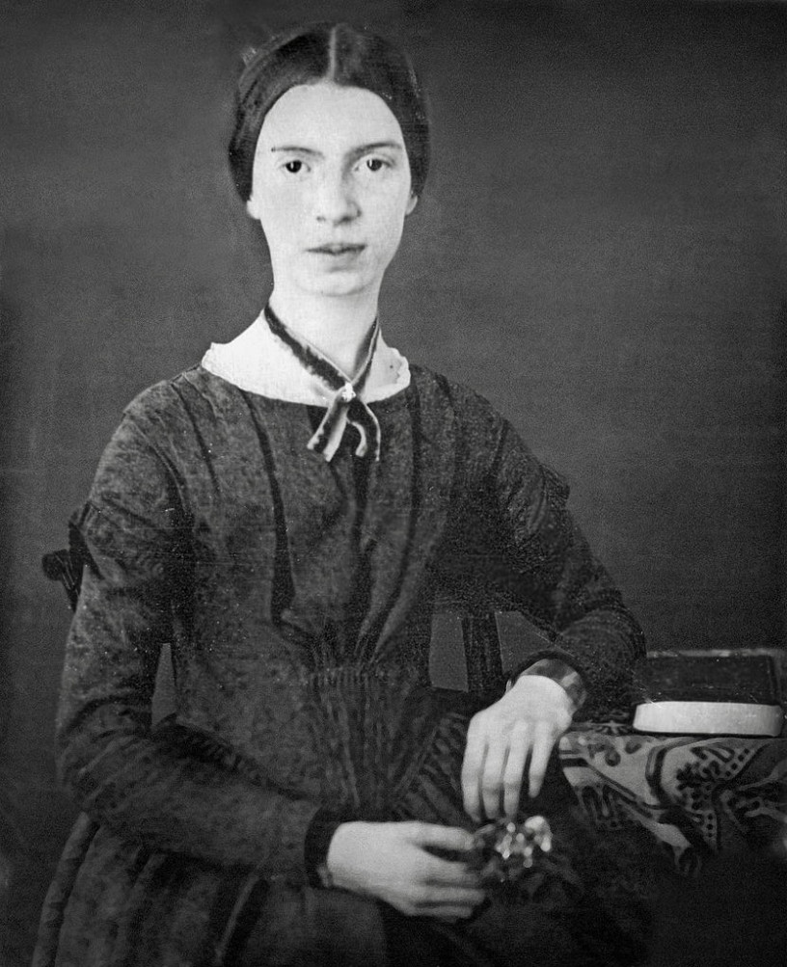

“If I read a book and it makes my whole body so cold no fire can ever warm me,
I know that is poetry.” --Emily Dickinson

Fall 2019, English 15A, Creative Writing – Poetry
Professor: Mr. Dominguez
Office: Annex 2
Phone: EXT 3745
E-mail: david.dominguez@reedleycollege.edu
Office Hours: My online office hours are MWF from 10:00 -11:40 on your class’s Canvas discussion board (for general questions about lectures, reading assignments, etc.…) or via email for private questions regarding grades and other personal matters.

Changes to the Syllabus/ Calendar:
The instructor reserves the right to make changes to the syllabus or the course outline. Missing class or not checking Canvas is not an excuse for not being aware of any changes that are made to the syllabus or the course outline.

Catalog Description:
A course intended for students who enjoy reading and writing poetry. In this course, students will study poems by professional writers and fellow students and use what they learn to write their own original poetry. The strongest poems written in this class are often recommended for publication in Reedley College's literature journal, Symmetry.

Course Content:
Learning Outcomes
- Evaluate manuscripts on the basis of intention, merit, and received criticism, using shared critical vocabulary.
- Recognize and employ effective strategies for composing poems on the basis of received criticisms.

Course Objectives
- Recognize the impact of poetic style and voice
- Recognize the influence of various points of view
- Make decisions regarding poetic structure on the basis of thematic purpose
- Understand the nuances of poetic language—literal vs. figurative; denotative vs. connotative
- Recognize the importance of effective research
- Create strong sensory images as a method of re-creating experience
- Read/examine professional models from the standpoint of craft
- Respond (offer constructive criticism and praise) with sensitivity to others’ literary efforts
Please Purchase the Following REQUIRED Texts at the Reedley College Bookstore or Amazon depending on availability with the exception of History, which you will order directly from the publisher:

Magic City
ISBN: 9780819512086
Author(s): Yusef Komunyakaa
Publisher: Wesleyan

In Search of Duende, second edition
ISBN: 9780811218559
Author(s): Federico Garcia Lorca
Publisher: New Directions

Separate Escapes
ISBN: 9780912592497
Author(s): Corrinne Clegg Hales
Publisher: ASHLAND POETRY PRESS

Looking for The Gulf Motel
ISBN 978-0-8229-6201-4
Author: Richard Blanco
Publisher: University of Pittsburg Press

History
NO ISBN
Author(s): Philip Levine
Publisher: Miramar Editions
→ Please order directly from the publisher. Please send checks or money orders made out to Christopher Buckley (he is the editor in chief). You may also send cash. The cost of the book is $8.00. This includes shipping, so we are getting a nice little discount and making a contribution to the arts and a small publisher that does exceptional work. In your envelope, please include a short note that says, “Dear Mr. Buckley, I am a student in Professor Dominguez’s poetry writing class. I am enclosing $8.00 for History by Philip Levine. Thank you.” Under “Thank you,” write your name and mailing address. We have a deadline to order this book. Please send your payment by February 14. Please honor this deadline or you will not be able to get a book. Thank you. Here is the publisher’s address:

Miramar Editions
342 Oliver Road
Santa Barbara, CA 93109

Getting Your Poems Published:
Each year, Reedley College publishes Symmetry. Symmetry is a literature journal that showcases the best essays, creative nonfiction, short stories, and poems written by Reedley College students. This semester, I will pick the best poems written for our class and publish them in Symmetry. This is also a chance for you to share your work with an audience.

Format for All Assignments:
PLEASE NOTE THE FOLLOWING MLA Guidelines (poems that do not follow these MLA guidelines may not be accepted)…Poems must be typed in Times New Roman. Font must be size 12. Print quality must be clear and black. Double space all work. Do not bold face the font. Do not use inappropriate capitalization. Do not use unnecessary italics. Do not center justify your poem. One inch margins top, bottom. Last name, page number in upper right-hand corner. One inch margins left, right. In the top left-hand corner of the first page, type the following pieces of information:

Name (first, last)
Instructor: Mr. Dominguez
Course: English 15, Poetry Writing
Date: (Applicable due date)
Poem One: Center the Title of Your Poem

Semester Grading:
This semester, you are going to introduce yourself to the class, write 4 poems, and revise one of them for your final exam. You will be graded based on your ability to demonstrate knowledge of our texts, on your ability to show knowledge of craft, on your ability to use basic writing skills, on your ability to demonstrate well-written sentences, and on your ability to follow directions.

A=510-459, B=458-408, C=407-357, D=356-306, F=305-0.

Extra Credit:
Extra credit may be offered during the semester. When you turn it in, I will put it in my extra credit folder. At the end of the semester, I will calculate final grades; if you have earned a “C” or higher because of how you have done on the required course work, I will then add your extra credit to your final grade. Thus, the extra credit will not raise your grade from an “F” or a “D” to a “C.” It can, however, raise your final grade from a “C” to a “B” or from a “B” to an “A.”

Our Course Policies

Office Hours and Course Communication
- My office hours will be held M, W, and F from 10:00 AM-11:40 AM on the discussion board. You will find me under the thread titled Office Hours. During these hours, I will sit and respond to general questions on the syllabus, readings, lectures, and assignments. You may post your questions 24 hours a day; I will do my best to respond during my next scheduled office hour. Feel free to catch me on the discussion board if you would like to chat about any of those subjects.
- If you have personal issues to discuss with me, such as health concerns, family, work, or a personal emergency, please feel free to email me 24 hours a day. I will do my best to respond during my next scheduled office hour.

Dropping and Attendance
- To avoid being dropped from the course, you must complete your first two assignments of the semester. If you do not complete these assignments, you will be dropped from the course. If you wish to drop yourself from the course, you must do so before the official Reedley College drop deadline, which is March 12 at 5:00pm via Web Advisor. Thank you.
- Attendance will be taken regularly. Each time you submit an assignment, you will be considered present. If you do not submit an assignment, you will be considered absent. If you submit an assignment late, you will still be marked present.

Late Work
- Late work will be accepted without penalty if you have a documentable excuse that I am willing to consider. Contact me in advance of a deadline or immediately after a deadline (in the event of a medical emergency) and send me documentation via email. In the past, I have accepted late work with documentation and applied no penalty for issues such as court appearances, required training for members of the military, and for medical emergencies that involve yourself or an immediate family member. Please do your best to contact me in advance if you believe you have a documentable excuse that you would like to discuss with me. Please be advised that I do not simply accept all documented excuses.
- Late work that is not justified with a documented excuse will be accepted with a 10-point deduction each day they are late. If an assignment is so late it has lost more points than it is worth, the assignment will not be accepted.
- PLEASE NOTE: The final will not be accepted late and must be completed within the posting dates. In rare cases, a medical emergency may justify a make-up assignment.
- Please remember that the application of these policies is up to my discretion as your professor.

Academic Behavior and the Discussion Board
- You must maintain a respectful tone with me and each other on the discussion board. When I read your posts, I expect to see proper English. Not capitalizing “I” when it is a first-person pronoun, for example, is not proper English. The language used to write text messages is definitely not proper English. Students who fail to maintain a respectful tone may be dropped from the course—consider yourselves warned. When posting a message addressed to me, format it like this…

Dear Professor Dominguez
Your message….
Thank you.
Sincerely,
Student’s First Name

Academic Behavior and Email Correspondence
- If you send me an email, begin with “Dear Mr. Dominguez” and end with “Thank you” and “Sincerely, [your name].” Emails must show proper English. Emails written informally will be ignored. Here is a properly written email:

Dear Mr. Dominguez,
May I have your feedback on my poem, especially concrete imagery? I have attached it to my email. I’m worried that it may not address the writing prompt. Thank you.
Sincerely, Andrew

- Here is an email I will ignore:

hey guy check out my work and tell me whats wrong let me no b/c i need to finish for ur assignment.

Accommodations for Students with Disabilities
- If you have a verified need for an academic accommodation or materials in alternate media (i.e., Braille, large print, electronic text, etc.) per the Americans with Disabilities ACT (ADA) or Section 504 of the Rehabilitation Act, please contact me as soon as possible. To receive accommodations, you or your counselor must provide me with paperwork from the Reedley College DSPS Office by the end of the second week of the semester or I may not be unable to accommodate you. Thank you.

Technology
- Students must be familiar with technology. Students must be able to use Canvas and all its features, Microsoft Word (full version, not the online version or Google Docs or Pages or something similar), have quality Internet service, have a reliable computer, and be able to use their SCCCD email. In addition, students will need to access videos and PowerPoint. All assignments will be submitted electronically via Canvas. Problems with technology is not an excuse for falling behind in the class or for not turning in work.

Plagiarism
- If you are caught plagiarizing any work in any way shape or form, you may receive an “F” on the assignment, in class, or dropped from the course, with the appropriate grade, and referred to campus administration. This is a zero-tolerance policy.

Final Thoughts
- These policies are designed to help us enjoy a course that is organized, fair, and consistent. They are meant to help you develop practices that will help you in your academic career while being mindful of the fact that sometimes life gets in the way. In my experience, successful students persevere and learn to overcome obstacles, so always do your best to be present and to turn in your work on time.

Course Outline:
With the exception of week 1, lectures will posted on a Tuesday by 5:00PM. Lectures are recorded rather than synchronous to better accommodate your schedules. Poems 1-4 will be due on a Sunday night by 11:59 PM. The final will be due as indicated in the course outline.

Week One: Students read the syllabus, buy books, say hello on the discussion board, and begin reading The Fields Darken with Silence by Ricardo Zamorano Baez in the required readings folder on the modules page. Finish reading it by January 19.
Tuesday, January 19: Lecture posted on free verse poetry, first-person narration, concrete imagery, and romantic imagery. Lecture posted on The Fields Darken with Silence.
Tuesday, January 26: Lecture posted on The Fields Darken with Silence. Poem 1 assigned.
Tuesday, February 2: Workshop for poem 1 via the discussion board from 10-12. No lecture posted.
Sunday, February 7: Poem 1 due at 11:59PM. Students begin reading Looking for the Gulf Motel and Magic City and finish by February 16 and 23 respectively.
Tuesday, February 9: Lecture posted on line, line break, stanza, setting, and tone.
Tuesday, February 16: Lecture posted on Looking for the Gulf Motel.
Tuesday, February 23: Lecture posted on Magic City. Poem 2 assigned.
Tuesday, March 2: Workshop for poem 2 via the discussion board from 10-12. No lecture posted.
Sunday, March 7: Poem 2 due at 11:59PM. Students begin reading Separate Escapes by Connie Hales. Finish reading by March 16.
Tuesday, March 9: Lecture posted on music.
Tuesday, March 16: Lecture posted on Separate Escapes.
Tuesday, March 23: Lecture posted on Separate Escapes. Poem 3 assigned.
Tuesday, March 30: Spring break. No lectures posted.
Tuesday, April 6: Workshop for poem 3 via the discussion board from 10-12. No lecture posted.
Sunday, April 11: Poem 3 due at 11:59PM. Students begin reading History by Philip Levine. Finish reading by April 20.
Tuesday, April 13: Lecture posted on the prose poem.
Tuesday, April 20: Lecture posted on History.
Tuesday, April 27: Lecture posted on History. Poem 4 assigned.
Tuesday, May 4: Workshop for poem 4 via the discussion board from 10-12. No lecture posted.
Sunday, May 9: Poem 4 due at 11:59PM. Students begin reading “Play and Theory of the Duende” which you will find in In Search of Duende by Federico Garcia Lorca. Finish reading by May 11.
Tuesday, May 11: Lecture posted on “Play and Theory of the Duende.” Final assigned.
Tuesday, May 18: Final due at 12:00PM. Please note that this assignment is due at noon.

In addition, we will have conversations on the discussion board about poetry. Points will not be awarded to students who participate. Rather, this is a chance for you to discuss the books that we are reading with your classmates and me. The discussion board gives you a chance to be part of a writing community and to share your work with each other. Thus, the conversations are worth far more than a scattering of points.

