Course Syllabus – Spring 2019
ACCTG-4A-51635 (T/TH 11:00am -1:15pm)
FINANCIAL ACCTG
Reedley College

Instructor: Eunji Seo, CPA, CMA, CIA
Office Hours: Monday - Thursday 9:45am-10:45am
Friday 9:45 am - 10:45am (Virtual office hour)
Office Location: Business 44
Phone: 559-638-0339
Email: eunji.seo@reedleycollege.edu

Class Meeting Room: Business 42

Class Section No. | 51635
T/TH Lecture | 11:00am – 12:50pm
T/TH Lab | 12:50pm – 1:15pm

Prerequisites: None

Advisories: English 1A and Mathematics 201

Student Learning Outcomes:
Upon completion of this course, students will be able to:
- analyze the effects of business transactions on assets, liabilities, equity, revenues and expenses.
- apply knowledge of accounting principles in preparing journal entries in various situations.
- prepare the four basic financial statements; balance sheet, income statement, statement of owner's equity and the statement of cash flows.
- use critical thinking to evaluate the ethical decisions made by a company that was cited for accounting fraud or irregularities.
Course Objectives:
In the process of completing this course, students will:
- Explain the nature and purpose of generally accepted accounting principles (GAAP) and International Financial Reporting Standards (IFRS). Point out the differences as each topic develops.
- Define and use accounting terminology.
- Explain what a system is and how an accounting system is designed to satisfy the needs of specific businesses and users; summarize the purpose of journals and ledgers.
- Apply transaction analysis in the process of preparing the four basic financial statements.
- Distinguish between cash basis and accrual basis accounting and their impact on the financial statements.
- Identify and illustrate how the principles of internal control are used to manage a firms resources and minimize risk.
- Explain the content, form, and purpose of the basic financial statements (including footnotes) and the annual report, and how they satisfy the information needs of investors, creditors, and other users.
- Explain the nature of current assets and related issues, including the measurement and reporting of cash, receivables, inventory and cost of goods sold.
- Explain the reporting of current liabilities, estimated liabilities, and other contingencies.
- Explain the valuation and reporting of current liabilities, estimated liabilities, and other contingencies.
- Identify and illustrate issues relating to long-term asset acquisition, use, cost allocation, and disposal.
- Distinguish between capital and revenue expenditures.
- Explain the importance of operating, investing and financing activities reported in the Statement of Cash Flows.
- Identify and illustrate issues relating to stockholders' equity, including issuance, repurchase of capital stock and dividends.
- Interpret company activity, profitability, liquidity and solvency through selection and application of appropriate financial analysis tools.
- Identify the ethical implications inherent in financial reporting and be able to apply strategies for addressing them.

Required Textbook and Other Items To Be Used:
- Financial & Managerial Accounting Infomration for decisions, (with Connect Code for Online assignment ), John J. Wild, Ken W. Shaw, and Barbara Chiappetta McGraw-Hill Irwin 7th Edition.
- Students are required to have online connection in order to complete the online assignments for each chapter.
- An access code to Connect, the publisher’s learning platform, for the assignments is required for the course.
- A basic calculator is strongly recommended.

Materials To Be Covered in Course ACCT 4A:
Chapters 1 through 12 in the above textbook will be covered.

Methodology:
Students will be expected to read the material in the chapters, complete assigned problems, and be prepared to discuss the assigned chapters. Lectures will serve the purpose of clarifying and expanding on the reading material. After discussing new subject matter, students are expected to work on exercises in class.

Assignments:
- Chapters should be read before the class discussions.
- All online assignments with due date are posted in Connect. You need to ensure to register in Connect and complete the assignments in order to receive a full credit allocated into each assignment.

Studying Accounting:
Accounting course is such that perfect attendance is essential for mastery of the course content. A missed class cannot be duplicated. Accounting is best learned through doing. As such, allocating time for studying Acconting is essential. This will require a considerable commitment of time and efforts from you. Typically, a successful student in college can count on about 2 hours of independent study for every hour in the classroom.

Class Attendance:
- You need to attend class regularly and participate. Roll is taken in each class. Your presence is considered important to the quality of your learning and insures your opportunity to participate and contribute to your learning. A student should consider class their job and grades to be their pay. Employees who do not show up for work do not get paid. Learn to be on time and to schedule and manage your other commitments on your time away from class.
- Since employers allow sick leave, you will be allowed three missed classes. Two tardies are equal to one absence. After four absences you may be dropped from class for non-attendance if the absences occur before the 9-week drop date. If you must be gone, use the days wisely. Remember - all assignments must be submitted by due date in order to get a full credit.
- Dropping from this class is YOUR RESPONSIBILITY. Failure to drop could result in a letter grade being issued. The end of the ninth week of instruction is the last day to drop a full term class in person and receive a "W" on transcript. Please refer to school web site for details.

Academic Calendar – Important Dates

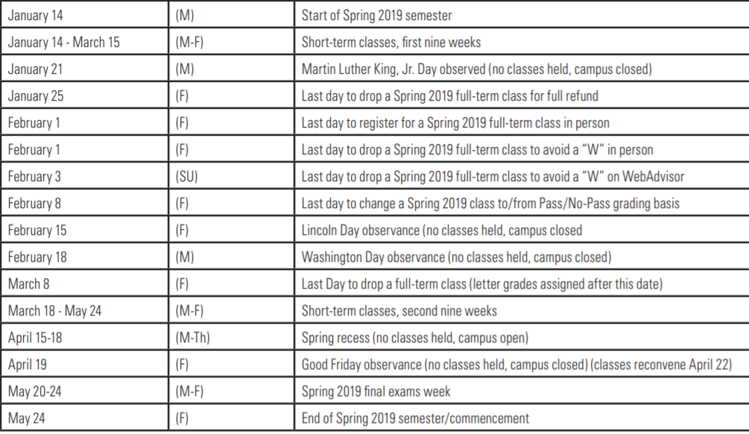

Cancelled Class Notification
If a class has to be cancelled, a cancellation notice will be placed on the classroom door. In addition, the cancelled class will be notified to students through Canvas.

Tentative Class Schedule & Connect Due Dates - See Appendix I below

Performance Evaluation and Grading Policies:
Course grades will be based on the total number of points obtained by an individual as a percentage of total points possible. Grades will be awarded using an absolute scale and will not be curved.

No. | Performance Evaluation Breakdown | Points | %
1 | 6 exams (highest 5 exams x 100 points/exam) | 500 | 51.8%
2 | Comprehensive Final Exam @ 150 points | 150 | 15.5%
3 | LearnSmart (highest 11 ch x 5 points/ch) | 55 | 5.7%
4 | Homework (highest 11 ch x 20 points/ch) | 220 | 22.8%
5 | Stock Research | 20 | 2.1%
6 | Ethics Case Study | 20 | 2.1%
 | Possible Points | 965 | 100.0%

Stock Research & Ethics Case Study: additional information will be provided for details when the project is explained in class.
McGraw Hill’s Connect Assignments: LearnSmart & Homework will be graded online based on the grading policy that the instructor has set up in Connect. For Homework, there will be 10% penalty per day for late submission in Connect. All grades are final unless an error in math is made during the computation of the grade. The instructor reserves the right to adjust the course outline, scoring, grading, and content as needed. There will be NO MAKE-UP TESTS. Instead, one of the regular scores (your lowest or missed test) will be thrown out for calculating your semester grade.

Grading Scale is used as follows:
Grade Scale
Points Range (from - to) |  | Grade | %
869 | 965 | A | 90%
772 | 868 | B | 80%
676 | 771 | C | 70%
579 | 675 | D | 60%
zero | 578 | F | < 60%

Academic Dishonesty
Students at Reedley College are entitled to the best education that the college can make available to them. Students, their instructors, and their classmates, share the responsibility to ensure that this education is honestly attained. Because cheating, plagiarism, and collusion in dishonest activities erode the integrity of the college, each student is expected to exert an entirely honest effort in all academic endeavors. Academic dishonesty in any form is a very serious offense and will incur serious consequences.

Cheating is the act or attempted act of taking an examination or performing an assigned, evaluated task in a fraudulent or deceptive manner, such as having improper access to answers, in an attempt to gain an unearned academic advantage. Cheating may include, but is not limited to, copying from another’s work, supplying one’s work to another, giving or receiving copies of examinations without an instructor’s permission, using or displaying notes or devices inappropriate to the conditions of the examination, allowing someone other than the officially enrolled student to represent the student, or failing to disclose research results completely.

Plagiarism is a specific form of cheating: the use of another’s words or ideas without identifying them as such or giving credit to the source. Plagiarism may include, but is not limited to, failing to provide complete citations and references for all work that draws on the ideas, words, or work of others, failing to identify the contributors to work done in collaboration, submitting duplicate work to be evaluated in different courses without the knowledge and consent of the instructors involved, or failing to observe computer security systems and software copyrights. Incidents of cheating and plagiarism may result in any of a variety of sanctions and penalties, which may range from a failing grade on a particular examination, paper, project, or assignment in question to a failing grade in the course, at the discretion of the instructor and depending on the severity and frequency of the incidents.

Technological Gadgets
Mobile electronic devices such as MP3 players and mobile phones must be silenced and put away during class. There is an exception for tablets and laptops, but these devices are only allowed to be used in class during lecture and discussion for note taking. Computer use for note taking must be approved by the instructor and proof of those notes will be periodically checked by your instructor. If this privilege is abused or computer use becomes distracting, your instructor will suspend this privilege. Mobile phone conversations, including texting, are distracting in the classroom setting and are not allowed. If you use the cell phone in class, your instructor has a right to ask you leave the classroom to show the respect to your peers and instructor. Please wait until break to use your phone.

Special Needs Requests
If you have a verified need for an academic accommodation or materials in alternate media (i.e., Braille, large print, electronic text, etc.) per the Americans with Disabilities Act (ADA) or Section 504 of the Rehabilitation Act, please contact me as soon as possible.

Other Policies and Procedures:
- Hats and sunglasses are NOT to be worn during class.
- The instructor has the right to teach and you and your classmates have the right to learn.
- Please be considerate and respectful of others.
- See your college catalog for additional guidelines.

Appendix A
Tentative Class Schedule & Connect Due Dates
Week | Date | Day | CH | Discussion Materials | LearnSmart (by 7:00am) | Homework (by11:59pm)
1 | 01/15/19 | T | n/a | Introduction to Class
 | 01/17/19 | TH | 1 | Accounting in Business | 01/23/19 | 01/23/19
2 | 01/22/19 | T | 1
 | 01/24/19 | TH | 2 | Business Transactions | 01/24/19 | 02/04/19
3 | 01/29/19 | T | 2
 | 01/31/19 | TH | 2
4 | 02/05/19 | T | 3 | Exam # 1 - (CH 1 & 2)
 | 02/07/19 | TH | 3 | Adjusting Accounts | 02/07/19 | 02/18/19
5 | 02/12/19 | T | 3
 | 02/14/19 | TH | 3
6 | 02/19/19 | T | 4 | Exam # 2 - (CH 3)
 | 02/21/19 | TH | 4 | Merchandising Operations | 02/21/19 | 02/27/19
7 | 02/26/19 | T | 4
 | 02/28/19 | TH | 5 | Inventories & Cost of Sales | 02/28/19 | 03/11/19
8 | 03/05/19 | T | 5
 | 03/07/19 | TH | 6 | Cash & Internal Control | 03/07/19 | 03/18/19
9 | 03/12/19 | T | 6 | Exam # 3 - (CH 4 & 5)
 | 03/14/19 | TH | 6
10 | 03/19/19 | T | 7 | A/R | 03/19/19 | 03/25/19
 | 03/21/19 | TH | 7
11 | 03/26/19 | T | 8 | Exam # 4 (CH 6 & 7)
 | 03/28/19 | TH | 8 | Long-term Assets | 03/28/19 | 04/03/19
12 | 04/02/19 | T | 8
 | 04/04/19 | TH | 9 | Current Liabilities | 04/04/19 | 04/10/19
13 | 04/09/19 | T | 9
 | 04/11/19 | TH | 10 | Exam # 5 (CH 8 & 9)
14 | 04/16/19 | T |  | No Class - Spring Break
 | 04/18/19 | TH |  | No Class - Spring Break
15 | 04/23/19 | T | 10 | L/T Liabilities | 04/23/19 | 04/29/19
 | 04/25/19 | TH | 10
16 | 04/30/19 | T | 11 | Equity | 04/30/19 | 05/06/19
 | 05/02/19 | TH | 11
17 | 05/07/19 | T | 12 | Exam # 6 (CH10 & CH11)
 | 05/09/19 | TH | 12 | Statement of Cash Flows | 05/09/19 | 05/15/19
18 | 05/14/19 | T | 12
 | 05/16/19 | TH | n/a | Final Exam Review
19 | 05/21/19 |  |  | Final Exam

Appendix B

SYLLABUS ACKNOWLEDGMENT

ACCTG-4A-51635 (T/TH 11am -1:15pm)
SPRING 2019
EUNJI SEO, CPA, CMA, CIA

I acknowledge discussing the Accounting 4A Course Guide (Syllabus) in class and I understand the policies and procedures of this course. I particularly understand the online assignments, NO make-up, and grading policies as outlined in this course guide. I am aware that a copy of the syllabus and related materials are available on Canvas during the semester and that I may make a copy of said documents if desired. I also understand that I need to do all my online assignments in Connect and should submit them before due date in order to receive a full possible credit for each assignment.

Your Full Name (Print)
Signature & Date
Email Address | (State the one you check often)
Student 4-digit Code | (Please neither social security number, nor student ID)

