Course Syllabus – FALL 2018
ACCTG-4B-56884 MANAGERIAL ACCTG
Reedley College

Instructor: Eunji Seo, CPA, CMA, CIA
Office Hours: Monday - Thursday 9:45am-10:45am
Friday 9:45 am - 10:45am (Virtual office hour)
Office Location: Business 44
Phone: 559-638-0339
Email: eunji.seo@reedleycollege.edu

Class Meeting Room: Business 42
Mon & Wed Lecture: 7:30 am - 9:20am
Mon & Wed Lab: 9:20 am - 9:45am

Advisories: English 1A and Mathematics 201
Prerequisites: Accounting 4A
Student Learning Outcomes:
Upon completion of this course, students will be able to:
- use correct accounting terminology appropriate to the subject matter.
- calculate the cost of inventory using both job and process order costing systems.
- prepare a flexible budget performance report.
- perform capital budgeting and decision making analysis using net present value, accounting rate of return and payback methods.

Course Objectives:
In the process of completing this course, students will:
- Identify and illustrate the primary activities and information needs of managers and explain the role of the managerial accountant as a member of the management team; compare and contrast financial and managerial accounting.
- Define and illustrate various cost terms, concepts and behaviors, and evaluate their relevancy for different decision-making purposes.
- Distinguish between product and period costs and prepare and evaluate a Schedule of Costs of Goods Manufactured, Schedule of Costs of Goods Sold and Income Statement.
- Prepare the contribution-margin income statements and define related terms.
- Explain cost-volume-profit analysis, degree of operating leverage, and safty margin and employ each as an analytical tool.
- Describe the traditional types of product costing systems (including job-order and process), illustrate the flow of costs in each, and prepare related accounting records.
- Discuss the impact of technology on the business environment, its implications for product and service costs, and the development of activity-based costing and management.
- Explain the purposes of budgeting, prepare a master budget and its component schedules, and relate the budget to planning and control.
- Explain the development and use of standard costs and flexible budgets, prepare and interpret variance analysis reports and relate them to responsibility accounting and control.
- Explain the nature of and need for segment reporting and the relationship with cost, revenue, profit and investment centers.
- Compare and contrast absorption costing and variable costing, prepare income statements using both methods, and reconcile the resulting net incomes.
- Define relevant costs and benefits and prepare analyses related to special decisions.
- Explain the nature of capital expenditure decisions and apply and evaluate various methods used in making these decisions; including time value of money, accounting rate of return and payback methods.
- Identify the ethical implications inherent in managerial accounting and reporting and be able to apply strategies for addressing them.

Required Textbook and Other Items To Be Used:
- Financial & Managerial Accounting Infomration for Decisions, (with Connect Code for Online assignment ), John J. Wild, Ken W. Shaw, and Barbara Chiappetta McGraw-Hill Irwin 7th Edition.
- Students are required to have online connection in order to complete homework and class practice for each chapter. An access to Connect for the assignments is required for the course.
- A basic calculator is strongly recommended. One will not be provided nor may you share.
- Connect web site for registration will be provided through Canvas.

Materials To Be Covered in ACCT 4B:
Chapters 14 through 24 (11 chapters) in the above textbook. There may be a brief review of accounting that will reference chapters prior to chapter 14.

Methodology:
Students will be expected to read the material in the chapters, complete assigned problems, and be prepared to discuss the assigned chapters. Lectures will serve the purpose of clarifying and expanding on the reading material. After discussing new subject matter, students are expected to work on exercises in and after class.

Assignments:
- Chapters should be read before the class discussions.
- All online assignments with due date are posted in Connect. You need to ensure to register in Connect and complete the homework in order to receive a full credit allocated into each assignment - see the details in “Performance Evaluation” section described below.

Studying Accounting:
Accounting course is such that perfect attendance is essential for mastery of the course content. A missed class cannot be duplicated. Accounting is best learned through doing. As such, allocating time for studying Acconting is essential. This will require a considerable commitment of time and efforts from you. Typically, a successful student in college can count on about 2 hours of independent study for every hour in the classroom.

Class Attendance:
- You need to attend class regularly and participate. Roll is taken in each class. Your presence is considered important to the quality of your learning and insures your opportunity to participate and contribute to your learning. A student should consider class their job and grades to be their pay. Employees who do not show up for work do not get paid. Learn to be on time and to schedule and manage your other commitments on your time away from class.
- Since employers allow sick leave, you will be allowed three missed classes. Two tardies are equal to one absence. After four absences you may be dropped from class for non-attendance if the absences occur before the 9-week drop date. If you must be gone, use the days wisely. Remember - all assignments must be submitted by due date in order to get a full possible credit.
- Dropping from this class is YOUR RESPONSIBILITY. Failure to drop could result in a letter grade being issued. The end of the ninth week of instruction is the last day to drop a full term class in person and receive a "W" on transcript. Please refer to school web site for details.

Academic Calendar – Important Dates

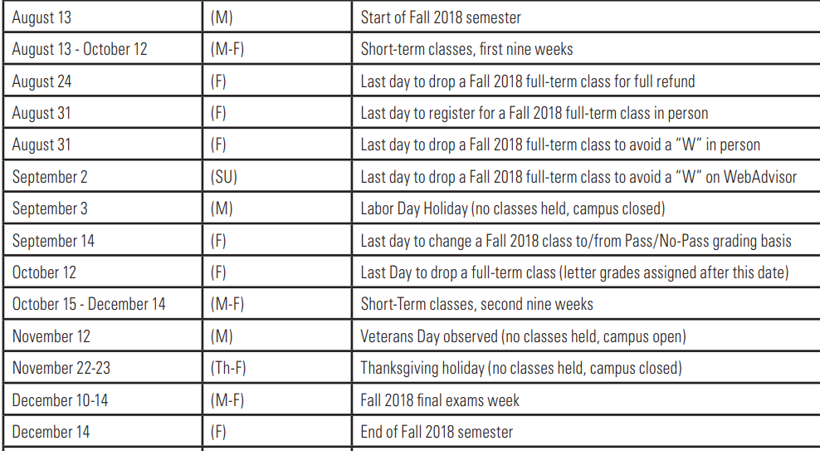

Cancelled Class Notification
If a class has to be cancelled, a cancellation notice will be placed on the classroom door. In addition, the cancelled class will be notified to students through Canvas.

Tentative Class Schedule & Connect Due Dates - See Appendix I below

Performance Evaluation and Grading Policies:
Course grades will be based on the total number of points obtained by an individual as a percentage of total points possible. Grades will be awarded using an absolute scale and will not be curved.

No. | Assignment Breakdown for ACCT 4B | Points | Percent
1 | Exams (100 points x highest 4 exams) | 400 | 44%
2 | Comprehensive Final Exam (150 points) | 150 | 17%
3 | LearnSmart (5 points x highest 10 chapters) | 50 | 6%
4 | Connect Homework (20 points x highest 10 chapters) | 200 | 22%
5 | Financial Statement Analysis Project | 100 | 11%
 | TOTAL Possible Points | 900 | 100%

McGraw Hill’s Connect Assignments: LearnSmart & Homework will be graded online based on the grading policy that the instructor has set up in Connect. For Homework, there will be 10% penalty per day for late submission in Connect. All grades are final unless an error in math is made during the computation of the grade. The instructor reserves the right to adjust the course outline, scoring, grading, and content as needed. There will be NO MAKE-UP TESTS. Instead, one of the regular scores (your lowest or missed test) will be thrown out for calculating your semester grade.

Kahoot Quizzes: The points are based on your participation, not based on how many points you earned as there are more than correct answers. If you participate in class, you earn 5 points, regardless of whether your answer is correct. If you are absent, you do not earn points. Mo makeup for quiz is allowed as all the correct answers are discussed in class.

Semester Project: additional information will be provided for details when the project is explained in class.

Grading Scale is used as follows:

Grade Scale
Points Range (from - to) |  | Letter Grade | Percentage
810 | 900 | A | 90%
720 | 809 | B | 80%
630 | 719 | C | 70%
540 | 629 | D | 60%
zero | 539 | F | Below 60%

Academic Dishonesty
Students at Reedley College are entitled to the best education that the college can make available to them. Students, their instructors, and their classmates, share the responsibility to ensure that this education is honestly attained. Because cheating, plagiarism, and collusion in dishonest activities erode the integrity of the college, each student is expected to exert an entirely honest effort in all academic endeavors. Academic dishonesty in any form is a very serious offense and will incur serious consequences.

Cheating is the act or attempted act of taking an examination or performing an assigned, evaluated task in a fraudulent or deceptive manner, such as having improper access to answers, in an attempt to gain an unearned academic advantage. Cheating may include, but is not limited to, copying from another’s work, supplying one’s work to another, giving or receiving copies of examinations without an instructor’s permission, using or displaying notes or devices inappropriate to the conditions of the examination, allowing someone other than the officially enrolled student to represent the student, or failing to disclose research results completely.

Plagiarism is a specific form of cheating: the use of another’s words or ideas without identifying them as such or giving credit to the source. Plagiarism may include, but is not limited to, failing to provide complete citations and references for all work that draws on the ideas, words, or work of others, failing to identify the contributors to work done in collaboration, submitting duplicate work to be evaluated in different courses without the knowledge and consent of the instructors involved, or failing to observe computer security systems and software copyrights. Incidents of cheating and plagiarism may result in any of a variety of sanctions and penalties, which may range from a failing grade on a particular examination, paper, project, or assignment in question to a failing grade in the course, at the discretion of the instructor and depending on the severity and frequency of the incidents.

Technological Gadgets
Mobile electronic devices such as MP3 players and mobile phones must be silenced and put away during class. There is an exception for tablets and laptops, but these devices are only allowed to be used in class during lecture and discussion for note taking. Computer use for note taking must be approved by the instructor and proof of those notes will be periodically checked by your instructor. If this privilege is abused or computer use becomes distracting, I will suspend this privilege. Mobile phone conversations, including texting, are distracting in the classroom setting and are not allowed. Please wait until break to use your phones.

Special Needs Requests
If you have a verified need for an academic accommodation or materials in alternate media (i.e., Braille, large print, electronic text, etc.) per the Americans with Disabilities Act (ADA) or Section 504 of the Rehabilitation Act, please contact me as soon as possible.

Other Policies and Procedures:
- Hats and sunglasses are NOT to be worn during class.
- The instructor has the right to teach and you and your classmates have the right to learn.
- Please be considerate and respectful of others.
- See your college catalog for additional guidelines.

Appendix I Tentative Class Schedule & Connect Due Dates

Reedley College ACCTG4B Class Calendar - FALL 2018 (Course # 56884)
# of wk | Date | Day | CH | Course Discussion Materials | LearnSmart (by 7:00am) | Homework (by 11:59pm)
1 | 8/13/18 | M | n/a | Intro to Class
 | 8/15/18 | W | 14 | Intro to Managerial ACCT | 08/26/18 | 08/26/18
2 | 8/20/18 | M | 14
 | 8/22/18 | W | 14
3 | 8/27/18 | M | 15 | Job Order Costing | 08/27/18 | 09/04/18
 | 8/29/18 | W | 15
4 | 9/3/18 | M |  | No Class - Labor Day
 | 9/5/18 | W |  | Exam #1 ( CH14 & CH15)
5 | 9/10/18 | M | 16 | Process Costing | 09/10/18 | 09/16/18
 | 9/12/18 | W | 16 | Financial Analysis Report Due
6 | 9/17/18 | M | 17 | Activity-based Costing | 09/17/18 | 09/25/18
 | 9/19/18 | W | 17
7 | 9/24/18 | M |  | Exam #2 (CH16 & CH17)
 | 9/26/18 | W | 19 | Variable vs. Absorption Costing | 09/26/18 | 10/02/18
8 | 10/1/18 | M | 19
 | 10/3/18 | W | 18 | Cost Volume Profit Analysis | 10/03/18 | 10/09/18
9 | 10/8/18 | M | 18
 | 10/10/18 | W |  | Exam # 3 ( CH19 & CH18)
10 | 10/15/18 | M | 23 | Relevant Costing for Managerial Decision | 10/15/18 | 10/21/18
 | 10/17/18 | W | 23
11 | 10/22/18 | M | 24 | Capital Budgeting | 10/22/18 | 10/30/18
 | 10/24/18 | W | 24
12 | 10/29/18 | M | 24
 | 10/31/18 | W |  | Exam #4 (CH23 & CH24)
13 | 11/5/18 | M | 20 | Master Budgeting | 11/05/18 | 11/13/18
 | 11/7/18 | W | 20
14 | 11/12/18 | M |  | No Class - Veterans Day
 | 11/14/18 | W | 21 | Flexible Budget & Standard Costing | 11/14/18 | 11/25/18
15 | 11/19/18 | M | 21
 | 11/21/18 | W | 21
16 | 11/26/18 | M |  | Exam#5 (CH20 & CH21)
 | 11/28/18 | W | 22 | Performance Measurement & Responsibility Acct | 11/28/18 | 12/04/18
17 | 12/3/18 | M | 22
 | 12/5/18 | W |  | Final Exam Review
18 | 12/14/18 | F | 7am | Comprehensive Final Exam

Appendix II

SYLLABUS ACKNOWLEDGMENT
ACCTG-4B-56884 MANAGERIAL ACCTG

FALL 2018
EUNJI SEO, CPA, CIA, CMA

I acknowledge discussing the Accounting 4B Course Guide (Syllabus) in class and I understand the policies and procedures of this course. I particularly understand the online assignments, NO make-up, and grading policies as outlined in this course guide. I am aware that a copy of the syllabus and related materials are available on Canvas during the semester and that I may make a copy of said documents if desired. I also understand that I need to do all my online assignments in Connect and should submit them before due date in order to receive a full possible credit for each assignment.

Your Full Name (Print)
Signature & Date
Email Address | (State the one you check often)
Student 4-digit Code | (Please neither social security number, nor student ID)

