NR6 – DENDROLOGY
Course 59342
Syllabus for Spring Semester 2017

Lecture Tuesday 4 – 4:50 PM, Friday 9:00 – 9:50 AM

Laboratory Friday 10:00 AM – 12:50 PM
Room FEM 8
Instructors: Kent Kinney

Office FEM10, Phone: (559) 638-3641 Ext. 3275
Office Hours: T, W 3:00 PM and Th 9:00 AM
Email: kent.kinney@reedleycollege.edu

Books:
Hardin 2001 Textbook of Dendrology – Required
Stuart 2001 Trees and Shrubs of California -- Required
Elpel 2006 Botany in a Day -- Required
Paruk 1997 Sierra Nevada Tree Identifier -- Optional
Gerstenberg 1983 Common Trees and Shrubs of the Sierra Nevada -- Required
Schoenherr 1992 A Natural History of California – Optional
Jepson 1993 The Jepson Manual Higher Plants of California - Optional
Course Objectives:
To introduce students to plant communities of California and to develop competence in identifying common trees and shrubs of the region. Students will gain skills using plant keys and preparing plant collections.
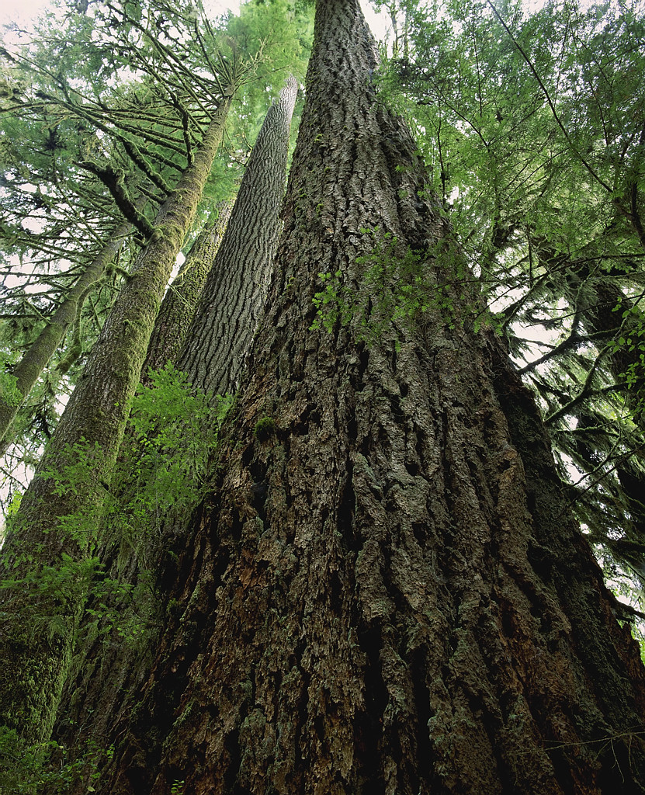

Tentative Schedule
 |  | Tuesday/Friday Lecture | Friday Lab
Week 1 |  | Orientation
Week 1 |  | Nomenclature | Assignment of Projects
Week 2 |  | Nomenclature
Week 2 |  | Morphology | FFA NR Contest Setup
Week 3 |  | Morphology
Week 3 |  | Classification | Leaf and Twig Morphology
Week 4 |  | Classification
Week 4 |  | Exam Preparation | Plant Keys
Week 5 |  | Exam 1 Tuesday
Week 5 |  | Presidents Holiday Friday | Presidents Holiday Friday
Week 6 |  | Plant Families
Week 6 |  | Plant Families | Collecting Plant Specimens
Week 7 |  | Variation
Week 7 |  | Habitat and Range | Pine Identification
Week 8 |  | Riparian Biome
Week 8 |  | Field Trip | Field Trip 1, Kings River Riparian – Reedley Tree Planting
Week 9 |  | Coastal Species
Week 9 |  | Field Trip 7:00 AM to 5:00 PM | Field Trip 2, Coastal Species
Week 10 |  | Foothill Woodland
Week 10 |  | Field Trip | Field Trip 3, Oak Woodland/Int Mt Nur
Week 11 |  | Reproductive Morphology
Week 11 |  | Exam Preparation | *Species Exhibit Due and Presented
Week 12 |  | Exam 2 Friday @ 9:00 AM
Week 12 |  | Exam Critique/Chaparral Biome | FFA Forestry Competition Setup
Week 13 |  | Lower Montane Biome
Week 13 |  | Field Trip | Field Trip 4, Chaparral
Spring | Break
Week 14 |  | Upper Montane
Week 14 |  | Field Trip 8:00 AM to 4:00 PM | Field Trip 5, Lower Montane
Week 15 |  | Southern California
Week 15 |  | Sequoia Lake NR 110/116 | Sequoia Lake NR 110/116
Week 16 |  | *Plant Collection Due Tuesday/ Review for Final Exam
Week 16 |  | Fieldtrip Leave at 8:00AM –Return 5:00 PM | Field Trip 6, Upper Montane
Week 17 |  | Review for plant ID Final
Week 17 |  | Plant Press Conference | Plant Final Identification Test Friday
Week 18 |  | Final Exam Tuesday @ 4:00

Attendance and Grading Policy:
The success of any class depends on the presence and active participation of each student; therefore, you are expected to attend every class. If you miss class more than 6 times during the semester (without a valid reason) you may be dropped from the course. Examination grades may be based on a curve and final grades will be assigned based on a straight percentage system according to the following scale:

Course Grade Cumulative Percent  A 90-100  B 80-89  C 70-79  D 60-69  F < 59 | Breakdown of Grades Percent  Midterm Exam I 10  Midterm Exam II 10  Plant Collection 30  Tree Species Exhibit 10  Plant ID Final 25  Lecture Final 15  Extra Credit 10  Nursery Maintenance (25%)  Flash Cards (25%)  FFA Contest (25%)  Other (25%)

Student Conduct Standards:
Reedley Student Conduct Standards shall be observed. A student may be disciplined utilizing the procedures set out in Administrative Regulation 5520 related to college attendance or activity.

Field Trips:
There may be several required field trips taken during the semester. These trips will generally be taken during scheduled lab times but we may sometimes need to leave prior to or return to campus after the scheduled class time. You should make every effort to coordinate in advance with your other teachers if this occurs.

If you do not attend a fieldtrip that occurs outside of a regularly-scheduled laboratory or lecture you will be expected to submit an alternate assignment.

Always come prepared to go outside during lab. “Being Prepared” means to wear hiking boots or work boots, wear long pants, and to bring other items such as water, bug repellent, rain gear (even if there is a slight chance of rain), warm cloths, and a plant collection bag and hand shears.

Required material and equipment:
You will need botany paper and mounting supplies for an herbarium plant collection. You should have hand shears to collect plant samples and a large plastic bag on all field trips.

Accommodations:
If you have a need for an academic accommodation or materials in alternate media (i.e., Braille, large print, electronic text, etc.) per the Americans with Disabilities Act(ADA) or Section 504 of the Rehabilitation Act, please contact me as soon as possible.

