NR6 – DENDROLOGY
Course Syllabus for spring 2014
Course 52071

Lecture 1 - Tues 4:00 – 4:50 PM, room FEM 8 Lecture 2 - Fri 9:00 – 9:50 AM, room FEM 8
Laboratory F 10:00 AM – 12:50 PM
Instructors: Kent Kinney

Office FEM10, Phone: (559) 638-3641 Ext. 3275
Office Hours: T, Th 9:00 AM; W 3:00 PM
Email: kent.kinney@reedleycollege.edu

Books:
Hardin 2001 Textbook of Dendrology – Required
Stuart 2001 Trees and Shrubs of California -- Required
Elpel 2006 Botany in a Day -- Required
Paruk 1997 Sierra Nevada Tree Identifier -- Optional
Gerstenberg 1983 Common Trees and Shrubs of the Sierra Nevada -- Optional
Schoenherr 1992 A Natural History of California – Optional
Jepson 1993 The Jepson Manual Higher Plants of California - Optional
Course Objectives:
To introduce students to plant communities of California and to develop competence in identifying common trees and shrubs of the region. Students will gain skills using plant keys and preparing plant collections.
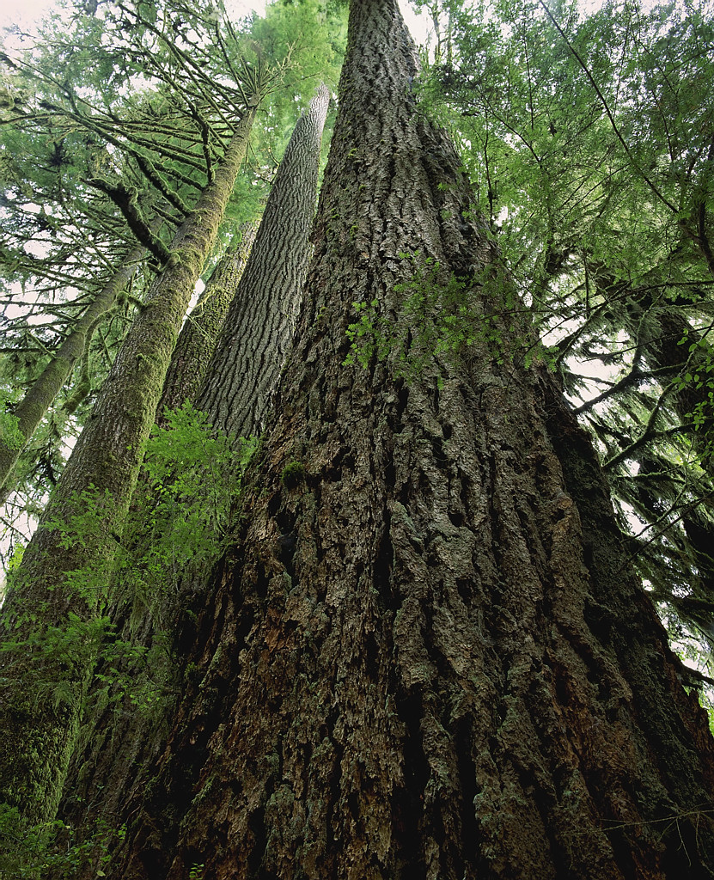

Tentative Schedule
 |  | Tuesday/Friday Lecture | Friday Lab
Week 1 | 14-Jan | Orientation
Week 1 | 17-Jan | Nomenclature | Assignment of Projects
Week 2 | 21-Jan | Nomenclature
Week 2 | 25-Jan | Morphology | FFA NR Contentest Setup
Week 3 | 28-Jan | Morphology
Week 3 | 31-Jan | Classification | Leaf and Twig Morphology
Week 4 | 4-Feb | Classification
Week 4 | 7-Feb | Exam Preparation | Plant Keys
Week 5 | 11-Feb | Exam 1 Tuesday
Week 5 | 14-Feb | Presidents Holiday Friday | Presidents Holiday Friday
Week 6 | 18-Feb | Plant Families
Week 6 | 21-Feb | Plant Families | Collecting Plant Specimens
Week 7 | 25-Feb | Variation
Week 7 | 28-Feb | Habitat and Range | Pine Identification
Week 8 | 4-Mar | Riparian Biome
Week 8 | 7-Mar | Field Trip | Field Trip 1, Kings River Riparian
Week 9 | 11-Mar | Coastal Species
Week 9 | 14-Mar | Field Trip 7:00 AM to 5:00 PM | Field Trip 2, Coastal Species
Week 10 | 18-Mar | Foothill Woodland
Week 10 | 21-Mar | Field Trip | Field Trip 3, Oak Woodland
Week 11 | 25-Mar | Reproductive Morphology
Week 11 | 28-Mar | *Species Exhibit Due and Presented | *Species Exhibit Due and Presented
Week 12 | 1-Apr | Exam Preparation
Week 12 | 4-Apr | Exam 2 Friday @ 9:00 AM | FFA Forestry Competition Setup
Week 13 | 8-Apr | Exam Critique/ Chapparral Biome
Week 13 | 11-Apr | Field Trip | Field Trip 4, Chaparral
 |  | Spring Break April 14 - 18
Week 14 | 22-Apr | Lower Montane
Week 14 | 25-Apr | Sequoia Lake NR 110/116 | Sequoia Lake NR 110/116
Week 15 | 29-Apr | Upper Montane
Week 15 | 2-May | Field Trip | Field Trip 5, Lower Montane
Week 16 | 6-May | Southern California
Week 16 | 9-May | Field Trip 8:00 AM to 4:00 PM | Field Trip 6, Upper Montane
Week 17 | 13-May | *Plant Collection Due Tuesday
Week 17 | 16-May | Review for Final Exam | Plant Final Identification Test Friday
Week 18 | 20-May | Final ExamTuesday May 20 @ 4:00

Attendance and Grading Policy:
The success of any class depends on the presence and active participation of each student; therefore, you are expected to attend every class. If you miss class more than 6 times during the semester (without a valid reason) you may be dropped from the course. Examination grades may be based on a curve and final grades will be assigned based on a straight percentage system according to the following scale:

Course Grade Cumulative Percent  A 90-100  B 80-89  C 70-79  D 60-69  F < 59 | Breakdown of Grades Percent  Midterm Exam I 10  Midterm Exam II 10  Plant Collection 30  Tree Species Exhibit 10  Lab Final 25  Lecture Final 15  Extra Credit 10  Arboretum Maintenance (25%)  Flash Cards (25%)  FFA Contest (25%)  Other (25%)

Field Trips:
There may be several required field trips taken during the semester. These trips will generally be taken during scheduled lab times but we may sometimes need to leave prior to or return to campus after the scheduled class time. You should make every effort to coordinate in advance with your other teachers if this occurs.

If you do not attend a fieldtrip that occurs outside of a regularly-scheduled laboratory or lecture you will be expected to submit an alternate assignment.

Always come prepared to go outside during lab. “Being Prepared” means to wear hiking boots or work boots, wear long pants, and to bring other items such as water, bug repellent, rain gear (even if there is a slight chance of rain), warm cloths, and a plant collection bag and hand shears.

Required material and equipment:
You will need botany paper and mounting supplies for an herbarium plant collection. You should have hand shears to collect plant samples and a large plastic bag on all field trips.

Accommodations:
If you have a need for an academic accommodation or materials in alternate media (i.e., Braille, large print, electronic text, etc.) per the Americans with Disabilities Act(ADA) or Section 504 of the Rehabilitation Act, please contact me as soon as possible.

