SYLLABUS

Class Hours | T 2 p.m. – 4:50 p.m. Room : Phys 70  Th 2 p.m. – 4:50 p.m. Room : Phys 75
Class No | 55006
Instructor | Sharon Wu
Phone | 638-3641 ex-3497
Office Hours | M,W,Th 11:00 am – 11:50 am  or By appointment
Office | FEM 1D
E-mail | sharon.wu@reedleycollege.edu

Course Objectives:
In the process of completing this course, students will:
A. Perform some of the simpler calculations in the areas of electricity, magnetism, light, and atomic and nuclear physics.
B. Use the appropriate language of physics and mathematics to solve problems in the areas of electricity, magnetism, light, and atomic and nuclear physics.
C. Perform simple physics experiments in the areas of electricity, magnetism, light, and atomic and nuclear physics ;to acquire understanding of more difficult concepts in general physics.
D. Understand and apply basic physics concepts presented in lectures to the completion of problem assignments and lab reports.
E. Employ the scientific method in experiments in physics which yield results consistent with information presented in lectures.

Learning Outcomes:
Upon completion of this course, students will be able to:
A. Recognize the systematic nature of the discipline of physics in the areas of electricity, magnetism, light, and atomic and nuclear physics and develop new ideas using previously held knowledge as the foundation.
B. Apply sound reasoning skills, developed through the problem solving process of physics, to responsible decision making.
C. Apply knowledge in the areas of electricity, magnetism, light, and atomic and nuclear physics in other science related courses.

Course Outline:
A. Electrostatics
B. Electric Field
C. Electric Potential
D. Capacitance
E. Electric Circuits
F. Magnetism
G. Electromagnetic Induction
H. Electromagnetic waves
I. Optics
J. Modern Physics

Course Prerequisite:
PHYS 2A (C grade or better).

Textbook:
Title: Physics 9e
Authors: John D. Cutnell & Kenneth W. Johnson
Publisher: John Wiley & Sons, Inc.

Blackboard
Blackboard is used to post course information, assignments, and announcements.
To log-in Reedley College Blackboard:
User name: your student ID
Password: (* Be sure to change your password after you login)

WileyPLUS
We continue to use WileyPlus for homework assessment. You need to log into the section for PHYS 2B.


Go to www.wileyplus.com, and find Reedley PHYS 2B for Spring 2012, and log into your account using the username and password from last semester. WileyPlus will transfer your PHYS 2A account to access PHYS 2B session.

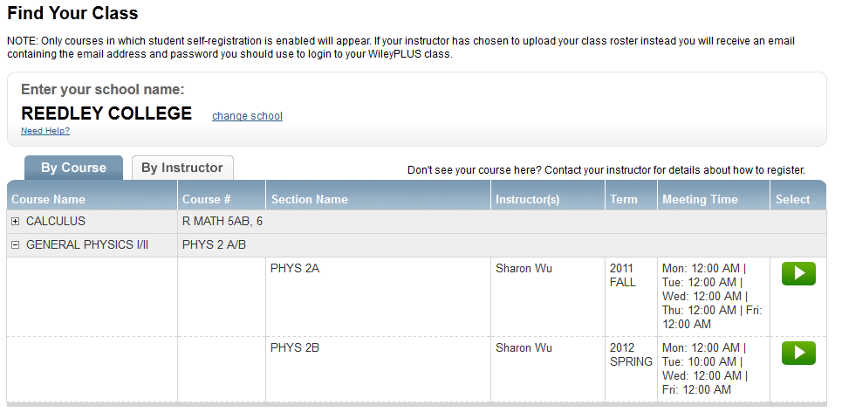

Or use following link: http://edugen.wileyplus.com/edugen/class/cls253917/

Homework Assignments:
Homework is assigned for each chapter on WileyPlus.

Laboratory:
This class has a lab that is mandatory. There are data sheets that you will need to complete as part of your lab activity that will be due at the end of the lab session. You are required to follow a number of safety precautions in the laboratory. You must read and sign the safety agreement before beginning of the first lab.

Tests:
There will be four tests and one final exam. The tests and final exam will have conceptual questions that are multiple choices and detailed physics problems that need to be solved. Early tests can be arranged with a very good reason. A more difficult late test can only be arranged if you have an excuse verified by an impartial party (i.e., a doctor or a court note).

Grading:
30% of the final grade points are from the average score of homework assignment
10% of the final grade points are from the average score of laboratory work
60% of the final grade points are from the average score of midterms and final.
Final grade is assigned using following scale:
90-100 % A 60- 69 % D
80- 89 % B < 60 % F
70- 79 % C
- If you have perfect attendance and your grade is within 1 point (or 1%) of the next higher letter grade, the instructor will award you the next higher letter grade.

Attendance (Also see Attendance Policy under Academic Regulations in Class Schedule):
Attendance will be taken at beginning of each class. Students, who leave the class before the end of class, will be counted as tardy. Two tardiness count as one absence. Your classmates and I would greatly appreciate that you take care of your personal needs (i.e., using the restroom, getting a drink…etc.) before the class begins.
Students will be dropped from the class if they fail to attend the first class session of the semester. During the semester up to final drop date, any student who missed more than two weeks of class meetings (cumulative) will be dropped from this class (12 hours of classes).

Student Conduct (Also see Student conduct under Campus Policies in Class Schedule):
Students are expected to conduct themselves in a responsible manner in the classroom. Specific rules and regulations have been established in Board Policy 5410. A copy of this policy is available in the college library, the Admissions Office, the Vice President of Student Services, the Vice President of Instruction’s Office, and in the Student Activities Office. Failure to adhere to the accepted standards will result in disciplinary action.

Accommodations for students with disabilities:
If you have a verified need for an academic accommodation or materials in alternate media (i.e., Braille, large print, electronic text, etc.) per the Americans with Disabilities Act (ADA) or Section 504 of the Rehabilitation Act, please contact me as soon as possible.

Plagiarism and Cheating Policy (See Cheating and Plagiarism under Campus Policies):
Cheating and plagiarism is prohibited in the class. Incidents of cheating and plagiarism will result a failing grade on the particular examination or assignment in question.

Canceled Class Notification:
Click on “Canceled Class Meetings” on Reedley College webpage (www.reedleycollege.edu) for class cancellations.

Important Dates:

Class begin | Monday | 01/07/2013
Last day to register | Friday | 01/25/2013
Last day to change to/from a Pass/No-Pass grading basis | Friday | 02/01/2013
Last date to drop this class | Friday | 03/08/2013
No classes:
Martin Luther King Jr. Day | Monday | 01/21/2013
Lincoln Day | Friday | 02/15/2013
Washington Day | Monday | 02/18/2013
Spring Recess | Mon - Fri | 03/25/2013 – 03/29/2013
Final Exam | Thursday | 05/16/2013  2:00 pm – 3:50 pm

