Reedley College Animal Science Program

Course Syllabus – Spring 2013

Course Number & Name: AS 1 – General Livestock Production |  |  |  | Section Number: 50306

Instructor Information:

Contact Information:

Jodie Brown
Phone/Voice Mail: 960.4930

E-mail: jodie.brown@reedleycollege.edu

Class Meets:  Lecture: Mondays & Wednesdays  11:00 – 11:50 am in AGR 2 |  | Lab: Mondays, 2:00 – 5:05 pm in AS Pavilion  (Note: Lab sessions of this course may periodically meet at off-campus sites.)
Holidays: Holidays will be observed as per the State Center Community College District Schedule.

Drop Deadline:
The last day for a student to drop this course is Friday, March 8th . After this date, the student must receive a grade.

Final Exam Date:
See Catalog

Prerequisites: None | Units: 3 (based on 2 hours lecture and 3 hours lab per week)

Text & Other Required Materials:  Introduction to Animal Science:Global, Biological, Social and Industry Perspectives, 4th edition, W. Stephen Damron, ISBN 9780136064442,  Publisher: Prentice Hall, Copyright: 2008  Notebook & writing utensil for both lecture and lab sessions. | 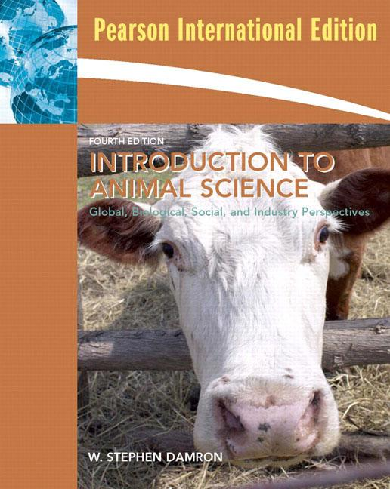
Supplemental References
Animal Industry Trade Magazines, Livestock Breed Magazines, Sire Directories, and numerous Internet Sites.

Method for Measuring Student Advancement and Determining Grades
The methods for measuring students' achievement & determining grades are:

Writing Assignment
Laboratory Reports

Computational Problem-solving
Homework Problems, Field & Lab Work

Skill Demonstrations
Class Performance, Field & Lab Work
Examinations
Multiple Choice, True/False, Matching, Essay

Grading Scale: A = 90-100%, B = 80-89%, C = 70-79%, D = 60-69%, F = under 60%.
The final grade will be determined from 25% class assignments & tests, 25% final exam, and 50% lab points.

Attendance Requirements:
Attendance is required since most of the learning occurs in a lecture/laboratory situation.
- Students are responsible for obtaining notes/information missed due to an absence from the instructor.
- Please notify the instructor if you know in advance that you will be absent from class.
- College policy dictates that an instructor should drop a student with two consecutive weeks of unexcused absences.
- At the end of the 9th week of instruction, no withdrawals are permitted and the student must receive a grade.
- Make up tests and assignments will only be allowed for emergency situations and pre-excused absences.

Behavioral Standards:
All students are expected to act in a mature, responsible manner that respects the rights of all other students, the instructor, and any guest presenters that may participate in the class. All cell phones and other electronic gadgets that may cause distraction are to be turned “off” during lecture and lab sessions.

Cheating & Plagiarism:
In keeping with the philosophy that students are entitled to the best education available, and in compliance with Board Policy 5410, each student is expected to exert an entirely honest effort toward attaining an education. Violations of this policy will result in disqualification for the course.

Accommodation Statement:
If you have a verified need for an academic accommodation or materials in alternate media (i.e., Braille, large print, electronic text, etc.) per the Americans with Disabilities Act (ADA) or Section 504 of the Rehabilitation Act, please contact me as soon as possible.

Course Description:
This course is a survey of the livestock industry, the supply of animal products and their uses, with a special emphasis on the origin, characteristics, adaptation, and contributions of farm animals to the agriculture industry. This course will analyze the economic trends and career opportunities in animal agriculture.

Lecture & Laboratory Topics:
See attached spreadsheets for lecture & lab topics, student assessment methods and respective point values.

Learning Objectives:

The student will:
- Describe animal contributions to human needs
- Identify common market classifications for economically significant species of livestock
- Apply safe and ethical animal handling techniques
- Judge and rank classes of livestock based on physical conformation and performance records
- Perform basic veterinary procedures commonly required in the livestock industry
- Evaluate career opportunities found in the livestock industry
- Apply knowledge of the fundamental differences and the respective nutritional requirements of the ruminant and non-ruminant digestive systems to the formulation of diets for livestock
- Identify the major breeds of beef cattle, dairy cattle, sheep, swine, and horses, and list their respective economically important traits
- Identify external and internal anatomical features of livestock using appropriate terminology
- Identify equipment, facilities, tools, and supplies commonly utilized in the livestock industry
- Evaluate meat animal carcasses in accordance with industry quality and yield grading standards
- Describe the major segments of the beef, sheep, swine, dairy, and horse industries
- Discuss major issues, trends, and challenges facing the livestock industry
- Collect and calculate data used to ensure scientifically-based management decisions

