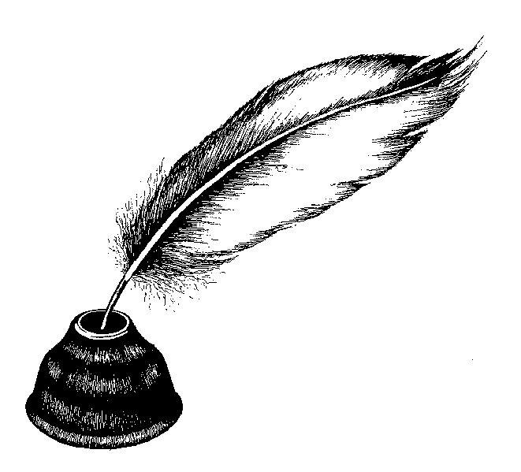

“Upgrade your grey matter, ‘cause one day it may matter.”

~ Del the Funky Homosapien
English 125
Writing Skills for College
MW 12:00PM-1:50PM
CCI 207
Fall 2011
Reedley College

Instructor: Drew A. Stutsman
E-mail: profstutsman@gmail.com
Office Hours: By appointment

Rationale:
In this course, students will develop the process of writing, revising, and finishing essays, which includes the logical development and organization of ideas. Students will avoid common writing errors, develop their writing skills by reading model essays and analyzing rhetorical strategies, develop critical thinking skills by matching the structures of writing to meaning and audience, and by using writing as thinking to explore and express ideas. This course is a companion to ENGL 126 and prepares students for ENGL 1A. Students must successfully complete written course work to receive credit.

Required Textbooks:

40 Model Essays: A portable anthology (Jane E. Aaron) Bedford/St. Martin 2005
·ISBN-10: 9780312438296
·ISBN-13: 978-0312438296

The Least You should know about English (Form A – 11th edition) (Paige Wilson & Teresa Ferster Glazier)
·ISBN-10: 9780495906339
·ISBN-13: 978-0495906339

Course Objectives:
At the conclusion of this course, the student will be able to:
1. Select interesting and appropriate topics.
2. Utilize the different phases of the writing process to enhance their writing.
3. Develop topics and ideas into short essays.
4. Write effective topic sentences.
5. Support and develop topic sentences with adequate, unified ideas.
6. Use appropriate transition devices to achieve coherence.
7. Select among and use appropriate methods of sequencing/ordering information.
8. Select among and use appropriate rhetorical strategies/methods of development for appropriate purposes and audiences.
9. Provide and use feedback to recommend and implement appropriate revision strategies.
10. Recognize and correct major grammatical errors.
11. Manipulate major punctuation marks.
12. Distinguish among commonly confused words and produce, in context, the correct one.

Course Work:
Reading Assignments: Please don’t con yourself into thinking that you can pass this class without doing the assigned reading. All reading assignments are to be completed by the date indicated. You will receive a suggested reading schedule for The Least You should know about English and 40 Model Essays: A Portable Anthology, but remember you are expected to complete the books by the date indicated in the forthcoming course schedule. Quizzes will also be given over the reading assignments.

Reaction Papers: Occasionally, I will assign reaction papers to chosen reading assignments and/or movies. This writing is informal, meaning that it will be your thoughts in an unformatted manner. Reaction papers should be about 500 words, typed and double-spaced. My hope is that your papers will be a jumping off point for class discussions. I am really interested in personal takes on certain issues and I encourage you flex your deconstructive muscles.

Essays: You will be required to write one (1) 500-word essay, two (2) 750 word and one (1) 1000 word essay. You will be given the opportunity to rewrite your first essay to improve your grade. To be considered for a grade all papers must be typewritten, double-spaced using a typewriter, word processor or computer. All papers must adhere to proper MLA format. All papers are due at the beginning of the class period on the date they are due unless otherwise indicated. I recommend that you bring your rough drafts to the tutor sessions. Mentors are also located at the Learning Center and their drop-in hours are posted on the door. Late papers will only be accepted one class period late and then dropped one (1) letter grade. No late paper will be accepted after this grace period is given and you will receive an F for the assignment. Being absent is not an excuse for a late paper unless you have spoken to me directly and received permission to turn the paper in late. The research paper cannot be turned in late under any circumstance.

Plagiarism and Cheating:
You are expected to do your own work at all times. Incidents of plagiarism and cheating will result in an F grade on that assignment and your name will be reported to the Dean of Instruction. You must always use the sources fairly in your papers and give proper credit according to MLA guidelines. If you are unsure of how to do this correctly, please speak to me before you turn in that final draft. I have a good eye for spotting a fake and I am well versed in using the Internet. Any paper that has undocumented material that is not cited properly will receive and F grade, with no exceptions.

Attendance Policy:
Congratulations, you're in college now. With that privilege comes the responsibility to attend class on a regular basis. If you want to be successful, all reading and writing assignments must be completed by the date specified. Your commitment to my class must include good attendance, punctuality, and taking the initiative to participate in classroom discussion. My policy is that you miss no more than three classes throughout the semester. You will still be responsible to make-up any assignment(s) you may miss. A good thing to do is to buddy up with someone in class, swap e-mail addresses and/or phone numbers. I will not respond to e-mails asking me about assignments missed. It is up to you to find out the assignments on your own. Because this class will focus on current issues in politics and society, I expect a large portion of each class session to be devoted to discussion. I expect you to not only to have done the reading prior to class but also the thinking for discussion. Thinking is a requirement for this class.

Free Writing:
At the beginning of each class you will free write. Free write is easy and only has one rule—Write for 10 minutes nonstop. Subject matter for free write will be topical and relevant to life in America today. You are required to have a notebook that will compile all of your free writes throughout the semester. I reserve the right to collect the notebooks at any point in the semester to check the integrity of the assignment. If you choose to write about your private life, it’s cool. Just write in the margin above the free write “Private” or “Mind your own business, Mr. Stutsman.”

Assignments:
All assignments are will be completed in your journal. Please don't miss class because you haven't done the assignment. The class time you miss will only dig the hole deeper, meaning that it will become more difficult to succeed in my class. The grades on late writing assignments will be reduced one letter grade for each school day the assignment is late. Papers turned in to my box will be considered late and dropped a letter grade as indicated in my policy.

Quizzes:
There will be several reading quizzes. You can expect a quiz after each reading assignment in Still Water Saints. Sorry, no make-up quizzes are allowed.

Workshop Sessions:
Workshop sessions will take place the class period before the due date for each paper. You will be given a questionnaire that will help you critique a classmate’s first draft. Workshops are critical to receiving a better grade on papers (I’ve seen some papers go up 2 grades just from participating in the activity). Critiques will be turned in with each paper, as well as a rough draft.

Requirements and Grades:
Essays: 70%
Participation: 15%
Quizzes/Free Writing: 15%

Class Rules:
- Be prepared for class. Bring your book, papers you are working on, notes, handouts, pens, pencils, etc.
- No talking to your neighbors while someone else is talking, including me. Chronic talkers will be invited to teach class for 10 minutes for zero (0) extra credit.
- All cell phones must be turned off upon entering class. Do not answer a cell phone during class. Do not look at your cell phone during class. Do not go outside to talk on your cell phone during class, unless you have talked to me ahead of time and you are expecting some type of emergency call, in which case you must use a vibrating function, sit in the back of class and quietly exit to take the call.
- If you come to class late, come in and sit down quietly. Do not ask your neighbor what we are doing. Do not come up to me to find out what we are doing. Wait until a break or until after class to find out what is going on.
If you don’t follow the above rules, or are disruptive in anyway, I will ask you to leave class for the day. If you continue to not follow the rules or to be disruptive, I will file a report with the Dean of Students. (You are disruptive if you are talking while we are doing class work, if you are doing other work besides the assigned task, if you do not follow directions, if you do not follow the above rules, if you use an inappropriate tone, etc.)
Other Tips and such:
- Keep a copy of all your work until the end of the semester.
- Maintain a progressive attitude – Positive people tend to have positive outcomes (and the opposite is true too).
- Showing up is not enough: It’s true that being present helps you to learn, but if you do not do the assignments, you will not pass.
- Turning work in is not enough: just doing the assignment does not warrant a passing grade. You need to be doing passing work to pass the class.
- If you stop coming to the class, be sure to drop. It is your responsibility to do so, not mine. Forgetting to do so could earn you an “F” as a final semester grade. Let me know if you are going to drop so that I don’t worry about you.

ACCOMMODATIONS FOR STUDENTS WITH DISABILITIES: Please inform me of any special circumstances you might have. If you have special needs as addressed by the Americans with Disabilities Act (ADA), including alternate media requests, please notify me immediately. Reasonable efforts will be made to accommodate your needs.

