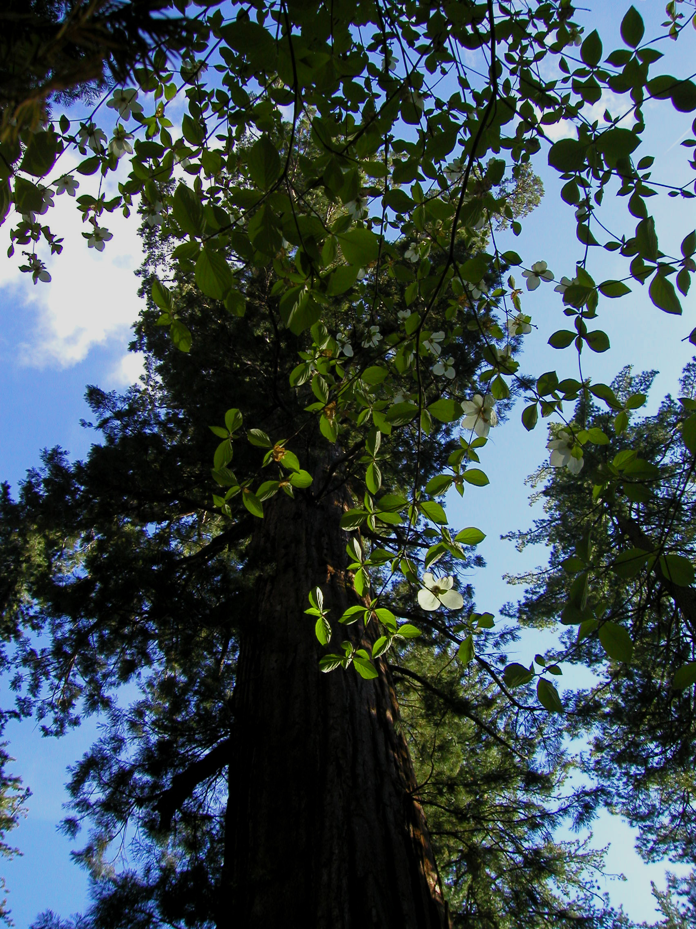
NR 25 – Forest & Resource Management
Reedley College – Spring 2009
Lecture 1:00-1:50 T, Room FEM 7

Instructor
Rob Cannell Office: FEM 4-F, Phone: (559) 638-3641, Ext. 3525
Office Hours: W 10:00-1100, Th 10:00-11:50 am
Email: robert.cannell@reedleycollege.edu

Course Objectives
This course will provide opportunities for research of management plans for public and private resource lands. The process through which land management plans are created will be explored. Emphasis will be placed on management of forests, applying skills, science, and knowledge to solve practical field problems.

Textbook (not required)
Davis, L.S., N.K. Johnson, P.S. Bettinger, and T.E. Howard. 2001. Forest management, 4th Edition. McGraw-Hill Co. Inc., New York, NY.

Classroom Conduct
Please turn cellular phones and pagers off during class time. Sunflower seeds and tobacco products are NOT permitted in the classroom or laboratory setting.

Accommodation Statement
“If you have a verified need for an academic accommodation or materials in alternate media (i.e., Braille, large print, electronic text, etc.) per the Americans with Disabilities Act (ADA) or Section 504 of the Rehabilitation Act, please contact me as soon as possible.”

.
Meeting Attendance

Throughout the semester you will be required to attend at least two meetings which deal with natural resources issues. Examples may include; city council meetings, federal public comment period, natural resources competition, forestry competition, SAF, and any other meeting deemed appropriate. At these meetings you will be required to attain verification of attendance and write a two page report summarizing the issue, major points covered, any decisions, the overall outcome, and your opinion. These assignments must be completed by the last day of class (May, 12th).

Participation and Grading Policy
Final grades will be curved based on a percentile of the highest point total in the class. Grades will be assigned based on a straight percentage system according to the following scale:

Course Grade | Cumulative Percent | Breakdown of Grades | Percentage
A | 90-100 | Reports | 10%
B | 80-89 | Meetings | 15%
C | 70-79 | Participation | 15%
D | 60-69 | Presentations | 20%
F | <59 | Two Midterm Exams | 20%
 |  | Cumulative Final Exam | 20%
 |  | TOTAL | 100%

LAST DAY TO DROP THE COURSE Friday, March 13th A LETTER GRADE IS ASSIGNED AFTER THIS DATE.

Tentative Schedule

Week Lecture Topic
1/13 Introduction/Forest Management

1/20 Management Plans

1/27 Multiple Use

2/3 NEPA

2/10 CEQA

2/17 Midterm Exam 1

2/24 People Management

3/3 Contracting Work

3/10 Policy & Law

3/17 Environmental Mitigation

3/24 Endangered Species

3/31 Midterm Exam II

4/7 Spring Break

4/14 Forest Management

4/21 Forest Management Planning

4/28 Ecosystem Management

5/5 Holistic Management

5/12 Review

5/19 1:00 – 2:50 pm Final Exam

