Circuits with Lab Spring 2009
Engineering 6
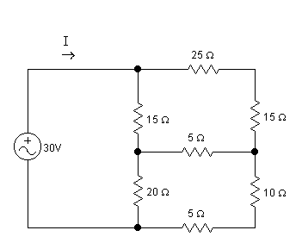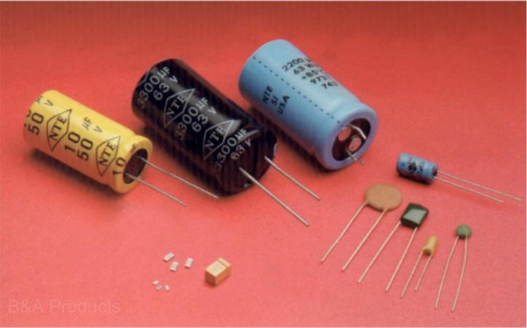

Instructor: Dr. John Heathcote Class Times: Lecture: MWF 11-11:50 pm SOC-32
Lab: Th 2:00-4:50 pm PHY-70/ LFS-C

Online Option: All lectures will be recorded and available
online. Online students are required to
attend the lab meetings.
Office: FEM – 4D

Phone: 638-3641 ext. 3215

e-mail: john.heathcote@reedleycollege.edu

Office Hours: Tuesday 12:00-12:50 pm
Wednesday 1:30-2:20 pm
Thursday 12:00-12:50 pm (in Math Center)

If you cannot make regular office hours, feel free to make an appointment.

Required Text: Fundamentals of Electric Circuits, 4th Edition, Alexander and Sadiku, McGraw Hill with ARIS
online access

Catalog Description: An introductory course emphasizing the solutions of the equations arising from the applications of Kirchhoff’s Laws and Thevinen’s Theorem to DC and AC circuits. Topics include mesh and nodal analysis, periodic forcing functions, phasors, frequency response, resonant circuits, natural and complete response, analog signal systems, dependent sources, and the characteristics of operational amplifiers.

Prerequisite: Physics 4B
Corequisite: Math 7
Advisories: Eligibility for English 125 and 126

Grading: 75% Tests
15% Online and Written Homework, Classwork and Quizzes
10% Laboratory Performance and Reports

Grading Scale: A: 90-100%
B: 80-89%
C: 70-79%
D: 60-69%
F: <60%

Tests: There will be five tests given during the term. The tests will be given during a lab period. Some of the tests cover the most recent chapters and some are comprehensive. Some of the tests may have a lab component during which you will be asked to individually perform lab activities.

Homework: Homework will be assigned in order to practice the problem-solving skills taught in class. There will be both online and written assignments. The online homework will be submitted using the ARIS online course management system. Written assignments will also be required. To receive full credit, the assignments should be performed neatly and submitted on time. Draw the circuit diagrams for each problem.

Class Work and Quizzes: Group work problems may be assigned and completed at the beginning of some lab periods. These will be problems related to homework problems to further students’ understanding and practice problem-solving skills. Quizzes may also be given occasionally.

Laboratory Performance and Reports: This course includes a laboratory section during which we will perform experiments to complement the coursework for the class. The laboratory grade will be based on performance during the lab experiment and some required written reports. Grades for laboratory reports may be based on the quality of your experimental work, the analysis of the experiment, the accuracy of your experimental calculations, and your ability to set up circuit equipment.

Late Work and Make-up Tests: Homework and laboratory reports should be submitted on time. If there is a valid reason that the work must be turned in late, please inform the instructor ahead of time. Otherwise, late work will not receive full credit. Make-up tests will only be arranged upon prior approval. If you will know that you will miss a test, you MUST let the instructor know beforehand. If you are sick on the day of a test, you must call the instructor on that day.

Attendance: Attendance at the lab sessions is mandatory. Class attendance will be recorded. If you miss more than two (2) lab sessions, you may be dropped.

Make-Up Labs: If you must miss a lab session and want to make up the points, you will need to make up the laboratory work at another time. You will have to work around the instructor’s schedule in order to find a time when he can supervise the laboratory work.

Add Date: Friday, January 30th Last day to add a course
Drop Date: Friday, March 13th Last day to drop this course
Holidays: Monday, January 19th Martin Luther King Jr. Day
Friday-Monday, Feb. 13-16th Presidents’ Day Holidays
Monday-Friday, April 6-10th Spring Recess Holidays
Final: Monday, May 18th 11:00 am Last test of semester will be given during exam period
(Alternate times for final exam will be given if necessary)

Accommodations for Students with Disabilities:
If you have a verified need for an academic accommodation or materials in alternate media (i.e., Braille, large print, electronic text, etc.) per the Americans with Disabilities Act (ADA) or Section 504 of the Rehabilitation Act, please contact me as soon as possible.

Blackboard Course Site:
A Blackboard course website is set up for this course. You can look here for class notes, assignments, schedules, or posted solutions. You can also access the Tegrity website from here, which allows you to view recorded lectures. It can be accessed via the Blackboard link on the Reedley College home page. Your user name is your seven digit student number. If you have never changed it, your password is the same.

Lecture/Lab

Schedule (subject to change):

Week 1 | Chapters 1 and 2 | Introductory Lab
Week 2 | Chapters 2 and 3 | Unknown Resistance Lab
Week 3 | Chapters 3 and 4 | Voltage Divider Lab
Week 4 | Chapter 4 | Test #1
Week 5 | Chapter 4 | Linearity and Superposition Lab
Week 6 | Chapter 5 | Op Amp Lab
Week 7 | Chapters 5 and 6 | Non-Inverting Amp Lab
Week 8 | Chapter 6 | Test #2
Week 9 | Chapter 7 | Energy Storage Lab
Week 10 | Chapters 7 and 8 | First Order Circuits Lab
Week 11 | Chapter 8 | Second Order Circuits Lab
Week 12 | Chapter 8 | Test #3
Spring Break
Week 13 | Chapter 9 | AC Circuit Lab
Week 14 | Chapter 10 | AC Circuit Lab
Week 15 | Chapter 11 | Test #4
Week 16 | Chapters 11 and 12 | Black Box Lab
Week 17 | Chapter 12 | Soldering Lab
Week 18 | Finals Week | Test #5
COURSE OUTCOMES:

Upon completion of this course, students will be able to:

- Determine unknown electrical quantities using the basic v-i characteristic equations of electrical components.

- Solve DC circuit problems using a variety of analytical techniques.

- Solve AC circuit problems using phasor methods.

- Solve steady-state AC power problems.

- Use basic electrical test and analysis equipment in a laboratory setting.

- Plan, execute, and write reports for laboratory experiments.

COURSE OBJECTIVES:

In the process of completing this course, students will:

- Derive and use the v-i (voltage-current) characteristic equations for resistors, operational amplifiers, and independent and dependant power sources.

- Solve DC electrical circuit analysis problems using Kirchhoff’s voltage and current laws.

- Apply series and parallel resistor theorems.

- Apply current and voltage division theorems.

- Solve DC electrical circuit analysis problems using the analysis techniques of mesh current and node voltage.

- Solve DC electrical circuit analysis problems using the analysis techniques of superposition, Thevenin’s Theorem, and Norton’s Theorem.

- Derive and use the v-i characteristic equations for energy storage devices (capacitors and inductors).

- Solve first order circuit problems involving energy storage devices (both natural and forced response problems).

- Solve second order circuit problems involving energy storage devices (both natural and forced response problems).

- Learn and use phasor analysis techniques for solving AC steady-state circuit problems.

- Apply KVL, KCL, node voltage, mesh current, Thevenin’s Theorem, Norton’s Theorem, and superposition analysis techniques to solve AC steady-state circuit problems.

- Calculate power quantities in AC steady-state circuit problems using the appropriate equations and the power triangle.

- Calculate electrical quantities in three-phase AC electrical circuits.

- Learn to competently use electrical laboratory test and analysis equipment.

