Graphics Spring 2009
Engineering 2
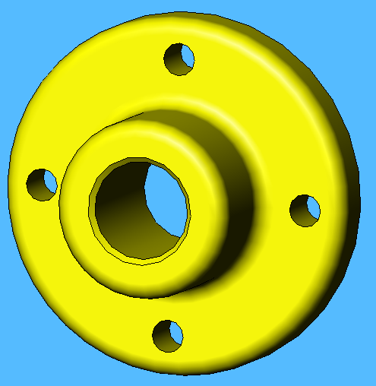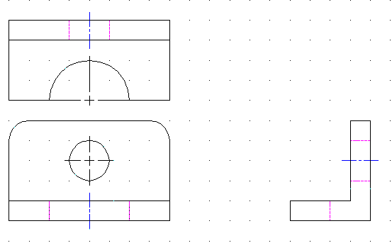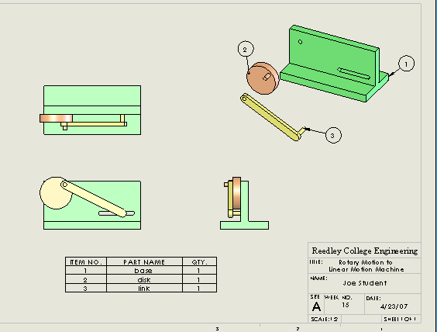

Instructor: Dr. John Heathcote Class Times: Lecture: W: 2:30 pm - 4:20 pm
Labs: Online

Office: FEM – 4D Room: FEM-4E

Phone: 638-3641 ext. 3215

e-mail: john.heathcote@reedleycollege.edu

Office Hours: Tuesday 12:00-12:50 pm
Wednesday 1:30-2:20 pm
Thursday 12:00-12:50 pm (in Math Center)

If you cannot make regular office hours, feel free to make an appointment.

Prerequisites: Math 102 and 103
Advisories: Math 4A, eligibility for English 125 and 126

Required Text: Introduction to Solid Modeling using SolidWorks 2008, William Howard and Joseph Musto, McGraw Hill. (A download code for the student version of the software comes packaged with the text.)

Suggested Supplies: Memory stick for storing computer files

Online Labs:
When taught in the traditional style, this class involves 6 hours of lab time each week in order to do the CAD and solid model drawings. In the online-lab style, you are responsible to create your drawings on your own time. The lab assignments will be stated during class and posted online. A Blackboard course website is set up for this course. You can look here for class notes, assignments, and schedules. You will also submit work electronically at this site. It can be accessed via the Blackboard link on the Reedley College home page. Your user name is your seven digit student number. If you have never changed it, your password is the same.

Weekly Schedule:
Even though we will meet only once a week, this class is being organized like a three-day-a-week class. There will be three lesson/assignment combinations each week. The first one will be our meeting time on Wednesday afternoon. I will give some instruction and then each student will perform a short lab in class. Then, there will be two online lesson/assignment combinations the rest of the week. The deadlines for each assignment will be clearly stated. Some instruction may be posted as well, in the form of written notes or streaming video.

Access to Computer for Drawing Labs: The computer drawings for weekly labs will be done on either SolidWorks or DWGeditor. Both of these programs come with the textbook. Students can perform the drawings on their own computer or in one of the computer labs on campus. SolidWorks is available in FEM-4E and on select computers in the library computer lab.
Catalog Description: The principles of orthographic drawing, pictorial drawing, and descriptive geometry and their application to the visualization, representation, analysis, solution, and documentation of engineering problems, using freehand sketching and computer-aided drafting. CAD problems will involve two-dimensional multiview drawings and three-dimensional wire frame and extruded solid models.

Grading: Lab Assignments: 40%
Two skills tests: 30%
Two projects: 30%

Grading Scale: A: 90-100%
B: 80-89%
C: 70-79%
D: 60-69%
F: <60%

Lab Assignments: Each week, students must perform drawing activities to learn and practice concepts and techniques in engineering graphics. These drawings will be turned in each week (either electronically or on paper) and reviewed by the instructor. Assignments should be turned in on time in order to get full credit.

Lab Grades and Corrections: Every lab drawing/activity will be graded based upon accuracy and meeting the deadline. If you turn in your file on-time, you will have the opportunity to correct mistakes and improve your grade. If you do not turn in your file on-time, you will not receive full credit on the assignment nor will you be able to make corrections.

Skills Tests: Two skills tests will be given during the term. These tests will be held during the regular class period. These will involve computer skills and understanding of engineering graphics concepts.

Projects: Engineering drawings are used in many types of applications, so each student will perform projects that apply the concepts of the course toward solving engineering problems.

Cheating and Plagiarism: All work is to be done by each individual student. Any act involving submission of work that is not your own (this could involve copying files from another student or any other act of deception) will result in penalties to all students involved. These penalties may include a failing grade on that assignment, failing grade for the course, and/or referral to the vice president of student services.

Accommodations for Students with Disabilities:
If you have a verified need for an academic accommodation or materials in alternate media (i.e., Braille, large print, electronic text, etc.) per the Americans with Disabilities Act (ADA) or Section 504 of the Rehabilitation Act, please contact me as soon as possible.

Attendance: Class attendance will be recorded. If you miss more than two class sessions, you may be dropped. Course withdrawals, however, are ultimately the responsibility of the student.

Add Date: Friday, January 30th Last day to add a course
Drop Date: Friday, March 13th Last day to drop this course
Holidays: Monday, January 19th Martin Luther King Jr. Day
Friday-Monday, Feb. 13-16th Presidents’ Day Holidays
Monday-Friday, April 6-10th Spring Recess Holidays
Final: Wednesday, May 20th 2:00 pm Final projects will be presented during exam period
COURSE OUTCOMES:

Upon completion of this course, students will be able to:

- graphically represent three-dimensional objects using accepted engineering practices.

- communicate graphically using computer tools and freehand sketching.

- solve technical design problems using computer-drawing software.

- apply the technical graphics principles to the solution of engineering problems.

COURSE OBJECTIVES:

In the process of completing this course, students will:

- use computer-drawing software to geometrically construct two-dimensional shapes.

- use computer-drawing software to construct multi-view orthographic projections of three-
dimensional objects.

- create auxiliary and sectional views of objects.

- use proper dimensioning and tolerance techniques to fully define an object.

- demonstrate proficiency at freehand technical sketching.

- use computer-drawing software to create three-dimensional wire-frame and solid models.

- design solutions to engineering challenges by use of engineering drawings.

- apply the principles of orthographic projection, isometrics, and descriptive geometry to the
solution of engineering problems.

Course Schedule (Subject to change):

Week #: | Topics:
1 | Computer Skills, SolidWorks Part Modeling
2 | SolidWorks Part modeling, using relations
3 | 2D Constructions
4 | More 2D Constructions
5 | Multiview Drawings
6 | More multi-views; creating part from multi-view
7 | SolidWorks Drawing Files,  Dimensioning Techniques
8 | Additional Part Modeling Techniques
9 | Test #1, Project #1 Due
10 | Chaps 4 and 5: Parametric models
11 | Auxiliary Views
12 | Auxiliary Views and Developments
13 | SolidWorks Assemblies
14 | Modeling Mechanisms, Animating Assemblies
15 | Advanced Assemblies,  Assembly Drawings
16 | Extra Time
17 | Test #2
18 | Project Presentations

