English 125: Writing Skills for College

Reedley College, Reedley, 2009

Instructor: Elizabeth Martin
Office / Phone: TBA
E-mail: martinelizabeth60@gmail.com
Office Hours: By appointment
Course Information: English 125, Section 53836. POR-2, T-TH, 2:00pm-3:50pm.

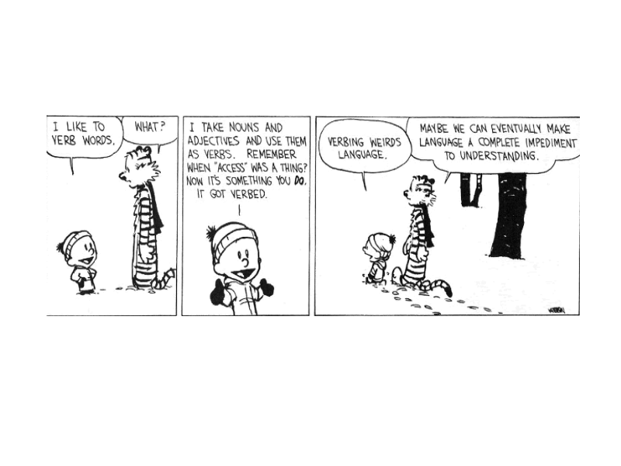
Course Overview

This course focuses on the development of the process of writing, revising, and finishing short papers, including the logical development and organization of ideas. It emphasizes avoiding common writing errors; develops writing skills by reading model essays and analyzing rhetorical strategies; and develops critical thinking skills by matching the structures of writing to meaning and audience. In this class, we’ll start thinking about writing as a way of thinking about, exploring and expressing ideas.

General English 125 Objectives

Reading critically and fluently discussing what we read are two important parts of this class, but not a complete picture. Here are some of the goals you will be expected to meet to be successful in 125. You will learn how to:

- Pre-write constructively to generate ideas and determine ideas, opinions, positions, and ultimately theses and plans
- Respond to a prompt quickly and independently
- Write a developed essay with a clear thesis and support
- Write with some sophistication: introduction should be more than a thesis; a conclusion should be more than a summary; an essay should have ample substance
- Plan and revise fairly independently employing all stages of the writing process as necessary and appropriate
- Recognize and revise common errors such as problems with comma splices throughout a piece
- Construct idiomatically correct sentences although there may be an “accent” resulting from a consistent type of ESL error
- Use a variety of rhetorics and structures, including documented sources
- Use MLA style with some guidance to set up papers and document sources

Required Texts, Materials and Expenses

- Beason, Larry and Mark Lester. A Commonsense Guide to Grammar and Usage, 5th ed. New York: Bedford/St. Martin’s, 2009.
- Moore, Alan and Dave Gibbons. Watchmen. New York: DC Comics, 1987.
- Kirszner, Laurie. Patterns for College Writing. 11th Edition. Boston: Bedford St. Martin’s, 2009.
- A College Dictionary.
- A spiral notebook for notes and annotations.
- A portfolio (two pocket folder), AND a folder to keep all of your work for the course, paperclips, a stapler
- Money set aside to copy individual writing projects for workshopping.

About the Course

Writing Assignments
Writing is not just a demonstration of one’s ability to write. Writing is a tool, a strategy for generating ideas, for analyzing information, for inventing responses, critiquing your own thoughts, or creating a record of your thinking. In this class writing will serve many purposes. Consequently, you will be asked to write for many different reasons. Your writing will not simply be a reflection of your competence, it will be a representation of your engagement in the class.

You will do shorter writing assignments, such as summary-analyses and focused freewrites. You will also compose four longer essays that will be fodder for your portfolio, and subject to two or three revisions. Writing assignments will all engage in some way with what we read. As you learn new strategies and techniques for writing, it is important to incorporate them into your projects. Learning in this class is cumulative.

Specifications: All writing assignments (done outside of class) must be formatted with one-inch margins with a twelve-point font (you have to change the margins on a Word document—it defaults to 1 ½ inches). The length of these writing projects will vary. An author’s note must be included when a writing project is turned in. You will need to bring copies for the other members of your workshop group and an author’s note each time we do workshopping.

Some of the kinds of writing we will do are:

Essays, in which you will explore ideas in a way that does not, necessarily, follow
a formula, but does incorporate various rhetorical moves that you will use deliberately, again with consideration to your audience.

Freewrites: A sort of informal writing to explore a certain topic. The purpose of a freewrite is to get your thinking about a certain reading or group of readings down on paper, to generate class discussion, or to prepare to write something more formal.

Reading

For this class (and probably for most of the classes for the rest of your academic career) you will be expected to read actively and critically. In more concrete terms, that means that for nearly all of your reading assignments I will require some form of annotation, either notes in the margin or a double-entry journal. You will be expected to talk about the reading in class, write summaries of the reading, and take quizzes over the reading. In short, if you don’t read, or you fail to read actively, you will be lost and unable to participate in class or do your assignments. Being sure to keep up with the reading is important because everything else you do for the class depends on how much and how closely you have read.

Annotation: is done in the margins of the book itself, or in a notebook kept for such a purpose (if you just can’t bring yourself to write in a book) and consists of questions, lists of ideas in a chunk of reading, gut reactions, etc. I will frequently check to see that you are annotating the reading.

Summary/Analyses, not just a way to show me that you read the text, but summary should be an accurate communication of the literal meaning of the reading which takes into account the author of the text’s purpose, audience, and genre. The second move in this assignment is analysis, where I will be looking for your ability to think about how the writing functions as a text, and your ability to make connections between the writing and your experiences

Small Group, Class Discussions, and Workshops

Class participation is mandatory and will be a necessary part of your success in this class. Therefore, you will need to come to class prepared with homework done and ideas to share – everyday. Graded class participation will include small group work, small group workshopping, online workshops, and large group discussions. In order to get points for these activities, you must be A: Present, and B: Actively participating. If you’re shy about sharing ideas in class, please come see me and we can discuss some strategies that may be helpful for you.

Workshopping is an important component to this class. Workshopping gives you the opportunity to get audience feedback on your writing; workshops are also an opportunity to get ideas for approaching various writing tasks, to understand the range of rhetorical components – besides grammar – that are available for revision, and finally to assess a piece of writing for it’s rhetorical effectiveness. Participating in these workshops will help you to read and revise your own work with more fluency and expertise.

Blackboard

Every so often, instead of coming to class physically, we might have an electronic class on Blackboard. This class could consist of a group workshop, in which members of a group post and respond to one another’s project, or a class discussion with the electronic submission of homework.

To be able to deal with the sometimes inconsistent nature of technology, I would encourage you to write your workshopping responses in a word processing program, save it to disk, and then PASTE that work into the text field on Blackboard. If you’re having a technical problem with Blackboard, though, I encourage to try and solve it. Call tech support. Contact your classmates. Wait a few hours and try again. Try it on a different computer. Email me and let me know you’re having difficulty. Ultimately, the responsibility for participating in the Blackboard class is yours, even if the server or your computer is being difficult.

Resources

The Writing Center is a great resource for feedback on essays on a drop-in basis. This gives you an outside “expert” opinion other than mine, which gives you a broader sense of your audience.

I do, however, encourage you strongly to enroll at The Writing Center. That way, you will have support year-round on each and every project, and a tutor you can always turn to for tips, tricks, advice, and strategies. (Also, I offer some extra credit for enrollment in the Writing Center).

Evaluation

Your final grade will – first of all – depend on meeting the requirements of the course (see below). After the requirements of the course have been met, the percentage of work accomplished will be figured to get your final grade. Failure to meet any of the requirements of the course listed below may cause the student to receive a failing grade for the class.

Requirements for the course
1. All four writing projects must be attempted
2. 4 absences or less
3. Turn in portfolios on time (Late portfolios will not be accepted)
4. Participation – every day – in class and on-line
5. No more than eight missed assignments.

In addition, final grades will be based on the following:
Participation: activities, quizzes, shorter writing 50%
Drafts 20%
Final Portfolio 30%

Grading Scale
90-100% A
80-89% B
73-79% C
64-72% D
0-63% F

Portfolios – 30%
A portfolio is a collection of your written work over time. As an evaluative tool, the portfolio will be a representation of your best work and your growth as a writer over the semester. At the end of the semester, you will turn in a portfolio. I will grade this portfolio based on criteria found in the rubric that we will discuss as a class. I will pass this rubric out to you later in the semester.

Drafts- 20%
I will respond to the drafts of writing projects you turn in to me, and give you points. They are worth 25 points a piece, but these points are given not necessarily for quality of writing, but for effort, following the directions I gave you for the assignment, and turning it in on time. The only time that your writing will be graded on terms of quality is at the portfolio readings—I will give you feedback, but that feedback will not determine the amount of points you get.

You can keep track of your grade by keeping track of the points I give you on your assignments. In this way, you can anticipate what kind of portfolio grade you need to get to receive the grade you desire for the class.

Class Participation– 50%

This part of your grade includes shorter writing assignments, exercises, discussion participation, workshopping, quizzes, and other activities that you do as part of the community of learners. As we will do a lot of group work, and as you will all depend on each other for feedback and learning in this classroom, it will be important for everyone to come to class prepared, willing to participate in class discussions or small group work, and ready to take risks in responding to the opinions and work of others -- every single day.

Specifically, “class participation” includes writing and reading assignments done for class, being prepared to participate – and participating—in class discussion and group work, coming to conferences, and being willing – and able – to help others, being respectful of learning and inquiry, as well as being open to learning new things.

Late Assignments

Late work will not be accepted, not even if you were absent the day the work was assigned or the day that it was due. Larger assignments can be emailed on the day they are due, but they must be sent by the time class ends on that due date. One or two smaller assignments (the work that constitutes your participation grade) will not decimate your grade, so I feel this policy is fair—your grade would only suffer from this policy if you are chronically absent or chronically late turning in work. You may not make up work done in a class you have missed unless we have discussed the matter and reached an agreement about it.

Attendance

Since we do a lot of in-class writing and discussion, good attendance is mandatory. If you have more than 4 absences, you will be dropped from the course. Coming late to class is distracting to both the students and the instructor. Please try to show up on time for every class meeting. Any early departure from class or tardy greater than ten minutes is counted as an absence.

Please note: If you are absent from class, it is your responsibility to check on announcements made while you are away. It is also your responsibility to make sure that are counted “present” if you are tardy.

Religious Observances

Students who will be absent from class due to religious observance must provide notice of the date(s) to me, in writing, by the end of the second week of classes.

Policies

Students with Disabilities
If you have a verified need for an academic accommodation or materials in alternate media (i.e., Braille, large print, electronic text, etc.) per the Americans with Disabilities Act (ADA) or Section 504 of the Rehabilitation Act, please contact me as soon as possible.

Cheating and Plagiarism (as defined in the RC handbook)
Bottom line: do not copy someone else’s words or ideas without giving them credit. Do not use another student’s paper as your own. Do not use a paper you wrote from another class in this class. Do not have another person write the paper for you. All of these are forms of cheating. You will receive a zero on the assignment and a report will be filed with the administration for their review.

Dropping the Class
If you choose to withdraw from the class, please keep in mind that it is your responsibility to drop from the course before the final day to drop. If you do not drop yourself and simply stop attending the class, you may earn an F in the course. That said, I may drop people so that others may join the class. If you do not attend the first week of class, you may be dropped. If you attend the first day, but not the next two classes, I will assume that you are not interested in taking the course, and may drop you then as well.

Computer Requirements
Skills Needed:
- Familiarity with computers (knowing where the power switch is located, for example)
- Know the basics of word processing (saving files, using spell check, moving text, using the help function, etc.) . (See the “Word Processing Formats” section below).
- Know how to access the Internet and navigate the Internet (use a browser, utilize search engines, save and print from the Internet)
- Know how to send e-mail and e-mail with attachments. (See the “E-mail” section below).
- Have some familiarity with Blackboard. We will be using Blackboard as part of our classroom. Our Blackboard site contains documents, announcements and other information needed for our course; in addition, Blackboard allows for e-mailing and online discussions. There are various tabs to the left of the screen in Blackboard. These tabs lead you to necessary and supplementary documents, to all assignments and schedules, and more. You can access our Blackboard directly from the Reedley College Website (click on the “Blackboard” link found under the “Distance Learning” link; or in the “Quick Links” pull-down menu).

Hardware Needed:
- Pentium (PC) or Mac equivalent
- Home Internet access is desirable. You can use the computers on campus; however, they are not always available, so you will need to find out when each lab is open and available for drop-in use. You should also know if your local library has computers available with Internet access. If your home computer crashes, is in need of repair, or you lose Internet access, you must find an alternative way to complete the required work on time for this class. This means, of course, that you need to constantly back up the work from your hard drive to a disk, flash drive, or other moveable source.

Disruptive Classroom Behavior

Certain behaviors during class will not be tolerated for the sake of our learning environment; I reserve the right to ask you to leave the class with an absence if you are disruptive of other’s learning. Disruptive behavior includes (but is not limited to) talking, passing notes, arguing, sleeping during class, working on assignments for our class or other classes other than the one being covered in class at the time, receiving cell phone calls during class, text messaging during class, having your cell phone on your desk, not having the materials needed for class, or having your head on your desk. The first time a student violates these rules, he will receive a verbal warning from the teacher. The second time (and any time thereafter), the student will be dismissed from the class with an absence.

Important Dates

A more detailed schedule will be posted on Blackboard soon. In the mean time, please skim this list of due dates to be sure that you don’t have any conflicts or concerns with the semester ahead.

Tues. Sept 1
Draft 1 of Paper #1
Whole Class Workshop

Thurs. Sept 3
Small Group Workshop for Paper #1

Tues Sept 8
Draft 2 of Paper #1
Pass out Prompt #2

Tues Sept 22
Draft 1 of Paper #2 Due
Whole Class Workshop

Tues Sept 29
Draft 2 of Paper #2 Due
Pass out Prompt for Paper #3

Thurs Oct 22
Paper #3, Draft 1 Due
Small Group Workshop

Tues Nov 2
Paper #3, Draft 2 Due

Thurs Nov 5
Pass out Prompt for Paper #4

Tues Nov 24
Draft 1 of Paper #4 Due
Group Workshop

Thurs Dec 3
Mock Portfolio Reading

Tues Dec 7
Portfolios Due

