Syllabus for Biology 3
Biology, an Ecological Approach

Instructor:

Gary W. Potter (e-mail GWPOTT@aol.com), Please include Biol. 3 in the subject line or I will not open your e-mail!

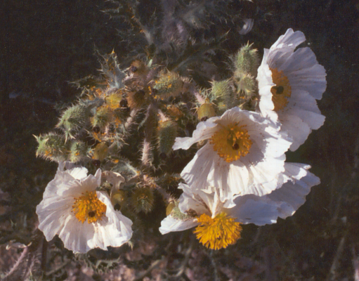
Meeting Times:

Monday & Wednesday, 6:00 PM until 8:15 PM.

Holidays:

January 16: Martin Luther King, Jr. holiday
February 17--20: President's Day holiday
April 10--15: Spring Recess

Midterm Exam Dates:

6 weeks: Wednesday, February 15, 2006.
12 weeks: Wednesday, March 29, 2006.

Final Exam Date:

Monday, May 15, 2006.

Other Important Dates:

January 27: Last day to register for or drop a Spring 2006 full-length class to avoid a "W".
March 2: Last day to apply for scholarships and Cal Grants.
March 10: Mid-term grade report.
March 10: Last day to drop a Spring 2006 full-length class without a letter grade.
March 20: Registration for continuing students begins for Summer or Fall, 2006.
March 31: Last day to file intent to graduate.
May 19: End of semester, Commencement Exercises.

Course Description:

Biology 3 is a 4 unit biology course with an ecological approach. It is designed to meet graduation and transfer requirements for laboratory science class for non majors.

Required Materials:

1. Textbook: Tobin, A., Asking About Life, 3rd edition (2000) Brooks/Cole Publishing.
2. Hard cover composition book (available at bookstore) or 3 ring binder.
3. Text: Sierra Nevada Natural History, revised ed. Storer, T., Usinger, R., & Lukas, D. Univ. of California Press. 2004.
4. Biology Drawing Paper, one 4H and one 2H pencil, for lab plates
5. Camera – for field trips
Course Outline (With reading assignments):

Week Lecture & Lab. Topics.

1 Lecture: About Plant Biology, Biological Methods and Concepts. (Chapter 1)
Lab. 1: What is life? Observation and Interpretation.
Lab. 1 A: Importance of Plants to Humans.
Lab. 1 B: The Metric System

2 Lecture: Introduction to Chemistry & The Chemistry of Life. (Chapter 2)
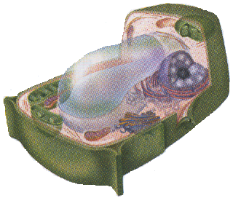
Lab. 2 B: The Microscope.

3 Lecture: Cell Structure and Function. (Chapter 3)
Lab. 3 A: Diffusion & Osmosis
Lab. 3 B: Cell Cycle

4 Lecture: Plant Cells and Tissues. (Chapters 3 & 4)
Lab. 4: Tissues

5 Lecture: Roots, Stems, & Leaves. (Chapters 5, 6, & 7)
Lab. 5: Plant Organs

6 Lecture: Introduction to Flowers, Fruits, and Seeds.

Midterm Exam: Wednesday, September 21, 2005.

7 Lecture: Plant Growth and Development. (Chapter 11)
Lab. 6: Plant Growth and Development

8 Lecture: Plant Metabolism (Photosynthesis & Respiration). (Chapter 10)
Lab. 7: Plant Metabolism.

9 Lecture: Introduction to Genetics (Mendelian Genetics, DNA and the Genetic
Code. (Chapters 12 & 13)
Lab. 8: Genetics, Meiosis, & Life Cycles.

10 Lecture: Plant Classification & the Monerans. (Chapters 16 & 17)
Lab. 9: Kingdom Monera (Archea and Bacteria)

11 Lecture: Kingdom Protista & Kingdom Fungi (Chapter. 18 & 19)
Lab. 10 A: Kingdom Protista.
Lab. 10 B: Kingdom Fungi.

12 Lecture: Introduction to the Plant Kingdom, Alternation of Generations, and the
Bryophytes. (Chapters 20 and 12 (part))

Midterm Exam: Wednesday, November 2, 2005.

13 Lecture: Seedless Vascular Plants (Chapter 21).
Lab. 11: Kingdom Plantae: Bryophytes and Tracheophytes.

14 Lecture: Introduction to Seed Plants: Gymnosperms (Chapter 22)
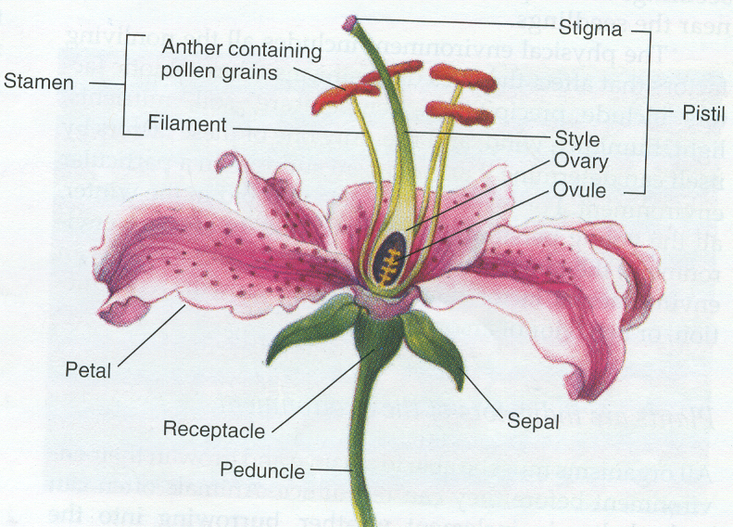
Lab. 12: Gymnosperms

15 Lecture: Seed Plants: Angiosperms. (Ch. 23)
Lab. 13: Flowering Plants

16 Lecture: Flowers and Plant Reproduction: Sporophyte and Gametophyte in the
Angiosperms, development of fruits and seeds.
Lab. 14: Fruits and Seeds

17 Lecture: Plant Ecology: Climate, Biomes, and Plant communities. Review for
Final Exam.
.
Final Exam: Monday, December 12, 2005.

Expectations: You are expected to attend all class sessions. Two or more absences from laboratory periods and four absences from lecture periods will very likely put you in jeopardy of failing. Unless there are extenuating circumstances, such absences may also get you dropped from the course. You are responsible for finding out what you missed and for making up missed work due to absence. Each exam will consist of a 100 point written section and a 30 point laboratory practical exam.

Grading: Your grade will be determined by using an accumulative point total of all laboratory reports, quizzes, and exams. Quizzes and Lab Reports are worth 10 points each, the written exams are worth 100 points each, and the laboratory practical exams are worth 30 points each. Extra credit will be limited to a few bonus questions on tests and an occasional special quiz or assignment. Extra credit will not be given for any other work! At the end of the semester, your accumulated point total will be divided by the total number of points possible to determine your percentage grade. Your final letter grade will be determined using the following grading scale:

90% to 100% = A
80% to 89.9% = B
70% to 79.9% = C
60% to 69.9% = D
0% to 59.9% = F

Grades will not be rounded! 89.99999999% is a B+ not an A-!

