Circuits with Lab Spring 2008
Engineering 6
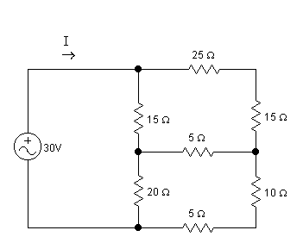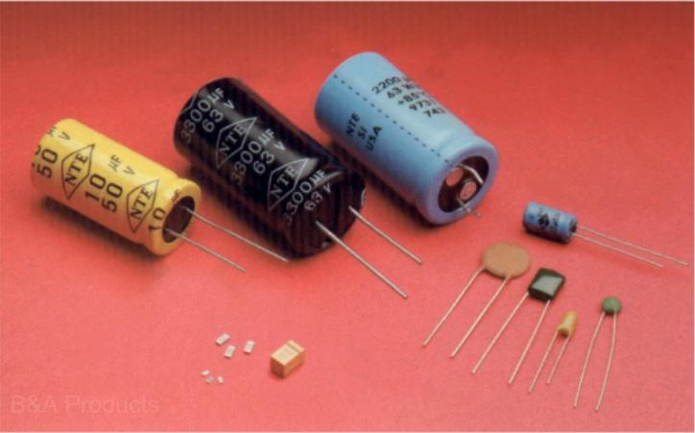

Instructor: Dr. John Heathcote Class Times: Lecture: MWF 11-11:50 pm PHY-70
Lab: Th 2:00-4:50 pm PHY-70

Online Option: All lectures will be recorded and available
online. Online students are required to
attend the lab meetings.
Office: FEM – 4D

Phone: 638-3641 ext. 3215

e-mail: john.heathcote@reedleycollege.edu

Office Hours: Tuesday 1:00-1:50 pm
Wednesday 1:30-2:20 pm
Thursday 1:00-1:50 pm

If you cannot make regular office hours, feel free to make an appointment.

Required Text: Fundamentals of Electric Circuits, 3rd Edition, Alexander and Sadiku, McGraw Hill

Catalog Description: An introductory course emphasizing the solutions of the equations arising from the applications of Kirchhoff’s Laws and Thevinen’s Theorem to DC and AC circuits. Topics include mesh and nodal analysis, periodic forcing functions, phasors, frequency response, resonant circuits, natural and complete response, analog signal systems, dependent sources, and the characteristics of operational amplifiers.

Prerequisite: Physics 4B
Corequisite: Math 7
Advisories: Eligibility for English 125 and 126

Grading: 75% Tests
15% Homework, Classwork and Quizzes
10% Laboratory Performance and Reports

Grading Scale: A: 90-100%
B: 80-89%
C: 70-79%
D: 60-69%
F: <60%

Tests: There will be five tests given during the term. The tests will be given during a lab period. Some of the tests cover the most recent chapters and some are comprehensive. Some of the tests may have a lab component during which you will be asked to individually perform lab activities.

Homework: Homework will be assigned in order to practice the problem-solving skills taught in class. They will be marked for completion and certain problems may be graded in depth. To receive full credit, the assignments should be performed neatly and submitted on time. Draw the circuit diagrams for each problem.

Class Work and Quizzes: Group work problems may be assigned and completed at the beginning of some lab periods. These will be problems related to homework problems to further students’ understanding and practice problem-solving skills. Quizzes may also be given occasionally.

Laboratory Performance and Reports: This course includes a laboratory section during which we will perform experiments to complement the coursework for the class. The laboratory grade will be based on performance during the lab experiment and some required written reports. Grades for laboratory reports may be based on the quality of your experimental work, the analysis of the experiment, the accuracy of your experimental calculations, and your ability to set up circuits equipment.

Late Work and Make-up Tests: Homework and laboratory reports should be submitted on time. If there is a valid reason that the work must be turned in late, please inform the instructor ahead of time. Otherwise, late work will not receive full credit. Make-up tests will only be arranged upon prior approval. If you will know that you will miss a test, you MUST let the instructor know beforehand. If you are sick on the day of a test, you must call the instructor on that day.

Attendance: Attendance at the lab sessions is mandatory. Class attendance will be recorded. If you miss more than two (2) lab sessions, you may be dropped.

Make-Up Labs: If you must miss a lab session and want to make up the points, you will need to make up the laboratory work at another time. You will have to work around the instructor’s schedule in order to find a time when he can supervise the laboratory work.

Add Date: Friday, January 25th Last day to add a course
Drop Date: Friday, March 7th Last day to drop this course
Holidays: Monday, January 21st Martin Luther King Jr. Day
Friday-Monday, Feb. 15-18th Presidents’ Day Holidays
Monday-Friday, March 17-21st Spring Recess Holidays
Final: Monday, May 12th 11:00 am Last test of semester will be given during exam period

Accommodations for Students with Disabilities:
If you have a verified need for an academic accommodation or materials in alternate media (i.e., Braille, large print, electronic text, etc.) per the Americans with Disabilities Act (ADA) or Section 504 of the Rehabilitation Act, please contact me as soon as possible.

Blackboard Course Site:
A Blackboard course website is set up for this course. You can look here for class notes, assignments, schedules, or posted solutions. You can also access the Tegrity website from here, which allows you to view recorded lectures. It can be accessed via the Blackboard link on the Reedley College home page. Your user name is your seven digit student number. If you have never changed it, your password is the same.

Schedule (subject to change):

1/7  Chapter 1: Basic Concepts | 1/8 | 1/9  Chapter 1: Basic Concepts | 1/10  Lab 1: Intro,  Series, Parallel Resistors | 1/11  2.1-2.4: Ohm’s Law, Kirchhoff’s Laws
1/14  2.5-2.6: Series, Parallel Resistors | 1/15 | 1/16  3.1-3.3: Nodal Analysis | 1/17 Ch. 1 and 2 HW due  Lab 2: Power in DC circuits; Finding an “Unknown” resistance | 1/18  3.4-3.5, 3.8: Mesh Analysis
1/21 | 1/22 | 1/23  Extra mesh and nodal analysis | 1/24 Ch. 3 HW due / In-class practice  Lab 3: Volt divider design lab | 1/25  4.1 Linearity
1/28  4.3: Superposition | 1/29 | 1/30  Go over review assignment | 1/31  Test #1 Chaps 1-3 | 2/1  4.4: Source Transformations
2/4  4.5-4.6: Thevenin’s and Norton’s Theorems | 2/5 | 2/6  4.8,4.10: Maximum Power, Practical Sources | 2/7 Chapter 4 HW Due  Lab 4: Linearity / Superposition | 2/8  5.1-5.3: Op Amps
2/11  Op Amps with no feedback | 2/12 | 2/13  5.4-5.7: Op Amp Configurations | 2/14 Chapter 5A HW Due  5.8: Cascaded Op Amps  Lab #5: Op Amp lecture/lab | 2/15
2/18 | 2/19 | 2/20  6.1-6.5: Inductors | 2/21 Chapter 5B HW Due / In-class practice  Lab #6: Op Amp  adjustable circuit or op-amp blinker | 2/22  6.1-6.5: Capacitors
2/25  6.2, 6.4: DC Conditions  6.6: Applications | 2/26 | 2/27  Go over review assignment | 2/28  Test #2 Chaps 4-5 | 2/29  7.1,7.2: Source-Free RC Circuit
3/3  7.3: The Source-Free RL  Circuit | 3/4 | 3/5  7.5, 7.6: Step Response of a First Order Circuit | 3/6 Chap. 6 HW Due  Lab#7: Energy storage elements | 3/7  7.5, 7.6: Step Response of a First Order Circuit
3/10  8.1-8.3: Second Order Circuits, The Series RLC circuit | 3/11  Ch. 8A HW due | 3/12  8.4-8.6: The Parallel RLC Circuit | 3/13  Chap. 7 HW due  Lab #8: First Order Circuits | 3/14  8.6: Step Response of Second Order Circuits
3/17 | SPRING BREAK
3/24  8.7: General Second Order Circuits | 3/25 | 3/26  8.7: General Second Order Circuits | 3/27 Ch. 8 HW due/ In-class practice  Lab #9: Second Order Circuits | 3/28  9.1-9.2: Sinusoids
3/31  9.3: Phasors | 4/1 | 4/2  Go over review assignment | 4/3  Test #3 (DC cumulative exam) | 4/4  9.4, 9.5:  Phasors and Impedance
4/7  9.6,9.7: KVL, KCL with phasors | 4/8 | 4/9  10.2: Nodal Analysis | 4/10  Ch. 9 HW due  Lab #10: Soldering Lab | 4/11  10.3: Mesh Analysis
4/14  10.4,10.5:  Source Transformations and superposition | 4/15 | 4/16  10.7: Op Amp AC circuits | 4/17 Ch. 10 HW due/ In-class practice /  Lab #11: AC Phasor Analysis | 4/18  11.1, 11.2: Instantaneous and Average Power
4/21  11.3: Maximum Average Power Transfer | 4/22 | 4/23  11.4, 11.5: Effective or RMS value, Apparent Power, Power Factor | 4/24  Test #4 (Chap 9-10) | 4/25  11.6, 11.7: Complex Power, Conservation of AC Power
4/28  11.8:  Power Factor Correction | 4/29 | 4/30  12.1, 12.2:  Balanced Three-Phase Voltages | 5/1 Ch. 11 HW due  Lab #12: Power factor correction | 5/2  12.3:  Balanced Y-Y Connection
5/5  12.4: Balanced Y-Δ  12.5, 12.6: Balanced Δ-Δ | 5/6 | 5/7  12.7: Power in a Balanced System | 5/8  Chapter 12 HW Due/ In-class practice / Handout rev E | 5/9  Review
5/12
11:00: Test #5
II. COURSE OUTCOMES:

Upon completion of this course, students will be able to:

- Determine unknown electrical quantities using the basic v-i characteristic equations of electrical components.

- Solve DC circuit problems using a variety of analytical techniques.

- Solve AC circuit problems using phasor methods.

- Solve steady-state AC power problems.

- Use basic electrical test and analysis equipment in a laboratory setting.

- Plan, execute, and write reports for laboratory experiments.

III. COURSE OBJECTIVES:

In the process of completing this course, students will:

- Derive and use the v-i (voltage-current) characteristic equations for resistors, operational amplifiers, and independent and dependant power sources.

- Solve DC electrical circuit analysis problems using Kirchhoff’s voltage and current laws.

- Apply series and parallel resistor theorems.

- Apply current and voltage division theorems.

- Solve DC electrical circuit analysis problems using the analysis techniques of mesh current and node voltage.

- Solve DC electrical circuit analysis problems using the analysis techniques of superposition, Thevenin’s Theorem, and Norton’s Theorem.

- Derive and use the v-i characteristic equations for energy storage devices (capacitors and inductors).

- Solve first order circuit problems involving energy storage devices (both natural and forced response problems).

- Solve second order circuit problems involving energy storage devices (both natural and forced response problems).

- Learn and use phasor analysis techniques for solving AC steady-state circuit problems.

- Apply KVL, KCL, node voltage, mesh current, Thevenin’s Theorem, Norton’s Theorem, and superposition analysis techniques to solve AC steady-state circuit problems.

- Calculate power quantities in AC steady-state circuit problems using the appropriate equations and the power triangle.

- Calculate electrical quantities in three-phase AC electrical circuits.

- Learn to competently use electrical laboratory test and analysis equipment.

