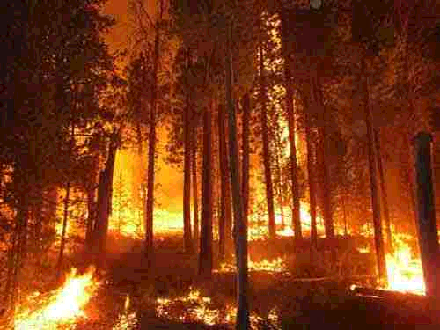
NR 5 – WILDLAND FIRE TECHNOLOGY
Reedley College – Fall, 2008
Lecture/Lab 12:00-4:50 F

Instructor: Rob Cannell
Office: FEM 4F, Phone: (559) 637-2525
Office Hours: MWF 10:00 – 11:00 am
Email: robert.cannell@reedleycollege.edu

Course Objectives
This course prepares students for entry-level wildland fire suppression employment with State and Federal fire agencies. Certifications for National Wildland Fire Coordinating Group S-130, S-190, and I-100 will be offered.

This class also strives to develop physical skills and stamina that is necessary for arduous work. Fire line construction, fuels reduction, and chainsaw use will be a component of our lab exercises. Maintenance and use of hand tools and chainsaws will be incorporated as well as fire hose and nozzle experience.

Reedley College Policies
To receive a grade for this course, students must complete all assigned work. Cheating or plagiarism will result in removal from the class result in an “F” grade. Foul language or disruption to the instruction will not be tolerated, you will be asked to leave the class. There will be no tobacco use in any building or school farm. Safety rules must be strictly followed including the use of protective equipment and cautious behavior. Please turn cellular phones and pagers off during class time.

Accommodation Statement
“If you have a verified need for an academic accommodation or materials in alternate media (i.e., Braille, large print, electronic text, etc.) per the Americans with Disabilities Act (ADA) or Section 504 of the Rehabilitation Act, please contact me as soon as possible.”

Text Books
- Lowe J. D. 2002. Wildland firefighting practices. Delmar publishing co. Albany, NY. This is recommended

- National wildfire coordinating group. 1994. Introduction to wildland fire behavior, S-190. National interagency fire center. Boise, ID. This is a required text

- National wildfire coordinating group. 2003. Firefighter training, S-130. National interagency fire center. Boise, ID. This is a required text

- Teie, W. C., and D. Hubert. 1994. Firefighter’s handbook on wildland firefighting. Deer Valley press. Rescue, CA. Optional reference

Attendance
The class will meet promptly at 1200 hours and conclude at 1650 hours each Friday unless otherwise specified by the instructor. It is the responsibility of the student to check on class meeting changes if a class session is missed. To be considered present students should be attentive, properly attired, and ready for classroom or field activities regardless of weather or other factors. .

Attendance will count for 20% of your final grade. Attendance points will be deducted for any class a student misses. You will have 10 points out of 100 deducted from your attendance grade for each absence.

Participation in Laboratory Work
Firefighting is a particularly labor-intensive task. Safety and success depend on every person’s full participation. In this class you will be practicing actual fireline work. For the safety of others, and yourself, you must perform tasks in a responsible manner. You must have your own safety equipment on in order to be allowed to participate in laboratories. You will receive no participation credit if you are not prepared for field tasks.

Your performance in the physical laboratory training is assessed for a grade. If you cannot safely carry out the tasks for any reason, including a health condition, you should notify the teacher. Consideration will be given to modify the requirements on an individual basis.

Certification
To receive a certificate of successful completion a student must pass all S-190 and S-130 and I-100 unit exams with a satisfactory score (specified for each unit). A student may receive a passing grade in the class without qualifying for the certificate. Some employment may require the certificate however.

Grades
Unit Examinations 25%
Final Exam 25%
Laboratory Skills 25%
Participation 25%
The cumulative course grade will be based upon the following:

A 90 – 100%
B 80 – 89%
C 70 – 79%
D 60 – 69%
F 59% or less

* Quizzes and examinations must be made up within one week with instructor’s prior approval. THIS IS CRITICAL TO YOUR SUCCESS AND COMPLETION OF THIS COURSE.

Required Equipment
Each student must have the following items during each class in order to be allowed to participate:
Hardhat, Leather Gloves, Safety Glasses, Boots (minimum 8” high), Long Pants (no cuffs), Long Sleeve Cotton Work Shirt. Details will be given during the first class meeting.

LAST DAY TO DROP THE COURSE October 17, A LETTER GRADE IS ASSIGNED AFTER THIS DATE.

Tentative Schedule
Date Lecture Topic Lab Topic
8/22 S-130 (U. 0&1, 1 1/2hr) S-130 (U. 2, 3 1 1/2hr)
8/29 S-130 (U. 0&1, 1 1/2hr) S-130 (U. 2, 3 1 1/2hr)
9/5 S-130 (U. 4a, 4b, 4 1/2hr) Chainsaw Safety
9/12 S-130 (U. 4c, 2hr) S-130 (U. 4d, 3hr)
9/19 S-130 (U. 5 & 6, 4hr) Tool Care and Use
9/26 Sequoia Lake Field Trip
10/3 S-130 (U. 7 & 8, 4hr) Fire Line Construction
10/10 S-130 (U. 9, 10a, & 10b 2hr) S-130 (U. 11, 2hr)
10/17 S-130 (U. 12, 5 1/2hr) S-130 (U. 12
10/24 Sequoia Lake Field Trip
10/31 S-130 (U. 13 & 14, 3hr) S-130 (U. 15, 1hr)
11/7 Hose Lays with Engine Mobil Attack with Engine
11/14 S-130 (U. 16 & 17 2 1/2hr) Compass/GPS Practical
11/21 Tree Felling and Bucking S -130 Exam
11/28 Turkey Day
12/4 Fuel S-190 (U. 0, ½hr - S-190 (U. 1, 1½hr)
12/11 Weather/Topography S-190 (U. 2, 3hr.)
12/18 Final – S-190

