Statics

Fall 2008

Engineering 8
Sections # 56506 and #56278



Instructor: Dr. John Heathcote Class Times: TTh, 12:00-1:15 pm, LFS-6
Or Online

Office: FEM – 4D

My office is in the back left corner of FEM-4E. It is okay to enter the computer lab even if there is a class. Just quietly walk in and look for me in my office.

Phone: 638-3641 ext. 3215

e-mail: john.heathcote@reedleycollege.edu

Office Hours: Monday, 1:30-2:30 pm
Wednesday, 1:30-2:30 pm
Thursday, 2:00-3:00 pm
Or feel free to stop by or make an appointment

Important Note about this Course:

This course is being taught with both a traditional “face-to-face” section of students and an online section of students. The assignments and tests will be the same for both groups of students. Students in the “face-to-face” section will be taught in class each week, while students in the online section will receive that material online. (The online material will include videos of lectures and worked out problems and written notes.) Students in the “face-to-face” class can also access this online material to either catch up on missed work or to supplement in-class learning. Likewise, online students are welcome to come to a “face-to-face” class whenever they desire as well.

All students will submit the homework assignments online. Also, all students will take traditional written tests on campus.

Textbook Options:

Here are your options for purchasing a textbook and the online access to the course materials:

Option #1: Online access without any textbook. The entire textbook is available online. You can read the text, print out portions of it, and even highlight or add notes to the online textbook for later reading.

- Go to www.coursecompass.com. Select “register” under where it says “Students”. On the next screen, click “Next”. On the next screen, when it asks for a course ID, enter “heathcote69708”. On the next screen, select “Buy Now”. You can then purchase the access to the OneKey online site for this course for $68.60 using a credit card. Follow the instructions for registering for the course.

Option #2: Online access with either of these textbooks:
Principles of Statics, by R.C. Hibbeler Principles of Statics and Dynamics, by R.C. Hibbeler
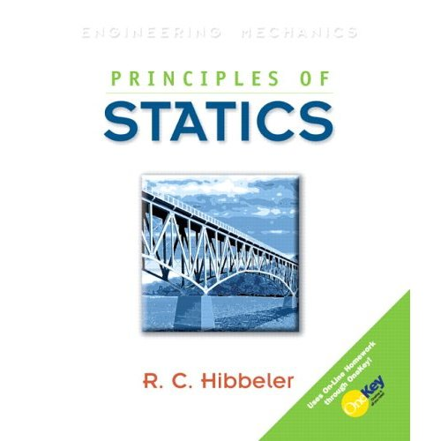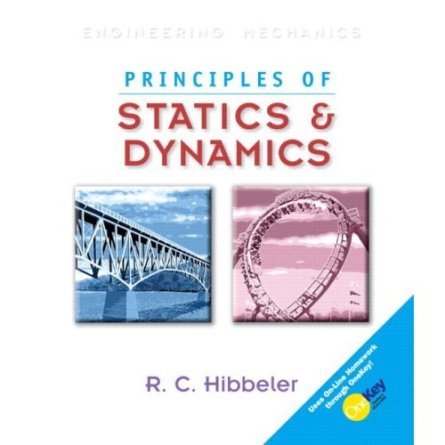

The bookstore will be selling the book on the left. However, they are only selling used copies of the book, without the access code. The book on the right, Principles of Statics and Dynamics, will also work. It includes all of the content from Principles of Statics, plus additional chapters in dynamics that we will not cover in this course.

It is important that you receive a valid OneKey access code when you purchase the textbook. If you purchase a used book, you will probably not receive an access code. So, you would still need to buy an access code separately (as described in Option #1).

Once you have an access code that comes with your textbook, you will have to register for the CourseCompass website. Go to www.coursecompass.com. Select “register” under where it says “Students”. On the next screen, click “Next”. On the next screen, when it asks for a course ID, enter “heathcote69708”. On the next screen, select “Access Code”. You can then enter the access code that came with your textbook. (You may need to use all CAPITAL letters for your access code.)

Prerequisite: PHYS 4A
Corequisite: MATH 6

Grading: 80% Four Tests
10% Design Project
10% Homework

Tests and Final Exam: There will be four tests during the term. Each test may cover material from the entire semester. Rules for what is allowed for each test will be announced before each test.

Design Project: In order to apply some of the concepts from this course, a design project will be assigned. In this project, you will use what you have learned in the course to design or analyze some sort of engineering structure. The actual construction of this structure may not be assigned. An important part of this project will be the design report that accompanies it.

Homework: Homework will be assigned in order to practice the problem-solving skills taught in class. These homework problems will be accessed via the online site that corresponds to the textbook. Homework answers will be submitted online.

Late Work and Make-up Tests: Homework should be submitted on time in order to receive full credit. If there is a valid reason that the work must be turned in late, please inform the instructor ahead of time. Make-up tests will only be arranged upon prior approval. If you will miss a test, you MUST let the instructor know beforehand.

Cheating and/or plagiarism: Cheating and/or plagiarism will not be tolerated. A student will receive no credit for the assignment if in the opinion of the instructor the individual has cheated.

Grading Scale: 90-100% A
80-89.9% B
70-79.9% C
60-69.9% D
<60% F

Attendance: In order to successfully complete this course, you must learn the material that is presented during lecture. You should either attend class or access the material that is posted online.

Accommodations for Students with Disabilities:
If you have a verified need for an academic accommodation or materials in alternate media (i.e., Braille, large print, electronic text, etc.) per the Americans with Disabilities Act (ADA) or Section 504 of the Rehabilitation Act, please contact me as soon as possible.

Add Date: Friday, September 5th Last day to add a course
Drop Date: Friday, October 17th Last day to drop this course
Holidays: Monday, September 1st Labor Day
Tuesday, November 11th Veterans’ Day
November 27-28th Thanksgiving Day Holidays
Final Exam: Thursday, December 18th 12:00-1:50 pm
(for face-to-face section)

Exam Schedule for Online Students (all tests scheduled in FEM-4E at 7pm)
Exam #1: Wednesday, September 17,
Exam #2: Wednesday, October 22
Exam #3: Wednesday, November 19
Exam #4: Wednesday, December 17

Students in the face-to-face section will take their tests during regularly scheduled class times.

Catalog Description: The study of rigid bodies in static equilibrium when acted upon by forces and couples in two- and three- dimensional space. Included are equilibrium of rigid bodies, trusses, frames and machines, as well as the calculation of centers of mass, centroids, friction, and moments of inertia. Additional topics, which may be covered, include distributed forces in cables, beams, and fluid statics, mass moments of inertia, and virtual work.

Course Outline:

Unit | Chapters | Topics | Weeks
A | 1, 2, 3 | Introduction, Vectors, Force Systems | 1-5
B | 4, 5 | Moments, equilibrium in two and three dimensions | 5-10
C | 6, 8 | Structures, Friction | 10-14
D | 7, 9, 10 | Beams, shear and moment, center of mass, centroids, moments of inertia | 14-18

COURSE OUTCOMES:

Upon completion of this course, students will be able to:

- Solve mechanical equilibrium problems involving the equilibrium of particles and rigid bodies using both graphical and vector calculus techniques.
- Solve mechanical equilibrium application problems for trusses, frames, and machines.
- Calculate shear, normal forces, and bending moment for loaded beam problems and produce shear and bending moment diagrams.
- Solve friction application problems.
- Determine centroid, center of mass, and center of gravity for various objects and geometric shapes.
- Determine moment of inertia and mass moment of inertia for various objects and geometric shapes.
- Use the concept of virtual work to solve simple problems.

COURSE OBJECTIVES:

In the process of completing this course, students will:

- Understand the vector operations of addition, subtraction, dot product, and cross product and use them in applications.
- Draw the free body diagram of an object subjected to external forces and couples.
- Apply the principles of mechanical equilibrium to solve problems involving a force system acting on a point mass.
- Define and use the concepts of moment, couple, and resultant as they apply to static equilibrium problems.
- Apply the principles of mechanical equilibrium to solve problems involving forces and couples acting on a theoretical rigid body.
- Learn the analytical techniques appropriate for objects subjected to distributed forces.
- Solve truss, frame, and machine application problems, using the principles of mechanical equilibrium.
- Define and use the concepts of shear force, normal force, and bending moment in the solution of internal force problems.
- Generate shear and bending moment equations and draw shear and bending moment diagrams for a loaded beam.
- Solve different classes of dry friction problems.
- Apply the theory of dry friction to application problems.
- Define and calculate centroid, center of mass, and center of gravity for various 1-D, 2-D, 3-D, and composite bodies.
- Define and calculate moment of inertia and mass moment of inertia for various 1-D, 2-D, 3-D, and composite bodies.
- Use the concept of virtual work to solve simple problems in systems with variable equilibrium states.

