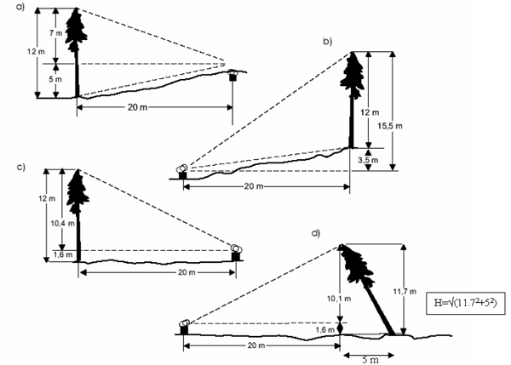
NR 20 –Forest Measurements
Reedley College – Spring 2007
Lecture 8:00-9:50 M FEM 7
Lab 7:00-9:50 F FEM 7

Instructor: Jason Pinkerton
Office: FEM 3, Phone: (559) 638-3641, Ext. 3260
Office Hours: M --- 10:00-12:00 and F --- 10:00-11:00 other times by appointment
Email: jason.pinkerton@reedleycollege.edu

Course Objectives:
The overall objective of this course is for students to gain an understanding of methods and principles of forest measurement at the tree, stand, and landscape (forest) level. Specific objectives include:
- Develop skills necessary for the measurement, analysis, and interpretation of forest measurement data.
- Understand the quantitative and statistical principles that support measurement and sampling methods.
- Provide familiarity with instruments and techniques used to acquire forest measurement data.
- Proficiency in timber cruising, log-scaling, and other skills broadly applied to forest ecosystem management.

Textbook(s):
Bell, J.F., and J.R. Dilworth. 2002. Log scaling & timber cruising. OSU Book Store, Inc. Corvallis, OR. (Required)
Avery, T.E. and H.E. Burkhart. 2002. Forest measurements. McGraw-Hill Companies, Inc. New York, NY. (Recommended)

Accommodation Statement:
“If you have a verified need for an academic accommodation or materials in alternate media (i.e., Braille, large print, electronic text, etc.) per the Americans with Disabilities Act (ADA) or Section 504 of the Rehabilitation Act, please contact me as soon as possible.”

Essential Information:
- It is your responsibility to stay informed on any changes to assignment due dates, readings, test material, etc. Missing a class doesn’t excuse you from this responsibility (i.e. if a due date for an assignment changes, new assignments are given, etc.). This means you should ask a trustworthy classmate for notes if you are absent. Being absent is not an excuse for late work, late assignments, or just not knowing what is happening.
- It is the student’s responsibility to officially withdraw from this and/or any course. Failure to do may result in a “F” grade being awarded. As an instructor, I have the option to drop students who miss more than four class periods.
- Cheating and/or plagiarism will not be tolerated. No credit will be given for an assignment if in the opinion of the instructor the individual has cheated.
- “If you have a verified need for an academic accommodation or materials in alternate media (i.e., Braille, large print, electronic text, etc.) per the Americans with Disabilities Act (ADA) or Section 504 of the Rehabilitation Act, please contact me as soon as possible.”
- Please turn cellular phones and pagers off during class time (1 point will be deducted from your final participation grade for each cell phone ring throughout the semester). Sunflower seeds and all tobacco products are NOT permitted in the classroom or laboratory setting.
Field Trips:
There may be several required field trips (FT) taken during the semester. These trips will generally occur during the scheduled class lecture or lab time. However, we may return to campus after our scheduled meeting times. If you are unable to attend a field trip you must arrange to make-up your absence with the instructor. You will still be responsible for the material covered and may be required to complete an alternative assignment. Failure to do so will result in a zero for the particular lab. Always come to lab prepared for outside activities. Prepared is defined as having sturdy hiking shoes or boot, long pants, water, food, and warm (appropriate) clothing. * On certain occasions students may be required to drive to field trip locations. Drivers must complete the Private Vehicle Usage form (blue form) available in the department office prior to the schedule trip. Carpooling is highly recommended!

Participation and Grading Policy:
Grading for this course is based on the sum of two exams, a comprehensive final, lab assignments, individual participation, and unannounced quizzes. Both lecture and laboratory material will be covered on midterm exams and quizzes. No early or makeup exams or quizzes will be given, unless previously (one week) authorized by the instructor. All late assignments will be deducted 15% and must be turned in within one week of due date to receive any credit. Individual participation will be considered when assigning your final grade. Final grades may be curved based on a percentile of the highest point total in the class. Grades will be assigned based on a straight percentage system according to the following scale:

Course Grade | Cumulative Percent | Breakdown of Grades | Points
A | 90-100 | Lab Reports | 25%
B | 80-89 | Quizzes | 15%
C | 70-79 | Participation | 20%
D | 60-69 | Two Midterm Exam(s) | 25%
F | <59 | Cumulative Final Exam | 15%
 |  | TOTAL | 100%

LAST DAY TO DROP THE COURSE Friday, March 9th A LETTER GRADE IS ASSIGNED AFTER THIS DATE.

Tentative Schedule

Date Lecture Topic Lab Topic
1/8 Introduction
1/12 Math Practice
1/15 M.L.King Jr. Birthday (NO CLASS)
1/19 Statistical Methods
1/22 Statistical Methods, Sampling Design
1/26 Sampling Design
1/29 Standing Tree Measurement
2/2 Tree Measurement
2/5 Log Rules
2/9 Log Scaling
2/12 Log Scaling
2/16 Presidents’ Holiday (NO CLASS)
2/19 Presidents’ Holiday (NO CLASS)
2/23 Log Scaling, Log Grading (FT)
2/26 Review
3/2 Exam 1
3/5 Standing Tree Measurement (Relaskop)
3/9 Tree Measurement (Relaskop)
3/12 Forest Inventory
3/16 Cruise Design & Data
3/19 Inventorying w/ Point Sampling
3/23 Inventorying w/ Point Sampling
3/26 Inventorying w/ 3P Sampling
3/30 3P Sampling (FT)
4/2 Spring Break (NO CLASS)
4/6 Spring Break (NO CLASS)
4/9 Review
4/13 Exam 2
4/16 FFA State Recruitment (NO CLASS)
4/20 Volume Equations
4/23 Tree Growth, Stand-Table Projection
4/27 Sequoia Lake Trip (NO CLASS)
4/30 Rangeland Resources
5/4 Measuring Rangeland Resources
5/7 Review
5/11 Review Open Lab
5/16 Wednesday 8:00 – 9:50 am Final Exam

