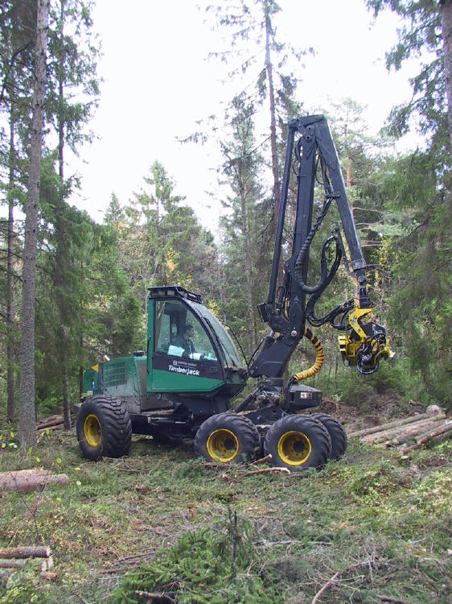
NR 21 – Forest Products (54034)
Reedley College – Fall 2007
Lecture 8:00 am – 12:00 pm F
Lab 12:00 pm – 5:50 pm F
Room FEM 7

Instructor: Jason Pinkerton
Office: FEM 3, Phone: (559) 638-3641, Ext. 3260
Office Hours: T --- 10:00-12:00, and TH --- 10:00-11:00 other times by appointment
Email: jason.pinkerton@reedleycollege.edu

Course Description:
Through the duration of this course you will be exposed to wood structures, current wood manufacturing processes, and wood industrial technology. Emphasis will be placed on timber sale preparation, administration, and primary and secondary manufacturing processes of forest products.

Upon completion of this course, students will be able to:
A. Differentiate among the major logging systems used in California
B. Prepare a simplified timber appraisal.
C. Assess lumber grades.
D. Use of a portable sawmill in the manufacturing of simple wood products.

Textbook (not required):
Bowyer, J.L., R. Shmulsky, and J.G. Haygreen. 2003. Forest Products and Wood Science, An Introduction 4th Edition. Iowa State Press.

Essential Information:
- Short-term courses are challenging partially due to their condensed design. You must remember we are covering 18 weeks of material in just 9 weeks of time. The pace of this course and other like it is highly demanding. Be prepared and ask several questions throughout the semester in order to ensure comprehension of difficult subject matter.
- It is your responsibility to stay informed on any changes to assignment due dates, readings, etc. Missing a class doesn’t excuse you from this responsibility (i.e. if a due date for an assignment changes, new assignments are given, etc.). This means you should ask a trustworthy classmate for notes if you are absent. Being absent is not an excuse for late work, late assignments, or just not knowing what is happening.
- It is the student’s responsibility to officially withdraw from this and/or any course. Failure to do may result in an “F” grade being awarded. As an instructor, I have the option to drop students who miss more than four class periods.
- Cheating and/or plagiarism will not be tolerated. No credit will be given for an assignment if in the opinion of the instructor the individual has cheated.
- “If you have a verified need for an academic accommodation or materials in alternate media (i.e., Braille, large print, electronic text, etc.) per the Americans with Disabilities Act (ADA) or Section 504 of the Rehabilitation Act, please contact me as soon as possible.”
- Please turn cellular phones and pagers off during class time. Sunflower seeds and all tobacco products are NOT permitted.

Field Trips
There may be several field trips taken during the semester. These trips will generally occur during the scheduled class time. However, we may return to campus after 5:00 pm on occasion or we may depart on days other than the scheduled class time. Field trips are designed to allow for on-site observation of silvicultural practices currently employed by industry. Therefore, attendance and participation is mandatory.

One extended three day field trip may occur during the semester. This trip will likely happen outside of our scheduled class period(s). This trip is highly recommended but not required. If you are unable to attend you must make up the required class time by completing a ten page report. Details concerning this paper will be discussed with the student(s) prior to missing this trip. If you plan to attend and miss other nor-NR classes, arrangements must be made with your other instructors’ prior to our departure. If you miss any field trip, NO participation points will be credited for that particular day.

Always come to lab prepared for outside activities. Being prepared means sturdy hiking shoes or boot, long pants, and water.

* On certain occasions students may be required to meet at field trip locations (e.g. Sequoia Lake). You are responsible for providing your own transportation to these locations. Ridesharing is highly recommended!

Attendance and Grading Policy
Field trips are designed to allow for on-site observation of harvesting and manufacturing techniques currently employed by industry. Therefore, attendance and participation is mandatory. If you miss a field trip, NO participation points will be credited. Upon approval of the instructor, you may make up one excused field trip and report. Students must locate a company manufacturing wood products, arrange a facility tour, and prepare a written report. Examples of possible field trip make-ups include: logging operations, lumber mills, lumber yards, housing tract construction, biomass facilities, and small scale wood factories. Contact me prior to absence to receive a list of potential sites.

Field trip reports are due at the beginning of the following class meeting, No Exceptions. Reports must follow the lab report format outlined on page four. Reports not meeting these guidelines will be reduced by one letter grade. Overdue reports will be docked 10 points per day late. Reports overdue by one week or greater will receive a zero.

Individual participation will be considered when assigning your final grade. Final grades may be curved based on a percentage of the highest point total in the class. Exam and final grades will be assigned based on a straight percentage system according to the following scale:

Course Grade | Cumulative Percent | Breakdown of Grades | Points
A | 90-100 | Field trip participation 5 @ (50 pts. each) | 250
B | 80-89 | Field trip reports 5 @ (50 pts. each) | 250
C | 70-79 | Take home exam | 100
D | 60-69 | Final | 200
F | <59
 |  | TOTAL | 800

LAST DAY TO DROP THE COURSE Friday, November 16th without a “W” Friday, October 26th

Tentative Lecture Schedule

Date Topic
10/19 Introduction, Wood Defect and Identification, Sequoia Lake Field Trip NR 109/115

10/26 Field Trip: Lab USDA Forest Service, Sierra National Forest

11/2 Field Trip: Sequoia Lake Portable Sawmill Class Meets at Sequoia Lake (Students Drive) Tree growth, Wood Characteristics, Volume Calculations

11/9 Field Trip: Northern California Humboldt State University and Industry Tour – Nov. 7 – 9, Take Home Exam

11/16 Field Trip: Sierra Forest Products at Terra Bella Lumber Production

11/23 Thanksgiving Holiday – NO CLASS

11/30 Field Trip: Sierra Pine Particle Board Facility – Martel, CA

12/7 Timber Harvesting on Public and Private Lands, Land Policies

12/10 7:00 – 8:50 am Final Exam

Field Trip Report Format (required)

- Title page
  - Field Trip Location
  - Your Name
  - Course
  - Date
- Introduction
  - A short description of the field trip.
- Discussion
  - A detailed discussion of:
    - What you saw, how it influenced your opinion, what you learned, etc.
- Conclusion
  - What you think now after this experience.

Note*
You may include diagrams, tables, or photographs if permitted. A reference section is required if using outside resources.

Each report will be 3-5 pages:
- Typed, 12 point font
- Double spaced
- One inch margins on all sides.

