1

Speech 2
Interpersonal Con~m~,ication
FaLl 2006

INSTRUCTOR: Helen Chavez, M.A.
M&ILBOX#: 638—3641 ext. 3837
OFFICE HOURS: Available by appointment only

Course Objectives: During this course, students will:

1. To understand the theories and principles of interpersonal communication.

2. To employ more accurate and supportive listening skills.

3. To become aware of one’s communication behavior and to recognize where improvement is needed.
4. To improve interpersonal relations and conflict-management strategies through self introspection and an analysis of communication techniques.

5. To become more successful in communication with others, developed through analysis of personal communication situations and making appropriate choices.

6. To develop confidence in interacting on an interpersonal level.

Required Textbook: DeVito, Joseph A. The Interpersonal Communication Book.. 10th ed. ‘ York: Harper Collins, 2004.

Course Requirements: Further information will be j ‘en for these assignments.
Assignments Point Value
Six Tests’ 300
Cultural Artifact Project 100
Group Project 200
Participation/Attendance 200
Journal ?
Total Points 800
Course Requirements and Assignments:

- Six tests 300 points (50 points each)

The procedure for test taking will be as follows: 1) Each student will take a brief test (10 questions) which will be turned in to me 2) in groups of 5 or 6 students, a second test will be taken (15 questions- the same 10 questions from the individual test plus 5 more) and the group decides which are the correct answers 3) group members then complete and sign a single answer sheet. A student’s score is the total of the correct answers on his/her individual test plus the total number of correct answers on the group sheet. Due to this system, there can be no make-ups of group tests – please be on time on test day in order to have a chance at the total number of points.
Test#l Chapters 1-2
Test#2 Chapters 3-5
Test#3 Chapters 6-7
Test#4 Chapters 8—9
Test#5 Chapters 10—11
Test#6 Chapters 12-14

B. Cultural Artifact Project 100 points

Bring in a cultural artifact along with a 2-3 page double spaced, typed paper explaining: (1)how important your artifact is in describing who you are; (2)how it symbolizes your culture; and (3)what significance it has in your culture. On the date the paper is due, please bring your cultural artifacts and be prepared to discuss a few of the main ideas of your paper.

C. Group Project 200 points
2
Groups of 2-3 individuals develop an analysis of the interpersonal communication between characters in a movie. Each in group will present their analysis to the class and present suggestions to improve the communication between the characters. Groups shall show the scene on a VCR. Each group will have 15 minutes to show its scene and present its analysis. Please keep the presentations of the scenes to a minimum of 5; the analysis is what is being graded. A typed, full sentence outline will be handed in at the time of the presentation. Scenes must be approved by the instructor.
3
D. Participation 200 points

To reap the benefits of this class, participation is essential as well as attendance in class discussions, acticities and brief homework assignments. Therefore:

• Students must turn OFF Cell Phones! No radios, CD players etc. are allowed in class. When in doubt, le
• Students are expected to participate in classroom learning activities and participate in class discussions.

• Students are expected to listen attentively when the instructor or a student is speaking. Distracting behavior such as studying, talking, or reading is unacceptable.

• Students are required to adequately complete all assigned readings, exercises, and brief occasional homework assignments.
• Because participation is impossible without attending class, you may miss one week (1 night) of class without penalty. Your first absence count whether you have a good excuse or not. Each absence beyond the first (i.e., your second, third, fourth, fifth, etc.) will cost you 25 points. The only exceptions to this rule are severe illness (a visit to the Student Heath Center, a doctor’s office visit, emergency room visit, etc.), and college-approved trips/activities. Appropriate documentation for absences beyond the first is necessary the class day/night directly before or after the one you miss. That means: I will need the excuse IN WRITING from a credible person capable of verifying the excuse the first time you return back to class.
NOTE: Arriving tardy twice and/or leaving class early twice, will equal one absence each time this
occurs.
• Your classroom behavior/manner will also be evaluated by the instructor. Always remember to be respectful of others and on your best behavior. If you get out of line (rowdy, rude, disrespectful, etc.), it will be impossible for you to earn a decent grade. Any distracting or other rude behaviors that take place during a presentation or class discussion will have a detrimental effect on your participation grade, as well as your right to remain in this class!!

NOTE: Students will lose some and/or all participation points if there are numerous violations of these rules.
4
E. Journal ? (participation points will be deducted or extra credit points will be added)

The text consist of three parts. The first part covers chapters 1-5, the second part covers chapters 6-9, and the last part covers chapters 10-14. You are required to write a two page double-spaced, typed journal for each part (3 journal entries in all)! These journals are designed for you to relate text concepts to your life experience.
These three journal entries are a requirement. No points will be given but participation points will be deducted (50%) if you fail to turn in these entries. Also, these must be done correctly. If not done right, points will be deducted. Therefore, I do NOT wish to read repetition of what was said in the text or in general class discussion (defining concepts, etc.) I DO wish to read descriptions of your communication (i.e., specific situations, exchanges, and events) that are of specific concepts; for example, apprehension, self-awareness, culture shock, etc.

Extra Credit: There may be an opportunity to earn extra credit points. This opportunity is NOT guaranteed especially for those who demonstrate a lack of respect for this class therein. Extra Credit will only be granted to those students who demonstrate proper classroom conduct throughout the semester. This is absolutely at the teacher’s discretion! But regardless of extra credit points or not, these MUST be turned in at the end of the semester. It is a Requirement!

Grade Distribution:

I give numerical scores to all work you do. I do not give letter grades on any assignment. there are 800 points possible for the semester. I add up your points at the end of the semester to determine your grade. Save and add up all graded work that is returned to you, so you can have a rough ideas of the grade you are earning in class. Plus, your saved work becomes your receipts.
Total Points= 800
Grade Points
A 800—720
B 719—640
C 639—560
D 559—480
F 479—0

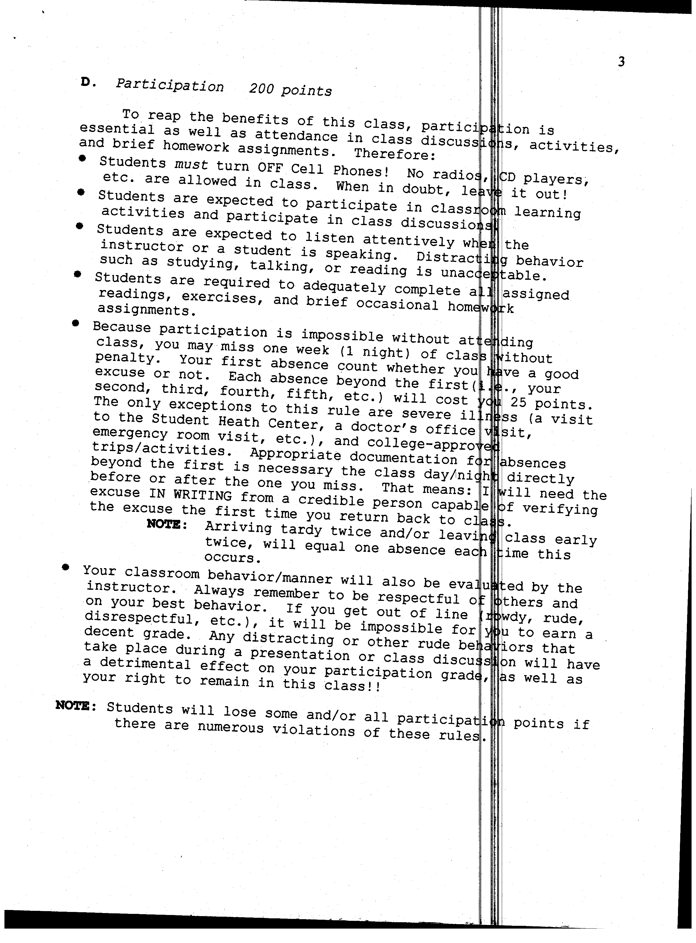

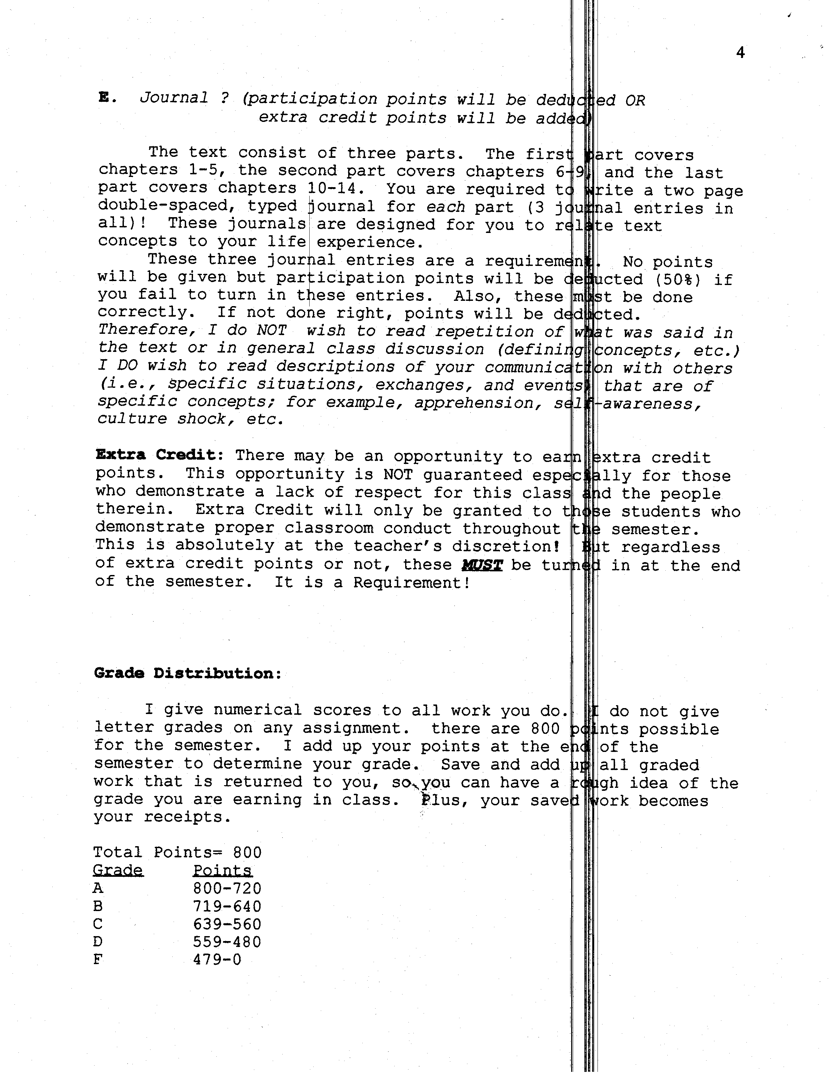

5
Late Assignments:

Excuses for late work or absences are those such as community college—sponsored trips, medical, and family emergencies (a note from a faculty member or medical doctor is required upon your return). Unexcused reasons include (but are not limited to) job/work-related problems, stress from other classes, etc. Remember, there is a difference be “excuse” and a “reason”. Just because you have a reason does not mean the late work or absence will be excused.

Group presentations must be given on the day scheduled. No late presentations will be allowed. Individuals missing a group presentation will receive zero credit for the assignment regardless of the reason(excused or unexcused). There is simply no way to make it up.

ALL written assignments turned in late will be lowered 20 points for each class meeting it is late regardless of the reason or the excuse. If you are unable to get your papers to me personally, get a friend or someone to do it for you. At any time, I reserve the right to refuse a late paper or assignment.

If you are absent for a quiz, you may make up the individual portion of the quiz upon your return. Meaning, the first day/night you come back to class you take the quiz! Otherwise, you will receive zero points. However, the group portion of the quiz cannot be made up. I will simply adjust your score accordingly. You will receive a maximum of only 30 out of 50 points.
6
Drop Policy:
Be advised that after the drop date (Friday, October
13th.. . I’ M NOT SURE ON THIS, FIND OUT FOR YOURSELF!!) you will be
issued a letter grade “A” through “F” if you are still enrolled in class. It is your responsibility to drop the corse not mine!

PLEASE NOTE:
The College’s policies regarding student conduct6 in classes, including cheating and plagiarism, are located in the college catalogue and the schedule of courses. You should be aware of these policies and abide by them. Also, students with disabilities are reminded that is your responsibility to identify yourself to the Reedley College Disable Student you instructor(s) so reasonable accommodation for learning and evaluation within the course can be made.

*IT IS YOUR RESPONSIBILITY TO MONITOR YOUR PROGRESS IN THIS

CLASS, AND TO KNOW WHEN CLASS ASSIGNMENTS AND 0THER WORKS ARE DUE. I AM CAPABLE OF MAKING MISTAKES, SO YOU NEED TO BE AWARE OF DATES, TIMES, ETC. AND LET ME KNOW OF ANY ERRORS AND PROBLEMS THAT MIGHT ARISE. I DO NOT SEARCH OUT STUDENTS TO INFORM THEM OF THEIR GRADES OR ANYTHING ELSE. IT IS A GOOD IDEA TO KEEP EVERY ASSIGNMENT/WORK THAT YOU DO IN THIS CLASS (actually, in every class) AS PROOF OF YOUR STATUS AT LEAST UNTIL YOU RECEIVE YOUR FINAL GRADE AT THE END OF THE SEMESTER.
7

PROPOSED SCULE
(Tentative-could be changed)

You are expected to have read the chapter in the book before we analyze it in
class.
W 8/16 Introduction to the course
Chapter 1
W 8/23 Chapter 1
Chapter 2
W 8/30 Test#1
Chapter 3
W 9/06 Chapter 4
W 9/13 Chapter 5
Test#2
(Begin writing Journal 1-- 2PGS

W 9/20 Artifact Discussion and Paper Due
W 9/27 Chapter 6
Group Presentation Demonstration--lecture
W 10/04 Chapter 7
Test#3
W 10/11 Chapter 8 Group Members Names Due

{Oct. 13, 2006: Final Drop Date
8

W 10/18 Chapter 8 (continue)

W 10/25 Chapter 9
Test#4
[Begin writing Journal 2-— 2PGS]

W 11/01 Chapter 10
Chapter 11
W 11/08 Test#5 Movie/Concept(s) Due
Chapter 12

W 11/15 Chapter 13

W 11/22 Chapter 14
(Begin writing Journal 3-- 2PGS]
W 11/2 9 Group Presentations and Outlines Due

W 12/0 6 Group Presentations and Outlines Due

W 12/13 Final Exam: (6:00—8:OOpm)
-Test#6
-Journals 1, 2, and 3 Due

