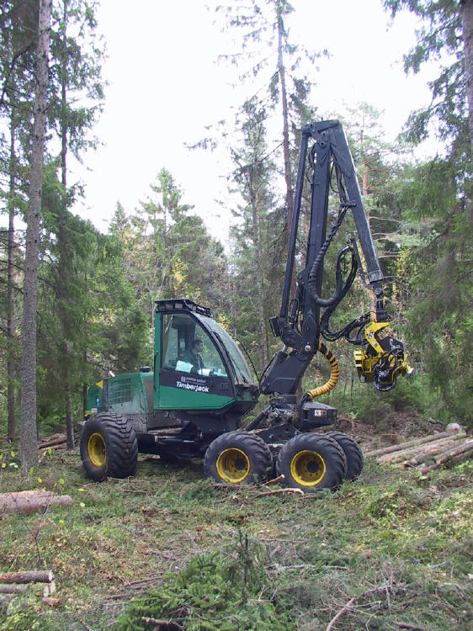
NR 21 – Forest Products (54034)
Reedley College – Fall 2006
Lecture 8:00-12:00 F
Lab 12:00-6:50 F
Room FEM 7

Instructor: Jason Pinkerton
Office: FEM 3, Phone: (559) 638-3641, Ext. 3260
Office Hours: T --- 10:00-12:00, and TH --- 10:00-11:00 other times by appointment
Email: jason.pinkerton@reedleycollege.edu

Course Description:
Through the duration of this course you will be exposed to wood structures, current wood manufacturing processes, and wood industrial technology. Emphasis will be placed on timber sale preparation, administration, and primary and secondary manufacturing processes of forest products.

Upon completion of this course, students will be able to:
A. Differentiate among the major logging systems used in California
B. Prepare a simplified timber appraisal.
C. Assess lumber grades.
D. Use of a portable sawmill in the manufacturing of simple wood products.

Textbook (not required):
Bowyer, J.L., R. Shmulsky, and J.G. Haygreen. 2003. Forest Products and Wood Science, An Introduction 4th Edition. Iowa State Press.

Essential Information:
- It is your responsibility to stay informed on any changes to assignment due dates, readings, etc. Missing a class doesn’t excuse you from this responsibility (i.e. if a due date for an assignment changes, new assignments are given, etc.). This means you should ask a trustworthy classmate for notes if you are absent. Being absent is not an excuse for late work, late assignments, or just not knowing what is happening.
- It is the student’s responsibility to officially withdraw from this and/or any course. Failure to do may result in a “F” grade being awarded. As an instructor, I have the option to drop students who miss more than four class periods.
- Cheating and/or plagiarism will not be tolerated. No credit will be given for an assignment if in the opinion of the instructor the individual has cheated.
- “If you have a verified need for an academic accommodation or materials in alternate media (i.e., Braille, large print, electronic text, etc.) per the Americans with Disabilities Act (ADA) or Section 504 of the Rehabilitation Act, please contact me as soon as possible.”
- Please turn cellular phones and pagers off during class time. Sunflower seeds and all tobacco products are NOT permitted.

Field Trips
There are several field trips taken during the semester. These trips will generally occur during the scheduled class time. However, on occasion we may return to campus after 6:50 pm. Always come to lab prepared for outside activities. Being prepared means sturdy hiking shoes or boot, long pants, gloves, hardhats, safety glasses, LUNCH, and water. On certain occasions students may be required to drive to field trip locations. Drivers must complete the Private Vehicle Usage form (blue form) available in the department office prior to the schedule trip. Ridesharing is highly recommended!

Attendance and Grading Policy
Field trips are designed to allow for on-site observation of harvesting and manufacturing techniques currently employed by industry. Therefore, attendance is mandatory. If you miss a field trip, NO participation points will be credited. Upon approval of the instructor, you may make up one excused field trip and report. Students must locate a company manufacturing wood products, arrange a facility tour, and prepare a written report. Examples of possible field trip make-ups include: logging operations, lumber mills, lumber yards, housing tract construction, biomass facilities, and small scale wood factories.

Field trip reports are due at the beginning of the following class meeting, No Exceptions. Reports must follow the lab report format outlined on page four. Reports not meeting these guidelines will be reduced by one letter grade. Overdue reports will be docked 10 points per day late. Reports overdue by one week or greater will receive a zero.

Individual attendance and participation will be considered when assigning your final grade. Final grades may be curved based on a percentage of the highest point total in the class. Exam and final grades will be assigned based on a straight percentage system according to the following scale:

Course Grade | Cumulative Percent | Breakdown of Grades | Points
A | 90-100 | Field trip attendance 5 @ (50 pts. each) | 250
B | 80-89 | Field trip reports 5 @ (50 pts. each) | 250
C | 70-79 | Take home exam | 100
D | 60-69 | Final | 200
F | <59
 |  | TOTAL | 800

LAST DAY TO DROP THE COURSE Friday, November 17th without a “W” Friday, October 27th

Tentative Lecture Schedule

Date Topic

10/20 Introduction,
Field Trip: Lab USDA Forest Service, Sierra National Forest

10/27 Sequoia Lake Field Trip NR 109/115

11/3 Field Trip: Sequoia Lake Portable Sawmill (Students Drive)
Tree growth, Wood Characteristics

11/10 Field Trip: Northern California Lake Tahoe Industry Tour – Nov. 7 – 9, Veterans Day – NO CLASS, Take Home Exam

11/17 Field Trip: Sierra Forest Products at Terra Bella Lumber Production and Jon Wagy Lumber Mill at Springville

11/24 Thanksgiving Holiday – NO CLASS

12/1 Timber Harvesting on Public and Private Lands, Land Policies

12/8 Field Trip: AES Mendota Biomass Powerplant
Pulp and Paper, Energy and Chemical Products

12/13 7:00 – 8:50 am Final Exam

Field Trip Report Format (required)

- Title page
  - Field Trip Location
  - Your Name
  - Course
  - Date
- Introduction
  - A short description of the field trip.
- Discussion
  - A detailed discussion of:
    - What you saw, how it influenced your opinion, what you learned, etc.
- Conclusion
  - What you think now after this experience.

Note*
You may include diagrams, tables, or photographs if permitted. A reference section is required if using outside resources.

Each report will be 3-5 pages:
- Typed, 12 point font
- Double spaced
- One inch margins on all sides.

