REEDLEY COLLEGE
COMPUTER CONCEPTS
(10/14/2006 to 12/15/2006)

Course: | IS18 | Office: | BUS 47
Room: | BUS 49 | Phone: | (559)638-3641 ext3410
Days: | TTH | Time: | 4:00pm to 5:500pm
Course #: | 52353 | Office Hours: | Monday 2:00pm to 3:00pm RC POR5  Tuesday Thursday noon to 1:00pm DVC 107
Instructor: | Rio Waller | Office Hours:
E-mail: | rio.waller@reedleycollege.edu | Office Hours:

http://www.reedleycollege.edu

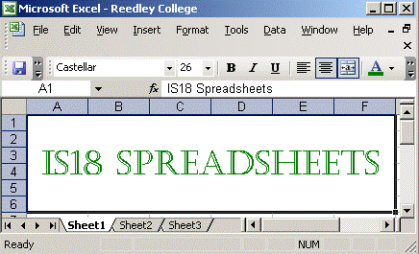
Course Objectives:
This course provides an introduction to spreadsheet fundamentals for the business manager. This course will cover creating and formatting worksheets, using formulas and functions, and creating graphs using a spreadsheet. The student is expected to complete assignments in the computer laboratory outside of class.

HOW TO SUCCEED IN THIS CLASS:
- Read the textbook
- Submit completed assignments
- Take all quizzes
- Participate in discussions
- Be self-motivated
- Contact the instructor when needing assistance

Attendance
Attendance is required! With a 9 week class missing two class periods will subject student to drop.

STUDENT INITIATED DROPS:
If you wish to drop this course, it is your responsibility to do so. The instructor may or may not drop a student. Do not count on being dropped. The student has the ultimate responsibility for dropping the course.

REINSTATEMENT:
Reinstatement, only if the instructor agrees, must be made by formal petition and is the responsibility of the student.

GRADING:
Assignments 50%
Quizzes 40%
Final/Mid-tern 10%

The following grading scale will be used:
90 – 100 A
80 – 89.9 B
70 – 79.9 C
60 – 69.9 D

Other Policies:
    - The instructor reserves the right to change the time schedule, the number of assignments, and any other information related to the course or scheduling – on this syllabus or otherwise. Changes will be announced online.
    - You are expected to conduct yourself with the highest moral and ethical behavior. Any cheating, plagiarism, or offensive behavior will be dealt with severely. At instructor discretion, you may be failed in the class. An academic dishonesty report will be filed with the Dean of Students. The college regards cheating as a serious offense. Remember, more than intelligence, more than beauty, more than money, more than anything else in the world - honesty, integrity, and ethics are the most valuable qualities any individual can have. SEE COLLEGE CATALOG FOR DETAILS OF CAMPUS POLICY.
    - All students participating in college athletic/student activities must coordinate their schedules with the instructor.
    - The textbook is mandatory. If you do not have one by the end of the second week, you will be dropped from the course.
    - Accommodations for Students with Disabilities:
If you have special needs as addressed by the Americans with Disabilities Act (ADA) please notify me immediately. Reasonable efforts will be made to accommodate your special needs.

Tentative Schedule:
 | Concepts and Quizzes | Assignments
Week 1 | Tutorial 1 Lecture and Quiz | Case Problem
Week 2 | Tutorial 2 Lecture and Quiz | Case Problem
Week 3 | Tutorial 3 Lecture and Quiz | Case Problem
Week 4 | Tutorial 4 Lecture and Quiz | Case Problem
Week 5 | Tutorial 5 Lecture and Quiz | Case Problem
Week 6 | Tutorial 6 Lecture and Quiz | Case Problem
Week 7 | Tutorial 7 Lecture and Quiz | Case Problem
Week 8 | Tutorial 8 Lecture and Quiz | Case Problem
Week 9 | Final

Click here to type into a web browser the following address for the official IS18 outline.

http://www.reedleycollege.edu/thecollegepage/tcp/Curriculum/outlines/is/is%2018%200805.doc

