Instructor: | David Borofka
Office: | CCI 213
Office Hours: | MWF, 9:00-10:00  TTh, 9:15-10:30
Phone/Voice Mail: | 638-3641 ext. 3681
E-Mail: | david.borofka@reedleycollege.edu

English 2 (Fall 2006)
Critical Reading and Writing through Literature

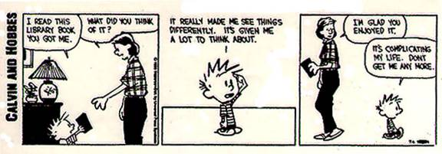

Objective: | A course designed to develop critical thinking, reading, and writing skills beyond the level achieved in ENGL 1A/1AH. The course will focus on the development of logical reasoning and analytical and argumentative writing skills based primarily on works of fiction and literary criticism.
Texts: | Arguing through Literature (Judith Ferster); How to Read Literature Like a Professor (Tomas C. Foster)
Course Site: | We will be using a Blackboard course site in conjunction with our face-to-face lecture and discussion. To access the course site go to the following URL: http://blackboard.reedleycollege.edu. Login using your seven-digit student ID number as your username and password (you can change your password if you wish). Go to Personal Information and check to make sure your e-mail address is correct. You will need to be officially enrolled before you will be allowed to enter the site.  If you do not have an e-mail address, you can obtain one for free through State Center Community College District (www.scccd.org) or Hotmail or Yahoo; if you do not have internet access at home, you can get low-cost access from the District (via CVIP) as well. Throughout the semester I will be using e-mail for announcements of readings and other special events, and you should check your account often.  In order to do work from home, you should have the following programs (all of which are installed on computers here on-campus): Internet browser (such as Internet Explorer or Netscape); e-mail access; word processor (MS Word preferably, see Paper Format below); Adobe Acrobat Reader for research materials; Real Player or Windows Media Player for audio/video files. Your text book comes with a CD containing supplemental materials (Ariel).
Paper Format: | All work must be typed, double-spaced and in 12-point type. You must submit your work via the Assignments area of the course site. I will accept files in the following formats: Word documents (*.doc) or rich text format (*.rtf). Unfortunately, I can not convert documents saved in Microsoft Works format. If you use any program other than Word, you’ll need to learn how to save your work as Rich Text Format files (*.rtf).
Attendance: | Students who have more than four absences in the first nine weeks will be dropped.  The last day to drop this class is October 13.
Extra Credit: | During the course of the semester there will be several readings sponsored by the Reedley College Speakers Series, the Reedley College First Wednesdays at One, and the Fresno Poets Association. Following your attendance at a reading you must turn in an Extra Credit Form to receive as many as ten points per reading. You may earn as many as forty extra credit points. I will give you notice of dates and times.
Assignments: | During the course of the semester, you will write four papers. Quizzes will be unannounced and based on the reading for that day. The discussion/participation grade will be assessed at the end of the semester.
  Assignment | Points
  Paper 1 (connecting the literature with oneself) | 100
  Paper 2 (a close reading of the text) | 150
  Paper 3 (connecting the literature to the world) | 200
  Final Paper | 100
  Discussion/Participation | 100
  Quizzes | 100
  Total | 750
Grades: | Grades will be based on a standard 10% scale as follows:
  A | 675-750
  B | 600-674
  C | 525-599
  D | 450-524
  F | 000-449

