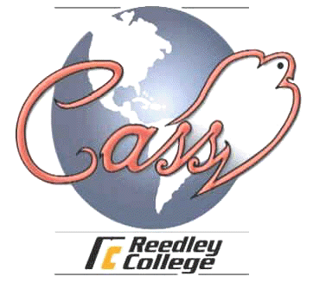
REEDLEY COLLEGE CASS PROGRAM
AGRICULTURE, NATURAL RESOURCES AND MANUFACTURING DEPARTMENT

COURSE INFORMATION
Fall 2006

Ag 260 – Agriculture Achievement I (.5 units)

Instructor: Jan Waterman, International Education Coordinator

Office: CASS Program Office, Agriculture Building, Room 14

Class Schedule: Tuesday 3:00-3:50 Ag15

Office Phone: 638-0329

E-Mail Address; jan.waterman@reedleycollege.edu

Course Description:
Provides students with activities which develop an understanding of American society and culture. Includes exposure to and discussion about the customs, principles, and ideals of the people of the United States with special emphasis on agricultural lifestyles.

Textbook:
Los Cuatro Acuerdoes:Una guia practica para la libertad personal (Four Agreements, Spanish-language edition) by Don Miguel Ruiz

Assignments and Grades:
This class is designed to develop student understanding of American culture and principles through group and individual activities and assignments. Personal responsibility and ongoing orientation to life in the U.S. will be focused. CASS student expectations will be demonstrated through theoretical and practical application. Agricultural lifestyles of six represented countries will be shared and highlighted through a group project.

Grade Scale: 90% = A, 80% - B, 70% = C, 60% = D, Less = F

Grades: A student’s achievement will be measured by:

Participation in assigned CASS activities
Homework
Group Project
Class Participation

If you have a verified need for an academic accommodation or materials in alternate media (i.e., Braille, large print, electronic text, etc.) per the Americans with Disabilities Act (ADA) or Section 504 of the Rehabilitation Act, please contact the instructor as soon as possible.

