Reedley College
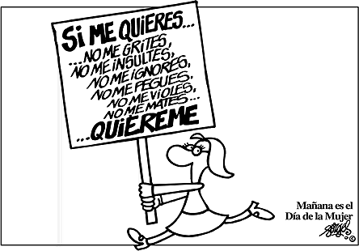

Syllabus -- FALL 2005

Span 3NS -- # 50046

Instructor: Felisa Heller
E-Mail: felisa.heller@reedleycollege.edu
Office Hours: Tuesdays at 4:00 PM, Mondays
Thursdays at 2:00
Office: FEM 4C (next to math computer lab)
Voice Mail: 638-0302

- Course Description (Catalog):

3NS - SPANISH FOR SPANISH SPEAKERS (4) CR/NC
Basic Skills Advisories: Eligibility for ENGL 125 and
ENGL 126 or similar skill levels in Spanish as determined by the instructor.
Subject Prerequisites: A basic speaking knowledge of Spanish as determined by an oral interview in Spanish

Fall 2005 Course Description
This course—taught in Spanish—will further develop reading and writing skills. The course will strongly emphasize written communication. Students are expected to complete all assignments posted in Blackboard

Blackboard: http://blackboard.reedleycollege.edu

Login Information: USERNAME: student number
PASSWORD: student number (this can be changed once you enter Blackboard)

Required Materials:

- ALONSO (0131834096)  ENTRE MUNDOS: AN INTEGRTED APPROACH
  $56.00 | $42.00
- E-mail account
- Computer disk or key

Recommended Dictionaries/Handbooks:
Diccionario Larousse del español moderno
In addition, you will find links to dictionaries site in Blackboard

F. Grading: Your final grade will be based on 6 elements for a total of 1000 points:

Participation in Bulletin Board Discussion: [150 points] Each assignment will have a topic or question about which students will post their comments and reply to others (at least three).

Reading Journal [100 points] You will post a journal entry for every reading you are assigned. In your entry you will include the following: an interaction with the text, a reference to a specific section or quote (either a part you really liked or disliked), any questions or doubts you might have.

Essays [350 points] The essays will be assigned starting the third week of instruction. You will have the opportunity to be reviewed by your peers and instructor before you hand in your last draft for grading.

Open-Book Quizzes: [150 points] There will be quizzes posted in Blackboard for each of your reading assignments. These quizzes can only be taken once and will be timed. Therefore, you should prepare your reading carefully ahead of time.

Group Project: [100 points] This project will present an aspect of the Hispanic culture—in Latin America, Spain or the United States. It will be posted online and you will be evaluated by your instructor (80 possible points) and members of your group (20 possible points). You will use PowerPoint with a sound track, narration. If you need technical help, please contact me as soon as possible.

Individual Project: [150 points] This project will present your outside reading to the class—the text should be by a Latin American, Spanish or Latino writer living in the US. It will be posted online and you will be evaluated by your instructor (120 possible points) and your classmates (30 possible points).

Grade equivalency:

900 -1000 = A 800 - 899 = B 700 -799 = C 600 - 699 = D ≤ 599 = F

If you are really concerned about your grade, consider switching to Credit-No Credit. Discuss the possibility with your counselor. The units count toward your degree, but CR-NC does reduce the grade pressure a bit.

G. Attendance: Students who are absent need to make up work missed. If absent more than two days, please call.

H. Drop Deadline: Fri, October 14 (Students will receive a midterm report on Oct. 16) Grades will always be posted in Blackboard.

I. No Class:
Monday, September 5 (Labor Day)
Friday, November 11 (Veterans Day)
Thursday-Saturday, November24-26 (Thanksgiving)

J. Final (Individual Project Presentation): Thursday, December 15, 4-5:50

Note: If you have any special needs as addressed by the Americans with Disabilities Act (ADA), please notify me immediately. Reasonable efforts will be made to accommodate your special needs.

Plan de estudios
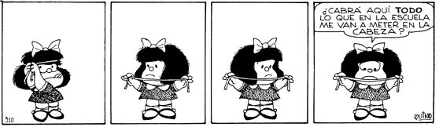

1° semana
- Introducciones, redacción, lectura, acentos
- * Alonso 1-15 (Capítulo 1)
- Tareas (Alonso, 10, 12, 14-15 “Actividad 21”)
2° semana
- Ser hispano
- La ortografía, presente de indicativo, acentos
- Alonso 16-28 (Capítulo 2)
- Tareas
- (Alonso 17 “Actividad 1”, 18 “En su diario”, 19-21)
- Ensayo 27-28 “Manos a la obra” (Para el martes próximo)
3° y 4° semanas
- Prueba, los acentos y la ortografía en el presente de indicativo
- El español en el mundo
- Sustantivos, adjetivos, los plurales, mayúsculas, acentos, puntuación
- Alonso 29-42 (Capítulo 3)
- Tareas (Alonso, 31-32, 39)
- Investigue y presente con PowerPoint, “El español en el Internet” 41
5° y 6° semanas
- De hombres y mujeres, literatura
- El español peninsular, la ortografía
- Alonso, 43-55 (Capítulo 4)
- Tareas
  - ¿Qué es el español peninsular y como se le puede diferenciar del latinoamericano?
  - “Lectura” 45-47
  - “Balada de los dos abuelos“ y “En su diario” 54
  - Ensayo, “Actividad 20” 55
7° y 8° semanas
- La familia y el amor
- Repaso de los acentos, más reglas de acentuación, el uso de sinónimos para evitar la monotonía
- Alonso, 56-69 (Capítulo 5)
- Prueba, acentos y ensayo

* DEANA ALONSO, ENTRE MUNDOS: AN INTEGRTED APPROACH FOR THE NATIVE SPEAKER

- Tareas
  - Escriban todas las reglas de acentuación
  - “En su diario” 58
  - “Lectura” 59-61
  - “Analizar y descubrir” 61-62
  - Ensayo, 69 “Actividad 16” o “Actividad 17”
9° y 10° semanas
- La familia en crisis
- El imperfecto y el pretérito
- Alonso, 70-88 (Capítulo 6)
- Tareas
  - Alonso 72-73, 74-81, 85,
  - Ensayo, 88, “Actividad 18”

11° y 12° semanas
- La comunidad: Los trabajadores migratorios
- La acentuación y los diptongos
- Alonso, 89-106 (Capítulo 7)
- Presentación en grupo de un tema relacionado con la temática del capítulo
- Ensayo, 104 “Actividad 22"

13° y 14° semanas
- Los hábitos de estudio
- Cambios ortográficos y el subjuntivo
- Alonso, 107-121 (Capítulo 8)
- Tarea 110-113, 115
- Redacción de una carta, 121

15°, 16° y 17° semanas
- Ser profesional
- Escribir una carta comercial y un currículum vitae
- Poner fin al uso del subjuntivo
- Alonso, 122-136 (Capítulo 9)
- Tarea, preparación de la presentación final, 128-130, 133-134
- Redacción, 135 (Actividades 19, 20 y 21)
- Examen de gramática, lectura y redacción

18° semanas
- Final, presentación individual (Relacionada a uno de los temas que hemos discutido en clase)
- Jueves, 15 de diciembre, 4:00-5:50

El trabajo que se hará en el laboratorio, Blackboard, no será anunciado con anterioridad.

