Reedley College
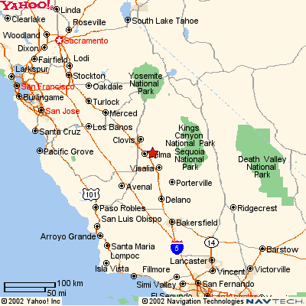

Syllabus -- FALL 2005

ESL 266--Academic Grammar and Writing--#50093
12:00-12:50, MWF in FEM 12 and TH in LAL 1
LEARNING COMMUNITY: INFORMATION IS POWER

Instructor: Felisa Heller
E-Mail: felisa.heller@reedleycollege.edu
Office Hours: Tuesdays at 4:00 PM, Mondays and
Thursdays at 2:00
Office: FEM 4C (next to math computer lab)
Voice Mail: 638-0302

This class is a learning community class with Stephanie Curry’s LITEC 258 (# 59502).
LITEC 258 will be meeting in the library.

Course Description (Catalog):
A writing course for ESL students who are completing language training or are nearly proficient, but need to develop academic composition skills before taking college-level courses. The goal of this course is to prepare students for English 125 or English 252.

Required Use of Technology for Assignments:
You will complete some assignments on the Internet using a web platform, Blackboard.
Your instructor will teach you how to use it and will give you plenty of practice as a group
before you are assigned homework.

Blackboard: http://blackboard.reedleycollege.edu
Login Information: USERNAME: your student number
PASSWORD: your student number
(The password can be changed once you enter Blackboard by clicking on
“Personal” on left of first screen)

Required Materials:
- FITZPATRICK (0131408895)  ENGAGING WRITING: Paragraphs and Essays
  $35.95 | $27.00
  New Used
This book is required
- In your library research, you will be doing additional reading of articles, stories and so on to prompt your writing
- A good English/English dictionary (Ms. Curry could recommend you one)

Note: If you have a verified need for an academic accommodation or materials in alternate media (for example, Braille, large print, electronic text, etc.) per the American with Disabilities Act or Section 504 of the Rehabilitation Act, please contact your instructor as soon as possible.

Course Objectives:
In the process of completing this course, students will:
- write essays with discernable structure (beginning/middle/end)
- write essays on assigned topics using basic rhetorical styles
- write summaries and reactions
- use transition words within and between paragraphs
- practice peer-editing, writing assignments before editing for a last time and turning them in for a grade
- adhere to standard English use of prepositions, spelling, punctuation, capitalization and
word order
- self-monitor for false cognates
- follow accepted English writing conventions

Learning Community Objectives:
- Access information resources to complete research based written essays
- Use a microcomputer and software to revise and edit academic writing
- Identify print and electronic resources on English language learning topics
- Evaluate in writing online resources

Requirements to obtain CREDIT (CR) or 70%:

Categories Weight
Four multiple-draft essays* (Homework) | 40%
One group writing project | 10%
Four summaries and reactions** (Homework) | 10%
Two timed impromptu essays* (In-class) | 10%
Two editing quizzes | 10%
FINAL EXAM (write an academic essay based on a prompt) | 20%
* Based on library research
**Two based on articles from research
Monday, September 5 (Labor Day)
Friday, November 11 (Veterans Day)
Thursday-Saturday, November24-26
(Thanksgiving)

Attendance: No Class:
- Attendance is recorded
- Students who are absent need
- to make up work. Check Blackboard!

Learning Community Drop Policy:
- First day of semester through end of third week- If a student drops one learning community course, the student will be disenrolled from all courses in that learning community.
- Fourth week through end of ninth week- If a student drops one learning community course, the student will only be dropped from that one learning community course. Students must meet with the learning community counselor to complete the learning community drop request form.
- Tenth week through end of semester- All students are unable to drop beginning the tenth week, except students with extenuating circumstances.

Contact Jennifer Casarez at 638-3641, Extension 3502 for more information about the Learning Community drop policy.

Study Plan

Weeks 1-2, August 15 – August 26  - Getting acquainted with each other, the syllabus and the text  - Understanding a reading, The Diary of a Young Girl  - Writing a descriptive paragraph  - Connecting ideas with coordinating conjunctions  - Text, Chapter 1, 1-24  Library assignment: Find a photograph of Anne Frank and write a description.  Writing assignment: Write a descriptive paragraph. | Weeks 7- 8, September 26-October 7  - Writing a simple division essay  - Understanding a reading, “To Be an American: Black, Catholic and Creole” by Alfred J. Guillaume, Jr.  - Expanding a paragraph into an essay  - From topic sentence to thesis statement  - Adjective clauses  - Text, Chapter 4, 75-100  Library assignment: Do research (three sources) on your background (ancestors). We will discuss this in class.  Writing assignment: Write a simple division essay based on your research.
Weeks 3- 4, August 29- September 9  Monday, September 5, Labor Day, (No class)  - Writing a narrative paragraph  - Understanding a reading, “A Walk to the Jetty” by Jamaica Kincaid  - Developing a paragraph, writing a conclusion, writing dialogue  - Time clauses, verb tenses  - Text, Chapter 2, 25-46  Library assignment: Do research on the author of “A Walk to the Jetty” and the setting (place) of this narration and write a summary on your findings. USE YOUR OWN WORDS. DO NOT COPY.  Writing assignment: Write a narrative paragraph | Weeks 9-10, October 10-21  - Writing a cause-and-effect essay  - Understanding a reading, “Global Economy Disparity” by Bruce Clark and John Wallace  - Vocabulary- Adjectives used as nouns, verbs used as adjectives  - The vocabulary of cause and effect  - Organization of body paragraphs and transition signals  - Essay conclusions  - Text, Chapter 5,101-134  Library assignment: Will depend on topic chosen.  Writing assignment: Write a simple division essay based on your research.
Weeks 5-6, September 12-23  - Writing an expository paragraph  - Understanding a reading, “Memory” by G. Myers  - Developing an effective topic sentence and controlling ideas  - Transition words and phrases  - Subordinate clauses  - Text, Chapter 3, 47-74  Library assignment: Do research (two articles) on a topic related to human psychology or health. We will brainstorm possibilities in class.  Writing assignment: Write an expository paragraph based on your research.  Editing Quiz 1  In-Class Writing Test 1 Based on a Prompt  Weeks 14-15, November 14-November 24  Thurs-Sat, Nov. 24-26, Thanksgiving, (No class)  - Writing a classification essay  - Understanding a reading, “NUMMI: A Class Study of Employee involvement” by David I. Levine with Paul S. Adler and Barbara Goldoftas  - Using direct quotations and paraphrasing  - Cohesion in body paragraphs  - Correct use of sources  - Plagiarism  - Text, Chapter 7, 166-198  Library assignment: Plagiarism and use of sources. Summarize (paraphrase) two articles related to the assigned reading from weeks 11-13.  Writing assignment: Write a classification essay on your major or professional goal.  Editing Quiz 2 | Weeks 11-13, October 24-November 10  Friday, November 11, Veterans Day (No class)  - Writing a comparison/contrast essay  - Understanding a reading, “Lifestyle Changes in Japan” by Sumiko Iwao  - Organizing before writing  - Introduction, controlling idea, thesis statement  - The vocabulary of comparison/contrast  - Text, Chapter 6, 135-165  Library assignment: Do research on two cultures (2 Internet sources, 1 article, part of book)  Writing assignment: Write a  comparison/contrast essay based on the  research done in the library and interview(s).  Week 16-17, November 28-December 11  - Writing an argumentative essay  - Understanding a reading, “McDonald’s or IBM” by Damien Jackson  - Support  - Opposing points of view  - Qualifiers  - Text, Chapter 9, 231-259  Library assignment: After choosing a topic with which one can write a “should” statement, go to the library and get some information (definitions, statistics). Remember to paraphrase and/or quote. DO NOT PLAGIARIZE.  Writing assignment: Write an argumentative essay with the topic you have chosen above.
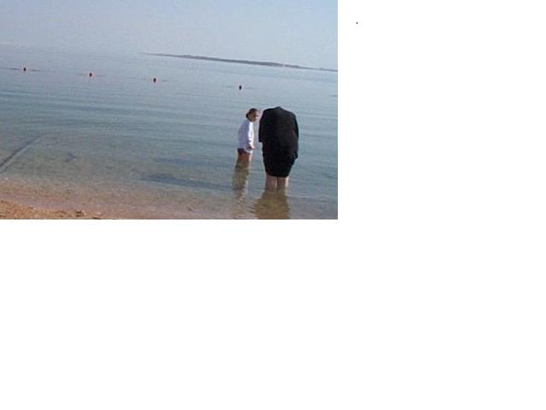  Dead Sea  Israel, January 2004 | Week 18- FINALS WEEK  ESL 266W Final –  Wednesday, December 14, 12:00-1:50  Final Exam -- Writing of 5-paragraph academic essay based on a prompt. It is worth 20% of your grade!

