Reedley College
Summer 2004
ESL 264 – 78220
Daily 8:00-1:15, LAL 1 & 2

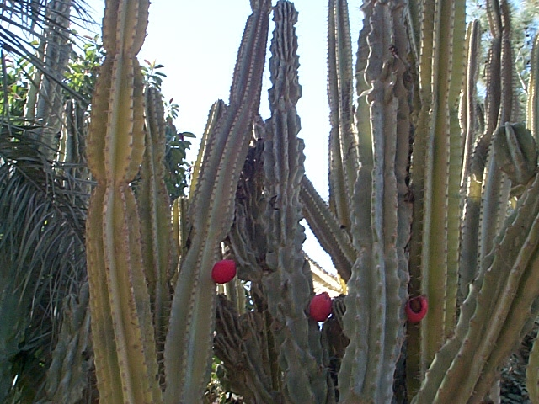

Instructor’s Name: Felisa Heller
Office: FEM 4C (Next to Math Computer Lab)
Office Hours: After class daily or by appointment
Phone Number: 638-0302
E-Mail: felisa.heller@reedleycollege.edu

Blackboard: http://10.64.4.80 (on campus)
http://198.189.163.11 (off campus)
Login: (your student number) = _______________________________
Password: “student”

Course Description: Integrated skills instruction in low-intermediate reading, writing, and grammar.
Designed to prepare speakers of other languages for ESL 265 (Intermediate).

Require Books: C. Pavlik, Grammar Sense 2 ($25.00, buy first)
S. Cisneros, The House on Mango Street ($9.95)

Objectives: A. Reading
- Read increasingly more complex materials on a variety of topics from different sources.
- Use strategies to recognize vocabulary in context
- Use strategies to increase reading comprehension and speed
- Use reading strategies in content-based and computer applications
B. Writing
- Write paragraphs and compositions in a variety of basic rhetorical styles.
- Develop content, organization, and coherence to communicate effectively in written work.
- Use content-based and word-processing applications in written work.
C. Grammar
1. Recognize and use some complex grammatical structure.
2. Apply editing, error-correction, and other skill-based strategies in written work.

Final Grade: All the points you received in the following areas will be added and a 70% of
the total is needed to receive credit (CR) in this class: homework; reading,
writing and grammar quizzes; compositions; and oral presentations.

Last Day to drop with no penalties and last day to withdraw:
June 29th and July 2nd
No Class: Monday, July 5th
^{Final Exam:} ^{Friday, August 6, 8:00 AM}
Additional Information: _________________________________________________________________
______________________________________________________________________________________
Classmates’ phone numbers: _____________________________________________________________
Classmates’ e-mails: ____________________________________________________________________

