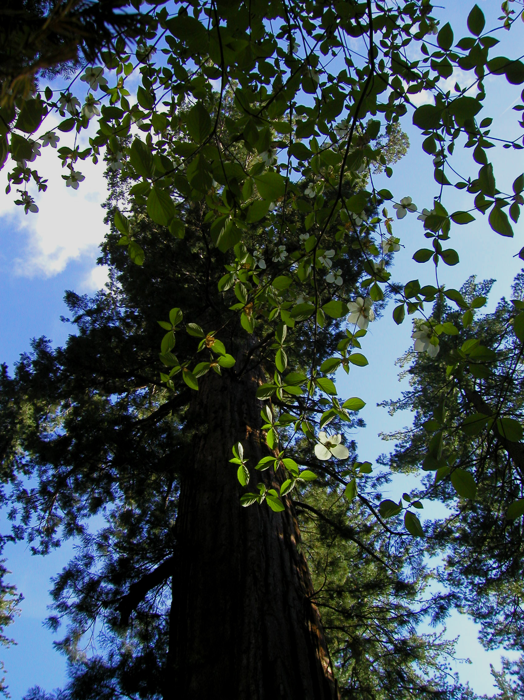
AGNR 1 – Career Preparation
Reedley College – Fall 2004
Lecture 12:00-12:50 TH FEM 7

Instructor: Jason Pinkerton
Office: FEM 3, Phone: (559) 638-3641, Ext. 3260
Office Hours: T --- 10:00-11:00, 2:00-3:00, and TH --- 10:00-11:00 other times by appointment
Email: jason.pinkerton@reedleycollege.edu

Course Objectives
Upon completion of this course, you will:
- Become familiar with the many career opportunities in forestry and natural resources.
- Develop a positive work ethic and attitude.
- Understand the importance of analyzing and comparing various career choices and the determination of jobs best suited to your abilities, needs, and interests.
- Accurately complete employment application forms.
- Effectively write a resume/personal data sheet.
- Build job search skills and procedures including verbal communication and written correspondence necessary for procuring employment.
- Develop interviewing skills and techniques.
- Enhance oral and written communication skills.

Classroom Conduct
Please turn cellular phones and pagers off during class time.

Reedley College Policies
To receive a grade for this course, students must complete all assigned work. There are NO makeup assignments for this course.

Attendance and Grading Policy
If you miss a lecture, you are responsible for obtaining notes from a classmate. Success in this class depends on the presence and active participation of each student; therefore, you are expected to attend every class. Your participation record will be considered when assigning your final grade. If you miss class >6 times during the semester (without a valid reason) you will be dropped from the course. Individual exam grades may be curved and final grades will be assigned based on a straight percentage system according to the following scale:

Course Grade | Cumulative Percent | Breakdown of Grades | Points
A | 90-100 | Application (Assignment 1) | 100
B | 80-89 | Personal File (Assignment 2) | 50
C | 70-79 | Resume (Assignment 3) | 100
D | 60-69 | Cover Letter (Assignment 4) | 50
F | <59 | Career Opportunities (Assignment 5) | 100
 |  | Scholarship Application (Assignment 6) | 50
 |  | Interview | 100
 |  | Participation | 50
 |  | TOTAL | 600

Textbook
Monica E. Breidenbach, Career Development: Strategies and Technologies for Career and Life Balance. - 4th ed. New Jersey: Patience-Hall, Inc., 2001.

LAST DAY TO DROP THE COURSE Friday, October 15th

Tentative Lecture Schedule

Date Lecture Topic Handouts

8/19 Syllabus/Class Planning Class Planning Guide
8/26 Job Applications Employment Applications OF 612
(Assignment 1)

9/2 Building a Personal File My Personal File, Assignment 2

9/9 Building a Resume Resumes, Assignment 3

9/16 NO CLASS (NR 108) Sequoia Lake Field Trip

9/23 Building a Cover Letter Cover Letters, Assignment 4

9/30 Community Involvement Volunteer Opportunities

10/7 Career Opportunities in Career Handouts
Natural Resources (Federal)

10/14 Career Opportunities in Career Handouts
Natural Resources (State)

10/21 Career Opportunities in Career Handouts Assignment 5
Natural Resources (Private)

10/28 NO CLASS (NR 109) Sequoia Lake Field Trip

11/4 Applying for Scholarships Scholarship Assignment 6

11/11 Preparing for Interviews Top Interview Questions

11/18 Professional Organizations Membership in SAF…

11/25 NO CLASS Thanksgiving Holiday

12/2 Job Interviews

12/9 Job Interviews

Finals week Job Interviews

