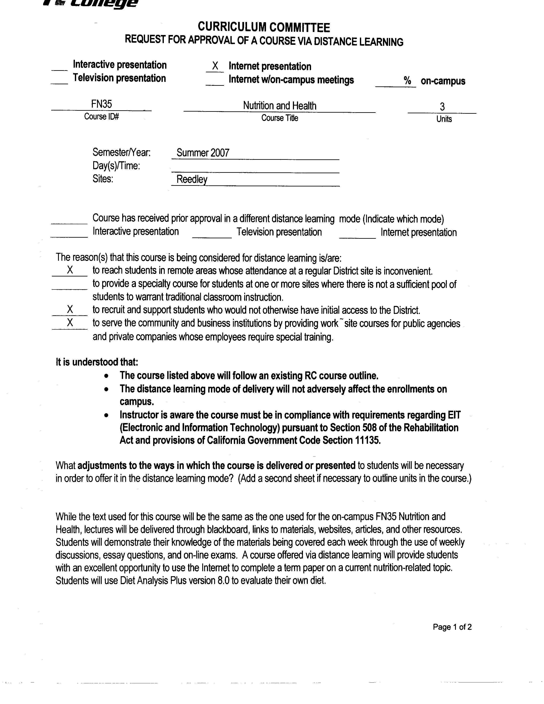
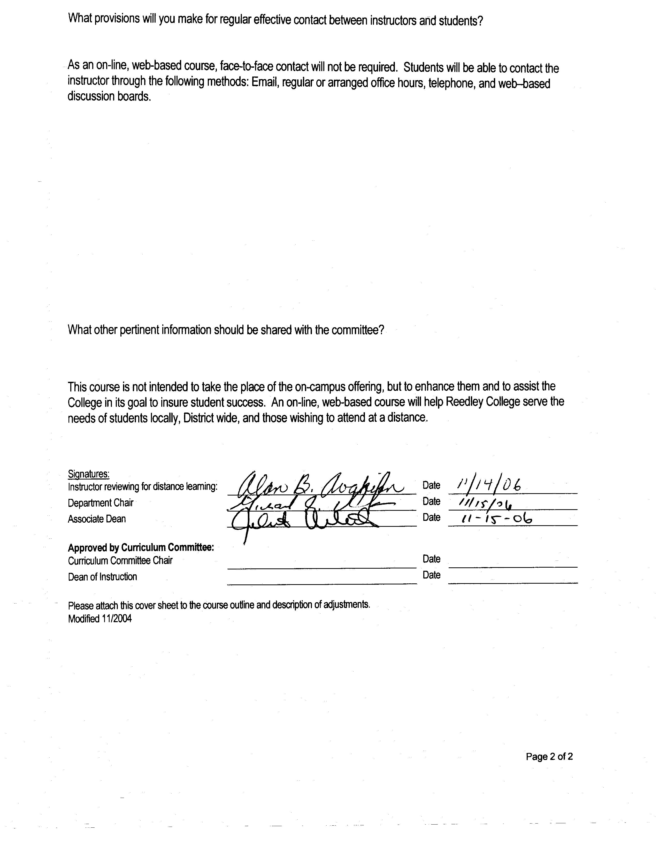


CREDIT COURSE OUTLINE

I. COVER PAGE

(1)  Course ID: FN 35 |  | (2)  Course Title: Nutrition and Health |  | (3)  Units: 3.0

(4) Lecture / Lab Hours: |  |  | (8)Classification:
Semester course  Hours per week | Lec hrs: | 3
 | Lab hrs: |  |  |  | Degree applicable: |  |  | x
Lab will generate ______ hour(s) per week outside work. |  |  |  |  | Non-degree applicable:
Short-term course:  Hours per course | Lec hrs: |  |  |  | Pre-collegiate basic skills:
 | Lab hrs:
Lab will generate ______ total hour(s) outside work. |  |  | (9)RC | Fulfills AS/AA degree requirement: (area) |  |  |  | Physical/Mental Wellness
(5)Grading Basis: | Grading scale only |  |  | General education category:
 | CR/NC option | x |  | Major:
 | CR/NC only
(6)Basic Skills Prerequisites: |  |  | (10)CSU: |  | Baccalaureate: |  |  | x
 |  |  | (11) Repeatable: (A course may be repeated  three times) |  |  |  |  | no
Basic Skills Advisories:  Eligibility for ENGL 125 and ENGL 126 or equivalent |  |  | For Office Use Only
 |  |  | CATID: 60004100 |  |  |  | DATATEL: 2814
(7)Subject Prerequisites: |  |  | Course LHE: 3.0 |  |  |  | Unit Code: 231530
 |  |  | VEA Code: N |  |  |  | SAM Priority: C
 |  |  | TOPS Code: 1306.00 |  |  |  | Effective Date: Spring 2002 (updated outcomes/objectives spring 2005)
Subject Corequisites: |  |  | CSU: E |  |  |  | Replaces:
Subject Advisories: |  |  | A, CSU-GE, UC |  |  |  | Replaced by:  Date:
(12)Catalog Description:

Relationship of diet to physical and emotional health: nutrients, diet patterns throughout the life cycle. Optimal nutrition to reduce the risks of cancer, heart disease, allergies, and other diseases. Social, psychological, and cultural dictates which affect food selection and health. Personal strategies to develop a nutrition plan for better health. Designed for students with an interest in Food Services. Not open to students with credit in FN 40, Nutrition.

Course ID: FN 35 |  | Course Title: Nutrition and Health

II. COURSE OBJECTIVES:

(Specify major objectives in terms of the observable knowledge and/or skills to be attained.)

In the process of completing this course, students will:

A. identify the social, physiological and cultural factors that influence food choices throughout the life cycle.
B. describe the body’s basic need for nutrients and give the details of many of the body systems as they relate to nutrition.
C. compare nutrition information from a scientific perspective to distinguish from fallacy.
D. use the concept of food grouping and exchange systems.
E. identify the major functions of carbohydrates, lipids, protein, vitamins, minerals and water.
F. describe food patterns that increase the risk of health problems an recommend appropriate modifications in dietaries to
reduce the risk of developing health problems.
G. compare his/her nutrient intake to that of the U.S. Recommended Dietary Allowances.

III. COURSE CONTENT OUTLINE:

A. Human Physiology and Nutrition
B. Diet Planning
C. Diet and Disease
D. The Carbohydrates
E. The Lipids
F. The Proteins
G. The Vitamins
H. Minerals and Water
I. Energy Balance and Weight Control
J. Nutrition and the consumer
K. Food Technology and Safety
L. Nutrition Assessment
M. Nutrition throughout the Life Cycle
N. World Food and Hunger

Course ID: FN 35 |  | Course Title: Nutrition and Health

IV. APPROPRIATE READINGS

Reading assignments may include but are not limited to the following:

1. Sample Text Title:

A. Nutrition: Concepts and Controversies, Sizer/Whitney 9th ed.

x | Global or international materials or concepts are appropriately included in this course
x | Multicultural materials and concepts are appropriately included in this course.

If either line is checked, write a paragraph indicating specifically how global/international and/or multicultural materials and concepts relate to content outline and/or readings.

This course will explore many ethnic foodways to show how basic diet-planning principles can apply to many different cuisines.

Students will have the opportunity to learn about global environmental choices which may help solve the hunger problem, improve the quality of life, and generate jobs.

Course ID: FN 35 |  | Course Title: Nutrition and Health

V. METHODS TO MEASURE STUDENT ACHIEVEMENT AND DETERMINE GRADES:
Students in this course will be graded in at least one of the following four categories. Please check those appropriate. A degree applicable course must have a minimum of one response in category A, B or C.

A. Writing
Check either 1 or 2 below
x | 1. Substantial writing assignments are required. Check the appropriate boxes below and provide a written description in the space provided.
 | 2. Substantial writing assignments are NOT required. If this box is checked leave this section blank. For degree applicable courses you must complete category B and/or C.
 | a. essay exam(s) | x | d. written homework
x | b. term or other papers(s) | x | e. reading reports
 | c. laboratory reports |  | f. other (specify)
Required assignments may include but are not limited to the following:

1. Written assignments require students to compare a Nutrition News Article from a scientific perspective to distinguish fact from fallacy.

B. Problem Solving
1. Computational or non-computational problem-solving demonstrations, including:
x | a. exam(s) |  | d. laboratory reports
 | b. quizzes |  | e. field work
x | c. homework problems |  | f. other (specify)

Required assignments may include, but are not limited to the following:

1. Analyze diet
2. Evaluate diet

Course ID: FN 35 |  | Course Title: Nutrition and Health

C. Skill demonstrations, including:
x | a. class performance(s) |  | c. performance exam(s)
 | b. field work |  | d. other (specify
Required assignments may include, but are not limited to the following:

1. Class participation in exercises involving critiques and comparisons of food group plans.
2. Students will define nutrition terms.

D. Objective examinations, including:
x | a. multiple choice |  | d. completion
x | b. true/false |  | e. other (specify)
 | c. matching items

Description/Explanation: Based on the categories checked, it is the recommendation of the department that the instructor’s grading methods fall within the following departmental guidelines; however, the final method of grading is still at the discretion of the individual instructor. The instructor’s syllabus must reflect the criteria by which the student’s grade has been determined. (A minimum of five (5) grades must be recorded on the final roster.)

If several methods to measure student achievement are used, indicate here the approximate weight or percentage each has in determining student final grades.

50% Exams 20% Diet Plan 10% Reading reports and critiques
10% Homework 10% Participation
FOR DEGREE APPLICABLE COURSES

Course ID: FN 35 |  | Course Title: Nutrition and Health

VI. COURSE OUTCOMES:

(Specify the learning skills the student demonstrates through completing the course and link critical thinking skills to specific course content and objectives.)

Upon completion of this course, students will be able to:

A. critically evaluate nutrition information.
B. analyze the relationship between diet and disease in order to apply to life’s situations.
C. evaluate their dietary intake and as a basis for making lifelong dieting choices.
FOR DEGREE APPLICABLE COURSES

Course ID: FN 35 |  | Course Title: Nutrition and Health

VII. EDUCATIONAL MATERIALS
For degree applicable courses, the adopted texts, as listed in the college bookstore, or instructor-prepared materials have been certified to contain college-level materials.

Validation Language Level (check where applicable): |  | College-Level  Criteria Met
 |  | Yes | No
Textbook |  | x
Reference materials |  | x
Instructor-prepared materials |  | x
Audio-visual materials |  | x
Indicate method of evaluation:
 | Used readability formulae (grade level 10 or higher)
x | Text is used in a college-level course
 | Used grading provided by publisher
 | Other: (please explain; relate to Skills Levels)
Computation Level (Eligible for MATH 101 level or higher where applicable) |  |  | x

Content
Breadth of ideas covered clearly meets college-level learning objectives of this course |  | x
Presentation of content and/or exercises/projects:
Requires a variety of problem-solving strategies including inductive and deductive reasoning. |  | x
Requires independent thought and study |  | x
Applies transferring knowledge and skills appropriately and efficiently to new situations or  problems. |  | x
List of Reading/Educational Materials
1. Text (sample):

A. Nutrition: Concepts and Controversies, Sizer/Whitney 9th ed.

Comments:

 | This course requires special or additional library materials (list attached).
x | This course requires special facilities: Classroom with LCD Projector and occasional use of computer lab

FORM A
TARGET COURSE | FN 35 |  | Nutrition and Health
 | Number |  | Title

BASIC SKILLS ADVISORIES PAGE The skills listed are those needed for “eligibility for English 125, 126, and Math 101.” These skills are listed as the outcomes from English 252, 262, and Math 250. In the right hand column, list at least three major basic skills needed at the beginning of the target course and check off the corresponding basic skills listed at the left.
Math Skills (eligibility for Math 101)
(as outcomes for Math 250)

Performing the four arithmetic operations on whole numbers, arithmetic fractions, and decimal fractions.
Making the conversions from arithmetic fractions to decimal fractions, from decimal fractions to percents, and then reversing the process.
Applying the concepts listed above to proportions, percents, simple interest, markup and discount.
Applying the operations of integers in solving simple equations.
Converting between the metric and English measurement systems
Reading Skills (eligibility for English 126)  (as outcomes for English 262)  x Using phonetic, structural, contextual, and dictionary skills to attack and understand words.  x Applying word analysis skills to reading in context.  x Using adequate basic functional vocabulary skills.  x Using textbook study skills and outlining skills.  x Using a full range of literal comprehension skills and basic analytical skills such as predicting, inferring, concluding, and evaluating. | 1. Ability to read and comprehend a college level textbook is crucial to success in this course.  2. Ability to convert textbook chapters and classroom notes is important for study purposes.  3. Ability to transfer text to classroom applications.
Writing Skills (eligibility for English 125)  (as outcomes for English 252)  x Writing complete English sentences and avoiding errors most of the time.  x Using the conventions of English writing: capitalization, punctuation, spelling, etc.  x Using verbs correctly in present, past, future, and present perfect tenses, and using the correct forms of common irregular verbs.  x Expanding and developing basic sentence structure with appropriate modification.  x Combining sentences using coordination, subordination, and phrases.  x Expressing the writer's ideas in short personal papers utilizing the writing process in their development. | 1. Ability to compose well-organized, clear, and analytical responses to writing assignments.  2. Ability to write basic responses to homework assignments.  3. Ability to write notes from text and lecture materials.
Check the appropriate spaces.
Eligibility for Math 101 is advisory for the target course.
x Eligibility for English 126 is advisory for the target course.
x Eligibility for English 125 is advisory for the target course.
If the reviewers determine that an advisory or advisories in Basic Skills are all that are necessary for success in the target course, stop here, provide the required signatures, and forward this form to the department chair, the appropriate associate dean, and the curriculum committee.

Content review completed by |  | Date

