
CURRICULUM COMMITTEE
REQUEST FOR APPROVAL OF A COURSE VIA DISTANCE LEARNING

 | Interactive presentation | x | Internet presentation
 | Television presentation |  | Internet w/on-campus meetings | 0% | on-campus

Course ID# NR 7 |  | Course Title Conservation of Natural Resources |  | Units 3

Semester/Year: |  | SP 2007
Day(s)/Time: |  | ARR
Sites: |  | NA

x | Course has received prior approval in a different distance learning mode (Indicate which mode)
x | Interactive presentation |  | Television presentation |  | Internet presentation

The reason(s) that this course is being considered for distance learning is/are:
x | to reach students in remote areas whose attendance at a regular District site is inconvenient?
 | to provide a specialty course for students at one or more sites where there is not a sufficient pool of
 | students to warrant traditional classroom instruction.
x | to recruit and support students who would not otherwise have initial access to the District.
 | to serve the community and business institutions by providing work-site courses for public agencies
 | and private companies whose employees require special training.

It is understood that:
- The course listed above will follow an existing RC course outline.
- The distance learning mode of delivery will not adversely affect the enrollments on campus.
- Instructor is aware the course must be in compliance with requirements regarding EIT (Electronic and Information Technology) pursuant to Section 508 of the Rehabilitation Act and provisions of California Government Code Section 11135.

What adjustments to the ways in which the course is delivered or presented to students will be necessary in order to offer it in the distance learning mode? (Add a second sheet if necessary to outline units in the course.)

Conservation of Natural Resources, NR 7, has been offered in traditional lecture and interactive mode for several years. It was the first course from Reedley College to be taught in distance mode. Using the Fujitsu system the course emanated from Reedley to Clovis and Oakhurst. The class is currently taught using presentation software, and accompanying note outlines via the forestry web page and as of late, blackboard. Adjustments to existing modes of teaching include frequent e-mail, blackboard discussion groups, telephone and personal contact when necessary. The class should lend itself well to internet presentation.

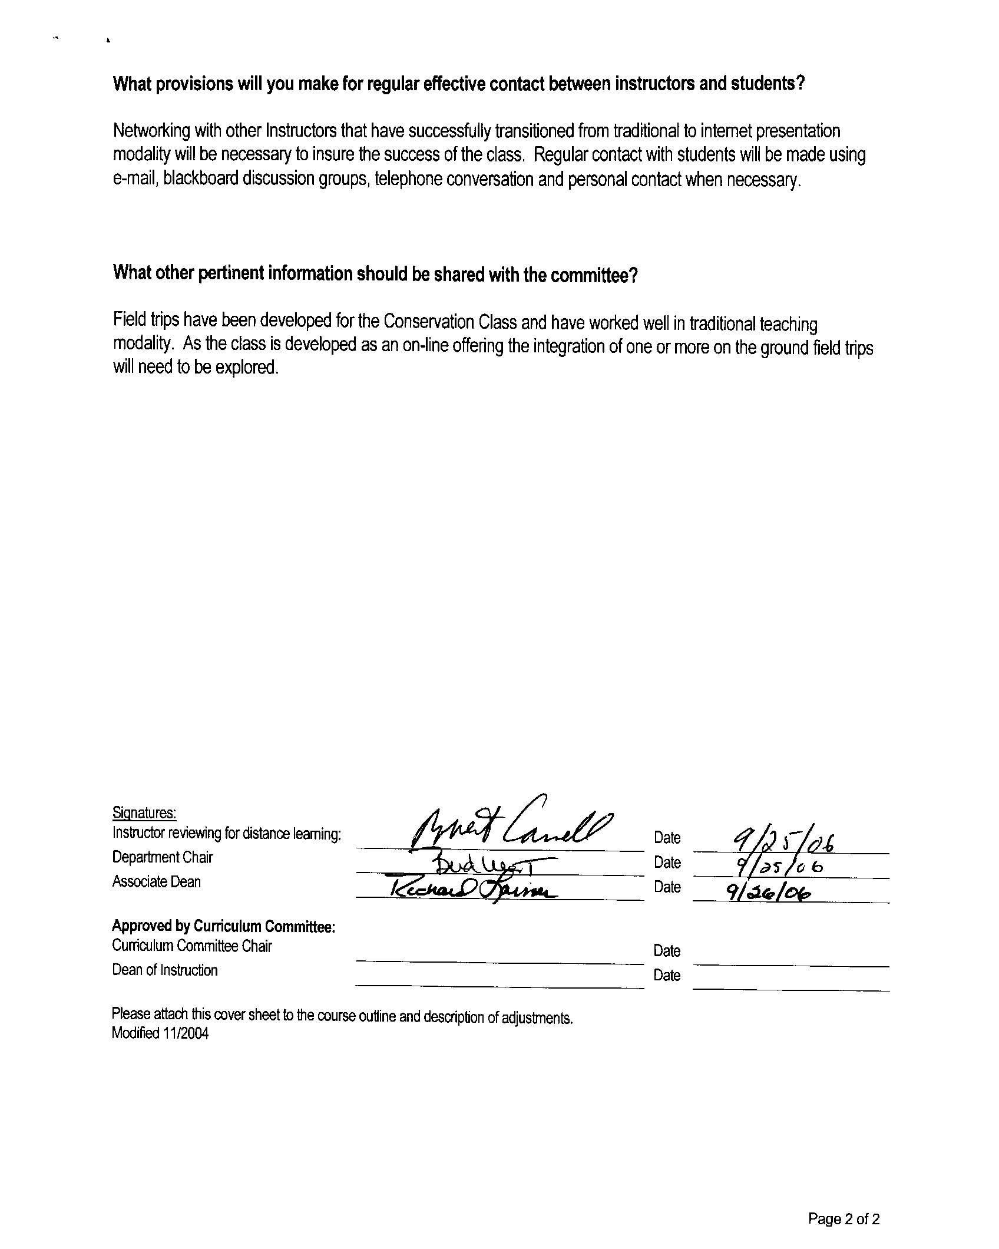
Original submission

