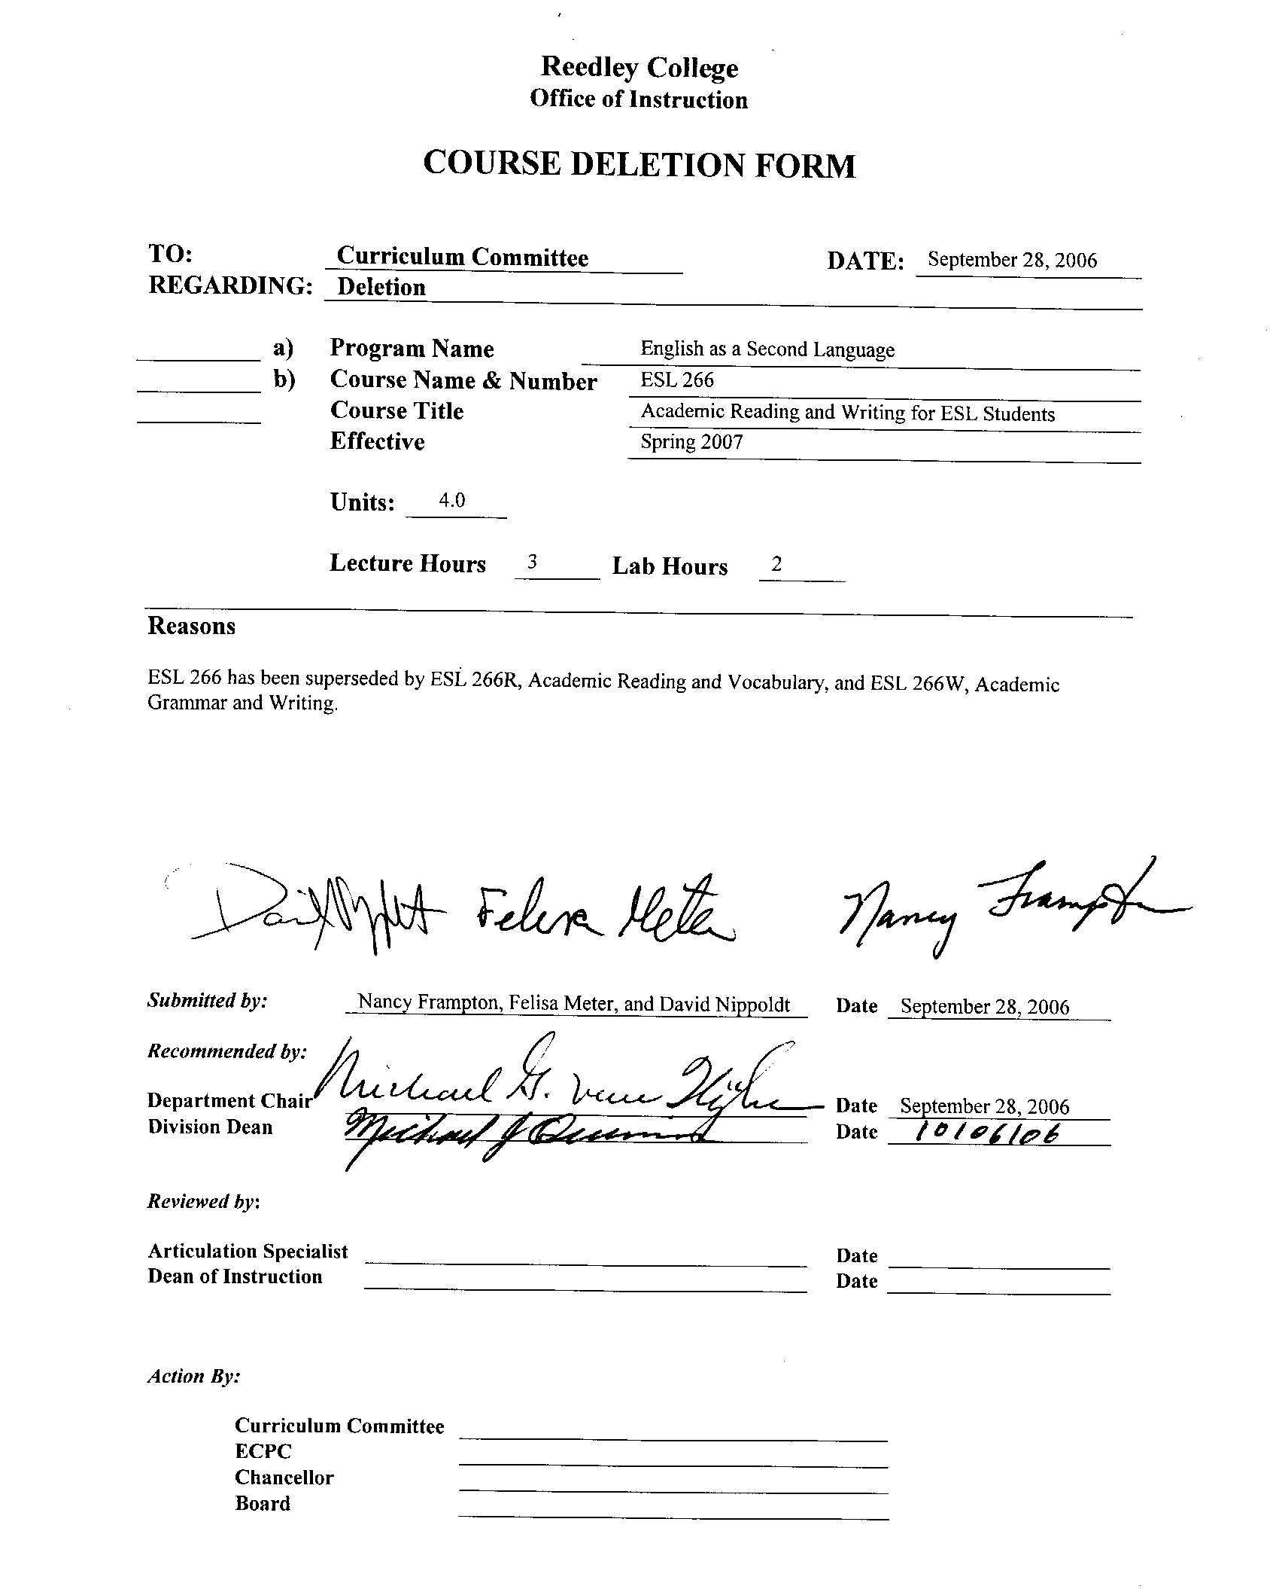


CREDIT COURSE OUTLINE

I. COVER PAGE

(1)  Course ID: ESL 266 |  | (2)  Course Title: Academic Reading and Writing for ESL Students |  | (3)  Units: 4.0

(4) Lecture / Lab Hours: |  |  | (8)Classification:
Semester course  Hours per week | Lec hrs: | 3
 | Lab hrs: | 2 |  |  | Degree applicable:
Lab will generate ______ hour(s) per week outside work. |  |  |  |  | Non-degree applicable: |  |  |  | x
Short-term course:  Hours per course | Lec hrs: |  |  |  | Pre-collegiate basic skills: |  |  |  | x
 | Lab hrs:
Lab will generate ______ total hour(s) outside work. |  |  | (9)RC | Fulfills AS/AA degree requirement: (area)
(5)Grading Basis: | Grading scale only |  |  | General education category:
 | CR/NC option |  |  | Major:
 | CR/NC only | x
(6)Basic Skills Prerequisites: |  |  | (10)CSU: |  | Baccalaureate: |  |  |  | no
 |  |  | (11) Repeatable: (A course may be repeated  three times) |  |  |  |  |  | 2
Basic Skills Advisories:
Appropriate placement score on accredited ESL test such as the CELSA.
 |  |  | For Office Use Only
(7)Subject Prerequisites:  ESL 265 |  |  | CATID: 10384703 |  |  | DATATEL: 2911 |  | Org Code: 241510
 |  |  | Tops Code: 1501.00 |  |  |  |  | SAM Priority: C
 |  |  | VEA Code: N |  |  |  |  | Course LHE: 4.50
Subject Corequisites: |  |  | Effective Date: Fall 2002 |  |  |  |  | Replaces: ESL 66  10384702
Subject Advisories: |  |  | CSU GE Code: 9.2 |  |  |  |  | Replaced by: ESL 266R  Date: Fall 2004
(12)Catalog Description:

An English class for students who are completing ESL training or are nearly fluent in English but who need further language training to help them succeed in the sequence of English courses offered at the college.

11/00

Course ID: ESL 266 |  | Course Title: Academic Reading and Writing for ESL Students

II. COURSE OBJECTIVES:

(Specify major objectives in terms of the observable knowledge and/or skills to be attained.)

Students should be able to demonstrate the following competencies:

A. analyze linguistic usage in L1 (first language) that interferes with correct usage of L2 (second language), for example, the syntactical arrangement of adjectives in Spanish.

B. recognize appropriate linguistic translations and translations that are not appropriate.

C. refine use of English stress, intonation patterns, and pronunciation.

D. use cognates in English when appropriate, paying special attention to English collocation restrictions.

E. use new English vocabulary and idiomatic expressions appropriately in conversation and written work.

F. use standard English spelling, punctuation and capitalization.

G. construct sentences using English grammar and mechanical conventions.

H. read and use basic reading, reference texts, and library resource material to enhance vocabulary development, language learning, and the understanding of general content information.

I. select styles of English appropriate to the audience and situation (i.e., slang, informal, and formal).

III. COURSE CONTENT OUTLINE:

A. Grammar Skills The emphasis in grammar will be placed on differentiating between L1 and L2 usage in the following areas:

1. Comparison of similar syntactical and morphological features.
2. Syntactical arrangement of sentence patterns.
3. Subject-verb agreement rules.
4. Placement and usage of adjective/adverb modification structures.
5. Pronoun usage, especially in extended discourse.
6. English verb conjugations denoting time and person vs. conjugation denoting person, case, and time.
7. Contrast between L1 and L2 usage of particular parts of speech in terms of appropriate context and frequency of use.
8. Practice with particular structures in L1 that cause interferences with correct usage in L2; e.g., negation, (avoiding double negatives).
9. Structures with variant forms, as determined by semantics and grammar: (e.g., verbals: infinitives, gerunds, participles; conditional forms).
10. Grammatical usage affected by sociolinguistic factors (e.g., the use of reflexive pronouns and passive voice which tend to be used more in some languages).
11. Grammatical errors that occur because of direct translation (e.g., prepositions used to express purpose, "for" vs "to");
12. Practice with common verbs, tenses and verbal expressions (e.g., "ask for", "know how", "listen to", "look at")
13. Practice with inverted question patterns auxiliaries, and negative structures.

B. Reading Skills

1. using context clues for comprehension and vocabulary development
2. identifying topic, main idea, supporting details

Course ID: ESL 266 |  | Course Title: Academic Reading and Writing for ESL Students

C. Writing Skills

1. practice using simple, complex, compound sentences with appropriate conjunctions and transition words
2. varying writing styles by using explanatory, imperative, and descriptive sentences
3. organizing thoughts into a logical sequence
4. dividing text into paragraphs
a. topic sentence
b. kinds of supporting details
c. logical order of sentences
5. proofreading, revising and editing

Course ID: ESL 266 |  | Course Title: Academic Reading and Writing for ESL Students

IV. APPROPRIATE READINGS

Reading assignments may include but are not limited to the following:

1. Text (sample):

- Linda Watkins-Goffman. Many Voices: A Multicultural Reader. New Jersey: Prentice Hall, 2001.
- Pamela Hartman. Quest 3: Reading and Writing in the Academic World. Boston: McGraw-Hill, 1999.
- Linda Lonon Blanton. The Multicultural Workshop: A Reading and Writing Program, Book 3. Boston: Heinle & Heinle Publishers, 1994.

In addition, the non-fiction list from which students choose a book to read and write about, includes biographies of minorities and world figures such as:

- Diego Rivera
- Frida Kahlo
- Gandhi
- Martin Luther King Jr.
- Maya Angelou
- Langston Hughes
- Pablo Neruda
- Gabriel Garcia Marquez

x | Global or international materials or concepts are appropriately included in this course
x | Multicultural materials and concepts are appropriately included in this course.

If either line is checked, write a paragraph indicating specifically how global/international and/or multicultural materials and concepts relate to content outline and/or readings.

The textbooks and materials chosen will reflect the multicultural make-up of both the nation and the campus. Students will become familiar with the U.S., which will facilitate their transition to an English-speaking, multicultural society.

Textbooks and materials will reflect the global background of ESL students.

Course ID: ESL 266 |  | Course Title: Academic Reading and Writing for ESL Students

V. METHODS TO MEASURE STUDENT ACHIEVEMENT AND DETERMINE GRADES:
Students in this course will be graded in at least one of the following four categories. Please check those appropriate. A degree applicable course must have a minimum of one response in category A, B or C.

A. Writing
Check either 1 or 2 below
x | 1. Substantial writing assignments are required. Check the appropriate boxes below and provide a written description in the space provided.
 | 2. Substantial writing assignments are NOT required. If this box is checked leave this section blank. For degree applicable courses you must complete category B and/or C.
x | a. essay exam(s) | x | d. written homework
 | b. term or other papers(s) | x | e. reading reports
 | c. laboratory reports |  | f. other (specify)
Required assignments may include but are not limited to the following:

1. essay exams such as those based on themes of readings
2. written homework such as summaries, free writing, journal entries and compositions
3. reading reports such as book reports on a fiction or non-fiction book

B. Problem Solving
1. Computational or non-computational problem-solving demonstrations, including:
 | a. exam(s) |  | d. laboratory reports
 | b. quizzes |  | e. field work
 | c. homework problems |  | f. other (specify)

Required assignments may include, but are not limited to the following:

Course ID: ESL 266 |  | Course Title: Academic Reading and Writing for ESL Students

C. Skill demonstrations, including:
x | a. class performance(s) |  | c. performance exam(s)
 | b. field work |  | d. other (specify)
Required assignments may include, but are not limited to the following:

1. class performance such as an oral presentation of their book report

D. Objective examinations, including:
x | a. multiple choice | x | d. completion
x | b. true/false | x | e. other (specify)
x | c. matching items

1. Short essay

Description/Explanation: Based on the categories checked, it is the recommendation of the department that the instructor’s grading methods fall within the following departmental guidelines; however, the final method of grading is still at the discretion of the individual instructor. The instructor’s syllabus must reflect the criteria by which the student’s grade has been determined. (A minimum of five (5) grades must be recorded on the final roster.)

If several methods to measure student achievement are used, indicate here the approximate weight or percentage each has in determining student final grades.

40% written homework
25% essay exams
10% skill demonstrations
25% objective exams

FORM B
TARGET COURSE | ESL 266 |  | Academic Reading and Writing for ESL Students
 | Number |  | Title

CONTENT REVIEW FOR ALL COURSES IN ADDITION TO BASIC SKILLS COURSES
List in Column 1 at least three specific major concepts, skills, or kinds of knowledge that a student will learn in the pre- or corequisite or advisory course that are essential to the successful completion in the target course. In Column 2, state why the skill in Column 1 is essential in relation to the content listed in the course outline of the target course.

COLUMN 1: Concepts, Skills, Kinds of Knowledge | COLUMN 2: Specifically how this is necessary in the target course
(List each prerequisite or advisory separately here. If you need more space, attach a second page B. Be sure to explain each course in Column 2.)  Name of prerequisite or advisory course:  ESL 265 _  Concepts, skills, etc. (List these.)  A. Grammar  1. Recognize and use more complex grammatical structures and sentence patterns in speaking and writing.  B. Writing  1. Write paragraphs and short compositions on a range of topics.  2. Summarize printed and pre-recorded material.  C. Listening Comprehension  1. Understand pre-recorded material of increasing difficulty (i.e., from controlled to authentic).  2. Respond to pre-recorded material both orally and in writing.  D. Speaking  1. Use increasingly more complex structures and vocabulary to communicate effectively in a wide range of situations and on a variety of topics.  E. Reading and Vocabulary  1. Read increasingly more complex topics from different sources.  2. Use strategies to recognize vocabulary in context.  3. Use strategies to increase reading and speed and comprehension. | A. To analyze linguistic usage in L1 that interferes with correct usage of L2.  B. To write paragraphs, including a book report, in logical sequence and proofread.  C. To do formal oral presentations, communicate in small groups, and follow lectures.  D. To read lengthy and advanced level texts.

If the courses listed in Column 1 are advisory, complete the information below and do not go on to the next page.

Advisory course(s):

Content review completed by
 | Signature(s) |  | Date

Dean's Signature
Date

Please forward this completed form to the Curriculum Committee.
Reedley College

REQUEST FOR COURSE REPEATABILITY
(For reasons other than alleviating substandard work)

Course ID: ESL 266 |  | Course Title: Academic Reading and Writing for ESL Students | Date: 11/08/01
Number of times course may be repeated, excluding initial enrollment (1, 2, or 3):
or
Maximum units to which course may be repeated, including initial enrollment:

The following information is required under Title V, Part VI, Section 58161
- Explain how the course content differs each time it is offered:

- The required text is changed once a year. Therefore, there are new readings introduced with each new book.
- The book reports—on fiction and the other non-fiction—are based on a different list each semester the course is offered
- There is more than one instructor teaching the course. Therefore, if the student takes the course more than once, the emphasis and teaching styles differ from semester to semester.

2. Using reasons “A” or “B” listed below, explain how the student, by repeating this course will gain an expanded educational experience (A or B):
 | A. Skills or proficiencies are enhanced by supervised repetition and practice within class periods. Explanation:
- Some students need more time on task to develop reading and writing skills, especially those that have a weak first language background.
- Editing and vocabulary development are essential in developing fluency in reading and writing. Repetition and practice will enhance the learning.
 | B. Active Participatory experience in individual study or group assignments is the basic means by which learning objectives are attained. Explanation:

