Reedley College
Proposed Course Modification

Course # / Title | AS 40 Fairs & Expositions

CHECK OFF SHEET
PRELIMINARY STEPS. Do before completing Course Modification Form.
(EACH BOX SHOULD BE CHECKED AS COMPLETED BEFORE SUBMISSION.)
☑ 1. Communicate with the Curriculum Chair regarding intent to modify an existing course outline (recommended, not required).
☑ 2. List term for implementation of modifications:
[ ] | Fall |  | [ X ] | Spring | 2007 | [ ] | Summer
☑ 3. Check one:
Do not complete Fresno City College course alignment page if:
X | No similar course or program at FCC.
 | Course currently in common with FCC course or accepted in lieu of and changes will not affect status.

Complete Fresno City College course alignment page if:
Course currently in common with FCC course or accepted in lieu of. Changes may affect status. Consult with counterparts at FCC and complete alignment page
Course not in common or accepted in lieu of but may be with proposed changes consult with FCC counterparts

☑ 4. Changes sought in the following:

CSU General Education Code | Yes |  | No | X
Transfer Baccalaureate List | Yes |  | No | X

If yes to either, schedule an appointment with the Articulation Officer
☑ 5. Changes sought in number of repeats for credit:

 | Yes
X | No

If yes, secure a Course Repetition form from the Curriculum Office.
PROPOSED COURSE MODIFICATION FORM
☑ Appropriate sections of Course Outline of Record completed.

FINAL steps (Do after completing Course Outline of Record)

☑ 1. Signature Form. Secure signatures of the Department Chair and the Associate Dean before submitting the completed course proposal to the Curriculum Office.

☑ 2. Program Description. Course modification will change an existing program which is or will be described in the college catalogue.

 | Yes | X | No

If yes, complete Program Description Form before submitting modification.

☑ 3. Final Check. All items above have been completed and checked off before modification is submitted.

Reedley College
PROPOSED COURSE MODIFICATION

All changes and modifications in the official course outline must come to the Curriculum Committee. Though minor changes may seem obvious, even these need to come to committee for information and to update the official curriculum. Changes in programs or in several department offerings should be submitted together if possible so that the whole picture is clear.

OUTLINE. Please fill in current existing course number, title, and units for course to be modified.

Department | Agriculture, Natural Resources, Manufacturing | Course No. | AS 40
Course Title | Fairs & Expositions | Units | 2
 | Effective Date | Spring 2007

A. PROPOSED CHANGES.
(Indicate below all proposed changes to be made in the course outline.)

I. Cover Page
 | 1. Course ID |  |  | 8. Classification (Degree applicable, Non-degree applicable, or
 | 2. Course Title |  |  | Pre-collegiate Basic skills)
 | 3. Units |  |  | 9. General Education Pattern, Graduation Requirement, and
 | 4. Lecture/Lab Hours |  |  | Major Category
 | 5. Grading Basis |  |  | 10. General Education Pattern/Baccalaureate (CSU)
 | 6. Entrance Skills: Basic Skills Prerequisites/Advisories |  |  | 11. Repeatability
 | 7. Subject Prerequisites/Corequisites/Advisories |  |  | 12. Catalog Description

Other pages

X | II. Course Outcomes |  | X | VI. Methods of Grading
X | III. Course Objectives |  |  | VII. Levels of Educational Materials
X | IV. Course Content Outline |  | Additional Pages (optional depending on course)
X | V. Approved Readings |  |  | Request for Repeatability/Limitation on Enrollment

B. DESCRIPTION OF CHANGES AND MODIFICATIONS.

ITEM NO. | CHANGED FROM | CHANGED TO | REASON
II | Old format | New format | Separate outcomes and objectives
III | Old format | New format | Separate outcomes and objectives
IV | Old course outline | New course outline | Update
V | See old document | See new document | Update
VI | Old format | New format | Updated components of grades
VII | See old document | See new document | Added to list; added special facilities

(Additional sheets may be attached if necessary.)

C. EXPLANATIONS. If course modification results in changes in the program which will require use of the program description form, please give rationale.

Please attach the complete outline before modifications to this form. If only the first page of the outline is being modified, also attach the new first page. If other pages of the outline are being modified, please attach the complete new outline.

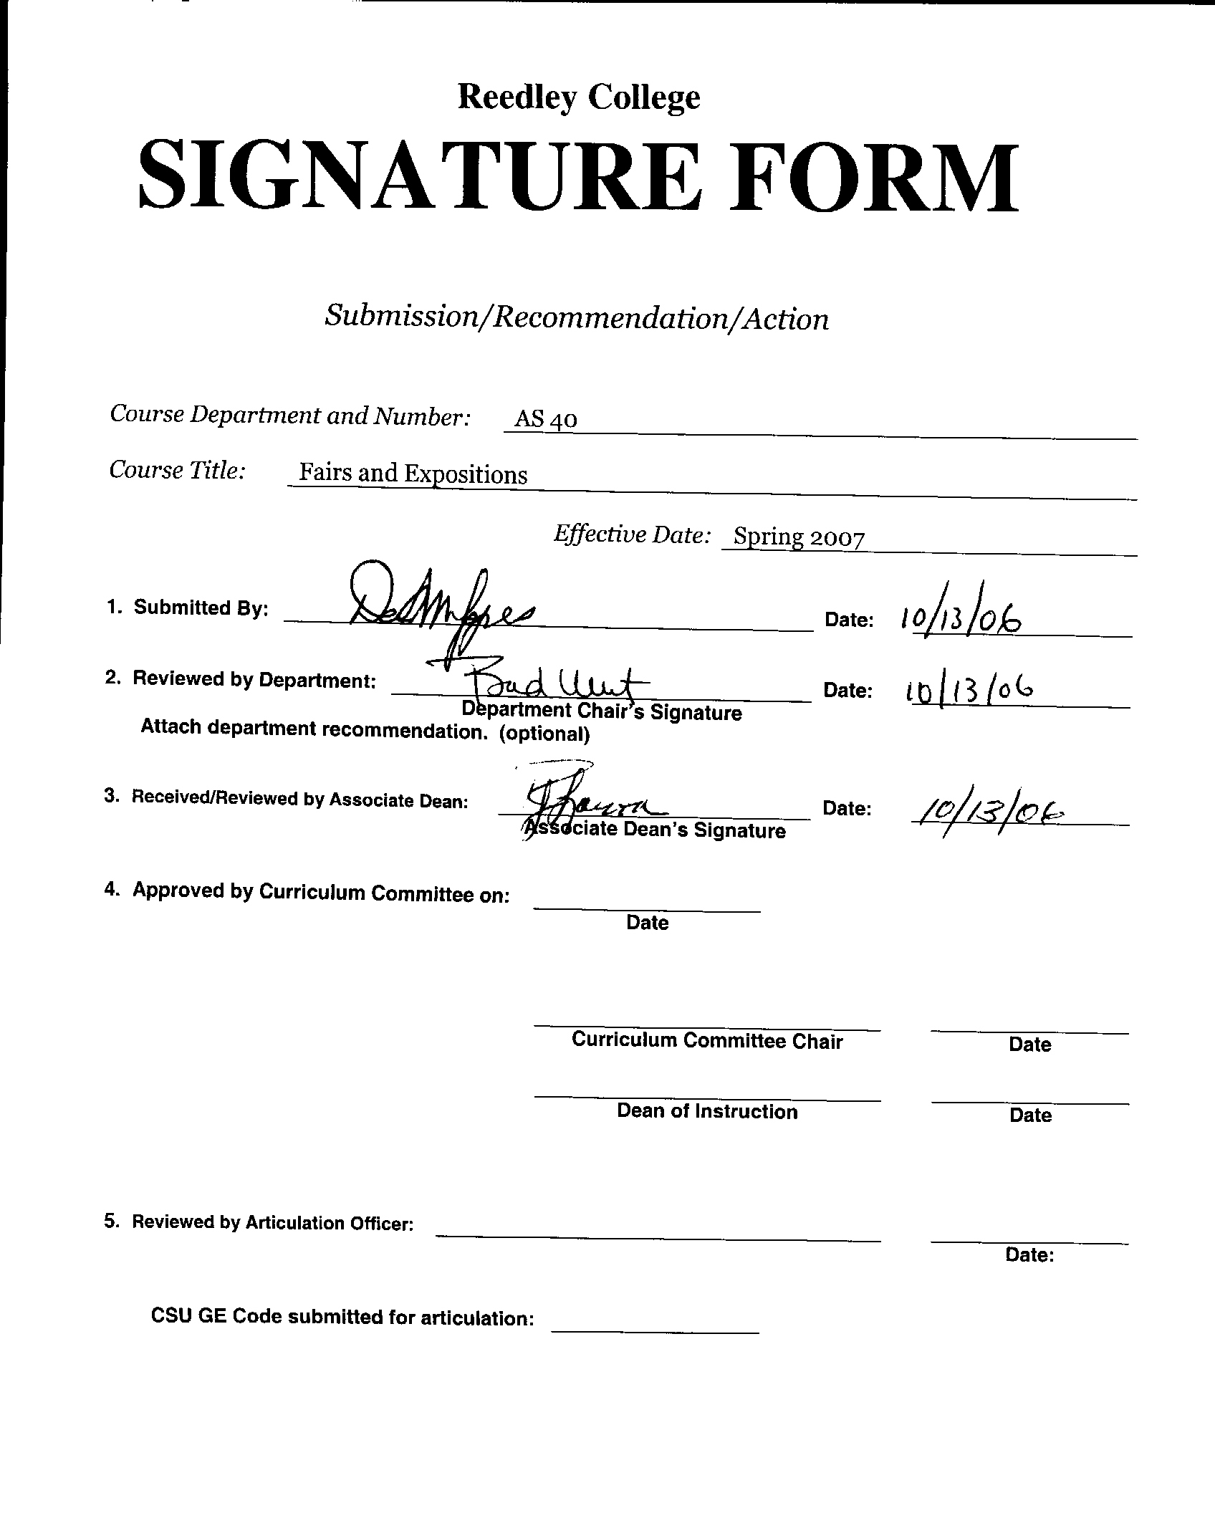


CREDIT COURSE OUTLINE

I. COVER PAGE

(1)  Course ID: AS 40 |  | (2)  Course Title: Fairs and Expositions |  | (3)  Units: 2

(4) Lecture / Lab Hours: |  |  | (8)Classification:
Semester course  Hours per week | Lec hrs: | 1
 | Lab hrs: | 3 |  |  | Degree applicable: |  |  | X
Lab will generate ______ hour(s) per week outside work. |  |  |  |  | Non-degree applicable:
Short-term course:  Hours per course | Lec hrs: |  |  |  | Pre-collegiate basic skills:
 | Lab hrs:
Lab will generate ______ total hour(s) outside work. |  |  | (9)RC | Fulfills AS/AA degree requirement: (area)
(5)Grading Basis: | Grading scale only | X |  | General education category:
 | CR/NC option |  |  | Major:
 | CR/NC only
(6)Basic Skills Prerequisites: |  |  | (10)CSU: |  | Baccalaureate: |  |  | X
 |  |  | (11) Repeatable: (A course may be repeated  three times) |  |  |  |  | 3
Basic Skills Advisories:  Eligibility for ENGL 125, ENGL 126 |  |  | For Office Use Only
 |  |  | CATID: |  |  |  | DATATEL:
(7)Subject Prerequisites (requires C grade or better): |  |  | Course LHE: 3.25 |  |  |  | Unit Code:
 |  |  | VEA Code: Y |  |  |  | SAM Priority: C
 |  |  | TOPS Code: 0101.00 |  |  |  | Effective Date:
Subject Corequisites: |  |  | CSU: |  |  |  | Replaces:
Subject Advisories: |  |  |  |  |  |  | Replaced by:  Date:
(12)Catalog Description:

A practical field course to introduce students to the subject of fairs, sales, and expositions, their rules, regulations, judging, scoring, and entry procedures for livestock and horses. Emphasis will be placed on animal handling techniques and the exhibition, showmanship, and management of animals on display in a public setting.

Course ID: AS 40 |  | Course Title: Fairs and Exposition

II. COURSE OUTCOMES:

(Specify the learning skills the student demonstrates through completing the course and link critical thinking skills to specific course content and objectives.)

Upon completion of this course, students will be able to:

- Select animals that are appropriate for show projects by evaluating strengths and weaknesses in conformation
- Apply safe and ethical animal handling techniques to the management, care and exhibition of a selected species of livestock
- Perform basic veterinary procedures commonly required for optimal management and care of a selected livestock species
- Apply a high level of work ethic, time management skills, and teamwork to the attainment of group goals and objectives

III. COURSE OBJECTIVES:

(Specify major objectives in terms of the observable knowledge and/or skills to be attained.)

In the process of completing this course, students will:

- Identify and correctly utilize the facilities, equipment, tools, and supplies needed for the successful management, care, and exhibition of a selected livestock species
- Determine the appropriate division and class categories (by species, age, and purpose) for a selected species of livestock by using a fair premium book
- Complete and submit livestock show entries
- Work in group settings to establish and accomplish team goals
- Train, feed, groom and prepare livestock for exhibition
- Discuss major issues, trends, and challenges facing the livestock show industry

Course ID: AS 40 |  | Course Title: Fairs and Expositions

IV. COURSE CONTENT LECTURE OUTLINE:

- Introduction To Fairs, Sales, And Expositions
  - State Rules And Eligibility Requirements
  - Using A Premium Book
  - Completing Entry Forms
  - Animal Health Requirements
- Evaluation & Selection Of Show Project Animals
  - Judging Systems & Standards
  - Anatomical Terms
  - Selecting A Suitable Show Project Animal
- Livestock Training And Handling
  - Animal Behavior
  - Safety
  - Ethics
  - Training Methods
  - Transporting Livestock
- Show Animal Management
  - Housing Requirements
  - Feeding & Nutritional Requirements
  - Veterinary Procedures & General Health Maintenance
  - Use Of Pharmaceuticals & Product Withdrawal Requirements
  - Monitoring Animal Growth & Performance
- Exhibiting Livestock at a Fair or Show
  - Livestock Showmanship Skills
  - Equipment & Tools Needed
  - Washing, Grooming, & Fitting Livestock For Show
  - Teamwork and Communication
  - Cooperation with Judges & Show Staff

Course ID: AS 40 |  | Course Title: Fairs and Expositions

IV. COURSE CONTENT LABORATORY OUTLINE:

- Project Animal Evaluation & Selection
- Procedures for Moving, Loading, & Handling Livestock Safely and Effectively
- Livestock Feeding, Management, Sanitation & Health Maintenance
- Showmanship Skill Development & Practice
- Washing, Grooming, & Fitting Livestock for Show
- Livestock Show Schedule & Procedures

Course ID: AS 40 |  | Course Title: Fairs and Expositions

V. APPROPRIATE READINGS

Reading assignments may include but are not limited to the following:

A. Sample Text Title: Fresno Fair Exhibits Handbook (updated annually)
Great Western Livestock Show Entry Catalog (updated annually)

Laboratory Text: Fresno Fair Exhibits Handbook (updated annually)
Great Western Livestock Show Entry Catalog (updated annually)

B. Other Readings: Various internet resources
Sample URL: http://www.moormans.com/

Global or international materials or concepts are appropriately included in this course
Multicultural materials and concepts are appropriately included in this course.

If either line is checked, write a paragraph indicating specifically how global/international and/or multicultural materials and concepts relate to content outline and/or readings.

Course ID: AS 40 |  | Course Title: Fairs and Expositions

VI. METHODS TO MEASURE STUDENT ACHIEVEMENT AND DETERMINE GRADES:
Students in this course will be graded in at least one of the following four categories. Please check those appropriate. A degree applicable course must have a minimum of one response in category A, B or C.

A. Writing
Check either 1 or 2 below
 | 1. Substantial writing assignments are required. Check the appropriate boxes below and provide a written description in the space provided.
 | 2. Substantial writing assignments are NOT required. If this box is checked leave this section blank. For degree applicable courses you must complete category B and/or C.
 | a. essay exam(s) | X | d. written homework
 | b. term or other papers(s) |  | e. reading reports
X | c. laboratory reports |  | f. other (specify)
Required assignments may include but are not limited to the following:

- Written reports on laboratory exercises, tours, and industry-related events

B. Problem Solving
1. Computational or non-computational problem-solving demonstrations, including:
X | a. exam(s) | X | d. laboratory reports
 | b. quizzes | X | e. field work
 | c. homework problems |  | f. other (specify)
Required assignments may include, but are not limited to the following:

- Laboratory reports to include computation of livestock performance measures (e.g., average daily gain, feed efficiency, performance indexes)

Course ID: AS 40 |  | Course Title: Fairs and Expositions

C. Skill demonstrations, including:
X | a. class performance(s) |  | c. performance exam(s)
X | b. field work |  | d. other (specify)
Required assignments may include, but are not limited to the following:

- Demonstration of appropriate animal handling and restraint techniques
- Demonstration of common veterinary procedures utilized in the livestock industry (e.g., injections, drenching)
- Demonstration of livestock showmanship techniques

D. Objective examinations, including:
X | a. multiple choice |  | d. completion
X | b. true/false |  | e. other (specify)
 | c. matching items

COURSE GRADE DETERMINATION:
Description/Explanation: Based on the categories checked in A-D, it is the recommendation of the department that the instructor’s grading methods fall within the following departmental guidelines; however, the final method of grading is still at the discretion of the individual instructor. The instructor’s syllabus must reflect the criteria by which the student’s grade has been determined. (A minimum of five (5) grades must be recorded on the final roster.)

If several methods to measure student achievement are used, indicate here the approximate weight or percentage each has in determining student final grades.

Examinations 25%
Laboratory Participation 75%
Total 100%

FOR DEGREE APPLICABLE COURSES

Course ID: |  | Course Title:

VII. EDUCATIONAL MATERIALS
For degree applicable courses, the adopted texts, as listed in the college bookstore, or instructor-prepared materials have been certified to contain college-level materials.

Validation Language Level (check where applicable): | College-Level  Criteria Met
 | Yes | No
Textbook
Reference materials
Instructor-prepared materials
Audio-visual materials

Indicate method of evaluation:
Used readability formulae (grade level 10 or higher)
Text is used in a college-level course
Used grading provided by publisher
Other: (please explain; relate to Skills Levels)

Computation Level (Eligible for MATH 101 level or higher where applicable)

Content
Breadth of ideas covered clearly meets college-level learning objectives of this course |  | X
Presentation of content and/or exercises/projects:
Requires a variety of problem-solving strategies including inductive and deductive reasoning. |  | X
Requires independent thought and study |  | X
Applies transferring knowledge and skills appropriately and efficiently to new situations or  problems. |  | X
List of Reading/Educational Materials

Fresno Fair Exhibits Handbook (updated annually), 2006
Great Western Livestock Show Entry Catalog (updated annually), 2006
Lab activities are included in the text.

Comments:

 | This course requires special or additional library materials (list attached).
X | This course requires special facilities: Reedley College School Farm instructional Laboratory

FORM A
TARGET COURSE | AS 40 |  | Fairs & Expositions
 | Number |  | Title

BASIC SKILLS ADVISORIES PAGE The skills listed are those needed for eligibility for English 125, 126, and Math 101. These skills are listed as the outcomes from English 252, 262, and Math 250. In the right hand column, list at least three major basic skills needed at the beginning of the target course and check off the corresponding basic skills listed at the left.

Math Skills (eligibility for Math 101)
(as outcomes for Math 250)

Performing the four arithmetic operations on whole numbers, arithmetic fractions, and decimal fractions.
Making the conversions from arithmetic fractions to decimal fractions, from decimal fractions to percents, and then reversing the process.
Applying the concepts listed above to proportions, percents, simple interest, markup and discount.
Applying the operations of integers in solving simple equations.
Converting between the metric and English measurement systems
Reading Skills (eligibility for English 126)  (as outcomes for English 262)  Using phonetic, structural, contextual, and dictionary skills to attack and understand words.  X Applying word analysis skills to reading in context.  X Using adequate basic functional vocabulary skills.  X Using textbook study skills and outlining skills.  X Using a full range of literal comprehension skills and basic analytical skills such as predicting, inferring, concluding, and evaluating. | Ability to read and comprehend written materials and apply them to lab exercises.  Ability to comprehend appropriate terms used to describe specific concepts.  Ability to prepare an outline in preparation for writing a term paper or similar assignment.
Writing Skills (eligibility for English 125)  (as outcomes for English 252)  X Writing complete English sentences and avoiding errors most of the time.  X Using the conventions of English writing: capitalization, punctuation, spelling, etc.  X Using verbs correctly in present, past, future, and present perfect tenses, and using the correct forms of common irregular verbs.  X Expanding and developing basic sentence structure with appropriate modification.  X Combining sentences using coordination, subordination, and phrases.  X Expressing the writer's ideas in short personal papers utilizing the writing process in their development. | Ability to compose well-organized, clear, and analytical responses to writing assignments.  Ability to take notes on teacher/student presentations.  Possess the skills necessary to explain oneself abstractly and chronologically in a coherent manner.

Check the appropriate spaces.
Eligibility for Math 101 is advisory for the target course.
X Eligibility for English 126 is advisory for the target course.
X Eligibility for English 125 is advisory for the target course.
If the reviewers determine that an advisory or advisories in Basic Skills are all that are necessary for success in the target course, stop here, provide the required signatures, and forward this form to the department chair, the appropriate associate dean, and the curriculum committee.

Content review completed by |  | Date

Reedley College

REQUEST FOR COURSE REPEATABILITY
(For reasons other than alleviating substandard work)

Course ID: AS 40 |  | Course Title: Fairs and Expositions | Date: 10/26/99
Number of times course may be repeated, excluding initial enrollment (1, 2, or 3): |  |  |  | 3
or
Maximum units to which course may be repeated, including initial enrollment: |  |  |  | 8
The following information is required under Title V, Part VI, Section 58161
1. Explain how the course content differs each time it is offered:

2. Using reasons AA@ or AB@ listed below, explain how the student, by repeating this course, will gain an expanded educational experience (A or B):
 | A. Skills or proficiencies are enhanced by supervised repetition and practice within class periods. Explanation:
x | B. Active participatory experience in individual study or group assignments is the basic means by which learning objectives are attained. Explanation:
Students select different projects each time they take the course.

re 2/98

