Reedley College
Proposed Course Modification

Course # / Title | CHDEV 12 / Child Abuse

CHECK OFF SHEET
PRELIMINARY STEPS. Do before completing Course Modification Form.
(EACH BOX SHOULD BE CHECKED AS COMPLETED BEFORE SUBMISSION.)
☑ 1. Communicate with the Curriculum Chair regarding intent to modify an existing course outline (recommended, not required).
☑ 2. List term for implementation of modifications:
[ ] | Fall |  | [ x ] | Spring | 2007 | [ ] | Summer
☑ 3. Check one:
Do not complete Fresno City College course alignment page if:
No similar course or program at FCC.
Course currently in common with FCC course or accepted in lieu of and changes will not affect status.

Complete Fresno City College course alignment page if:
 | Course currently in common with FCC course or accepted in lieu of. Changes may affect status. Consult with counterparts at FCC and complete alignment page
x | Course not in common or accepted in lieu of but may be with proposed changes consult with FCC counterparts

☑ 4. Changes sought in the following:

CSU General Education Code | Yes |  | No
Transfer Baccalaureate List | Yes |  | No | x

If yes to either, schedule an appointment with the Articulation Officer
☑ 5. Changes sought in number of repeats for credit:

 | Yes
x | No

If yes, secure a Course Repetition form from the Curriculum Office.
PROPOSED COURSE MODIFICATION FORM
☑ Appropriate sections of Course Outline of Record completed.

FINAL steps (Do after completing Course Outline of Record)

☑ 1. Signature Form. Secure signatures of the Department Chair and the Associate Dean before submitting the completed course proposal to the Curriculum Office.

☑ 2. Program Description. Course modification will change an existing program, which is or will be described in the college catalogue.

X | Yes |  | No

If yes, complete Program Description Form before submitting modification.

☑ 3. Final Check. All items above have been completed and checked off before modification is submitted.

Reedley College
PROPOSED COURSE MODIFICATION

All changes and modifications in the official course outline must come to the Curriculum Committee. Though minor changes may seem obvious, even these need to come to committee for information and to update the official curriculum. Changes in programs or in several department offerings should be submitted together if possible so that the whole picture is clear.

OUTLINE. Please fill in current existing course number, title, and units for course to be modified.

Department | Health Science | Course No. | CHDEV 12
Course Title | Child Abuse | Units | 2
 | Effective Date

A. PROPOSED CHANGES.
(Indicate below all proposed changes to be made in the course outline.)

I. Cover Page
 | 1. Course ID |  |  | 8. Classification (Degree applicable, Non-degree applicable, or
 | 2. Course Title |  |  | Pre-collegiate Basic skills)
x | 3. Units |  |  | 9. General Education Pattern, Graduation Requirement, and
 | 4. Lecture/Lab Hours |  |  | Major Category
 | 5. Grading Basis |  |  | 10. General Education Pattern/Baccalaureate (CSU)
 | 6. Entrance Skills: Basic Skills Prerequisites/Advisories |  |  | 11. Repeatability
 | 7. Subject Prerequisites/Corequisites/Advisories |  | x | 12. Catalog Description

Other pages

 | II. Course Outcomes |  |  | VI. Methods of Grading
 | III. Course Objectives |  |  | VII. Levels of Educational Materials
 | IV. Course Content Outline |  | Additional Pages (optional depending on course)
 | V. Approved Readings |  |  | Request for Repeatability/Limitation on Enrollment

B. DESCRIPTION OF CHANGES AND MODIFICATIONS.

ITEM NO. | CHANGED FROM | CHANGED TO | REASON
3 | 2 units | 3 units | To align with FCC

(Additional sheets may be attached if necessary.)

C. EXPLANATIONS. If course modification results in changes in the program, which will require use of the program description form, please give rationale.

Please attach the complete outline before modifications to this form. If only the first page of the outline is being modified, also attach the new first page. If other pages of the outline are being modified, please attach the complete new outline.

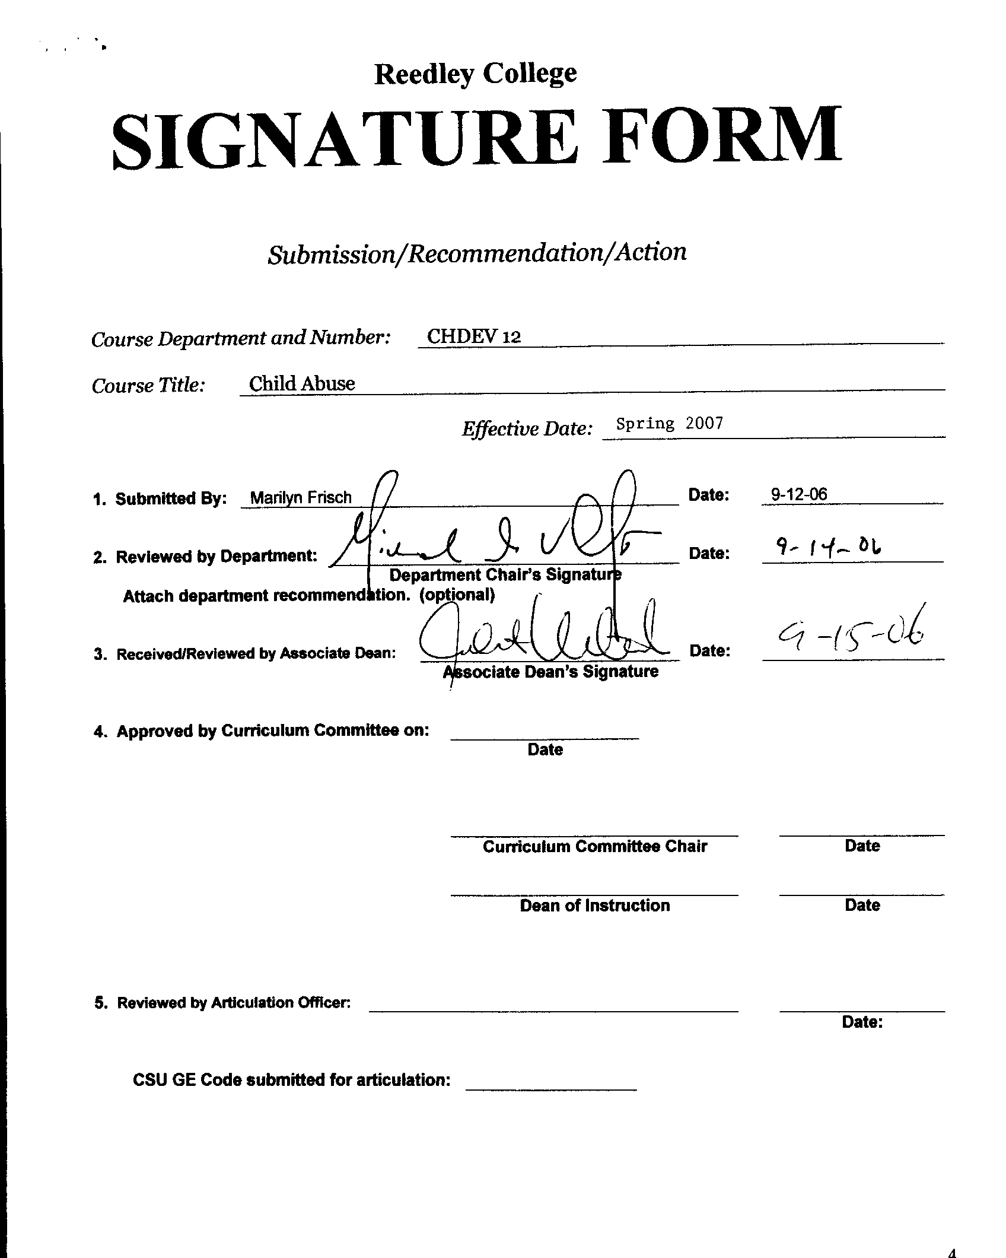

COURSE ALIGNMENT
REEDLEY COLLEGE/FRESNO CITY COLLEGE

Complete only if YES was checked on New Course Proposal Packet check off sheet for a similar department or course at FCC.

FCC Course | Child Development 12

RC Course ID | CHDEV 12 | Course Title | Child Abuse

The RC and FCC faculty members of the Child Development Department have communicated regarding the attached course. The following determination has been made:

Check the appropriate boxes:
□x The course department is the same □* X Prerequisites/Corequisites are the same.
□x The course number is the same □*X The catalog descriptions are the same.
□ X The course title is the same. □*X The number of repeats are the same.
□X The units are the same
□X The lecture/lab hours are the same. (rationale if not the same)
□X The grading basis is the same. (CR-NC/A-F)

□X It was determined that this course is a match.
(*Items with asterisk do not need to be an exact match.)
□ The course does not match but should be evaluated for acceptance in lieu of FCC’s
□ This course is not a match.

Please provide an explanation of the differences:

Marilyn Frisch |  | Sept. 12, 2006
RC Instructor |  | Date
Department Chair |  | Date
Associate Dean |  | Date



CREDIT COURSE OUTLINE

I. COVER PAGE

(1)  Course ID: CHDEV12 |  | (2)  Course Title: Child Abuse |  | (3)  Units: 3.0

(4) Lecture / Lab Hours: |  |  | (8)Classification:
Semester course  Hours per week | Lec hrs: | 3
 | Lab hrs: |  |  |  | Degree applicable: |  |  | x
Lab will generate ______ hour(s) per week outside work. |  |  |  |  | Non-degree applicable:
Short-term course:  Hours per course | Lec hrs: |  |  |  | Pre-collegiate basic skills:
 | Lab hrs:
Lab will generate ______ total hour(s) outside work. |  |  | (9)RC | Fulfills AS/AA degree requirement: (area)
(5)Grading Basis: | Grading scale only |  |  | General education category:
 | CR/NC option | X |  | Major:
 | CR/NC only
(6)Basic Skills Prerequisites: |  |  | (10)CSU: |  | Baccalaureate: |  |  | x
 |  |  | (11) Repeatable: (A course may be repeated  three times) |  |  |  |  | 0
Basic Skills Advisories:  Eligibility for English 125 and English 126 |  |  | For Office Use Only
 |  |  | CATID: |  |  |  | DATATEL:
(7)Subject Prerequisites (requires C grade or better): |  |  | Course LHE: |  |  |  | Unit Code:
 |  |  | VEA Code: |  |  |  | SAM Priority:
 |  |  | TOPS Code: |  |  |  | Effective Date:
Subject Corequisites: |  |  | CSU: |  |  |  | Replaces:
Subject Advisories: |  |  |  |  |  |  | Replaced by:  Date:
(12)Catalog Description:

This course will explore the issues related to abused, battered, and neglected children, along with the profile of abusers. Reporting laws and professional responsibilities will be identified. Identification, prevention and treatment of abused children and abusers will be covered.

Course ID: CHDEV 12 |  | Course Title: Child Abuse

II. COURSE OUTCOMES:

(Specify the learning skills the student demonstrates through completing the course and link critical thinking skills to specific course content and objectives.)

Upon completion of this course, students will be able to:

- define child abuse and explain the causes and incidences of occurrence.
- recognize the different types of abuse and analyze physical, behavioral and emotional indicators in each category.
- describe the dynamics of abusive families and the characteristics of high-risk children.
- identify the responsibilities of mandated reporters of suspected child abuse and the court process.
- apply knowledge and make referrals to various intervention and treatment programs.
- support and participate effectively in family group conferences, as it applies to the restorative justice process.

III. COURSE OBJECTIVES:

(Specify major objectives in terms of the observable knowledge and/or skills to be attained.)

In the process of completing this course, students will:

- define child abuse and explain the causes and incidences of occurrence.
- learn the different types of abuse and analyze physical, behavioral and emotional indicators in each category.
- explore the dynamics of abusive families and the characteristics of high-risk children.
- familiarize themselves with reporting laws, and the responsibilities of mandated reporters of suspected child abuse
and the court process.
- explore various prevention and intervention programs and services.
- compare and contrast the juvenile dependency procedure with the restorative justice process.

Course ID: CHDEV 12 |  | Course Title: Child Abuse

IV. COURSE CONTENT OUTLINE:

- Definition of child abuse
    - Legal definition
    - Cultural, ethnic, socio-economic factors
    - Compare and contrast abuse and discipline
    - Incidence of occurrence

- Indicators of the different types of child abuse
    - Physical abuse
    - Physical neglect
    - Emotional maltreatment
    - Sexual abuse

- What is not child abuse?
    - Cultural practices
    - Children fighting
    - Reasonable force
    - Disclosure of abuse beyond age 18
    - SIDS

- Profile of the abuser

- Reporting child abuse and neglect
    - Who reports?
    - Immunity from liability
    - Liability for failing to report
    - Purpose of reporting
    - Making a report
    - What happens to the report?
    - Confidentiality

- Legal Aspects
    - Investigation of child abuse
a. Interview questions and technique
b. 300 Hold / Welfare and Institution Code
    - The juvenile dependency proceedings
- Detention hearing
- Jurisdiction hearing
- Disposition hearing

- Prevention
    - Community resources

- Intervention
    - The restorative justice system
- Family group conferencing
    - Foster families
    - Group homes

- Treatment / Case plan
    - Counseling
    - Health Services
    - Effective parenting

1.Course ID: CHDEV 12 |  | Course Title: Child Abuse

V. APPROPRIATE READINGS

Reading assignments may include but are not limited to the following:
Sample Text Title: Child Abuse Prevention Handbook and Intervention Guide, by Bill Lockyer.

Other Readings: Understanding Child Abuse & Neglect, Allyn & Bacon
The Child Abusers, by Colin Pritchard.

 | Global or international materials or concepts are appropriately included in this course
x | Multicultural materials and concepts are appropriately included in this course.

If either line is checked, write a paragraph indicating specifically how global/international and/or multicultural materials and concepts relate to content outline and/or readings.

Most of the students taking this course are entering occupational fields that mandate reporting suspected child abuse. It is crucial that students exit the course with a clear understanding of what is abuse and what is not. Therefore, the students will gain information on cultural practices, which could easily be misinterpreted as child abuse markings. Various cultures practice physical healing remedies with family members who are ill. These practices such as cupping and coining leave marks in patterns that help an observer to identify it as a cultural practice, rather than abuse. Sensitivity to this type of practice spares healthy families the unnecessary grief of being reported to Child Protective Services.

Course ID: CHDEV 12 |  | Course Title: Child Abuse

VI. METHODS TO MEASURE STUDENT ACHIEVEMENT AND DETERMINE GRADES:
Students in this course will be graded in at least one of the following four categories. Please check those appropriate. A degree applicable course must have a minimum of one response in category A, B or C.

A. Writing
Check either 1 or 2 below
 | 1. Substantial writing assignments are required. Check the appropriate boxes below and provide a written description in the space provided.
 | 2. Substantial writing assignments are NOT required. If this box is checked leave this section blank. For degree applicable courses you must complete category B and/or C.
 | a. essay exam(s) |  | d. written homework
x | b. term or other papers(s) |  | e. reading reports
 | c. laboratory reports |  | f. other (specify)
Required assignments may include but are not limited to the following:

1. Research paper on a child abuse topic.
2. Report – autobiography dealing with child abuse, such as any in the collection written by David Peltzer.

B. Problem Solving
1. Computational or non-computational problem-solving demonstrations, including:
 | a. exam(s) |  | d. laboratory reports
 | b. quizzes |  | e. field work
 | c. homework problems | x | f. other (specify) (1)Analysis of reported child abuse cases and  development of a case plan.
Required assignments may include, but are not limited to the following:

1. Students will develop a case plan with intervention services.

Course ID: CHDEV 12 |  | Course Title: Child Abuse

C. Skill demonstrations, including:
 | a. class performance(s) |  | c. performance exam(s)
 | b. field work | x | d. other (specify) Restorative Justice / Family Group  Conferencing
Required assignments may include, but are not limited to the following:

1. Students will conduct a mock Family Group Conference.

D. Objective examinations, including:
x | a. multiple choice | x | d. completion
x | b. true/false |  | e. other (specify)
x | c. matching items

COURSE GRADE DETERMINATION:
Description/Explanation: Based on the categories checked in A-D, it is the recommendation of the department that the instructor’s grading methods fall within the following departmental guidelines; however, the final method of grading is still at the discretion of the individual instructor. The instructor’s syllabus must reflect the criteria by which the student’s grade has been determined. (A minimum of five (5) grades must be recorded on the final roster.)

If several methods to measure student achievement are used, indicate here the approximate weight or percentage each has in determining student final grades.

Writing 35%
Problem solving 10%
Skill 20%
Objective Exam 35%

FOR DEGREE APPLICABLE COURSES

Course ID: CHDEV 12 |  | Course Title: Child Abuse

VII. EDUCATIONAL MATERIALS
For degree applicable courses, the adopted texts, as listed in the college bookstore, or instructor-prepared materials have been certified to contain college-level materials.

Validation Language Level (check where applicable): | College-Level  Criteria Met
 | Yes | No
Textbook | x
Reference materials | x
Instructor-prepared materials | x
Audio-visual materials | x

Indicate method of evaluation:
Used readability formulae (grade level 10 or higher)
Text is used in a college-level course
Used grading provided by publisher
Other: (please explain; relate to Skills Levels) Professional Judgment | x

Computation Level (Eligible for MATH 101 level or higher where applicable)

Content
Breadth of ideas covered clearly meets college-level learning objectives of this course |  | x
Presentation of content and/or exercises/projects:
Requires a variety of problem-solving strategies including inductive and deductive reasoning. |  | x
Requires independent thought and study |  | x
Applies transferring knowledge and skills appropriately and efficiently to new situations or  problems. |  | x
List of Reading/Educational Materials

Text: Child Abuse Prevention Handbook, Attorney General’s Office,.
Supplemental text: Understanding Child Abuse & Neglect, Allyn & Bacon
The Child Abusers, by Colin Pritchard.

Video: Shadows to Light, Attorney General’s Office
Understanding, Identifying and Responding to Childhood Trauma, Magna Systems
Through The Eyes of The Child, Dave Thomas Foundation for Adoption

Comments:

 | This course requires special or additional library materials (list attached).
 | This course requires special facilities:

FORM A
TARGET COURSE
 | Number |  | Title

BASIC SKILLS ADVISORIES PAGE The skills listed are those needed for eligibility for English 125, 126, and Math 101. These skills are listed as the outcomes from English 252, 262, and Math 250. In the right hand column, list at least three major basic skills needed at the beginning of the target course and check off the corresponding basic skills listed at the left.

Math Skills (eligibility for Math 101)
(as outcomes for Math 250)
Performing the four arithmetic operations on whole numbers, arithmetic fractions, and decimal fractions.
Making the conversions from arithmetic fractions to decimal fractions, from decimal fractions to percents, and then reversing the process.
Applying the concepts listed above to proportions, percents, simple interest, markup and discount.
Applying the operations of integers in solving simple equations.
Converting between the metric and English measurement systems
Reading Skills (eligibility for English 126)  (as outcomes for English 262)  x Using phonetic, structural, contextual, and dictionary skills to attack and understand words.  x Applying word analysis skills to reading in context.  x Using adequate basic functional vocabulary skills.  x Using textbook study skills and outlining skills.  x Using a full range of literal comprehension skills and basic analytical skills such as predicting, inferring, concluding, and evaluating. | 1. Students will read and apply child abuse indicators to mandated reporting laws.  2. An understanding and use of the 300-code section of the Child Welfare and Institution code is required.  3. Students will read case studies, analyze and develop appropriate case plans.
Writing Skills (eligibility for English 125)  (as outcomes for English 252)  Writing complete English sentences and avoiding errors most of the time.  Using the conventions of English writing: capitalization, punctuation, spelling, etc.  Using verbs correctly in present, past, future, and present perfect tenses, and using the correct forms of common irregular verbs.  Expanding and developing basic sentence structure with appropriate modification.  Combining sentences using coordination, subordination, and phrases.  Expressing the writer's ideas in short personal papers utilizing the writing process in their development. | 1. Students are required to write a case plan.  2. Students will select a topic related to child abuse and write a research paper.  3. Students will select autobiographical readings and write a report.
Check the appropriate spaces.
Eligibility for Math 101 is advisory for the target course.
x Eligibility for English 126 is advisory for the target course.
x Eligibility for English 125 is advisory for the target course.
If the reviewers determine that an advisory or advisories in Basic Skills are all that are necessary for success in the target course, stop here, provide the required signatures, and forward this form to the department chair, the appropriate associate dean, and the curriculum committee.

Content review completed by |  | Date

