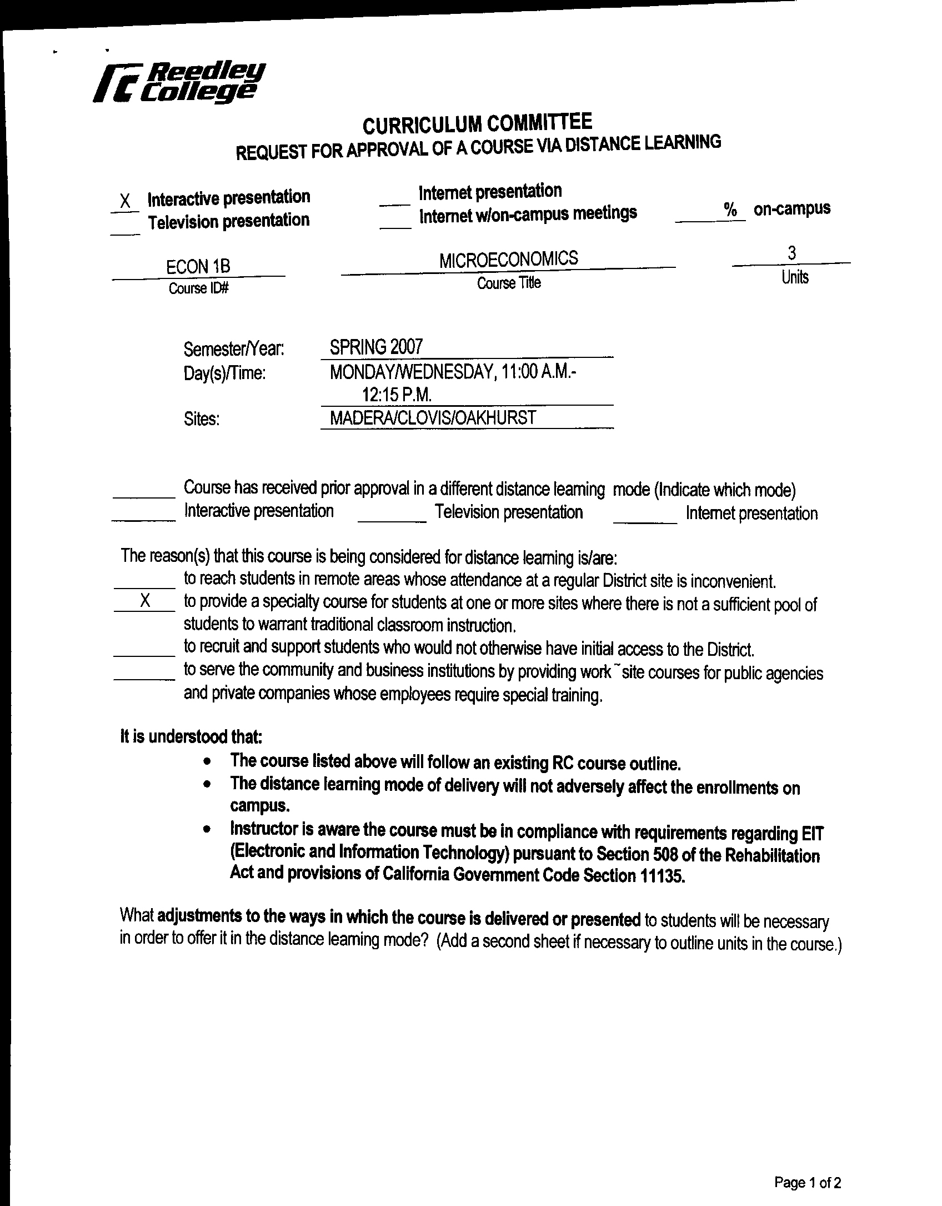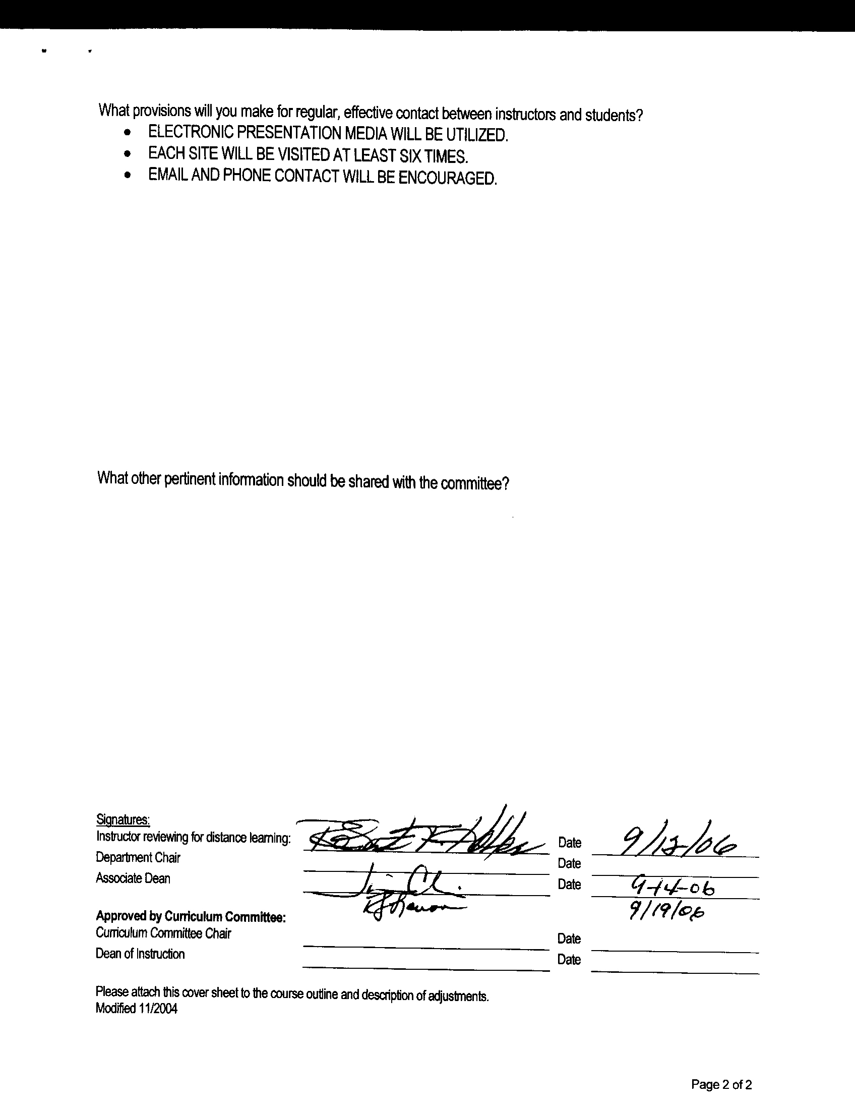


CREDIT COURSE OUTLINE

I. COVER PAGE

(1)  Course ID: ECON 1B |  | (2)  Course Title: Introduction to Microeconomics |  | (3)  Units: 3.0

(4) Lecture / Lab Hours: |  |  | (8)Classification:
Semester course  Hours per week | Lec hrs: | 3
 | Lab hrs: |  |  |  | Degree applicable: |  |  | x
Lab will generate ______ hour(s) per week outside work. |  |  |  |  | Non-degree applicable:
Short-term course:  Hours per course | Lec hrs: |  |  |  | Pre-collegiate basic skills:
 | Lab hrs:
Lab will generate ______ total hour(s) outside work. |  |  | (9)RC | Fulfills AS/AA degree requirement: (area)
(5)Grading Basis: | Grading scale only |  |  | General education category: |  |  |  | Social/Behavioral Sciences
 | CR/NC option | x |  | Major: |  | Business Administration, Social Science
 | CR/NC only
(6)Basic Skills Prerequisites: |  |  | (10)CSU: |  | Baccalaureate: |  |  | x
 |  |  | (11) Repeatable: (A course may be repeated  three times) |  |  |  |  | 0
Basic Skills Advisories:  Eligibility for ENGL 125, ENGL 126, and MATH 101 |  |  | For Office Use Only
 |  |  | CATID: 10337000 |  |  |  | DATATEL: 7761
(7)Subject Prerequisites (requires C grade or better): |  |  | Course LHE: 3.0 |  |  |  | Unit Code: 261015
 |  |  | VEA Code: Y |  |  |  | SAM Priority: D
 |  |  | TOPS Code: 2204.00 |  |  |  | Effective Date: Fall 2005
Subject Corequisites: |  |  | A, CSU |  |  |  | Replaces: outcomes/objectives
Subject Advisories: |  |  |  |  |  |  | Replaced by:  Date:
(12)Catalog Description:

An introduction to microeconomic theory covering consumer and producer choice, income distribution, the structure of product markets, and the role of the public sector.

Course ID: ECON 1B |  | Course Title: Introduction to Microeconomics

II. COURSE OUTCOMES:

(Specify the learning skills the student demonstrates through completing the course and link critical thinking skills to specific course content and objectives.)

Upon completion of this course, students will be able to:

A. describe the correct market structure.

B. analyze arguments for and against alternative case scenarios of future development of China.

C. hypothesize the direction of movement in civil rights, ecology, and anti-trust legislation.

D. compare and contrast trade surplus/deficit with future growth.

E. demonstrate profit maximization.

III. COURSE OBJECTIVES:

(Specify major objectives in terms of the observable knowledge and/or skills to be attained.)

In the process of completing this course, students will:

A. compare and contrast pure competition, monopolistic competition, oligopoly, and monopoly.

B. explain fluctuations in monetary exchange rates.

C. demonstrate a trade surplus/deficit.

D. analyze horizontal merger, vertical integration, and conglomerates as they relate to changes in the law.

E. compare capitalism, socialism, and communism.

F. apply the elasticity model.

Course ID: ECON 1B |  | Course Title: Introduction to Microeconomics

IV. COURSE CONTENT OUTLINE:

A. Current events--business section of the newspaper

B. Selected TV viewing--discussion and analysis--weekly

C. Elasticity

D. Cost/benefit analysis

E. Consumer behavior

F. Corporate veil--incorporation vs. sole proprietorship and partnership

G. Market period-short run vs. long run

H. Perfect competition

I. Monopoly

J. Monopolistic competition

K. Oligopoly

L. Ecology and conservation

M. International trade

N. Other economic systems

O. Growth and expansion

Course ID: ECON 1B |  | Course Title: Introduction to Microeconomics

V. APPROPRIATE READINGS

Reading assignments may include but are not limited to the following:

A. Sample Text Title:
1. Colander Economics 5th Edition

B. Other Readings:

Global or international materials or concepts are appropriately included in this course
Multicultural materials and concepts are appropriately included in this course.

If either line is checked, write a paragraph indicating specifically how global/international and/or multicultural materials and concepts relate to content outline and/or readings.

Course ID: ECON 1B |  | Course Title: Introduction to Microeconomics

VI. METHODS TO MEASURE STUDENT ACHIEVEMENT AND DETERMINE GRADES:
Students in this course will be graded in at least one of the following four categories. Please check those appropriate. A degree applicable course must have a minimum of one response in category A, B or C.

A. Writing
Check either 1 or 2 below
x | 1. Substantial writing assignments are required. Check the appropriate boxes below and provide a written description in the space provided.
 | 2. Substantial writing assignments are NOT required. If this box is checked leave this section blank. For degree applicable courses you must complete category B and/or C.
 | a. essay exam(s) |  | d. written homework
x | b. term or other papers(s) | x | e. reading reports
 | c. laboratory reports |  | f. other (specify)
Required assignments may include but are not limited to the following:

1. Evaluate China’s Dual System.

2. Review 5 business articles from the Fresno Bee.

B. Problem Solving
1. Computational or non-computational problem-solving demonstrations, including:
x | a. exam(s) |  | d. laboratory reports
 | b. quizzes |  | e. field work
 | c. homework problems |  | f. other (specify)
Required assignments may include, but are not limited to the following:

Sample question:
A. What Changes can be made in the short run?
A. Work overtime
B. Add a new shift
C. Build a new plant
D. Some of the above
E. None of the above

Course ID: ECON 1B |  | Course Title: Introduction to Microeconomics

C. Skill demonstrations, including:
 | a. class performance(s) |  | c. performance exam(s)
 | b. field work |  | d. other (specify)
Required assignments may include, but are not limited to the following:

D. Objective examinations, including:
x | a. multiple choice |  | d. completion
x | b. true/false |  | e. other (specify)
 | c. matching items

COURSE GRADE DETERMINATION:
Description/Explanation: Based on the categories checked in A-D, it is the recommendation of the department that the instructor’s grading methods fall within the following departmental guidelines; however, the final method of grading is still at the discretion of the individual instructor. The instructor’s syllabus must reflect the criteria by which the student’s grade has been determined. (A minimum of five (5) grades must be recorded on the final roster.)

If several methods to measure student achievement are used, indicate here the approximate weight or percentage each has in determining student final grades.

Term paper required 13%
Multiple choice 34%
Math 5%
True/False 35%
Reviews 13%
FOR DEGREE APPLICABLE COURSES

Course ID: ECON 1B |  | Course Title: Introduction to Microeconomics

VII. EDUCATIONAL MATERIALS
For degree applicable courses, the adopted texts, as listed in the college bookstore, or instructor-prepared materials have been certified to contain college-level materials.

Validation Language Level (check where applicable): |  | College-Level  Criteria Met
 |  | Yes | No
Textbook |  | x
Reference materials |  | x
Instructor-prepared materials |  | x
Audio-visual materials |  | x
Indicate method of evaluation:
Used readability formulae (grade level 10 or higher)
Text is used in a college-level course |  |  |  | x
Used grading provided by publisher
Other: (please explain; relate to Skills Levels)
Computation Level (Eligible for MATH 101 level or higher where applicable) |  | x

Content
Breadth of ideas covered clearly meets college-level learning objectives of this course |  | x
Presentation of content and/or exercises/projects:
Requires a variety of problem-solving strategies including inductive and deductive reasoning. |  | x
Requires independent thought and study |  | x
Applies transferring knowledge and skills appropriately and efficiently to new situations or  problems. |  | x
List of Reading/Educational Materials

Colander Economics 5th Edition

Comments:

 | This course requires special or additional library materials (list attached).
 | This course requires special facilities:

FORM A
TARGET COURSE | ECON 1B |  | Introduction to Microeconomics
 | Number |  | Title

BASIC SKILLS ADVISORIES PAGE The skills listed are those needed for eligibility for English 125, 126, and Math 101. These skills are listed as the outcomes from English 252, 262, and Math 250. In the right hand column, list at least three major basic skills needed at the beginning of the target course and check off the corresponding basic skills listed at the left.

Math Skills (eligibility for Math 101)  (as outcomes for Math 250)  x Performing the four arithmetic operations on whole numbers, arithmetic fractions, and decimal fractions.  x Making the conversions from arithmetic fractions to decimal fractions, from decimal fractions to percents, and then reversing the process.  x Applying the concepts listed above to proportions, percents, simple interest, markup and discount.  x Applying the operations of integers in solving simple equations.  Converting between the metric and English measurement systems | 1. Ability to follow a math routine to completion.  2. Ability to read word problems and formulate equations that lead to the desired solution.  3. Ability to read and interpret tables.
Reading Skills (eligibility for English 126)  (as outcomes for English 262)  x Using phonetic, structural, contextual, and dictionary skills to attack and understand words.  x Applying word analysis skills to reading in context.  x Using adequate basic functional vocabulary skills.  x Using textbook study skills and outlining skills.  x Using a full range of literal comprehension skills and basic analytical skills such as predicting, inferring, concluding, and evaluating. | 1. Ability to read and comprehend a college level textbook and various articles containing a variety of abstract terms from various disciplines such as Economics, Law, Sociology, and History.  2. Ability to convert textbook chapters and classroom lectures into outline form; ability to develop an outline in preparation for writing assignments.
Writing Skills (eligibility for English 125)  (as outcomes for English 252)  x Writing complete English sentences and avoiding errors most of the time.  x Using the conventions of English writing: capitalization, punctuation, spelling, etc.  x Using verbs correctly in present, past, future, and present perfect tenses, and using the correct forms of common irregular verbs.  x Expanding and developing basic sentence structure with appropriate modification.  x Combining sentences using coordination, subordination, and phrases.  x Expressing the writer's ideas in short personal papers utilizing the writing process in their development. | 1. Ability to compose well organized, clear, and analytical responses to reading assignments and homework.  2. Ability to compose a term paper or writing assignment.

Check the appropriate spaces.
x Eligibility for Math 101 is advisory for the target course.
x Eligibility for English 126 is advisory for the target course.
x Eligibility for English 125 is advisory for the target course.
If the reviewers determine that an advisory or advisories in Basic Skills are all that are necessary for success in the target course, stop here, provide the required signatures, and forward this form to the department chair, the appropriate associate dean, and the curriculum committee.

Content review completed by | Sonny Festejo | Date | 13 Feb 96

