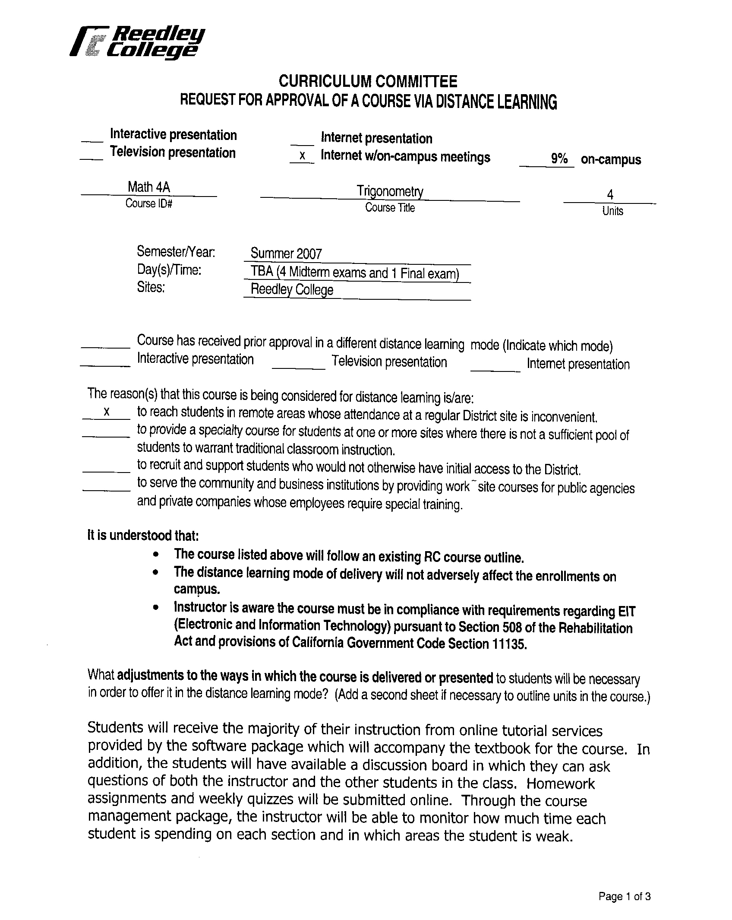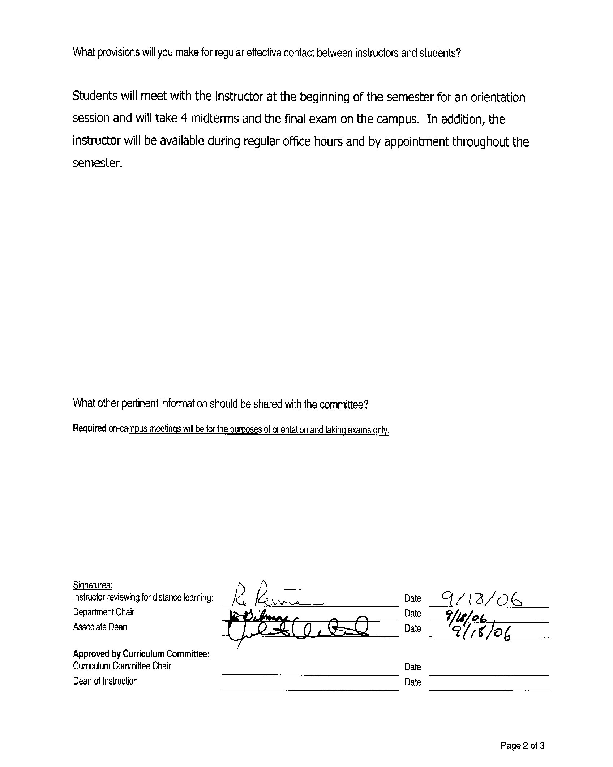


CREDIT COURSE OUTLINE

I. COVER PAGE

(1)  Course ID: MATH 4A |  | (2)  Course Title: Trigonometry |  | (3)  Units: 4.0

(4) Lecture / Lab Hours: |  |  | (8)Classification:
Semester course  Hours per week | Lec hrs: | 4
 | Lab hrs: |  |  |  | Degree applicable: |  |  | x
Lab will generate ______ hour(s) per week outside work. |  |  |  |  | Non-degree applicable:
Short-term course:  Hours per course | Lec hrs: |  |  |  | Pre-collegiate basic skills:
 | Lab hrs:
Lab will generate ______ total hour(s) outside work. |  |  | (9)RC | Fulfills AS/AA degree requirement: (area) |  |  |  | Math Competency
(5)Grading Basis: | Grading scale only |  |  | General education category:
 | CR/NC option | x |  | Major: |  | Math
 | CR/NC only
(6)Basic Skills Prerequisites: |  |  | (10)CSU: |  | Baccalaureate: |  |  | x
 |  |  | (11) Repeatable: (A course may be repeated  three times) |  |  |  |  | no
Basic Skills Advisories:
Eligibility for ENGL 125 and ENGL 126
 |  |  | For Office Use Only
(7)Subject Prerequisites:  MATH 102 and MATH 103 or equivalent |  |  | CATID: 104770.03 |  |  |  | Org Code: 252510
 |  |  | DATATEL #: 2751
 |  |  | Tops Code: 1701.00 |  |  |  | SAM Priority: E
 |  |  | VEA Code: N |  |  |  | Course LHE: 4.0
Subject Corequisites: |  |  | Effective Date: Spring 2002 |  |  |  | Replaces: MATH 4A 104770.01 (units/hours)
Subject Advisories: |  |  | CSU GE Code: |  |  |  | Replaced by:  Date:
(12)Catalog Description:

Angles, trigonometric and inverse trigonometric functions, right and oblique triangles, graphs, identities, trigonometric equations, vectors, polar coordinates, De Moivre’s Theorem, and applications.

11/00

Course ID: MATH 4A |  | Course Title: Trigonometry

II. COURSE OBJECTIVES:

(Specify major objectives in terms of the observable knowledge and/or skills to be attained.)

In the process of completing this course, the student will demonstrate the ability to:

A. Apply the trigonometric functions to solve for the part of a triangle.

B. Evaluate trigonometric functions of both acute and obtuse angles.

C. Solve problems involving vectors.

D. Apply the concept of radian measure to circular functions.

E. Graph the circular functions.

F. Apply trigonometric identities to algebraic expressions.

G. Solve trigonometric equations.

H. Apply the concept of polar coordinates to algebraic operations and graphs.

I. Apply computing and graphing technology.

III. COURSE CONTENT OUTLINE:

A. Trigonometric functions: basic concepts, angles, angle relationships, similar triangles, definitions of the trigonometric functions, applications.

B. Acute angles and right triangles: trigonometric functions of acute angels, reference angles, coterminal angles, evaluating trigonometric functions (exact and approximate), solving right triangles, applications of right triangles.

C. Set up, sketch and analyze vector application problems.

D. Radian measure and circular functions: radian measure, applications of radian measure, circular functions of real numbers, linear and angular velocity.

E. Graphs of the circular functions: graphs of the sine and cosine, graphs of the other circular functions.

F. Trigonometric relations (identities): fundamental identities, verifying trigonometric identities, sum and difference formulas for cosine, sine and tangent, cofunction identities, double angle identities, half angle identities.

G. Inverse trigonometric functions and trigonometric equations: Inverse trigonometric functions, trigonometric equations, inverse trigonometric equations.

H. Polar coordinates and De Moivre’s theorem: polar coordinates, complex numbers, De Moivre’s Theorem

I. Applying computer and/or graphing calculator technology: using a scientific calculator to perform trigonometric calculations, using a graphing calculator and/or computer software to explore trigonometric graphs.

Course ID: MATH 4A |  | Course Title: Trigonometry

IV. APPROPRIATE READINGS

Reading assignments may include but are not limited to the following:

1. Text (sample):

a. Trigonometry, Charles P. McKeague.

Global or international materials or concepts are appropriately included in this course
Multicultural materials and concepts are appropriately included in this course.

If either line is checked, write a paragraph indicating specifically how global/international and/or multicultural materials and concepts relate to content outline and/or readings.

Course ID: MATH 4A |  | Course Title: Trigonometry

V. METHODS TO MEASURE STUDENT ACHIEVEMENT AND DETERMINE GRADES:
Students in this course will be graded in at least one of the following four categories. Please check those appropriate. A degree applicable course must have a minimum of one response in category A, B or C.

A. Writing
Check either 1 or 2 below
 | 1. Substantial writing assignments are required. Check the appropriate boxes below and provide a written description in the space provided.
x | 2. Substantial writing assignments are NOT required. If this box is checked leave this section blank. For degree applicable courses you must complete category B and/or C.
 | a. essay exam(s) |  | d. written homework
 | b. term or other papers(s) |  | e. reading reports
 | c. laboratory reports |  | f. other (specify)
Required assignments may include but are not limited to the following:

B. Problem Solving
1. Computational or non-computational problem-solving demonstrations, including:
x | a. exam(s) |  | d. laboratory reports
 | b. quizzes |  | e. field work
x | c. homework problems | x | f. other (specify) in-class group activities

Required assignments may include, but are not limited to the following:

1. Problems assigned from the problem sets found in each chapter of the text.
2. Worksheets generated by the instructor to reinforce or clarify concepts presented in the text.
3. Group discovery activities students work on and complete during a class session.

Course ID: MATH 4A |  | Course Title: Trigonometry

C. Skill demonstrations, including:
 | a. class performance(s) |  | c. performance exam(s)
 | b. field work |  | d. other (specify
Required assignments may include, but are not limited to the following:

D. Objective examinations, including:
 | a. multiple choice |  | d. completion
 | b. true/false | x | e. other (specify)
 | c. matching items | Exams will be comprised of open-ended questions in which students show all steps of their solution process.

Description/Explanation: Based on the categories checked, it is the recommendation of the department that the instructor’s grading methods fall within the following departmental guidelines; however, the final method of grading is still at the discretion of the individual instructor. The instructor’s syllabus must reflect the criteria by which the student’s grade has been determined. (A minimum of five (5) grades must be recorded on the final roster.)

If several methods to measure student achievement are used, indicate here the approximate weight or percentage each has in determining student final grades.

Homework 30%
In-class activity work 10%
Exams 60%

FOR DEGREE APPLICABLE COURSES

Course ID: MATH 4A |  | Course Title: Trigonometry

VI. COURSE OUTCOMES:

(Specify the learning skills the student demonstrates through completing the course and link critical thinking skills to specific course content and objectives.)

After completing this course, the student will be able to:

A. Identify the appropriate function to use and then apply it to solve for the sides or angles of a triangle.

B. Find both approximate and exact trigonometric function values of both acute and obtuse angles through the use of reference angles and special angle values.

C. Set up, sketch and analyze vector application problems

D. Convert angles from degree measure to radian measure and vice-versa; evaluate trigonometric functions of angles in radian measure and apply the concept of radian measure to application problems involving linear and angular velocity.

E. Graph the fundamental graphs of sine, cosine and tangent, identifying their characteristics such as amplitude, period and phase shifts from their equations.

F. Apply the trigonometric identities such as the Pythagorean, sum and difference, cofunction, double angle and half angle identities to algebraic expressions to either verify or simplify the expression.

G. Solve trigonometric equations through the use of inverse trigonometric functions.

H. Apply the concept of polar coordinates to graphing, complex numbers and binomial expansion.

I. Use graphing calculator and/or computer technology to evaluate trigonometric functions and analyze graphs of the trigonometric functions.
FOR DEGREE APPLICABLE COURSES

Course ID: MATH 4A |  | Course Title: Trigonometry

VII. EDUCATIONAL MATERIALS
For degree applicable courses, the adopted texts, as listed in the college bookstore, or instructor-prepared materials have been certified to contain college-level materials.

Validation Language Level (check where applicable): |  | College-Level  Criteria Met
 |  | Yes | No
Textbook |  | x
Reference materials
Instructor-prepared materials
Audio-visual materials
Indicate method of evaluation:
 | Used readability formulae (grade level 10 or higher)
 | Text is used in a college-level course
 | Used grading provided by publisher
 | Other: (please explain; relate to Skills Levels)
Computation Level (Eligible for MATH 101 level or higher where applicable) |  | x

Content
Breadth of ideas covered clearly meets college-level learning objectives of this course |  | x
Presentation of content and/or exercises/projects:
Requires a variety of problem-solving strategies including inductive and deductive reasoning. |  | x
Requires independent thought and study |  | x
Applies transferring knowledge and skills appropriately and efficiently to new situations or  problems. |  | x
List of Reading/Educational Materials
1. Text (sample):

Trigonometry, Charles P. McKeague

Comments:

 | This course requires special or additional library materials (list attached).
 | This course requires special facilities:

FORM A
TARGET COURSE | MATH 4A |  | Trigonometry
 | Number |  | Title

BASIC SKILLS ADVISORIES PAGE The skills listed are those needed for Aeligibility for English 25, 26, and Math 1.@ These skills are listed as the outcomes from English 52, 62, and Math 54. In the right hand column, list at least three major basic skills needed at the beginning of the target course and check off the corresponding basic skills listed at the left.

Math Skills (eligibility for Math 101)
(as outcomes for Math 250)

Performing the four arithmetic operations on whole numbers, arithmetic fractions, and decimal fractions.
Making the conversions from arithmetic fractions to decimal fractions, from decimal fractions to percents, and then reversing the process.
Applying the concepts listed above to proportions, percents, simple interest, markup and discount.
Applying the operations of integers in solving simple equations.
Converting between the metric and English measurement systems
Reading Skills (eligibility for English 126)  (as outcomes for English 262)  x Using phonetic, structural, contextual, and dictionary skills to attack and understand words.  x Applying word analysis skills to reading in context.  x Using adequate basic functional vocabulary skills.  x Using textbook study skills and outlining skills.  x Using a full range of literal comprehension skills and basic analytical skills such as predicting, inferring, concluding, and evaluating. | 1. Students are required to comprehend a college level mathematics text with dense reading and sophisticated terminology.  2. Students are required to read and analyze word problems.  3. Students are required to make appropriate associations with previously read material.
Writing Skills (eligibility for English 125)  (as outcomes for English 252)  x Writing complete English sentences and avoiding errors most of the time.  x Using the conventions of English writing: capitalization, punctuation, spelling, etc.  x Using verbs correctly in present, past, future, and present perfect tenses, and using the correct forms of common irregular verbs.  x Expanding and developing basic sentence structure with appropriate modification.  x Combining sentences using coordination, subordination, and phrases.  x Expressing the writer's ideas in short personal papers utilizing the writing process in their development. | 1. Taking good notes is an essential skill for college level work.  2. Written answers are a part of homework questions.  3. Written answers are a part of test questions.

Check the appropriate spaces.
Eligibility for Math 101 is advisory for the target course.
x Eligibility for English 126 is advisory for the target course.
x Eligibility for English 125 is advisory for the target course.
If the reviewers determine that an advisory or advisories in Basic Skills are all that are necessary for success in the target course, stop here, provide the required signatures, and forward this form to the department chair, the appropriate associate dean, and the curriculum committee.

Content review completed by | Maria Kelly | Date | 2/20/01

FORM B
TARGET COURSE | MATH 4A |  | Trigonometry
 | Number |  | Title

CONTENT REVIEW FOR ALL COURSES IN ADDITION TO BASIC SKILLS COURSES
List in Column 1 at least three specific major concepts, skills, or kinds of knowledge that a student will learn in the pre- or corequisite or advisory course that are essential to the successful completion in the target course. In Column 2, state why the skill in Column 1 is essential in relation to the content listed in the course outline of the target course.

COLUMN 1: Concepts, Skills, Kinds of Knowledge | COLUMN 2: Specifically how this is necessary in the target course
(List each prerequisite or advisory separately here. If you need more space, attach a second page B. Be sure to explain each course in Column 2.)  Name of prerequisite or advisory course:  MATH 102 - Geometry _  Concepts, skills, etc. (List these.)  1. Be able to solve for the sides of a right triangle by using the Pythagorean Theorem.  2. Understand the parts of a circle and how area and perimeter are affected by these parts.  3. Be able to graph a circle and a triangle using coordinate geometry. | 1. Students will learn the three Pythagorean identities, all of which are derived from the Pythagorean Theorem.  2. Students will learn about radian measure which is based on the relationship between the central angle and the arc it intercepts.  3. Students will learn how to solve for parts of a triangle given its coordinates on a unit circle.

If the courses listed in Column 1 are advisory, complete the information below and do not go on to the next page.

Advisory course(s):

Content review completed by | Maria Kelly |  | 2/20/01
 | Signature(s) |  | Date

Dean's Signature | Ronald C. Taylor |  | 4/26/01
 |  |  | Date

Please forward this completed form to the Curriculum Committee.
FORM C
ESTABLISHING PREREQUISITES OR COREQUISITES

Every prerequisite or corequisite requires content review plus justification of at least one of the seven kinds below. Prerequisite courses in communication and math outside of their disciplines require justification through statistical evidence. Kinds of justification that may establish a prerequisite are listed below.

The target course | MATH 4A |  | Trigonometry
 | Number |  | Title

The proposed requisite course | MATH 102 |  | Geometry
 | Number |  | Title

Check one of the following that apply. Documentation may be attached.

1. The prerequisite/corequisite is required by law or government regulations.
Explain or cite regulation numbers:

2. The health or safety of the students in this course requires the prerequisite.
Justification: Indicate how this is so.

3. The safety or equipment operation skills learned in the prerequisite course are required for the successful or safe completion of this course.
Justification: Indicate how this is so.

4. The prerequisite is required in order for the course to be accepted for transfer to the UC or CSU systems.
Justification: Indicate how this is so.

5. Significant statistical evidence indicates that the absence of the prerequisite course is related to unsatisfactory performance in the target course.
Justification: Cite the statistical evidence from the research.

6. The prerequisite course is part of a sequence of courses within or across a discipline.

7. x Three CSU/UC campuses require an equivalent prerequisite or corequisite for a course equivalent to the target course:

CSU/UC CAMPUS | COURSE DEPT/NO. | PRE/COREQUISITE NO.
CSU - Hayward | MATH 1300 | One year High School Geometry
CSU - Chico | MATH 004 | Passing ELM score
CSU – Fresno | MATH 5 | Passing ELM score (ELM exam tests both Algebra & Geometry)

Explanation or justification: (Attach information if necessary.)

The | x | prerequisite |  | corequisite | MATH 102 |  | Geometry
 |  |  |  |  | Number |  | Title

has been justified for | MATH 4A |  | Trigonometry
 | Target course Number |  | Title

Discipline faculty members:

Department Chair: | Maria Kelly | Associate Dean: | S.A. Foletta

Approved by Curriculum Committee: | Rich Garrigus |  | 4/16/01
 | Curriculum Chair |  | Date
 | Ronald C. Taylor |  | 4/17/01
 | Dean of Instruction |  | Date

FORM B
TARGET COURSE | MATH 4A |  | Trigonometry
 | Number |  | Title

CONTENT REVIEW FOR ALL COURSES IN ADDITION TO BASIC SKILLS COURSES
List in Column 1 at least three specific major concepts, skills, or kinds of knowledge that a student will learn in the pre- or corequisite or advisory course that are essential to the successful completion in the target course. In Column 2, state why the skill in Column 1 is essential in relation to the content listed in the course outline of the target course.

COLUMN 1: Concepts, Skills, Kinds of Knowledge | COLUMN 2: Specifically how this is necessary in the target course
(List each prerequisite or advisory separately here. If you need more space, attach a second page B. Be sure to explain each course in Column 2.)  Name of prerequisite or advisory course:  MATH 103- Intermediate Algebra _  Concepts, skills, etc. (List these.)  1. Be able to solve equations, both linear and of higher degree.  2. Be able to factor algebraic expressions.  3. Be able to graph functions | 1. Student will learn to solve trigonometric equations where the variables are trigonometric functions instead of letters as in algebra.  2. Student will learn to verify or prove trigonometric identities through the use of factoring and algebraic manipulation.  3. Student will learn to graph the six basic trigonometric functions.

If the courses listed in Column 1 are advisory, complete the information below and do not go on to the next page.

Advisory course(s):

Content review completed by | Maria Kelly |  | 2/20/01
 | Signature(s) |  | Date

Dean's Signature | Ronald C. Taylor |  | 4/26/01
 |  |  | Date

Please forward this completed form to the Curriculum Committee.
FORM C
ESTABLISHING PREREQUISITES OR COREQUISITES

Every prerequisite or corequisite requires content review plus justification of at least one of the seven kinds below. Prerequisite courses in communication and math outside of their disciplines require justification through statistical evidence. Kinds of justification that may establish a prerequisite are listed below.

The target course | MATH 4A |  | Trigonometry
 | Number |  | Title

The proposed requisite course | MATH 103 |  | Intermediate Algebra
 | Number |  | Title

Check one of the following that apply. Documentation may be attached.

1. The prerequisite/corequisite is required by law or government regulations.
Explain or cite regulation numbers:

2. The health or safety of the students in this course requires the prerequisite.
Justification: Indicate how this is so.

3. The safety or equipment operation skills learned in the prerequisite course are required for the successful or safe completion of this course.
Justification: Indicate how this is so.

4. The prerequisite is required in order for the course to be accepted for transfer to the UC or CSU systems.
Justification: Indicate how this is so.

5. Significant statistical evidence indicates that the absence of the prerequisite course is related to unsatisfactory performance in the target course.
Justification: Cite the statistical evidence from the research.

6. The prerequisite course is part of a sequence of courses within or across a discipline.

7. x Three CSU/UC campuses require an equivalent prerequisite or corequisite for a course equivalent to the target course:

CSU/UC CAMPUS | COURSE DEPT/NO. | PRE/COREQUISITE NO.
San Francisco State University | MATH 107 | MATH 70
CSU – Chico | MATH 004 | MATH 003 (or ELM score)
CSU – Fresno | MATH 5 | MATH 4R (or ELM score)

Explanation or justification: (Attach information if necessary.)

The | x | prerequisite |  | corequisite | MATH 103 |  | Intermediate Algebra
 |  |  |  |  | Number |  | Title

has been justified for | MATH 4A |  | Trigonometry
 | Target course Number |  | Title

Discipline faculty members:

Department Chair: | Maria Kelly | Associate Dean: | S.A. Foletta

Approved by Curriculum Committee: | Rich Garrigus |  | 4/26/01
 | Curriculum Chair |  | Date
 | Ronald C. Taylor |  | 4/26/01
 | Dean of Instruction |  | Date

