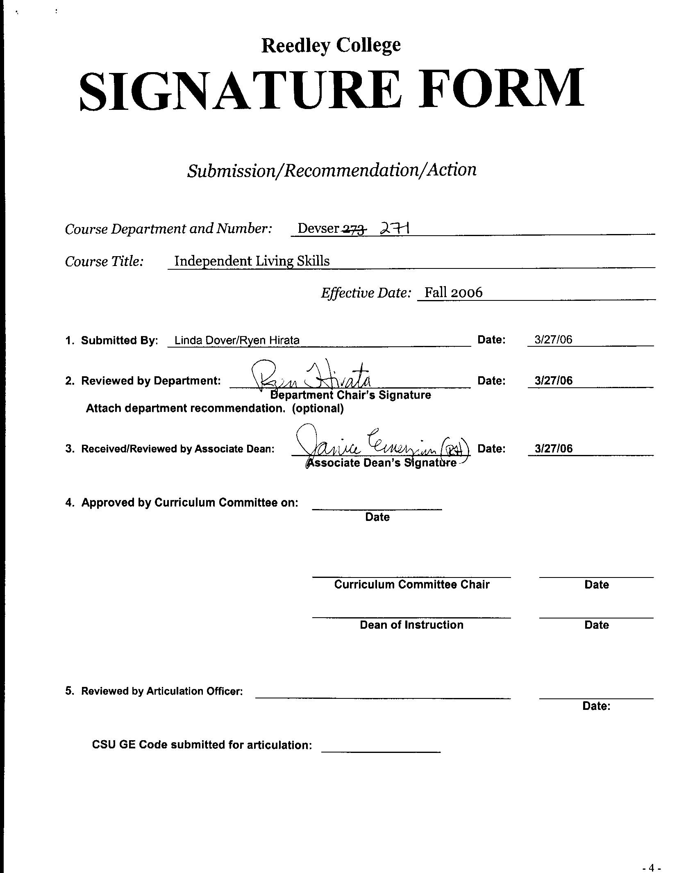



CREDIT COURSE OUTLINE

I. Cover Page
(1)  Course ID: DEVSER 271 |  | (2)  Course Title: Independent Living Skills for DSP&S Students |  |  |  |  |  |  |  | (3)  Units: 2
(4) Lecture / Lab Hours: |  |  |  | (8)Classification:
Semester course  Hours per week | Lec hrs:
 | Lab hrs: |  | 6 |  |  | Degree applicable:
*Lab will generate ______ hour(s) per week outside work. |  |  |  |  |  | Non-degree applicable: |  |  |  | x
Short-term course:  Hours per course | Lec hrs: |  |  |  |  | Pre-collegiate basic skills:
 | Lab hrs:
*Lab will generate ______ total hour(s) outside work. |  |  |  | (9)RC | Fulfills degree requirement: (area)
(5)Grading Basis: | Grading scale only |  |  |  | General education:
 | CR/NC option |  |  |  | General education category:
 | CR/NC only |  | x |  | Major category:
(6)Basic Skills Prerequisites:  None |  |  |  | (10)CSU: |  | Baccalaureate:
 |  |  |  | (11) Repeatable: (A course may be repeated  three times) |  |  |  |  |  | 3
Basic Skills Advisories:
none
 |  |  |  | For Office Use Only
(7)Subject Prerequisites: None |  |  |  | CATID: |  |  | Org Code:
 |  |  |  | Tops Code: 1304.00 |  |  | SAM Priority: E
 |  |  |  | VEA Code: |  |  | Course LHE: 4.50
Subject Corequisites: None |  |  |  | Effective Date: Spring 2007 |  |  | Replaces: DEVSER 273  Independent Living Skills for DSP&S Students
Subject Advisories: None |  |  |  | CSU GE Code: 9.4 |  |  | Replaced by:  Date:
(12)Catalog Description:

Basic independent living skills. Designed for the Developmentally Delayed Learner.

*See lecture/lab hours in Curriculum Handbook. 9/00

Course ID: DEVSER 271 |  | Course Title: Independent Living Skills for DSP&S Students

II. Course Objectives:

(Specify major objectives in terms of the observable knowledge and/or skills to be attained.)

In the process of completing this course, the student will demonstrate the ability to:
1. Achieve social acceptance
2. Have self –esteem, self acceptance and confidence skills
3. Allocate time setting priorities for self-care activities
4. Perform home management tasks independently
5. Be aware of the alternatives available for community mobility
6. Use the appropriate social contacts and establish social relationships
7. Self-direct in planning and managing life strategies
8. Be aware of appropriate personal choice currently used in life strategies and to be able to analyze additional alternatives
9. Plan and implement independence with class activities

III. Course Content Outline:
I. Self-care skills
II. Home management
A. Shopping field trip
B. Home cleaning tasks
III. Community mobility
IV. Social/recreational skills
V. Cognitive skills
VI. Classroom skills

Course ID: DEVSER 271 |  | Course Title: Independent Living Skills for DSP&S Students

IV. Appropriate Readings

Reading assignments may include but are not limited to the following:

1. Text (sample): No assigned text

Global or international materials or concepts are appropriately included in this course
Multicultural materials and concepts are appropriately included in this course.

If either line is checked, write a paragraph indicating specifically how global/international and/or multicultural materials and concepts relate to content outline and/or readings.

Course ID: DEVSER 271 |  | Course Title: Independent Living Skills for DSP&S Students
V. Methods to Measure Student Achievement and Determine Grades:
Students in this course will be graded in at least one of the following four categories. Please check those appropriate. A degree applicable course must have a minimum of one response in category A, B or C.
A. Writing
Check either 1 or 2 below
 | 1. Substantial writing assignments are required. Check the appropriate boxes below and provide a written description in the space provided.
X | 2. Substantial writing assignments are NOT required. If this box is checked leave this section blank. For degree applicable courses you must complete category B and/or C.
 | a. essay exam(s) |  |  | d. written homework
 | b. term or other papers(s) |  |  | e. reading reports
 | c. laboratory reports |  |  | f. other (specify)
Required assignments may include but are not limited to the following:

B. Problem Solving
1. Computational or non-computational problem-solving demonstrations, including:
 | a. exam(s) |  |  | d. laboratory reports
 | b. quizzes |  |  | e. field work
 | c. homework problems |  |  | f. other (specify)

Required assignments may include, but are not limited to the following:

Course ID: DEVSER 271 |  | Course Title: Independent Living Skills for DSP&S Students
C. Skill demonstrations, including:
 | a. class performance(s) |  |  | c. performance exam(s)
X | b. field work |  | X | d. other (specify
Required assignments may include, but are not limited to the following:
Mastery in social acceptance, self-esteem, prioritizing time, home management, community mobility, life management, life strategies and independent living.

D. Objective examinations, including:
 | a. multiple choice |  | d. completion
 | b. true/false |  | e. other (specify)
 | c. matching items

Description/Explanation: Based on the categories checked, it is the recommendation of the department that the instructor’s grading methods fall within the following departmental guidelines; however, the final method of grading is still at the discretion of the individual instructor. The instructor’s syllabus must reflect the criteria by which the student’s grade has been determined. (A minimum of five (5) grades must be recorded on the final roster.)

If several methods to measure student achievement are used, indicate here the approximate weight or percentage each has in determining student final grades.

