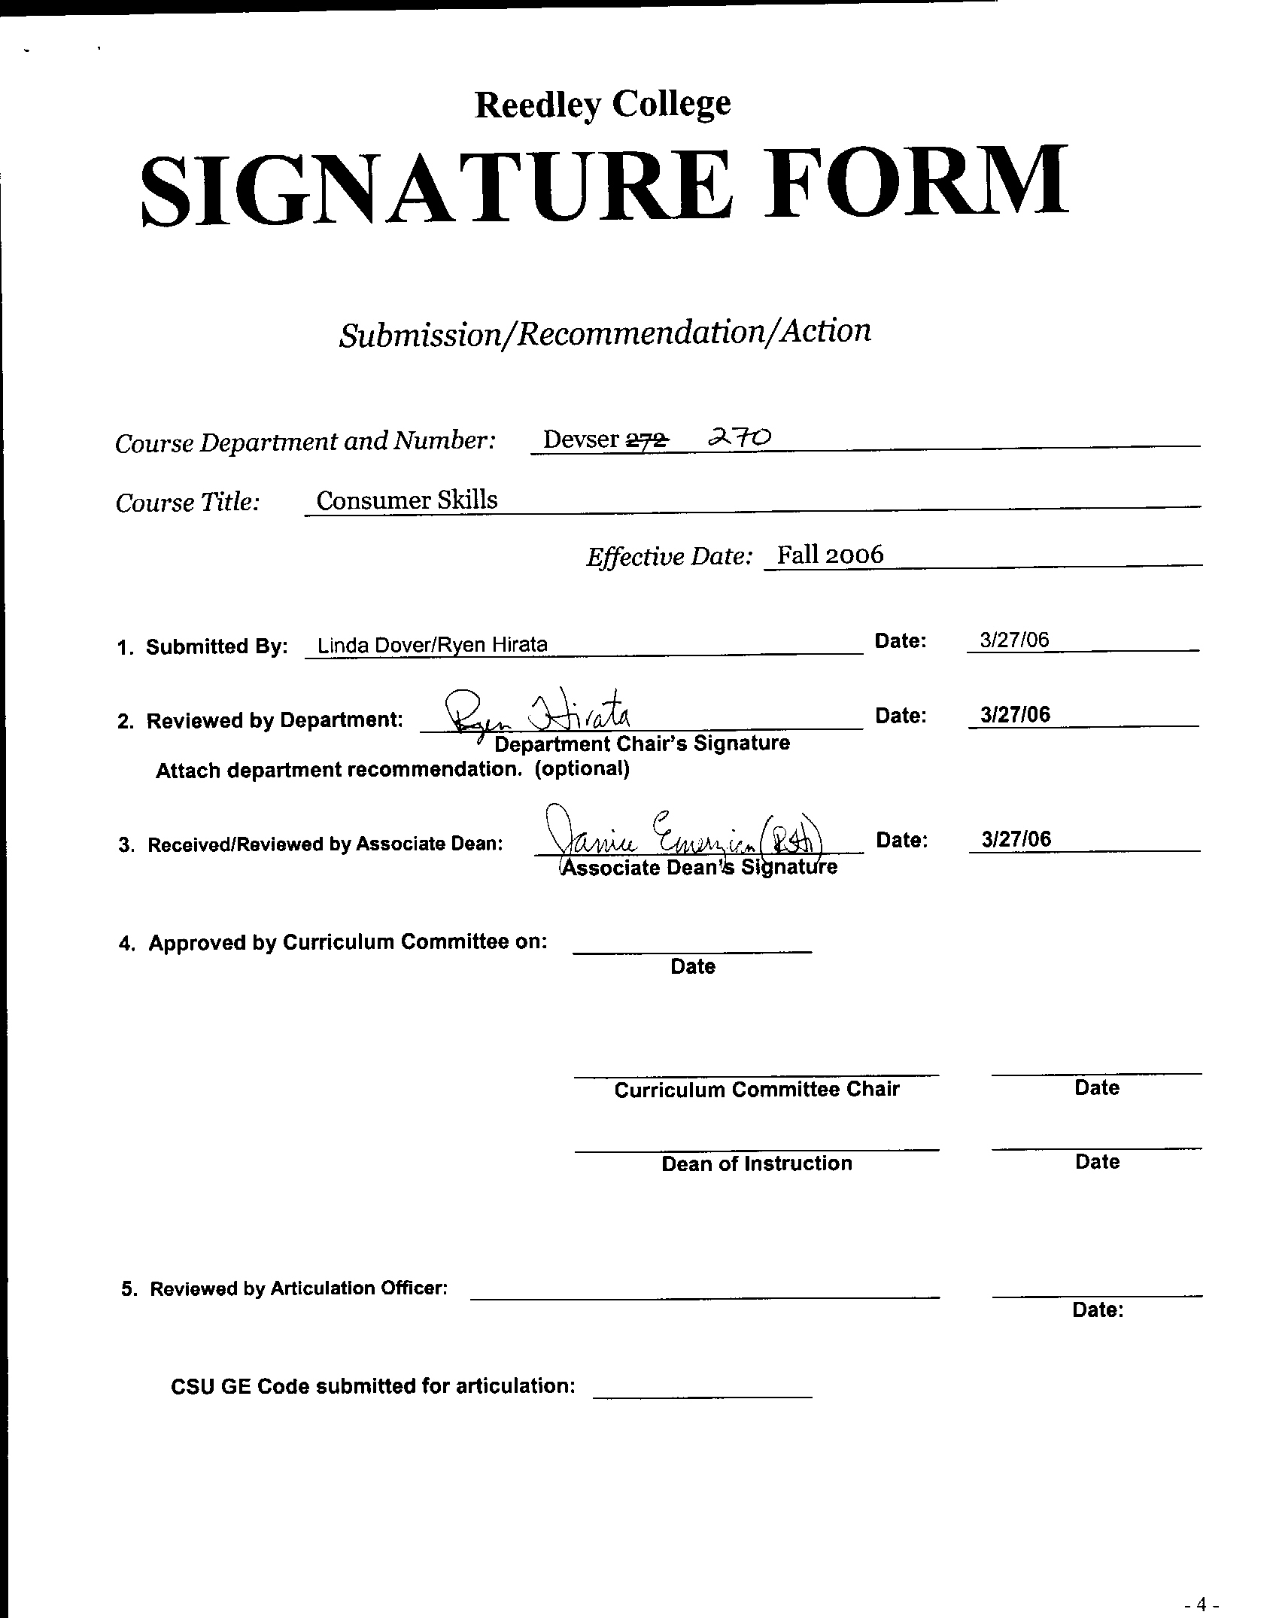



CREDIT COURSE OUTLINE

I. Cover Page
(1)  Course ID: DEVSER 270 |  | (2)  Course Title: Consumer Skills |  |  |  |  |  |  | (3)  Units: 2
(4) Lecture / Lab Hours: |  |  |  | (8)Classification:
Semester course  Hours per week | Lec hrs:
 | Lab hrs: |  | 6 |  |  | Degree applicable:
*Lab will generate ______ hour(s) per week outside work. |  |  |  |  |  | Non-degree applicable: |  |  | x
Short-term course:  Hours per course | Lec hrs: |  |  |  |  | Pre-collegiate basic skills:
 | Lab hrs:
*Lab will generate ______ total hour(s) outside work. |  |  |  | (9)RC | Fulfills degree requirement: (area)
(5)Grading Basis: | Grading scale only |  |  |  | General education:
 | CR/NC option |  |  |  | General education category:
 | CR/NC only |  | x |  | Major category:
(6)Basic Skills Prerequisites:  none |  |  |  | (10)CSU: |  | Baccalaureate:
 |  |  |  | (11) Repeatable: (A course may be repeated  three times) |  |  |  |  | 3
Basic Skills Advisories:
none
 |  |  |  | For Office Use Only
(7)Subject Prerequisites: none |  |  |  | CATID: 199100.01 |  |  |  | Org Code:
 |  |  |  | Tops Code: 1304.00 |  |  |  | SAM Priority: E
 |  |  |  | VEA Code: |  |  |  | Course LHE: 4.50
Subject Corequisites:  none |  |  |  | Effective Date: Fall 2002 |  |  |  | Replaces: DEVSER 272 Consumer Skills
Subject Advisories:  none |  |  |  | CSU GE Code: 9.4 |  |  |  | Replaced by:  Date:
(12)Catalog Description:

Emphasis on home management, personal finance, health and safety, and food and nutrition. Designed for the Developmentally Delayed Learner.

*See lecture/lab hours in Curriculum Handbook. 9/00

Course ID: DEVSER 270 |  | Course Title: Consumer Skills

II. Course Objectives:

(Specify major objectives in terms of the observable knowledge and/or skills to be attained.)

In the process of completing this course, the student will demonstrate the ability to:

1. Manage money
2. Analyze the consumer aspects of finding and maintaining a home
3. Develop a realistic financial plan, write checks, and balance a checkbook
4. Diagnose and seek help for consumer problems
5. Evaluate consumer frauds and deceptions in the consumer market
6. Demonstrate an awareness of the sources, costs and problems of credit use
7. Purchase, store, and prepare foods wisely and to use them in combinations that will maximize their nutritional values

III. Course Content Outline:
I. Home Management and Home Furnishings
A. Who is managing?
B. Resource, time, energy, money
II. Personal Finance
A. Exploration of basic financial skills
B. Monthly budget planning
III. Health and Safety
A. Spending you health dollars
B. Accident prevention
C. The consumer and health
IV. Food and Nutrition
A. Role of food in our lives
B. Nutrition
C. Reading a menu
D. Planning/preparing menu

Course ID: DEVSER 270 |  | Course Title: Consumer Skills

IV. Appropriate Readings

Reading assignments may include but are not limited to the following:

1. Text (sample): None

Global or international materials or concepts are appropriately included in this course
Multicultural materials and concepts are appropriately included in this course.

If either line is checked, write a paragraph indicating specifically how global/international and/or multicultural materials and concepts relate to content outline and/or readings.

Course ID: DEVSER 270 |  | Course Title: Consumer Skills
V. Methods to Measure Student Achievement and Determine Grades:
Students in this course will be graded in at least one of the following four categories. Please check those appropriate. A degree applicable course must have a minimum of one response in category A, B or C.
A. Writing
Check either 1 or 2 below
 | 1. Substantial writing assignments are required. Check the appropriate boxes below and provide a written description in the space provided.
 | 2. Substantial writing assignments are NOT required. If this box is checked leave this section blank. For degree applicable courses you must complete category B and/or C.
 | a. essay exam(s) |  | X | d. written homework
 | b. term or other papers(s) |  |  | e. reading reports
 | c. laboratory reports |  |  | f. other (specify)
Required assignments may include but are not limited to the following:
1. Complete a credit application
2. Develop a menu

B. Problem Solving
1. Computational or non-computational problem-solving demonstrations, including:
x | a. exam(s) |  |  | d. laboratory reports
 | b. quizzes |  | x | e. field work
x | c. homework problems |  |  | f. other (specify)

Required assignments may include, but are not limited to the following:
1. Develop a financial plan
2. Balance a checkbook

Course ID: DEVSER 270 |  | Course Title: Consumer Skills
C. Skill demonstrations, including:
x | a. class performance(s) |  | x | c. performance exam(s)
x | b. field work |  |  | d. other (specify
Required assignments may include, but are not limited to the following:

D. Objective examinations, including:
x | a. multiple choice |  | d. completion
 | b. true/false |  | e. other (specify)
 | c. matching items

Description/Explanation: Based on the categories checked, it is the recommendation of the department that the instructor’s grading methods fall within the following departmental guidelines; however, the final method of grading is still at the discretion of the individual instructor. The instructor’s syllabus must reflect the criteria by which the student’s grade has been determined. (A minimum of five (5) grades must be recorded on the final roster.)

If several methods to measure student achievement are used, indicate here the approximate weight or percentage each has in determining student final grades.

