Reedley College

New Credit Course Outline

Course # / Title | MAG 204 Hydraulics

CHECK OFF SHEET
PRELIMINARY STEPS (Do before completing Course Outline):

☑ 1. | Communicate with the Curriculum Chair regarding intent to propose a new course (scheduling an appointment for discussion is highly recommended for first time proposers).

☑ 2. | List term for Implementation: | [ ] | Fall |  | X | Spring | 2007 | [ ] | Summer

☑ 3. | Determine if there is a similar course or program at FCC:
 | Yes
X | No

If yes, you will fill out the RC/FCC Course Alignment form (included in packet) after you have completed the cover page (Part I, Items 1-12) of the Course Outline of Record.

☑ 4. | Determine placement of course:
Desired CSU General Education Code | Yes |  | No | X
Transfer Baccalaureate List | Yes |  | No | X
Corresponds for CSUF Course? | Yes |  | No | X

If Yes, schedule an appointment with the Articulation Officer.

☑ 5. | Course repeatability for credit: If any of these are checked
 | Yes
X | No

If yes, secure a Course Repetition form from the Curriculum Office.

☑ 6. | Suggested maximum enrollment for course: | 15

☑ COURSE OUTLINE OF RECORD completed.

FINAL steps (Do after completing Course Outline of Record)

☑ 1. | Signature Form. Secure signatures of the Department Chair and the Associate Dean before submitting the completed course proposal to the Curriculum Office.

☑ 2. | Program Description. Course will change an existing program/is part of a new program which is or will be described in the college catalogue.
X | Yes
 | No

If yes, fill out the Program Description form (included in packet) before submitting your finalized proposal to the Curriculum Office.

☑ 3. | Final Check. All items above have been completed and checked off before proposal is submitted.
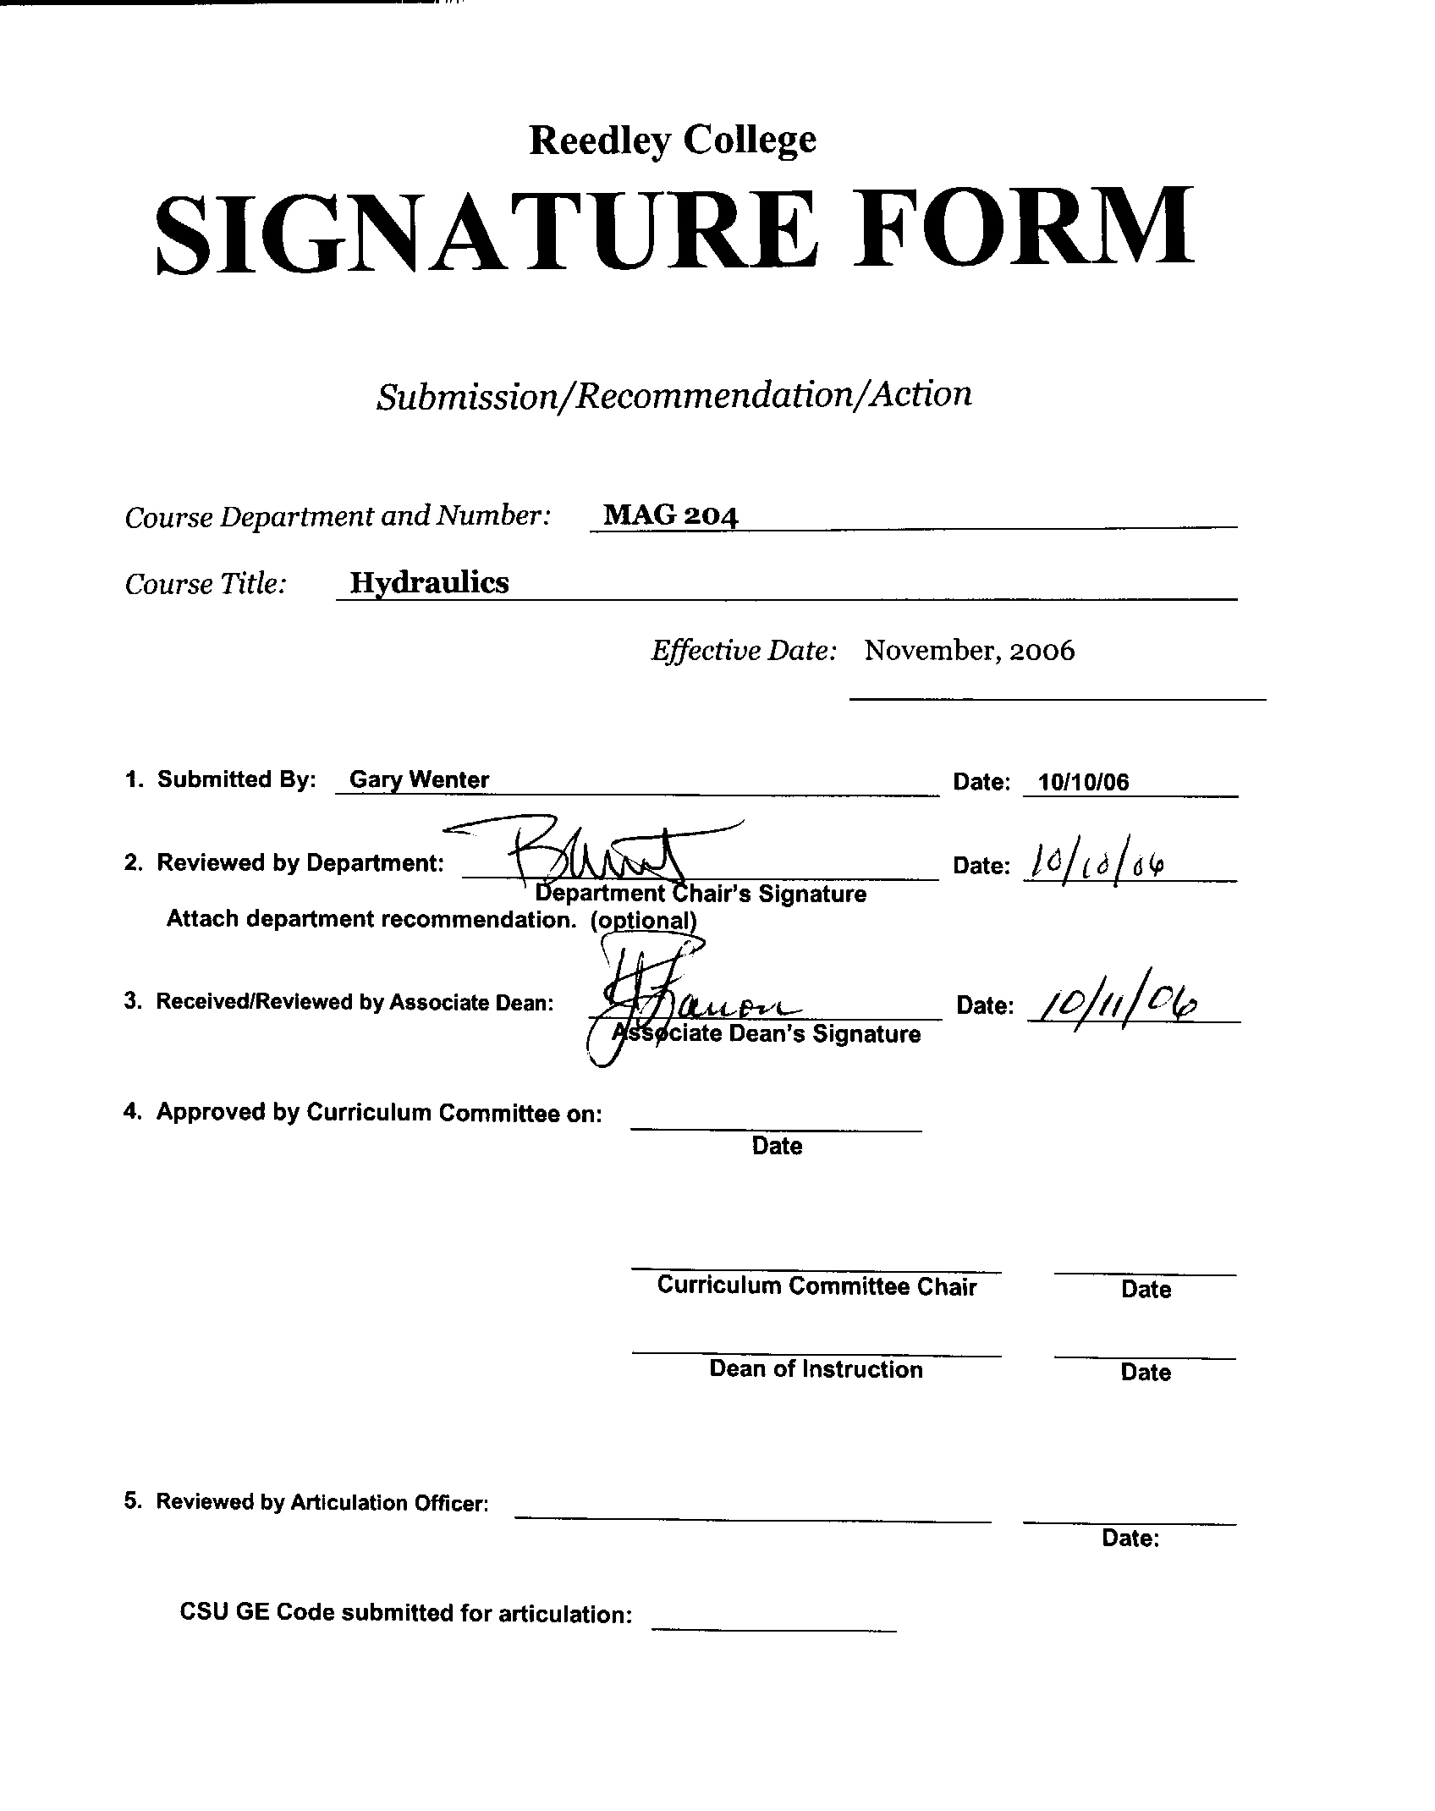


CREDIT COURSE OUTLINE

I. COVER PAGE

(1)  Course ID: MAG 204 |  | (2)  Course Title: Hydraulics |  | (3)  Units: 3

(4) Lecture / Lab Hours: |  |  | (8)Classification:
Semester course  Hours per week | Lec hrs: | 2
 | Lab hrs: | 2 |  |  | Degree applicable:
Lab will generate __1___ hour(s) per week outside work. |  |  |  |  | Non-degree applicable: |  |  | X
Short-term course:  Hours per course | Lec hrs: |  |  |  | Pre-collegiate basic skills:
 | Lab hrs:
Lab will generate ______ total hour(s) outside work. |  |  | (9)RC | Fulfills AS/AA degree requirement: (area)
(5)Grading Basis: | Grading scale only | X |  | General education category:
 | CR/NC option |  |  | Major:
 | CR/NC only
(6)Basic Skills Prerequisites: |  |  | (10)CSU: |  | Baccalaureate:
(11) Repeatable: (A course may be repeated
three times)
Basic Skills Advisories: |  |  | For Office Use Only
 |  |  | CATID: |  |  |  | DATATEL:
(7)Subject Prerequisites (requires C grade or better): |  |  | Course LHE: |  |  |  | Unit Code:
 |  |  | VEA Code: |  |  |  | SAM Priority:
 |  |  | TOPS Code: |  |  |  | Effective Date:
Subject Corequisites: |  |  | CSU: |  |  |  | Replaces:
Subject Advisories: |  |  |  |  |  |  | Replaced by:  Date:
(12)Catalog Description:

Introduction to the principles of hydraulics applied to farm, light industrial and on-highway equipment. Includes study of the technical language of fluid power, including graphical symbols, industrial standards, components, and maintenance of hydraulic units. Emphasis will be placed on the application of knowledge through machine testing and adjusting.

Course ID: MAG 204 |  | Course Title: Hydraulics

II. COURSE OUTCOMES:

(Specify the learning skills the student demonstrates through completing the course and link critical thinking skills to specific course content and objectives.)

Upon completion of this course, students will be able to:

- Select and use problem solving techniques appropriate to hydraulic systems on agricultural, construction and on-highway systems.
- Calculate lifting force of given pump pressure and surface area of lifting cylinders.
- Troubleshoot a system with low hydraulic pressure using inductive and deductive reasoning.
- Transfer knowledge and skills from a hydraulic testing bench to a machine system.
- Determine appropriate tools and procedures necessary to repair a given hydraulic component.
F. Design basic hydraulics systems using appropriate symbols.

III. COURSE OBJECTIVES:

(Specify major objectives in terms of the observable knowledge and/or skills to be attained.)

In the process of completing this course, students will:

- Demonstrate understanding of fluid drive systems.
- Identify components and explain operation of common hydraulic systems.
- Develop knowledge in hydraulic system nomenclature and symbols.
- Solve problems involving pressure and flow.
- Develop competency in the safe diagnosis and troubleshooting of hydraulic systems.
- Replace defective hydraulic components.
- Understand the physical laws of enclosed liquids.

Course ID: |  | Course Title:

IV. COURSE CONTENT OUTLINE:

- Introduction
  - Basic principles of hydraulics
  - How a hydraulic system works
  - Comparing open and closed center systems
  - Use of hydraulics

- Hydraulic Pumps & Motors
  - Displacement of pumps and motors
  - Gear pumps and motors
  - Vane pumps and motors
  - Piston pumps and motors
  - Pump and motor failures

- Hydraulic Valves
  - Relief valves
  - Pressure reducing valves
  - Pressure sequence valves
  - Check valves
  - Rotary selector valves
  - Spool valves
  - Flow control valves

- Hydraulic Cylinders
  - Single acting cylinders
  - Double acting cylinders
  - Cylinder seals
  - Cylinder operation

- Hydraulic Accessories
  - Fluids
  - Accumulators
  - Filters
  - Reservoirs
  - Coolers
  - Hoses

- Maintenance
  - Cleanliness
  - Cleaning and flushing systems
  - Preventing leaks
  - Preventing overheating
  - System pre-checks

- Diagnosis and Testing of Hydraulic Systems
  - Basic diagnostic steps
  - Testing the system
  - Troubleshooting charts

Course ID: MAG 204 |  | Course Title: Hydraulics

V. APPROPRIATE READINGS

Reading assignments may include but are not limited to the following:

A. Sample Text Title: FOS Hydraulics, 6th edition

B. Other Readings:

Global or international materials or concepts are appropriately included in this course
Multicultural materials and concepts are appropriately included in this course.

If either line is checked, write a paragraph indicating specifically how global/international and/or multicultural materials and concepts relate to content outline and/or readings.

Course ID: MAG 204 |  | Course Title: Hydraulics

VI. METHODS TO MEASURE STUDENT ACHIEVEMENT AND DETERMINE GRADES:
Students in this course will be graded in at least one of the following four categories. Please check those appropriate. A degree applicable course must have a minimum of one response in category A, B or C.

A. Writing
Check either 1 or 2 below
x | 1. Substantial writing assignments are required. Check the appropriate boxes below and provide a written description in the space provided.
 | 2. Substantial writing assignments are NOT required. If this box is checked leave this section blank. For degree applicable courses you must complete category B and/or C.
 | a. essay exam(s) | X | d. written homework
 | b. term or other papers(s) | X | e. reading reports
X | c. laboratory reports | X | f. other (specify) Service Reports
Required assignments may include but are not limited to the following:

Service reports on worked performed will be required in the course.

B. Problem Solving
1. Computational or non-computational problem-solving demonstrations, including:
X | a. exam(s) | X | d. laboratory reports
X | b. quizzes | X | e. field work
X | c. homework problems |  | f. other (specify)
Required assignments may include, but are not limited to the following:

Computations involving force, pressure, area and flow will be required of the student. Problem solving techniques related to system troubleshooting and component failure will be emphasized.

Course ID: MAG 204 |  | Course Title: Hydraulics

C. Skill demonstrations, including:
X | a. class performance(s) | X | c. performance exam(s)
X | b. field work |  | d. other (specify)
Required assignments may include, but are not limited to the following:

Laboratory activities are often skill based and will be graded on quantity and quality of worked performed.

D. Objective examinations, including:
X | a. multiple choice | X | d. completion
X | b. true/false | X | e. other (specify) Short answer, essay style questions
X | c. matching items

COURSE GRADE DETERMINATION:
Description/Explanation: Based on the categories checked in A-D, it is the recommendation of the department that the instructor’s grading methods fall within the following departmental guidelines; however, the final method of grading is still at the discretion of the individual instructor. The instructor’s syllabus must reflect the criteria by which the student’s grade has been determined. (A minimum of five (5) grades must be recorded on the final roster.)

If several methods to measure student achievement are used, indicate here the approximate weight or percentage each has in determining student final grades.

This class is designed to develop equipment technician skills to diagnose and repair hydraulic systems. Field laboratory skills will constitute 50% of the grade. The remaining 50% of the grade will consist of lecture tests, quizzes and homework.

