Reedley College
Proposed Course Modification

Course # / Title | Devser 264– Transition to College for Students with Disabilities

CHECK OFF SHEET
PRELIMINARY STEPS. Do before completing Course Modification Form.
(EACH BOX SHOULD BE CHECKED AS COMPLETED BEFORE SUBMISSION.)
☑ 1. Communicate with the Curriculum Chair regarding intent to modify an existing course outline (recommended, not required).
☑ 2. List term for implementation of modifications:
[ ] | Fall |  | [ x ] | Spring | 2007 | [ ] | Summer
☑ 3. Check one:
Do not complete Fresno City College course alignment page if:
 | No similar course or program at FCC.
X | Course currently in common with FCC course or accepted in lieu of and changes will not affect status.

Complete Fresno City College course alignment page if:
Course currently in common with FCC course or accepted in lieu of. Changes may affect status. Consult with counterparts at FCC and complete alignment page
Course not in common or accepted in lieu of but may be with proposed changes consult with FCC counterparts

☑ 4. Changes sought in the following:

CSU General Education Code | Yes |  | No | X
Transfer Baccalaureate List | Yes |  | No | X

If yes to either, schedule an appointment with the Articulation Officer
☑ 5. Changes sought in number of repeats for credit:

X | Yes
 | No

If yes, secure a Course Repetition form from the Curriculum Office.
PROPOSED COURSE MODIFICATION FORM
☑ Appropriate sections of Course Outline of Record completed.

FINAL steps (Do after completing Course Outline of Record)

☑ 1. Signature Form. Secure signatures of the Department Chair and the Associate Dean before submitting the completed course proposal to the Curriculum Office.

☑ 2. Program Description. Course modification will change an existing program which is or will be described in the college catalogue.

 | Yes | X | No

If yes, complete Program Description Form before submitting modification.

☑ 3. Final Check. All items above have been completed and checked off before modification is submitted.

Reedley College
PROPOSED COURSE MODIFICATION

All changes and modifications in the official course outline must come to the Curriculum Committee. Though minor changes may seem obvious, even these need to come to committee for information and to update the official curriculum. Changes in programs or in several department offerings should be submitted together if possible so that the whole picture is clear.

OUTLINE. Please fill in current existing course number, title, and units for course to be modified.

Department | DSP&S | Course No. | Devser 264
Course Title | Transition to College for Students with Disabilities | Units | 1
 | Effective Date | Spring 2007

A. PROPOSED CHANGES.
(Indicate below all proposed changes to be made in the course outline.)

I. Cover Page
X | 1. Course ID |  |  | 8. Classification (Degree applicable, Non-degree applicable, or
 | 2. Course Title |  |  | Pre-collegiate Basic skills)
 | 3. Units |  |  | 9. General Education Pattern, Graduation Requirement, and
 | 4. Lecture/Lab Hours |  |  | Major Category
X | 5. Grading Basis |  |  | 10. General Education Pattern/Baccalaureate (CSU)
 | 6. Entrance Skills: Basic Skills Prerequisites/Advisories |  |  | 11. Repeatability
 | 7. Subject Prerequisites/Corequisites/Advisories |  |  | 12. Catalog Description

Other pages

X | II. Course Outcomes |  |  | VI. Methods of Grading
X | III. Course Objectives |  |  | VII. Levels of Educational Materials
X | IV. Course Content Outline |  | Additional Pages (optional depending on course)
X | V. Approved Readings |  |  | Request for Repeatability/Limitation on Enrollment

B. DESCRIPTION OF CHANGES AND MODIFICATIONS.

ITEM NO. | CHANGED FROM | CHANGED TO | REASON
1 | Devser 264 | Devser 240 | Course Number Aligning
5 | CR/NC Option | CR/NC Only | To align with FCC course
II | No outcomes | Developed outcomes | For new curriculum format
III | Broad objectives | More specific objectives | To correlate with new course outcomes
IV | General Broad Categories | More specific topics | To align with new outcomes & objectives
V | Removed DSP&S Handbook | Added DSP&S TTC Workbook | Workbook developed specifically for the course

(Additional sheets may be attached if necessary.)

C. EXPLANATIONS. If course modification results in changes in the program which will require use of the program description form, please give rationale.

Please attach the complete outline before modifications to this form. If only the first page of the outline is being modified, also attach the new first page. If other pages of the outline are being modified, please attach the complete new outline.

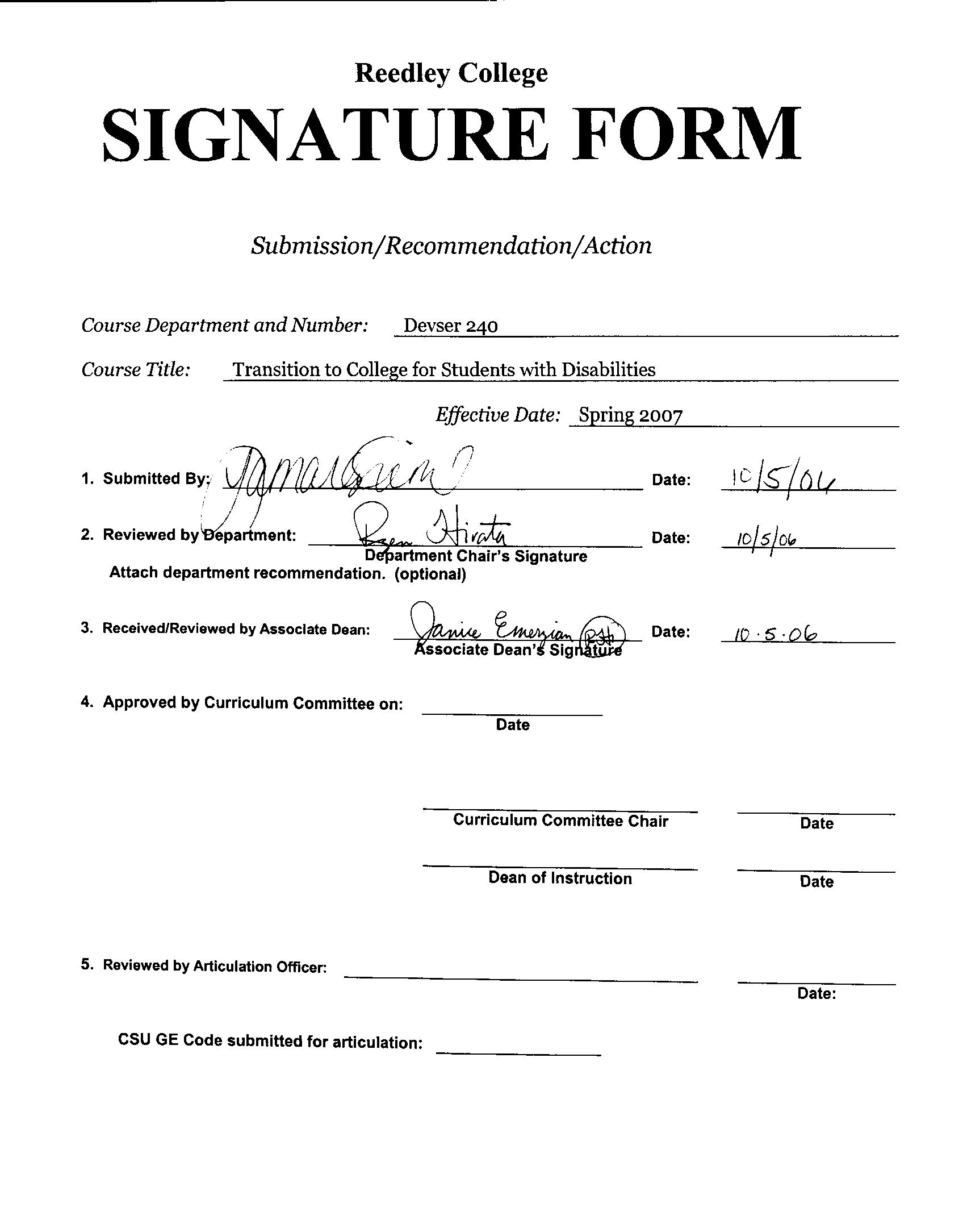



CREDIT COURSE OUTLINE

I. COVER PAGE

(1)  Course ID: Devser 240 |  | (2)  Course Title: Transition to College for Students with Disabilities |  | (3)  Units: 1.0

(4) Lecture / Lab Hours: |  |  | (8)Classification:
Semester course  Hours per week | Lec hrs: | 1
 | Lab hrs: |  |  |  | Degree applicable:
Lab will generate ______ hour(s) per week outside work. |  |  |  |  | Non-degree applicable: |  |  | X
Short-term course:  Hours per course | Lec hrs: |  |  |  | Pre-collegiate basic skills:
 | Lab hrs:
Lab will generate ______ total hour(s) outside work. |  |  | (9)RC | Fulfills AS/AA degree requirement: (area)
(5)Grading Basis: | Grading scale only |  |  | General education category:
 | CR/NC option |  |  | Major:
 | CR/NC only | X
(6)Basic Skills Prerequisites: |  |  | (10)CSU: |  | Baccalaureate:
 |  |  | (11) Repeatable: (A course may be repeated  three times) |  |  |  |  | 1
Basic Skills Advisories: |  |  | For Office Use Only
 |  |  | CATID: |  |  |  | DATATEL:
(7)Subject Prerequisites (requires C grade or better): |  |  | Course LHE: |  |  |  | Unit Code:
 |  |  | VEA Code: |  |  |  | SAM Priority:
 |  |  | TOPS Code: |  |  |  | Effective Date:
Subject Corequisites: |  |  | CSU: |  |  |  | Replaces:
Subject Advisories: |  |  |  |  |  |  | Replaced by:  Date:
(12)Catalog Description:

The course is designed to assist students with disabilities in preparing for their initial semester in a community college. The student will learn to navigate the State Center Community College District campuses, utilize resources and become familiar with academic policies, procedures and services. Course content will cover issues related to accommodations and resources available to students with disabilities to enable them to be successful in a college setting including disability evaluation and assessment, alternative media, course selection, and scheduling.

Course ID: Devser 240 |  | Course Title: Transition to College for Students with Disabilities

II. COURSE OUTCOMES:

(Specify the learning skills the student demonstrates through completing the course and link critical thinking skills to specific course content and objectives.)

Upon completion of this course, students will be able to:

- Complete the college application process.
- Complete the financial aid application process.
- Complete the college placement test process.
- Make initial request for services & accommodations.
- Complete the DSP&S intake process.
- Navigate at least 1 SCCCD campus.
- Utilize information found in the schedule of courses and college catalogue.
- Apply a variety of study skills to increase success in future college courses.

III. COURSE OBJECTIVES:

(Specify major objectives in terms of the observable knowledge and/or skills to be attained.)

In the process of completing this course, students will:

- Practice completion of various admission and financial aid applications
- Practice listing important identifying information (i.e. Full legal name, SSN, DOB, Phone, Address, etc.)
- Identify appropriate math & English courses for self, based on placement test results or discussions with counselor.
- Find information regarding programs of study and courses in the college catalog.
- Learn what a Student Education Plan is and how to get one.
- Learn how to develop a class schedule, using the schedule of courses.
- Identify important dates and deadlines on the academic calendar (i.e. start of semester, last day to add, drop – with & without a “W”, finals week & schedule, etc.)
- Identify academic requirements, regulations and administrative policies.
- Identify campus student activities.
- Identify programs of study, including certificate of achievement and certificate of completion.
- Tour at least 1 SCCCD campus.
- Identify services & accommodations available through the DSP&S office.
- Learn to describe their disabling condition.
- Learn to state what services they received in high school.
- Identify services and accommodations that would increase their ability to be successful in the college setting.

Course ID: Devser 240 |  | Course Title: Transition to College for Students with Disabilities

IV. COURSE CONTENT OUTLINE:
- SCCCD Overview
  - Fresno City College
  - Reedley College
    - Clovis Center
    - Madera Center
    - Oakhurst Center

- College Applications
  - Important identifying information
  - SCCCD application process
  - SCCCD application
  - Matriculation

- Financial Aid
  - Important identifying information
  - Eligibility – High School Diploma, High School Certificate of Completion
  - FASFA
  - BOG Fee Waiver
  - Grants
  - Scholarships

- Placement Testing
  - Accuplacer
  - Paper/Pencil placement testing
  - Other testing (i.e. Ability to Benefit Test, ESL, etc.)

- Campus Awareness
  - Programs of Study: AA/AS Degree, Certificates of Achievement and Certificates of Completion
  - Utilizing the College Catalog
  - Utilizing the schedule of courses
  - Major/Certificate Sheets
  - Student Education Plans
  - Student Activities
  - Support Services
  - Campus Tours

- Academic and Administrative Requirements
  - Student Fees
  - Course Load & Grading System: units, letter grading, CR/NC grading, Incompletes, withdrawals, GPA, etc.
  - Satisfactory Progress and Probationary Statuses
  - Student Rights and Grievance Process
  - Student standards of conduct
  - Important Dates and Deadlines: last day to register, drop for a refund, drop to avoid a “W”, change to or from CR/NC grading basis.
  - Early Alert Progress Reports
  - Keeping personal information current: changing address and phone number
  - Parking Regulations

- DSP&S
  - DSP&S Intake Process
  - Disability Verification
  - Services and Accommodations Available through DSP&S
  - Requesting Services and Accommodations through DSP&S
  - Priority Registration with DSP&S counselors

- Tools for Success
  - Characteristics of Successful Students
  - Responsibility and Self-Advocacy
  - Suggestions for Success: general listening, reading, note-taking and test preparation concepts

Course ID: Devser 240 |  | Course Title: Transition to College for Students with Disabilities

V. APPROPRIATE READINGS

Reading assignments may include but are not limited to the following:

A. Sample Text Title:
1) Reedley College Catalog
2) Fresno City College Catalog
3) Reedley College Schedule of Courses
4) Fresno City College Schedule of Courses

B. Other Readings:
- DSP&S Transition to College Course Workbook

Global or international materials or concepts are appropriately included in this course
Multicultural materials and concepts are appropriately included in this course.

If either line is checked, write a paragraph indicating specifically how global/international and/or multicultural materials and concepts relate to content outline and/or readings.

Course ID: Devser 240 |  | Course Title: Transition to College for Students with Disabilities

VI. METHODS TO MEASURE STUDENT ACHIEVEMENT AND DETERMINE GRADES:
Students in this course will be graded in at least one of the following four categories. Please check those appropriate. A degree applicable course must have a minimum of one response in category A, B or C.

A. Writing
Check either 1 or 2 below
 | 1. Substantial writing assignments are required. Check the appropriate boxes below and provide a written description in the space provided.
X | 2. Substantial writing assignments are NOT required. If this box is checked leave this section blank. For degree applicable courses you must complete category B and/or C.
 | a. essay exam(s) |  | d. written homework
 | b. term or other papers(s) |  | e. reading reports
 | c. laboratory reports |  | f. other (specify):
Required assignments may include but are not limited to the following:

B. Problem Solving
1. Computational or non-computational problem-solving demonstrations, including:
 | a. exam(s) |  | d. laboratory reports
X | b. quizzes |  | e. field work
 | c. homework problems | X | f. other (specify): Locating Information and navigation of SCCCD Campuses
Required assignments may include, but are not limited to the following:
- Locating Program of Study and Class information in College Catalog
- Locating class day/time in schedule of courses
- Locating administrative and academic requirements, policies & procedures in catalog & schedule of courses
- Locating Buildings utilizing a campus map.
- Field Trips to SCCCD Campus(s)
- Locating Classrooms when on campus

Course ID: Devser 240 |  | Course Title: Transition to College for Students with Disabilities

C. Skill demonstrations, including:
X | a. class performance(s) |  | c. performance exam(s)
 | b. field work |  | d. other (specify)
Required assignments may include, but are not limited to the following:

In class demonstration of:
- ability to accurately complete college forms and applications
- using the college catalog to locate information
- using the schedule of courses to locate information
- Using a campus map to navigate a SCCCD campus (during field trip)

D. Objective examinations, including:
X | a. multiple choice | X | d. completion
X | b. true/false | X | e. other (specify): short answer, oral response, demonstration
X | c. matching items

COURSE GRADE DETERMINATION:
Description/Explanation: Based on the categories checked in A-D, it is the recommendation of the department that the instructor’s grading methods fall within the following departmental guidelines; however, the final method of grading is still at the discretion of the individual instructor. The instructor’s syllabus must reflect the criteria by which the student’s grade has been determined. (A minimum of five (5) grades must be recorded on the final roster.)

If several methods to measure student achievement are used, indicate here the approximate weight or percentage each has in determining student final grades.

15% Application for Admission
15% Financial Aid Forms
15% Placement Testing
15% Campus Tour
15% DSP&S Intake
15% Participation
10% Quizzes

Reedley College

REQUEST FOR COURSE REPEATABILITY
(For reasons other than alleviating substandard work)

Course ID: Devser 240 |  | Course Title: Transition to College for Students with Disabilities | Date: 9/28/06
Number of times course may be repeated, excluding initial enrollment (1, 2, or 3): |  |  | 1
or
Maximum units to which course may be repeated, including initial enrollment:

The following information is required under Title V, Part VI, Section 58161
1. Explain how the course content differs each time it is offered:

Per Title V, section 56029 Special Class Course Repeatability, additional repeats allowed to accommodate a student’s educational limitations. Different techniques and approaches are introduced, depending on instructor and students enrolled each time the course is offered.

2. Using reasons “A” or “B” listed below, explain how the student, by repeating this course will gain an expanded educational experience (A or B):
X | A. Skills or proficiencies are enhanced by supervised repetition and practice within class periods. Explanation:
Repetition and practice will consistently reinforce general college concepts, the application process and prepare students for college enrollment. The repetition will provide a foundation where students have a better understanding and improved their ability to effectively complete forms for matriculation, DSP&S and overall be more prepared to effectively function in a college setting.
 | B. Active Participatory experience in individual study or group assignments is the basic means by which learning objectives are attained. Explanation:

