Reedley College
Proposed Course Modification

Course # / Title | ART 10 – Beginning Ceramics

CHECK OFF SHEET
PRELIMINARY STEPS. Do before completing Course Modification Form.
(EACH BOX SHOULD BE CHECKED AS COMPLETED BEFORE SUBMISSION.)
☑ 1. Communicate with the Curriculum Chair regarding intent to modify an existing course outline (recommended, not required).
☑ 2. List term for implementation of modifications:
[ x] | Fall | 2007 | [ ] | Spring |  | [ ] | Summer
☑ 3. Check one:
Do not complete Fresno City College course alignment page if:
 | No similar course or program at FCC.
x | Course currently in common with FCC course or accepted in lieu of and changes will not affect status.

Complete Fresno City College course alignment page if:
Course currently in common with FCC course or accepted in lieu of. Changes may affect status. Consult with counterparts at FCC and complete alignment page
Course not in common or accepted in lieu of but may be with proposed changes consult with FCC counterparts

☑ 4. Changes sought in the following:

CSU General Education Code | Yes |  | No | x
Transfer Baccalaureate List | Yes |  | No | x

If yes to either, schedule an appointment with the Articulation Officer
☑ 5. Changes sought in number of repeats for credit:

x | Yes
 | No

If yes, secure a Course Repetition form from the Curriculum Office.
PROPOSED COURSE MODIFICATION FORM
☑ Appropriate sections of Course Outline of Record completed.

FINAL steps (Do after completing Course Outline of Record)

☑ 1. Signature Form. Secure signatures of the Department Chair and the Associate Dean before submitting the completed course proposal to the Curriculum Office.

☑ 2. Program Description. Course modification will change an existing program which is or will be described in the college catalogue.

 | Yes | x | No

If yes, complete Program Description Form before submitting modification.

☑ 3. Final Check. All items above have been completed and checked off before modification is submitted.

Reedley College
PROPOSED COURSE MODIFICATION

All changes and modifications in the official course outline must come to the Curriculum Committee. Though minor changes may seem obvious, even these need to come to committee for information and to update the official curriculum. Changes in programs or in several department offerings should be submitted together if possible so that the whole picture is clear.

OUTLINE. Please fill in current existing course number, title, and units for course to be modified.

Department | Fine Arts/Social Science | Course No. | ART 10
Course Title | Beginning Ceramics | Units | 3.0
 | Effective Date | Fall 2007

A. PROPOSED CHANGES.
(Indicate below all proposed changes to be made in the course outline.)

I. Cover Page
 | 1. Course ID |  |  | 8. Classification (Degree applicable, Non-degree applicable, or
 | 2. Course Title |  |  | Pre-collegiate Basic skills)
 | 3. Units |  |  | 9. General Education Pattern, Graduation Requirement, and
 | 4. Lecture/Lab Hours |  |  | Major Category
 | 5. Grading Basis |  |  | 10. General Education Pattern/Baccalaureate (CSU)
 | 6. Entrance Skills: Basic Skills Prerequisites/Advisories |  | x | 11. Repeatability
 | 7. Subject Prerequisites/Corequisites/Advisories |  |  | 12. Catalog Description

Other pages

 | II. Course Outcomes |  |  | VI. Methods of Grading
 | III. Course Objectives |  |  | VII. Levels of Educational Materials
 | IV. Course Content Outline |  | Additional Pages (optional depending on course)
 | V. Approved Readings |  |  | Request for Repeatability/Limitation on Enrollment

B. DESCRIPTION OF CHANGES AND MODIFICATIONS.

ITEM NO. | CHANGED FROM | CHANGED TO | REASON
I.11 | 0 | 1 | Enhancement of skills and proficiencies

(Additional sheets may be attached if necessary.)

C. EXPLANATIONS. If course modification results in changes in the program which will require use of the program description form, please give rationale.

Please attach the complete outline before modifications to this form. If only the first page of the outline is being modified, also attach the new first page. If other pages of the outline are being modified, please attach the complete new outline.

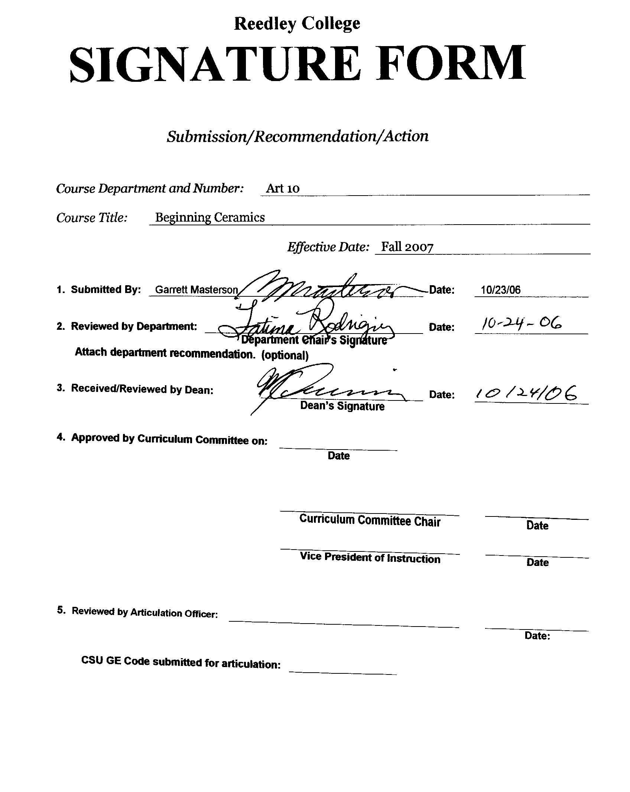



CREDIT COURSE OUTLINE

I. COVER PAGE

(1)  Course ID: ART 10 |  | (2)  Course Title: Beginning Ceramics |  | (3)  Units: 3.0

(4) Lecture / Lab Hours: |  |  | (8)Classification:
Semester course  Hours per week | Lec hrs: | 2
 | Lab hrs: | 4 |  |  | Degree applicable: |  |  | x
Lab will generate ______ hour(s) per week outside work. |  |  |  |  | Non-degree applicable:
Short-term course:  Hours per course | Lec hrs: |  |  |  | Pre-collegiate basic skills:
 | Lab hrs:
Lab will generate ______ total hour(s) outside work. |  |  | (9)RC | Fulfills AS/AA degree requirement: (area)
(5)Grading Basis: | Grading scale only |  |  | General education category: |  |  |  | C
 | CR/NC option | x |  | Major: |  | Art, Fine Arts
 | CR/NC only
(6)Basic Skills Prerequisites: |  |  | (10)CSU: |  | Baccalaureate: |  |  | x
 |  |  | (11) Repeatable: (A course may be repeated  three times) |  |  |  |  | 1
Basic Skills Advisories:  Eligibility for ENGL 125, ENGL 126, and MATH 101 |  |  | For Office Use Only
 |  |  | CATID: |  |  |  | DATATEL:
(7)Subject Prerequisites (requires C grade or better): |  |  | Course LHE: 5.0 |  |  |  | Unit Code: 244010
 |  |  | VEA Code: N |  |  |  | SAM Priority: E
 |  |  | TOPS Code: 1002.00 |  |  |  | Effective Date: Fall 2007
Subject Corequisites: |  |  | A, CSU, UC |  |  |  | Replaces: 10166002
Subject Advisories: |  |  |  |  |  |  | Replaced by:  Date:
(12)Catalog Description:

A concise history of ceramics. Basic studio practices in hand construction, throwing on the potter’s wheel, and glazing.

Course ID: ART 10 |  | Course Title: Beginning Ceramics

II. COURSE OUTCOMES:

(Specify the learning skills the student demonstrates through completing the course and link critical thinking skills to specific course content and objectives.)

Upon completion of this course, students will be able to:

1. Apply knowledge of forming clay (pinch, coil, slab and wheel) to create ceramic art.

2. Use a variety of historical, cultural techniques and methods of decorating pottery and sculpture

3. Demonstrate self-expression and creative problem solving.

4. Show their knowledge of the elements and principles of design as they relate to three-dimensional art.

5. Discuss and evaluate three-dimensional art and its effect on them and the world around them.

III. COURSE OBJECTIVES:

(Specify major objectives in terms of the observable knowledge and/or skills to be attained.)

Students will:

1. demonstrate the ability to use different methods of forming clay.
2. translate the elements and principles of design into three dimensional ceramic objects.
3. demonstrate through their work an historic and multi-cultural awareness as it relates to ceramics.
4. acquire basic skills in glazing (over & under) and slip decorating.
5. gain a working knowledge of ceramic kilns (primitive, modern, low and high fire, gas and electric) and how to utilize the appropriate firing techniques.
6. acquire a knowledge of timing and a sensitivity to the material.

Course ID: ART 10 |  | Course Title: Beginning Ceramics

IV. COURSE CONTENT OUTLINE:

Students receive group and personal instruction in, but not limited to, the history and practice in the following areas:
A. Hand building
1. Pinch Pot
a. combining forms
b. historical shapes
c. primitive firing
2. Bowl
a. humping and slumping
b. dry footing
c. glaze decoration
3. Tile
a. high and low relief
b. subtractive (carving into a form)
c. additive (modeling into a form)
d. multi color glazing techniques
4. Cylinder
a. use of armatures
b. handles and lids
c. Sgraffito and Mishima
5. Coil Pot
a. functional
b. nonfunctional
6. Slab Pot
a. geometric form
b. precision and control

B. Wheel Throwing
1. Wedging
2. Centering
3. Opening
4. Shaping
a. functional
b. nonfunctional
5. Trimming

C. Glazing
1. glaze calculation
2. low fire
3. high fire
4. underglaze
5. overglaze
D. Firing
1. Low fire
a. campfire
b. pit fire
c. Saggar
d. Raku
e. electric
f. gas
2. High fire
a. electric
b. gas
1) oxidation
2) reduction

E. Combination
1. Combining as many of the above as possible in one project

Course ID: ART 10 |  | Course Title: Beginning Ceramics

V. APPROPRIATE READINGS

Reading assignments may include but are not limited to the following:

Reading assignments may include but are not limited to the following:

A. Sample Text Title:
Casson, Michael. The Craft of the Potter. Barron’s
Nelson, Glenn and Burkett, Richard. Ceramics a Potter’s Handbook. Wadsworth
Speight, Charlotte and Toki, John. Hands in Clay. Mayfield Publishing.
Peterson, Susan. Craft and the Art of Clay. Prentice Hall

B. Other Readings:

x | Global or international materials or concepts are appropriately included in this course
x | Multicultural materials and concepts are appropriately included in this course.

If either line is checked, write a paragraph indicating specifically how global/international and/or multicultural materials and concepts relate to content outline and/or readings.

Ceramics from around the world (Japan, China, Korea, Africa, Middle Eastern Countries, Europe and the Americas) are studied in this course with strong emphasis on their historical contributions to current ceramics.

Course ID: ART 10 |  | Course Title: Beginning Ceramics

VI. METHODS TO MEASURE STUDENT ACHIEVEMENT AND DETERMINE GRADES:
Students in this course will be graded in at least one of the following four categories. Please check those appropriate. A degree applicable course must have a minimum of one response in category A, B or C.

A. Writing
Check either 1 or 2 below
 | 1. Substantial writing assignments are required. Check the appropriate boxes below and provide a written description in the space provided.
x | 2. Substantial writing assignments are NOT required. If this box is checked leave this section blank. For degree applicable courses you must complete category B and/or C.
 | a. essay exam(s) |  | d. written homework
 | b. term or other papers(s) |  | e. reading reports
 | c. laboratory reports |  | f. other (specify)
Required assignments may include but are not limited to the following:

B. Problem Solving
1. Computational or non-computational problem-solving demonstrations, including:
x | a. exam(s) |  | d. laboratory reports
x | b. quizzes |  | e. field work
x | c. homework problems | x | f. other (specify) Assigned projects

Required assignments may include, but are not limited to the following:

1. Quizzes and exams covering course content and vocabulary
2. Assigned reading
3. Fine Art Gallery or Museum visit
4. Report
5. Assigned projects
a. hand building
b. wheel throwing
c. glazing
d. firing
e. combination

Course ID: ART 10 |  | Course Title: Beginning Ceramics

C. Skill demonstrations, including:
x | a. class performance(s) |  | c. performance exam(s)
 | b. field work |  | d. other (specify
Required assignments may include, but are not limited to the following:

Students will be required to participate in daily classroom activities, discussions and critiques.

They will demonstrate a measured growth in hand/eye coordination and their knowledge of the elements and principles of design and ceramics as an artistic media for self-expression, through the following assignments:
1. pinch, coil, slab, and wheel construction
2. glazing
3. kiln firing

D. Objective examinations, including:
x | a. multiple choice |  | d. completion
x | b. true/false | x | e. other (specify) oral critiques are conducted
x | c. matching items

Description/Explanation: Based on the categories checked, it is the recommendation of the department that the instructor’s grading methods fall within the following departmental guidelines; however, the final method of grading is still at the discretion of the individual instructor. The instructor’s syllabus must reflect the criteria by which the student’s grade has been determined. (A minimum of five (5) grades must be recorded on the final roster.)

If several methods to measure student achievement are used, indicate here the approximate weight or percentage each has in determining student final grades.

Ceramic Projects and Classroom Participation 80-90%
Exam and paper 10-20%
FOR DEGREE APPLICABLE COURSES

Course ID: ART 10 |  | Course Title: Beginning Ceramics

VII. EDUCATIONAL MATERIALS
For degree applicable courses, the adopted texts, as listed in the college bookstore, or instructor-prepared materials have been certified to contain college-level materials.

Validation Language Level (check where applicable): | College-Level  Criteria Met
 | Yes | No
Textbook | x
Reference materials | x
Instructor-prepared materials | x
Audio-visual materials | x

Indicate method of evaluation:
Used readability formulae (grade level 10 or higher)
Text is used in a college-level course | x
Used grading provided by publisher
Other: (please explain; relate to Skills Levels)

Computation Level (Eligible for MATH 101 level or higher where applicable) |  | x

Content
Breadth of ideas covered clearly meets college-level learning objectives of this course |  | x
Presentation of content and/or exercises/projects:
Requires a variety of problem-solving strategies including inductive and deductive reasoning. |  | x
Requires independent thought and study |  | x
Applies transferring knowledge and skills appropriately and efficiently to new situations or  problems. |  | x
List of Reading/Educational Materials

Casson, Michael. The Craft of the Potter. Barron’s
Nelson, Glenn and Burkett, Richard. Ceramics a Potter’s Handbook. Wadsworth
Speight, Charlotte and Toki, John. Hands in Clay. Mayfield Publishing.
Peterson, Susan. Craft and the Art of Clay. Prentice Hall

Comments:

 | This course requires special or additional library materials (list attached).
x | This course requires special facilities: fully equipped ceramics studio

FORM A
TARGET COURSE | ART 10 |  | Beginning Ceramics
 | Number |  | Title
BASIC SKILLS ADVISORIES PAGE The skills listed are those needed for eligibility for English 125, 126, and Math 101. These skills are listed as the outcomes from English 252, 262, and
Math 250. In the right hand column, list at least three major basic skills needed at the beginning of the target course and check off the corresponding basic skills listed at the left.

Math Skills (eligibility for Math 101)  (as outcomes for Math 250)  x Performing the four arithmetic operations on whole numbers, arithmetic fractions, and decimal fractions.  x Making the conversions from arithmetic fractions to decimal fractions, from decimal fractions to percents, and then reversing the process.  Applying the concepts listed above to proportions, percents, simple interest, markup and discount.  x Applying the operations of integers in solving simple equations.  x Converting between the metric and English measurement systems | 1. Ability to calculate proportions  2. Ability to measure using fractions and percent conversions.  3. Ability to calculate weights and measurements.
Reading Skills (eligibility for English 126)  (as outcomes for English 262)  Using phonetic, structural, contextual, and dictionary skills to attack and understand words.  Applying word analysis skills to reading in context.  x Using adequate basic functional vocabulary skills.  x Using textbook study skills and outlining skills.  x Using a full range of literal comprehension skills and basic analytical skills such as predicting, inferring, concluding, and evaluating. | 1. Ability to read the material in college level reference materials.  2. Ability to understand technical terms and their use.  3. Ability to interpret written instructions.
Writing Skills (eligibility for English 125)  (as outcomes for English 252)  x Writing complete English sentences and avoiding errors most of the time.  x Using the conventions of English writing: capitalization, punctuation, spelling, etc.  Using verbs correctly in present, past, future, and present perfect tenses, and using the correct forms of common irregular verbs.  Expanding and developing basic sentence structure with appropriate modification.  Combining sentences using coordination, subordination, and phrases.  x Expressing the writer's ideas in short personal papers utilizing the writing process in their development. | 1. Ability to write college level reports.  2. Ability to express in writing information learned from lecture, research, and critiques.
Check the appropriate spaces.
x Eligibility for Math 101 is advisory for the target course.
x Eligibility for English 126 is advisory for the target course.
x Eligibility for English 125 is advisory for the target course.
If the reviewers determine that an advisory or advisories in Basic Skills are all that are necessary for success in the target course, stop here, provide the required signatures, and forward this form to the department chair, the appropriate associate dean, and the curriculum committee.

Content review completed by |  | Date

Reedley College

REQUEST FOR COURSE REPEATABILITY
(For reasons other than alleviating substandard work)

Course ID: ART 10 |  | Course Title: BEGINNING CERAMICS | Date: 10/23/06
Number of times course may be repeated, excluding initial enrollment (1, 2, or 3): |  |  | 1
or
Maximum units to which course may be repeated, including initial enrollment: |  |  | 6

The following information is required under Title V, Part VI, Section 58161
1. Explain how the course content differs each time it is offered:

The course will differ each semester for those students who are repeating because the curriculum content is addressed through a variety of projects which change in focus and depth. A coil pot assignment in one semester may emphasize form where in another semester the emphasis would shift to surface decoration.

2. Using reasons “A” or “B” listed below, explain how the student, by repeating this course will gain an expanded educational experience (A or B):
 | A. Skills or proficiencies are enhanced by supervised repetition and practice within class periods. Explanation:
Some elements of the curriculum are well served to be repeated in order to establish sound fundamentals and to practice the skills necessary for growth in the medium. Proficiency in the fundamentals of pottery allow for the focus to shift toward more conceptual and aesthetic approaches to each assignment.
 | B. Active Participatory experience in individual study or group assignments is the basic means by which learning objectives are attained. Explanation:

