Reedley College
Proposed Course Modification

Course # / Title | GEOG 4B World Geography

CHECK OFF SHEET
PRELIMINARY STEPS. Do before completing Course Modification Form.
(EACH BOX SHOULD BE CHECKED AS COMPLETED BEFORE SUBMISSION.)
☑ 1. Communicate with the Curriculum Chair regarding intent to modify an existing course outline (recommended, not required).
☑ 2. List term for implementation of modifications:
[ ] | Fall |  | [ ] | Spring | 2007 | [ ] | Summer
☑ 3. Check one:
Do not complete Fresno City College course alignment page if:
 | No similar course or program at FCC.
x | Course currently in common with FCC course or accepted in lieu of and changes will not affect status.

Complete Fresno City College course alignment page if:
x | Course currently in common with FCC course or accepted in lieu of. Changes may affect status. Consult with counterparts at FCC and complete alignment page
 | Course not in common or accepted in lieu of but may be with proposed changes consult with FCC counterparts

☑ 4. Changes sought in the following:

CSU General Education Code | Yes |  | No | x
Transfer Baccalaureate List | Yes |  | No | x

If yes to either, schedule an appointment with the Articulation Officer
☑ 5. Changes sought in number of repeats for credit:

 | Yes
x | No

If yes, secure a Course Repetition form from the Curriculum Office.
PROPOSED COURSE MODIFICATION FORM
☑ Appropriate sections of Course Outline of Record completed.

FINAL steps (Do after completing Course Outline of Record)

☑ 1. Signature Form. Secure signatures of the Department Chair and the Associate Dean before submitting the completed course proposal to the Curriculum Office.

☑ 2. Program Description. Course modification will change an existing program which is or will be described in the college catalogue.

 | Yes | x | No

If yes, complete Program Description Form before submitting modification.

☑ 3. Final Check. All items above have been completed and checked off before modification is submitted.

Reedley College
PROPOSED COURSE MODIFICATION

All changes and modifications in the official course outline must come to the Curriculum Committee. Though minor changes may seem obvious, even these need to come to committee for information and to update the official curriculum. Changes in programs or in several department offerings should be submitted together if possible so that the whole picture is clear.

OUTLINE. Please fill in current existing course number, title, and units for course to be modified.

Department | Science and Technology | Course No. | GEOG 4B
Course Title | World Geography | Units | 3
 | Effective Date

A. PROPOSED CHANGES.
(Indicate below all proposed changes to be made in the course outline.)

I. Cover Page
 | 1. Course ID |  |  | 8. Classification (Degree applicable, Non-degree applicable, or
 | 2. Course Title |  |  | Pre-collegiate Basic skills)
 | 3. Units |  |  | 9. General Education Pattern, Graduation Requirement, and
 | 4. Lecture/Lab Hours |  |  | Major Category
 | 5. Grading Basis |  |  | 10. General Education Pattern/Baccalaureate (CSU)
 | 6. Entrance Skills: Basic Skills Prerequisites/Advisories |  |  | 11. Repeatability
 | 7. Subject Prerequisites/Corequisites/Advisories |  |  | 12. Catalog Description

Other pages

x | II. Course Outcomes |  |  | VI. Methods of Grading
 | III. Course Objectives |  |  | VII. Levels of Educational Materials
x | IV. Course Content Outline |  | Additional Pages (optional depending on course)
x | V. Approved Readings |  |  | Request for Repeatability/Limitation on Enrollment

B. DESCRIPTION OF CHANGES AND MODIFICATIONS.

ITEM NO. | CHANGED FROM | CHANGED TO | REASON
II |  | Recognize, identify and discuss the major geographic features of all continents studied.  Use a map to discuss the geographic features of the regions studied.  Discuss the geographic basis for the major geopolitical and domestic issues in the regions studied.  Discuss current world issues using an international perspective rather than a local one. | Need to separate SLO from objectives
IV | Simple outline of regions covered | - Physical geography  - Cultural geography  - Economic Geography  - Political issues and geopolitics  - Map location work | Provide more detail concerning topics to be covered by students
V | Old Text | Updated text | Need new text to maintain currency in subject

(Additional sheets may be attached if necessary.)
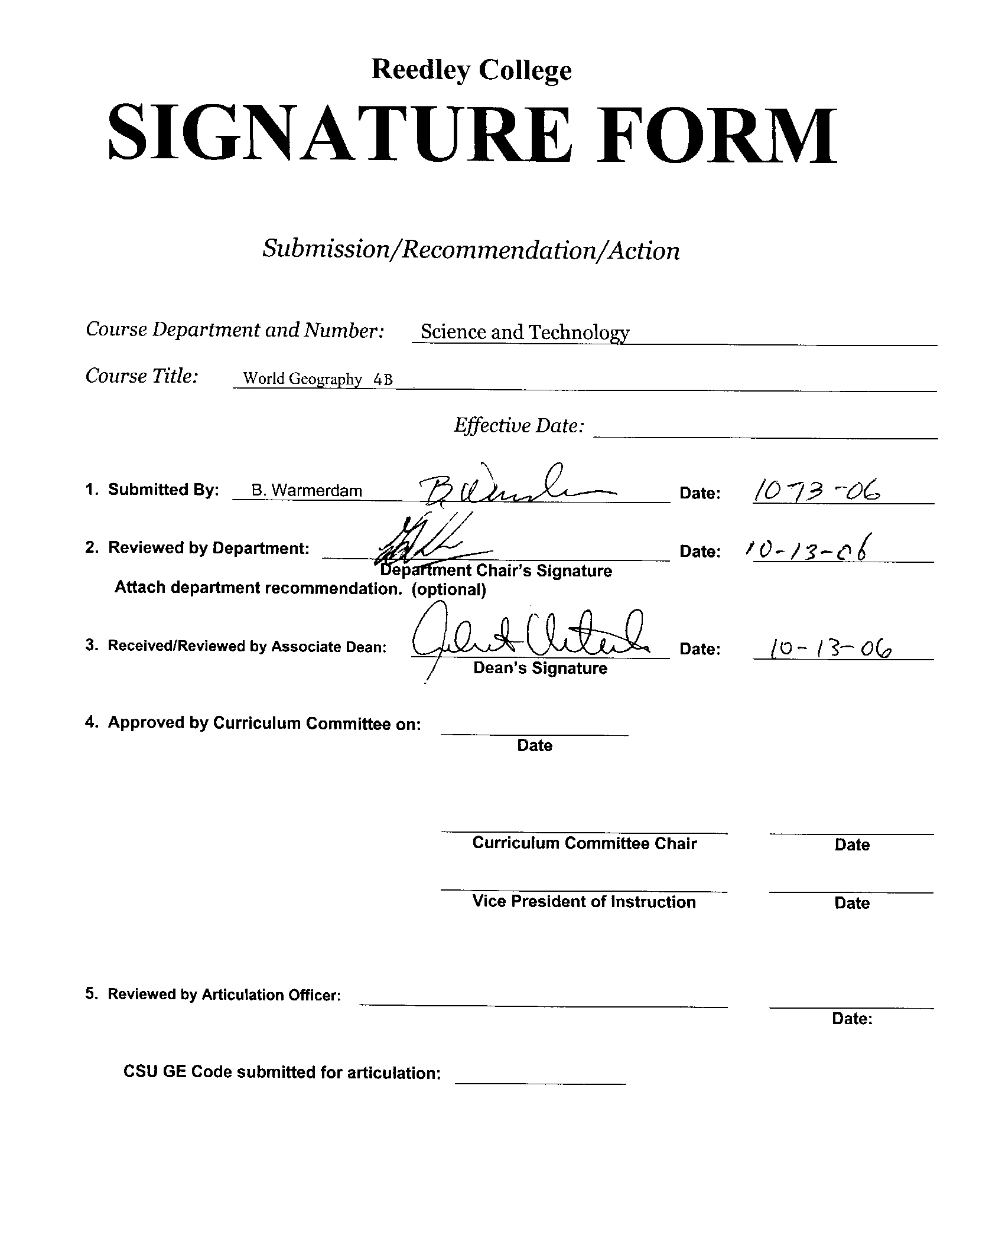

COURSE ALIGNMENT
REEDLEY COLLEGE/FRESNO CITY COLLEGE

Complete only if YES was checked on New Course Proposal Packet check off sheet for a similar department or course at FCC.

FCC Course | World Geography

RC Course ID | GEOG 4B | Course Title | World Geography

The RC and FCC faculty members of the Department have communicated regarding the attached course. The following determination has been made:

Check the appropriate boxes:
 The course department is the same □* Prerequisites/Corequisites are the same.
 The course number is the same □* The catalog descriptions are the same.
 The course title is the same. □* The number of repeats are the same.
 The units are the same
 The lecture/lab hours are the same. (rationale if not the same)
 The grading basis is the same. (CR-NC/A-F)

 It was determined that this course is a match.
(*Items with asterisk do not need to be an exact match.)
□ The course does not match but should be evaluated for acceptance in lieu of FCC’s
□ This course is not a match.

Please provide an explanation of the differences:

RC Instructor |  | Date
Department Chair |  | Date
Dean |  | Date



CREDIT COURSE OUTLINE

I. COVER PAGE

(1)  Course ID: GEOG 4B |  | (2)  Course Title: World Geography |  | (3)  Units: 3

(4) Lecture / Lab Hours: |  |  | (8)Classification:
Semester course  Hours per week | Lec hrs: | 3
 | Lab hrs: |  |  |  | Degree applicable: |  |  | x
Lab will generate ______ hour(s) per week outside work. |  |  |  |  | Non-degree applicable:
Short-term course:  Hours per course | Lec hrs: |  |  |  | Pre-collegiate basic skills:
 | Lab hrs:
Lab will generate ______ total hour(s) outside work. |  |  | (9)RC | Fulfills AS/AA degree requirement: (area)
(5)Grading Basis: | Grading scale only |  |  | General education category:
 | CR/NC option | x |  | Major:
 | CR/NC only
(6)Basic Skills Prerequisites: |  |  | (10)CSU: |  | Baccalaureate: |  |  | x
 |  |  | (11) Repeatable: (A course may be repeated  three times) |  |  |  |  | No
Basic Skills Advisories:  Eligibility for ENGL 125 and ENGL 126 |  |  | For Office Use Only
 |  |  | CATID: |  |  |  | DATATEL:
(7)Subject Prerequisites (requires C grade or better): |  |  | Course LHE: |  |  |  | Unit Code:
 |  |  | VEA Code: |  |  |  | SAM Priority:
 |  |  | TOPS Code: |  |  |  | Effective Date:
Subject Corequisites: |  |  | CSU: |  |  |  | Replaces:
Subject Advisories: |  |  |  |  |  |  | Replaced by:  Date:
(12)Catalog Description:

This course covers the Americas, Australia, New Zealand, and the Pacific Islands. A study of the physical settings, population patterns, natural resources, and economic and political status of these regions.

Course ID: GEOG 4B |  | Course Title: World Geography

II. COURSE OUTCOMES:

(Specify the learning skills the student demonstrates through completing the course and link critical thinking skills to specific course content and objectives.)

Upon completion of this course, students will be able to:

- Recognize, identify and discuss the major geographic features of the regions studied.

- Use a map to illustrate the geographic features of the regions studied.

- Discuss the geographic basis of the major geopolitical and domestic issues in the regions studied.

- Discuss current world issues using an international perspective rather than a local one.

III. COURSE OBJECTIVES:

(Specify major objectives in terms of the observable knowledge and/or skills to be attained.)

In the process of completing this course, students will:

- learn to interpret a map of the major countries, cities, and physical features of the Americas, Australia, New Zealand and the Pacific Islands..
- recognize and apply simple geographic terms and comprehend geographic principles.
- learn the factors that determine the cultural, economic and political development of countries and regions.

Course ID: GEOG 4B |  | Course Title: World Geography

IV. COURSE CONTENT OUTLINE:

- Introduction to World Geography
- Regions and regional geography
- The eight major world regions
- Distribution of wealth and poverty
- Industrialization
- Demographic transition
- Immigration and globalization

- North America
- Physical geography
- Cultural geography
- Economic geography
- Political issues and geopolitics
- Map location work

- Central and South America
- Physical geography
- Cultural geography
- Economic geography
- Political issues and geopolitics
- Map location work

- Australia and New Zealand
- Physical geography
- Cultural geography
- Economic geography
- Political issues and geopolitics
- Map location work

E. Pacific Islands
- Physical geography
- Cultural geography
- Economic geography
- Political issues and geopolitics
- Map location work

Course ID: GEOG 4B |  | Course Title: World Geography

V. APPROPRIATE READINGS

Reading assignments may include but are not limited to the following:

A. Sample Text Title: Essentials of World Regional Geography. Hobbs, Joseph J. / Salter, Christopher L.
5TH Edition, 2006 . Brooks/Cole Publishing Co.

B. Other Readings: Recent news articles provided by instructor

EXAMPLE: “Worse things than growing US Population,” Fresno Bee, Oct. 23, 2006.

x | Global or international materials or concepts are appropriately included in this course
x | Multicultural materials and concepts are appropriately included in this course.

If either line is checked, write a paragraph indicating specifically how global/international and/or multicultural materials and concepts relate to content outline and/or readings.

This course is, by its very nature, both international and multicultural in its approach and materials. It involves the study of many countries outside the United States, and delves into the nature of the people who are there, including their cultural background, way of life, and the issues they face. One of the goals of this course is that students would be able to discuss world issues from an international perspective rather than a local one.

Course ID: GEOG 4B |  | Course Title: World Geography

VI. METHODS TO MEASURE STUDENT ACHIEVEMENT AND DETERMINE GRADES:
Students in this course will be graded in at least one of the following four categories. Please check those appropriate. A degree applicable course must have a minimum of one response in category A, B or C.

A. Writing
Check either 1 or 2 below
x | 1. Substantial writing assignments are required. Check the appropriate boxes below and provide a written description in the space provided.
 | 2. Substantial writing assignments are NOT required. If this box is checked leave this section blank. For degree applicable courses you must complete category B and/or C.
 | a. essay exam(s) | x | d. written homework
x | b. term or other papers(s) |  | e. reading reports
 | c. laboratory reports |  | f. other (specify)
Required assignments may include but are not limited to the following:

Example of a written homework question:

“Discuss two probable impacts that the North American Free Trade Agreement (NAFTA) will have upon Mexico.”

B. Problem Solving
1. Computational or non-computational problem-solving demonstrations, including:
 | a. exam(s) |  | d. laboratory reports
 | b. quizzes |  | e. field work
x | c. homework problems |  | f. other (specify)
Required assignments may include, but are not limited to the following:

- Critical thinking skills required for successful completion of the course include:
  - Linking theory about development to facts about countries and regions.
  - Recognizing patterns of organization in the world that produce its regions and relationships.
  - Comparing and contrasting regions of the world.

Course ID: GEOG 4B |  | Course Title: World Geography

C. Skill demonstrations, including:
 | a. class performance(s) |  | c. performance exam(s)
 | b. field work |  | d. other (specify)
Required assignments may include, but are not limited to the following:

- The course covers many concepts of both physical and human geography; it is imperative for the students to read the pages assigned outside of class, and to complete the written homework assignments, in order to fully comprehend the material.

D. Objective examinations, including:
x | a. multiple choice |  | d. completion
 | b. true/false |  | e. other (specify)
x | c. matching items

COURSE GRADE DETERMINATION:
Description/Explanation: Based on the categories checked in A-D, it is the recommendation of the department that the instructor’s grading methods fall within the following departmental guidelines; however, the final method of grading is still at the discretion of the individual instructor. The instructor’s syllabus must reflect the criteria by which the student’s grade has been determined. (A minimum of five (5) grades must be recorded on the final roster.)

If several methods to measure student achievement are used, indicate here the approximate weight or percentage each has in determining student final grades.

The map tests require students to identify major countries, cities, and physical features of each of the regions studied.

10% Written Homework
20% Term Paper
70% Exams

FOR DEGREE APPLICABLE COURSES

Course ID: GEOG 4B |  | Course Title: World Geography

VII. EDUCATIONAL MATERIALS
For degree applicable courses, the adopted texts, as listed in the college bookstore, or instructor-prepared materials have been certified to contain college-level materials.

Validation Language Level (check where applicable): | College-Level  Criteria Met
 | Yes | No
Textbook | X
Reference materials
Instructor-prepared materials | X
Audio-visual materials | X

Indicate method of evaluation:
Used readability formulae (grade level 10 or higher)
Text is used in a college-level course | X
Used grading provided by publisher
Other: (please explain; relate to Skills Levels)

Computation Level (Eligible for MATH 101 level or higher where applicable)

Content
Breadth of ideas covered clearly meets college-level learning objectives of this course
Presentation of content and/or exercises/projects:
Requires a variety of problem-solving strategies including inductive and deductive reasoning. |  | X
Requires independent thought and study |  | X
Applies transferring knowledge and skills appropriately and efficiently to new situations or  problems. |  | X
List of Reading/Educational Materials

Essentials of World Regional Geography. Hobbs, Joseph J. / Salter, Christopher L.
5TH Edition, 2006 . Brooks/Cole Publishing Co

Contemporary World Regional Geography . Bradshaw, Michael J. / White, George W. / Dymond, Joseph P. . 2004. Mcgraw-Hill Publishing Company

Comments:

 | This course requires special or additional library materials (list attached).
 | This course requires special facilities:
FORM A
TARGET COURSE | GEOG 4B |  | World Geography
 | Number |  | Title

BASIC SKILLS ADVISORIES PAGE The skills listed are those needed for eligibility for English 125, 126, and Math 101. These skills are listed as the outcomes from English 252, 262, and Math 250. In the right hand column, list at least three major basic skills needed at the beginning of the target course and check off the corresponding basic skills listed at the left.

Math Skills (eligibility for Math 101)
(as outcomes for Math 250)

Performing the four arithmetic operations on whole numbers, arithmetic fractions, and decimal fractions.
Making the conversions from arithmetic fractions to decimal fractions, from decimal fractions to percents, and then reversing the process.
Applying the concepts listed above to proportions, percents, simple interest, markup and discount.
Applying the operations of integers in solving simple equations.
Converting between the metric and English measurement systems
Reading Skills (eligibility for English 126)  (as outcomes for English 262)  Using phonetic, structural, contextual, and dictionary skills to attack and understand words.  Applying word analysis skills to reading in context.  x Using adequate basic functional vocabulary skills.  x Using textbook study skills and outlining skills.  x Using a full range of literal comprehension skills and basic analytical skills such as predicting, inferring, concluding, and evaluating. | 1. The assigned textbook requires a student to read at college level.  2. Supplemental reading assignments require students to read magazine, newspaper and journal articles.  3. Research for term papers requires college level comprehension to be able to understand professional publications.
Writing Skills (eligibility for English 125)  (as outcomes for English 252)  x Writing complete English sentences and avoiding errors most of the time.  x Using the conventions of English writing: capitalization, punctuation, spelling, etc.  x Using verbs correctly in present, past, future, and present perfect tenses, and using the correct forms of common irregular verbs.  Expanding and developing basic sentence structure with appropriate modification.  Combining sentences using coordination, subordination, and phrases.  Expressing the writer's ideas in short personal papers utilizing the writing process in their development. | 1. Because a term paper and reports are required for this course, a student must be able to write clear sentences and be able organize a themed report.  2. Complete sentences are required for the short answer sections of exams.  3. The student must explain concepts in writing for reports.

Check the appropriate spaces.
Eligibility for Math 101 is advisory for the target course.
x Eligibility for English 126 is advisory for the target course.
x Eligibility for English 125 is advisory for the target course.
If the reviewers determine that an advisory or advisories in Basic Skills are all that are necessary for success in the target course, stop here, provide the required signatures, and forward this form to the department chair, the appropriate associate dean, and the curriculum committee.

Content review completed by |  | Date

